Project | IEEE 802.16 Broadband Wireless Access Working Group <http://ieee802.org/16>
Title | Text Proposal for Transformation Codebook Refinement and Tracking on Section 16.3.7.2.5.5.1
Date Submitted | 2010-07-09
Source(s) | Sudhir Ramakrishna,  Jerry Pi  Samsung Electronics Co., Ltd. | sudhir.r@samsung.com
Re: | Contribution in support of a comment on 16m SB  Section 16.3.7.2.5.5.1 Transformation codebook based feedback mode
Abstract | The contribution proposes the text of transformation codebook to be included in the 802.16m AWD (P802.16m/D6).
Purpose | To be discussed and adopted by TGm for the 802.16m AWD (P802.16m/D6).
Notice | This document does not represent the agreed views of the IEEE 802.16 Working Group or any of its subgroups. It represents only the views of the participants listed in the “Source(s)” field above. It is offered as a basis for discussion. It is not binding on the contributor(s), who reserve(s) the right to add, amend or withdraw material contained herein.
Release | The contributor grants a free, irrevocable license to the IEEE to incorporate material contained in this contribution, and any modifications thereof, in the creation of an IEEE Standards publication; to copyright in the IEEE’s name any IEEE Standards publication even though it may include portions of this contribution; and at the IEEE’s sole discretion to permit others to reproduce in whole or in part the resulting IEEE Standards publication. The contributor also acknowledges and accepts that this contribution may be made public by IEEE 802.16.
Patent Policy | The contributor is familiar with the IEEE-SA Patent Policy and Procedures:  <http://standards.ieee.org/guides/bylaws/sect6-7.html#6> and <http://standards.ieee.org/guides/opman/sect6.html#6.3>.  Further information is located at <http://standards.ieee.org/board/pat/pat-material.html> and <http://standards.ieee.org/board/pat>.

AWD Text Proposal for Transformation Codebook Refinement and Tracking on Section 16.3.7.2.5.5.1

Sudhir Ramakrishna, Jerry Pi,
Samsung Electronics Co., Ltd.

- Introduction & Proposal Rationale
[1] defines (in Section 16.3.7.2.5.5.1) a method by which the AMS can measure and feed back the transmit antenna correlation matrix, which is then used for transforming the codebooks. In the case of 8 transmit antennas, 120 bits are needed to feed back the correlation matrix. This is a significant overhead, especially when frequent feedbacks are needed and used to track channel conditions.
This contribution proposes an enhancement to the correlation matrix feedback in [1] for the 8 transmit antenna case, whereby one may reduce the frequency of the correlation matrix feedback, while still maintaining accuracy and the ability to track changes in the matrix, hence reducing the overhead in the application of the transformation method. This method does not require any additional signaling overheads, by re-using the sub-band PMI feedback that already exists in the usage scenarios for the transformation method (CL MU-MIMO on SLRU resources).
Section 3 provides the text modifications to [1] to implement this method, and the following appendix provides supporting simulation results.

- References
[1] IEEE 802.16m/D6, “802.16m Amendment Working Document (AWD)”

- Text proposal for inclusion in the 802.16m AWD/D5

Black: current text in D6
Blue: text to be added in D6
Insert the following text on page 647, line 46, of section 16.3.7.2.5.5.1:
------------------------------- Text Start ---------------------------------------------------------------
The total number of bits of feedback is 6 bits for 2 transmit antennas, 28 bits for 4 transmit antennas, and 120 bits for 8 transmit antennas. The AMS and ABS shall use the same transformation based on the correlation matrix fed back by the AMS. In the case that the ABS has eight transmit antennas, the AMS and the ABS shall further follow the procedure described below, in order to provide further information about the transmit correlation matrix, in addition to the information provided by the wideband correlation matrix R. The objective of this procedure is to provide a method for the AMS and ABS to continuously update the correlation matrix, denoted below as R_{t}. The following procedure applies to each ABS-AMS pair.

- Reset of the estimate of R_{t}:
When the AMS transmits the wideband correlation matrix R to the ABS, it shall set R_{t} = R. The ABS shall do likewise, i.e., upon receiving a wideband correlation matrix R reported by the AMS, it shall set R_{t} = R.

- Update of R_{t}:
Between two long-term feedback reports of the wideband correlation matrix R, both the AMS and the ABS shall simultaneously track and update/refine the correlation matrix R_{t}. R_{t} shall be updated each short reporting period, which is as defined in the Feedback Allocation A-MAP IE. The update is performed using the equations below. In these equations, the index n is in units of the short reporting period, and R_{t} [n] represents the update of R_{t} at time instant n based on the PMI information received at time instant (n-1). n = 0 corresponds to the reset event as defined in Step 1 above. The update equation is as follows

$$R_{t}[n]=\begin{aligned}\left\{0\text{.}9R_{t}[n−1]+0\text{.}1\sum_{s=1}^{M}{\frac{1}{M}{\tilde{v}}_{s}[n−1]{\tilde{v}}_{s}^{H}[n−1]},\text{if a PMI for subband }s\text{ reported at time instant }(n\text{-1}) | \right.\end{aligned}$$
--- Equation xxxx
where
- n is the PMI feedback period index
- ${\tilde{v}}_{s}[n−1]$is the codeword indicated by the PMI for subband s based on transformed codebook at time instant n-1
- M is the number of subbands for which a CQI/PMI is feedback.
------------------------------- Text End -----------------------------------------------------------------

Appendix: MU-MIMO SLS Simulation Results
Below shows the illustrative timeline diagram of the proposed method vs. current D6 method for 8TX transformation codebook transmission mode.
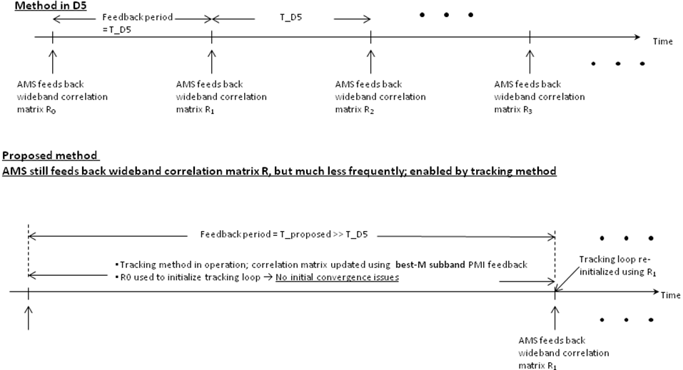
Summary of simulation assumption is listed below.

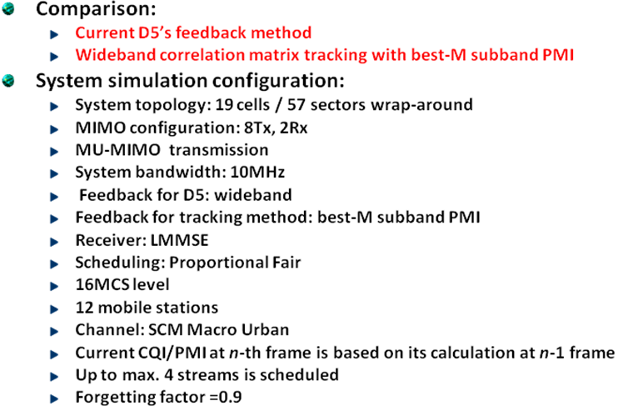

Summary of simulation results are shown as follow. Note that the proposed tracking method employs D6’s correlation matrix as its initialization matrix.

Case 1: System throughput at various best-M PMI/CQI feedback (M=1, 2, and 4) with antenna spacing λ/2. The feedback period for D5’ is 400 ms.

System Throughput | D6’s Method  (400 ms)  bps/Hz | Tracking Method  (20ms PMI feedback)  bps/Hz, % of D5 | Tracking Method  (5ms PMI feedback)  bps/Hz, % of D5
Best-M, M=1 | 5.773 | 5.788, 100.2% | 5.801, 100.5%
Best-M, M=2 | 5.801 | 5.942, 102% | 5.978, 103.5%
Best-M, M=4 | 5.831 | 6.115, 104.8% | 6.271, 107.2%

Case 2: System throughput at various best-M PMI/CQI feedback (M=1, 2, and 4) with antenna spacing λ/2. The feedback period for D5’ is 200 ms.

System Throughput | D6’s Method  (200 ms)  bps/Hz | Tracking Method  (20ms PMI feedback)  bps/Hz, % of D5 | Tracking Method  (5ms PMI feedback)  bps/Hz, % of D5
Best-M, M=1 | 5.945 | 5.952, 100% | 5.971, 100.2%
Best-M, M=2 | 5.983 | 6.091, 101.7% | 6.085, 101.7%
Best-M, M=4 | 6.011 | 6.195, 103.1% | 6.288, 104.3%

For small antenna spacing (λ/2), results shows the tracking method yield slight better performance over current D6 (baseline) performance by 0~7% throughput improvement, without additional feedback overhead.

Case 3: System throughput at various best-M PMI/CQI feedback (M=1 and 4) with antenna spacing 4λ. The feedback period for D6’ is 400 ms.

System Throughput | D6’s Method  (200 ms)  bps/Hz | Tracking Method  (20ms PMI feedback)  bps/Hz, % of D5 | Tracking Method  (5ms PMI feedback)  bps/Hz, % of D5
Best-M, M=1 | 5.185 | 5.098, 98.5% | 5.169, 99.8%
Best-M, M=4 | 5.211 | 5.201, 100% | 5.219, 100.2%

For large antenna spacing (4λ), results shows the tracking method yield similar performance to the current D6 (baseline) performance for the case of M=4, while slight performance degradation is observed for the case of M=1. Note that the transformation mode is targeted to enhance the base codebook performance when rank-1 channel is present. For large antenna spacing, the rank of channel would be essentially greater than 1(>1), thus the transformation mode would likely not be used.

Simulation results on the effect of PMI feedback error for tracking method is shown as follow
Case 4: System throughput at various feedback error (ε ) various best-M PMI/CQI feedback (M=1 and 4) with antenna spacing λ/2. The feedback period for D6’ is 400 ms.

System Throughput | D6’s Method  (400 ms)  bps/Hz | Tracking Method  (20ms PMI feedback)  bps/Hz, % of D5 | Tracking Method  (5ms PMI feedback)  bps/Hz, % of D5
Best-M, M=1, ε=1% | 5.770 | 5.781, 100% | 5.800, 100.5%
Best-M, M=4, ε=1% | 5.824 | 6.093, 103.8% | 6.185, 106.2%

Results also show the PMI feedback error has little impact on tracking performance for 1% of the feedback error.

