Project | IEEE 802.16 Broadband Wireless Access Working Group <http://ieee802.org/16>
Title | Proposal to support MSID privacy disabled operation mode(16.2.5.3.1)
Date Submitted | 2010-08-12
Source(s) | Youngkyo Baek, Rakesh Taori  Samsung Electronics  Xiangying Yang, Avishay Shraga,  Vivek G. Gupta, Muthaiah Venkatachalam  Intel Corporation  Oleg Marinchenco  Alvarion | E-mail: youngkyo.baek@samsung.com  xiangying.yang@intel.com  Phone : +1-503-7124242  *<http://standards.ieee.org/faqs/affiliationFAQ.html>
Re: | Sponsor Ballot Recirc # 1 on P802.16m/D7
Abstract | This contribution proposes mode of MSID privacy disabled operation to be included in the 802.16m amendment.
Purpose | To be discussed and adopted by WG SB
Notice | This document does not represent the agreed views of the IEEE 802.16 Working Group or any of its subgroups. It represents only the views of the participants listed in the “Source(s)” field above. It is offered as a basis for discussion. It is not binding on the contributor(s), who reserve(s) the right to add, amend or withdraw material contained herein.
Release | The contributor grants a free, irrevocable license to the IEEE to incorporate material contained in this contribution, and any modifications thereof, in the creation of an IEEE Standards publication; to copyright in the IEEE’s name any IEEE Standards publication even though it may include portions of this contribution; and at the IEEE’s sole discretion to permit others to reproduce in whole or in part the resulting IEEE Standards publication. The contributor also acknowledges and accepts that this contribution may be made public by IEEE 802.16.
Patent Policy | The contributor is familiar with the IEEE-SA Patent Policy and Procedures:  <http://standards.ieee.org/guides/bylaws/sect6-7.html#6> and <http://standards.ieee.org/guides/opman/sect6.html#6.3>.  Further information is located at <http://standards.ieee.org/board/pat/pat-material.html> and <http://standards.ieee.org/board/pat>.

Proposal to support MSID privacy disabled operation mode (16.2.5.3.1)
Youngkyo Baek, Rakesh Taori
Samsung Electronics

Xiangying Yang, Avishay Shraga,Vivek G. Gupta, Muthaiah Venkatachalam
Intel Corporation

Oleg Marinchenco
Alvarion

1. Introduction
Currently a legacy Access networks are deployed together with a legacy core networks (e.g. AAA server).
Due to development of the new 16m technologies we expect the 16m Access network will be deployed in some time.
So we may expect that 16m Access network is deployed together with a legacy core network. For example, some service providers may want to deploy 16m Access network but maintain their legacy core network.
As another case, some users, who has 16m AMS but subscribes legacy-supporting NSP, may use Roaming service through the local NSP supporting the advanced technology.
In those situations, some 16m features may not be available to support.(e.g. MSID privacy etc.).
Hence, MS MAC address is transmitted as a plaintext in AAI_RNG-REQ/RSP during network entry, which is similar to wirelessMAN OFDMA reference system.

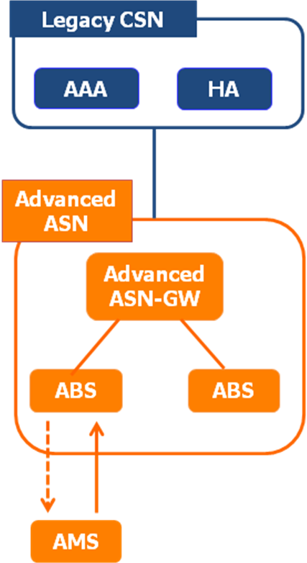
Figure 1. Deployment scenario of advanced ASN together with legacy CSN.
NWG agreed that it is considerable scenario that 16m Access network is deployed together with a legacy core network and made the following decision at July Tallinn meeting[4](see Figure 1) in order to support that scenario.
- MSID privacy is mandatory to support in advanced ABS, AMS, advanced ASNGW, advanced AAA, but optional to use.
- NAP shall advertise its capability to support MSID privacy when ASNGW is advanced.
- AMS (in accordance with HNSP) decides whether MSID privacy is used.
- There may be other 16m features impacting the legacy CSNs (FFS).
- Needs further discussion: Whether we need to hide the real MSID from ASN and VCSNs; over R3 and R5 (a bug?)
Considering their decision we suggest the following text proposal.

2. Text Proposal

Add some sentences at page 272 line 38 as follows
======================== Start of Proposed Text=====================
16.2.5.3.1 AMS identity privacy
AMS identity privacy support is the process of protecting the identity of AMS so that AMS MAC Address (ie., AMSID) is not revealed via air interface. While S-SFH Network Configuration bit = 0b1, AMS identity privacy is not possible due to the need to send the real AMSID as plain text in the AAI_RNG-REQ.
A hash value of the real AMSID, AMSID*, is defined for the privacy of the AMSID. The AMSID* is derived as follows:
AMSID*=Dot16KDF(AMSID|80-bit zero padding, NONCE_AMS, 48), where
• NONCE_AMS is a random 64-bit value generated by the AMS. When AMSID privacy is enabled If the S-SFH Network Configuration bit = 0b0 (see Table 838), the AMSID* is transmitted in the AAI_RNG-REQ message during network entry.
If the AMS does not receive a successful AAI_RNG-RSP message from the ABS, and if Ranging Request Retries (see Table 983) has not been exhausted, the AMS shall send another AAI_RNG-REQ message with the AMSID* derived from the same NONCE_AMS to the ABS. If Ranging Request Retries has been exhausted, the AMS shall use another AMSID* derived from a newly generated NONCE_AMS.
When operating in S-SFH Network Configuration bit = 0b1:
AMSID is used in stead of AMSID* when sending AAI_RNG-REQ message and deriving AK.

AMSID privacy is applied in the following way;
- AMSID privacy is mandatory to implement in ABS and AMS.
- The network with S-SFH Network Configuration bit = 0b0 must allow the AMS to connect using AMSID privacy mode or using the real AMS MAC address (i.e. not using AMSID privacy mode), AMS decision is based on the AMSID privacy policy obtained by the AMS. The definition of AMSID privacy policy is outside the scope of this specification.

============================== End of Proposed Text===============

3. References
- IEEE P802.16m/D7. DRAFT Amendment to IEEE Standard for Local and metropolitan area networks—Part 16: Air Interface for Broadband Wireless Access Systems—Advanced Air Interface, July 2010.
- IEEE 802.16m-08/003r9a. The Draft IEEE 802.16m System Description Document, May 2009.
- IEEE 802.16m-07/002r9. IEEE 802.16m System Requirements Document, Sep 2009.
- nwg-tll-00012-r002_NWG_Security_Meeting_Tallinn.ppt , June 2010

