Project | IEEE 802.16 Broadband Wireless Access Working Group <http://ieee802.org/16>
Title | Proposal on QoS parameters update for Default Service Flow (16.2.15.6)
Date Submitted | 2010-08-12
Source(s) | Youngkyo Baek  Jungshin Park  Samsung Electronics | E-mail: youngkyo.baek@samsung.com  shin02.park@samsung.com  Phone : +82-31-279-7321  *<http://standards.ieee.org/faqs/affiliationFAQ.html>
Re: | Sponsor Ballot Recirc # 1 on P802.16m/D7
Abstract | This contribution suggests changes for Default Service Flow Establishment
Purpose | To be discussed and adopted by WG SB
Notice | This document does not represent the agreed views of the IEEE 802.16 Working Group or any of its subgroups. It represents only the views of the participants listed in the “Source(s)” field above. It is offered as a basis for discussion. It is not binding on the contributor(s), who reserve(s) the right to add, amend or withdraw material contained herein.
Release | The contributor grants a free, irrevocable license to the IEEE to incorporate material contained in this contribution, and any modifications thereof, in the creation of an IEEE Standards publication; to copyright in the IEEE’s name any IEEE Standards publication even though it may include portions of this contribution; and at the IEEE’s sole discretion to permit others to reproduce in whole or in part the resulting IEEE Standards publication. The contributor also acknowledges and accepts that this contribution may be made public by IEEE 802.16.
Patent Policy | The contributor is familiar with the IEEE-SA Patent Policy and Procedures:  <http://standards.ieee.org/guides/bylaws/sect6-7.html#6> and <http://standards.ieee.org/guides/opman/sect6.html#6.3>.  Further information is located at <http://standards.ieee.org/board/pat/pat-material.html> and <http://standards.ieee.org/board/pat>.

Proposal on QoS parameters update for Default Service Flow (16.2.15.6)
Youngkyo Baek, Jungshin Park
Samsung Electronics

1. Introduction
Default service flows are activated after successful completion of Registration transaction. The document D7 defines the values of the QoS parameters for DSF, which enables AMS and ABS to set up DSF without DSA transaction after successful Registration. However, unfortunately there is no remedy to update of QoS parameters values for DSF.
Defining the values for QoS parameters of DSF in the standard can be problematic. The QoS parameters values for the DSF, specified by the current D7, does not permit the flexibility of changing/customizing the values by the operators for their subscribers in a different deployment or for a different usage scenario..
This contribution proposes the changes explained below to solve the problem.

2. Solution

To support change of QoS parameters values for DSF, define a new attribute “Change Count” to use in AAI_REG-REQ and AAI_DSC-REQ/RSP.
AMS shall include its stored “Change Count” value in the AAI_REG-REQ with other AMS capability information. ABS shall check the freshness of the received “Change Count” value.
If the received value matches with the values kept at ABS, ABS shall send AAI_REG-RSP to command the AMS to set up the DSF using the stored QoS information. If the received value does not match, ABS shall send AMS a new set of QoS parameters values and a new “Change Count” value in AAI_REG-RSP.
If the QoS parameters values and the change count are included in the AAI_REG-RSP, AMS shall set up the DSF using the received parameters values and replace its stored parameters configuration information with the information in AAI_REG-RSP.
If the AMS fails to set up the DSF then

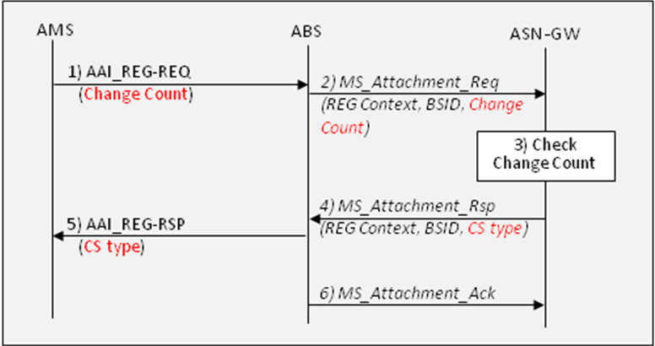
Fig.1 default service flow setup without configuration change

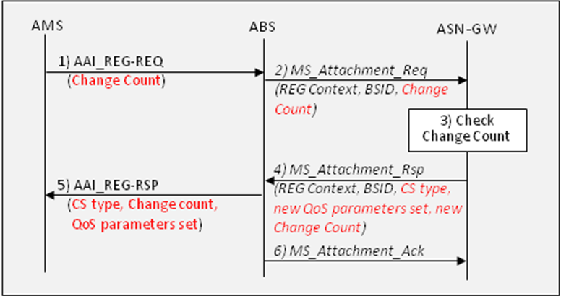
Fig.2 default service flow setup with configuration change

3. Text Proposal
#1. Add a new row in the table 686 at page 95 as follows:
======================== Start of Proposed Text =====================
Table 686—AAI_REG-REQ message Field Descriptions

M/O | Attributes / Array of attributes | Size (bits) | Value / Note | Conditions
… | … | … | … | …
M | QoS Configuration Change Count for default service flow | 3 | Indicates the QoS configuration change count for default service flow which has been received from the network for the last time and stored at AMS. The value of 0 means that AMS is configured with the default service flow setting in table 788. | N.A.
… | … | … | … | …

=========================== End of Proposed Text ===============

#2. Add two new rows in the table 687 at page 100 as follows:
======================== Start of Proposed Text =====================
Table 687—AAI_REG-RSP message Field Descriptions

M/O | Attributes / Array of attributes | Size (bits) | Value / Note | Conditions
… | … | … | … | …
O | QoS Configuration Change Count for default service flow | 3 | Indicates the new values for QoS configuration change count | Included if a new set of QoS parameters values is to be provided by ABS
O | QoS Parameters | variable | Same as the one defined in Table-743. | Included if a new set of QoS parameters values is to be provided by ABS
O | ARQ Enable | 1 | Same as the one defined in Table-743. | Included if a new set of QoS parameters values is to be provided by ABS
O | PHS Parameters | variable | Same as the one defined in Table-743. | Included if a new set of QoS parameters values is to be provided by ABS
O | ROHC Parameters | variable | Same as the one defined in Table-743. | Included if a new set of QoS parameters values is to be provided by ABS
… | … | … | … | …

============================== End of Proposed Text ===============
#3. Change the paragraph at page 390, line 31, as follows:
======================== Start of Proposed Text =====================
16.2.15.6 Registration
…
Upon successful registration, a DL FID and a UL FID, reserved for the default service flow, are activated at the AMS and ABS without using the DSA procedure for each UL and DL direction which can be used for upper layer signaling (e.g. DHCP).
AMS shall include the QoS configuration change count for default service flow, which has been received from the network for the last time and stored at AMS, in AAI_REG-REQ. ABS shall check the freshness of the received change count value. If the received count value matches with the values kept at ABS, ABS shall send AMS an AAI_REG-RSP. But if the received count value does not match, ABS shall send AMS an AAI_REG-RSP which includes a new QoS configuration change count value and a new set of QoS parameters values for default service flow.
If the QoS configuration change count and the set of QoS parameters are included in AAI_REG-RSP and received by AMS, AMS shall set up the default service flow using the parameters values included in AAI_REG-RSP and replace its stored parameters values for default service flow with the received values.
Otherwise, AMS shall set up the default service flow using its stored parameters values.
When the QoS configuration change count is agreed by 0, AMS shall set up the default service flow using predefined values for its service flow parameters (see Table 785) and CS type indicated in AAI_REG-RSP message.
When multiple CS types are enabled, the one CS type associated with the default service flow shall be defined using the CS type for default service flow parameter. Non-default service flows shall be set up, as needed, after registration procedure.
If the AMS fails to set up default service flows, it starts network exit by sending AAI_DREG-REQ with deregistration request code =00 after the AMS and ABS complete switching between TSTID and STID.
============================== End of Proposed Text ===============

4. References
- IEEE P802.16m/D7. DRAFT Amendment to IEEE Standard for Local and metropolitan area networks—Part 16: Air Interface for Broadband Wireless Access Systems—Advanced Air Interface, May. 2010.
- IEEE 802.16m-08/003r9a. The Draft IEEE 802.16m System Description Document, May 2009.
- IEEE 802.16m-07/002r9. IEEE 802.16m System Requirements Document, Sep 2009.

