Project | IEEE 802.16 Broadband Wireless Access Working Group <http://ieee802.org/16>
Title | Pilot Boosting for UL distributed LRU with 1-Tx stream in IEEE P802.16m/D7 (16.3.10)
Date Submitted | 2010-08-12
Source(s) | Sangheon Kim, Sihyun Park,  Jaewon Cho, Heewon Kang  Samsung Electronics | sangheon.kim@samsung.com
Re: | Change Request on 802.16m Draft Amendment, IEEE P802.16m/D7
Abstract | This contribution proposes the text for pilot boosting of UL distributed LRU
Purpose | To be discussed and adopted by TGm for the 802.16m amendment.
Notice | This document does not represent the agreed views of the IEEE 802.16 Working Group or any of its subgroups. It represents only the views of the participants listed in the “Source(s)” field above. It is offered as a basis for discussion. It is not binding on the contributor(s), who reserve(s) the right to add, amend or withdraw material contained herein.
Release | The contributor grants a free, irrevocable license to the IEEE to incorporate material contained in this contribution, and any modifications thereof, in the creation of an IEEE Standards publication; to copyright in the IEEE’s name any IEEE Standards publication even though it may include portions of this contribution; and at the IEEE’s sole discretion to permit others to reproduce in whole or in part the resulting IEEE Standards publication. The contributor also acknowledges and accepts that this contribution may be made public by IEEE 802.16.
Patent Policy | The contributor is familiar with the IEEE-SA Patent Policy and Procedures:  <http://standards.ieee.org/guides/bylaws/sect6-7.html#6> and <http://standards.ieee.org/guides/opman/sect6.html#6.3>.  Further information is located at <http://standards.ieee.org/board/pat/pat-material.html> and <http://standards.ieee.org/board/pat>.
Pilot Boosting for UL distributed LRU with 1-Tx stream
in IEEE P802.16m/D7 (16.3.10)
Sangheon Kim, Sihyun Park, Jaewon Cho, Heewon Kang
Samsung Electronics

Introduction
The uplink pilot power level for distributed LRU should be modified to improve detection performance for low SNR case such as cell-edge users. Although the total pilot overhead of DLRU is higher than that of CRU for 1stream, the number of pilot which can be used for channel estimation per tile is only four. Therefore, in the low SNR environment such as the cell edge, the channel estimation performance is degraded and it causes the degradation of detection performance. In this contribution, 2dB pilot boosting for DLRU is proposed based on the simulation results.

Simulation Results
Performance was evaluated for the several cases of I_{sizeoffset} and IoT level. PedB 3km/h channel was used and 1tx(AMS)/4rx(ABS) antenna configuration with xx lambda antenna spacing was assumed. Figure 1 shows the PER curves for the several boosting levels in the noise limited condition. The power of the data tone in the OFDM symbol not having pilot is fixed to the same level as that of the data tone in the OFDM symbol having pilot. As shown in the figure, pilot boosting can improve the link performance for low MCS.
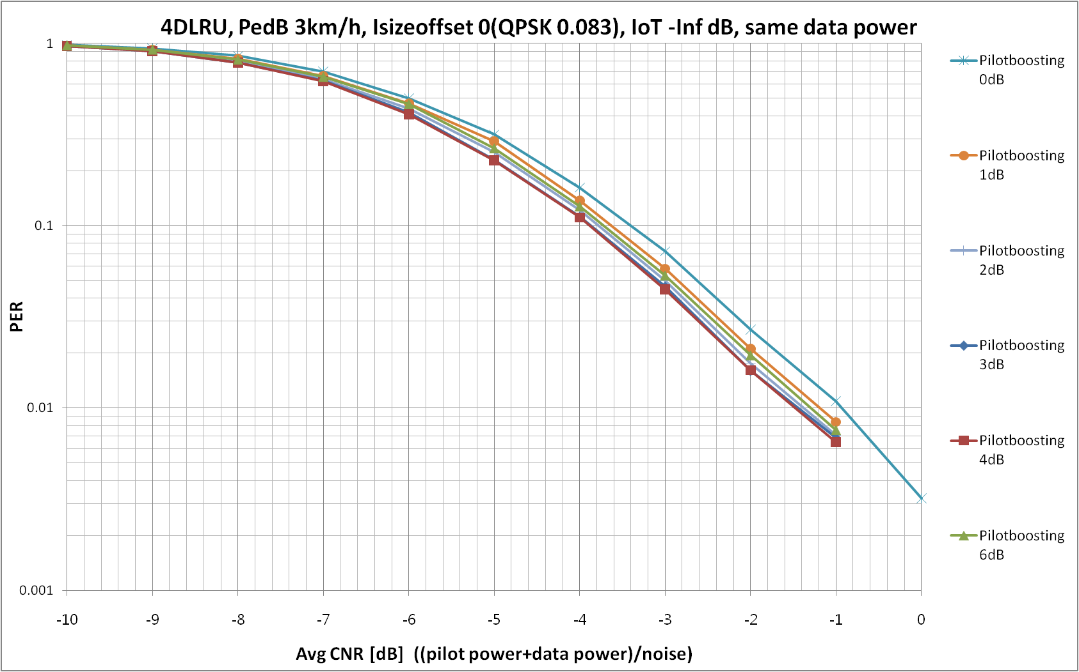
Figure1. PER performance in I_{sizeoffset} =0 and noise limited condition
We have evaluated the performance in the interference environment assuming 6dB and 0dB IoT levels. In order to observe the effects on the high MCS level, that is, high SNR region, we considered three more I_{sizeoffset} 16(QPSK and 0.52), 23(16QAM and 0.59), and 28(64QAM and 0.71). Figure2 and Figure 3 show the 6dB IoT and 0dB IoT, respectively. Through the results, we can see that boosting level higher than 3dB causes the degradation and 2dB boosting level is appropriate.

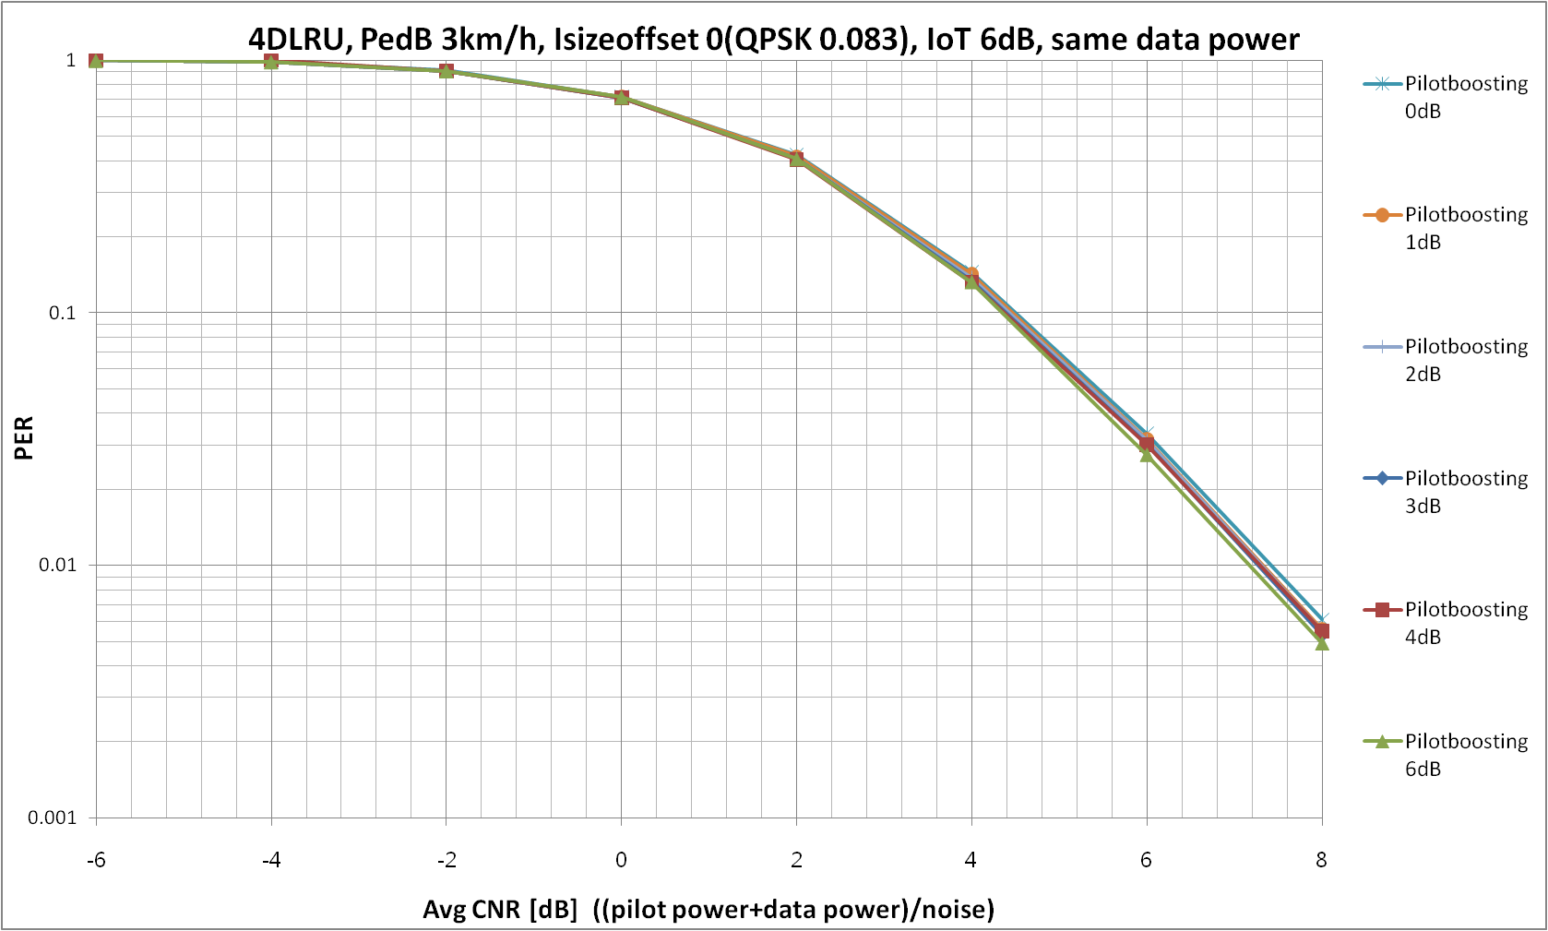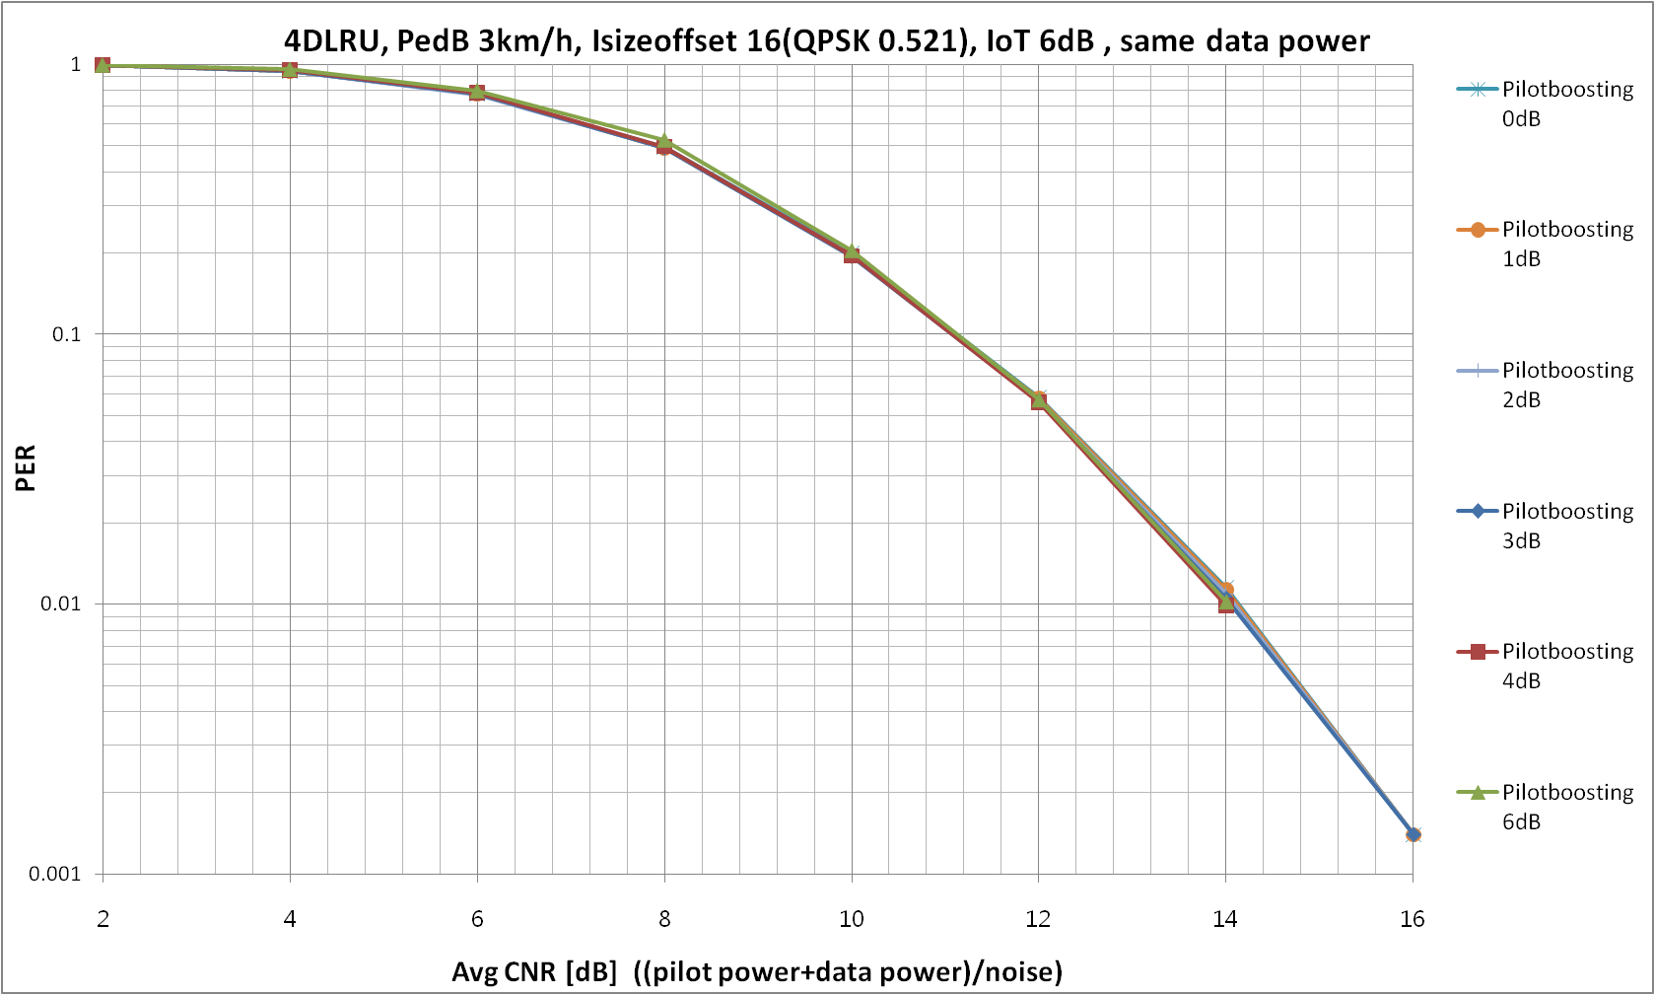
(a) I_{sizeoffset}, 0(QPSK and 0.08) (b) I_{sizeoffset} 16 (QPSK and 0.52)
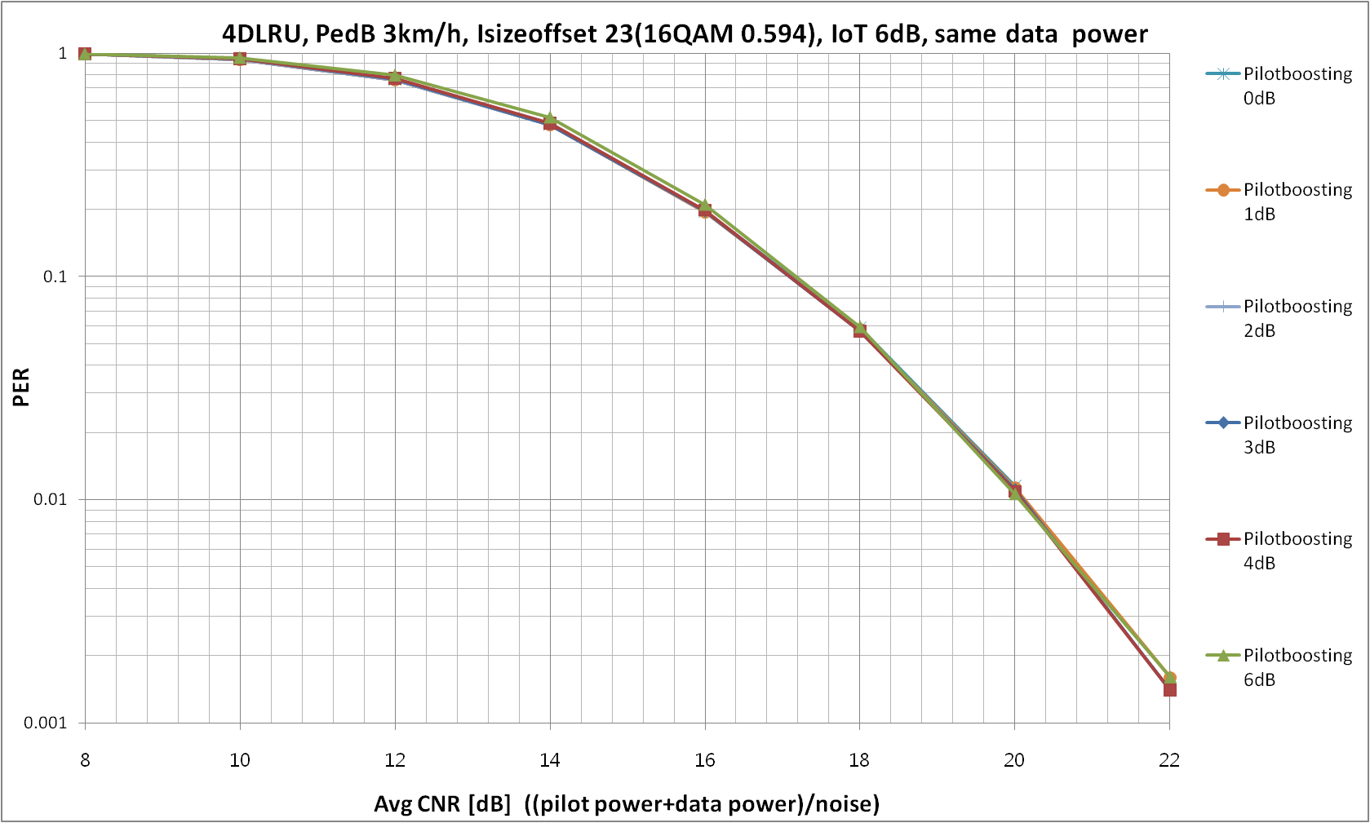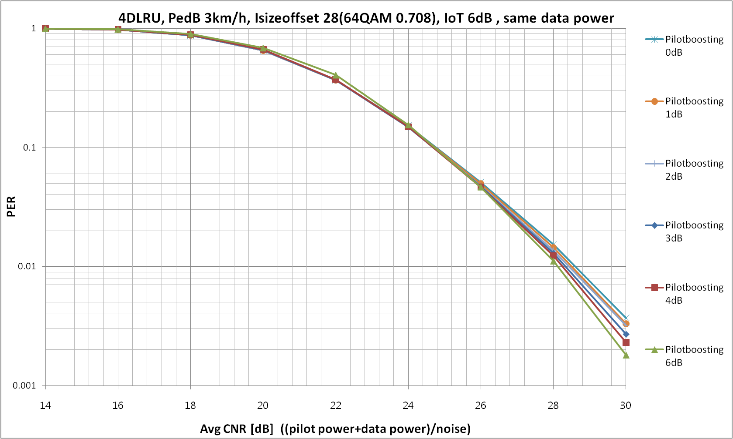
(c) I_{sizeoffset}, 23(16QAM and 0.59) (d) I_{sizeoffset}, 28(64QAM and 0.71)
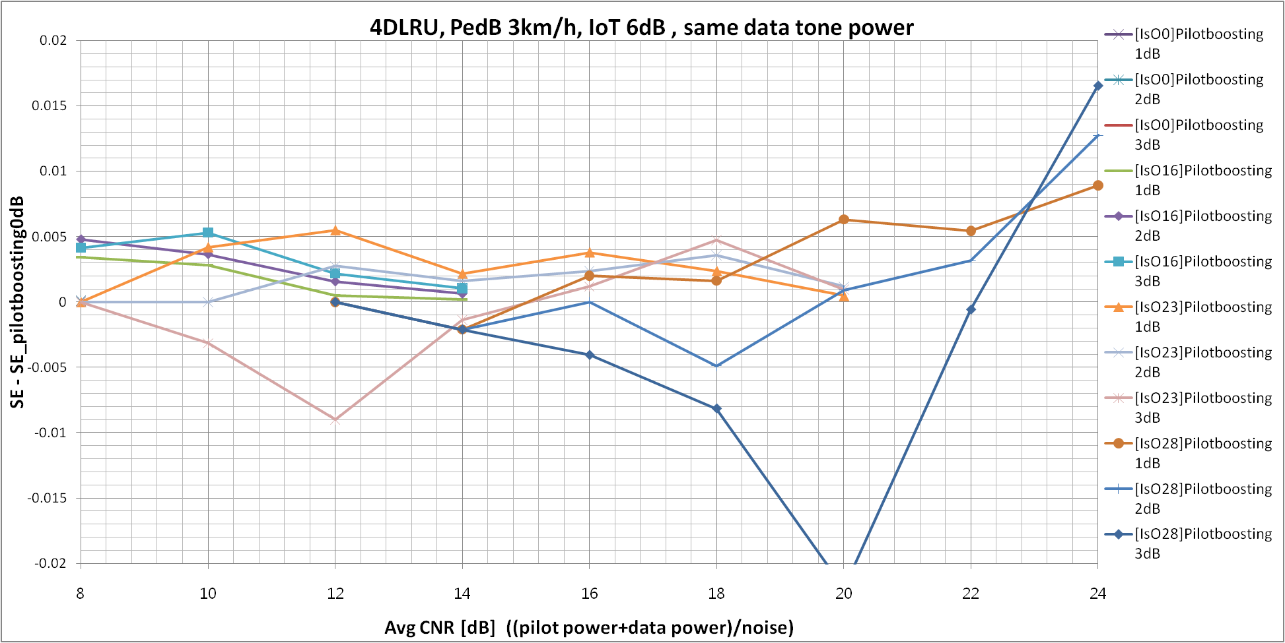
(e) Difference of spectral efficiency between boosting and non-boosting
Figure2. Performances in IoT 6dB
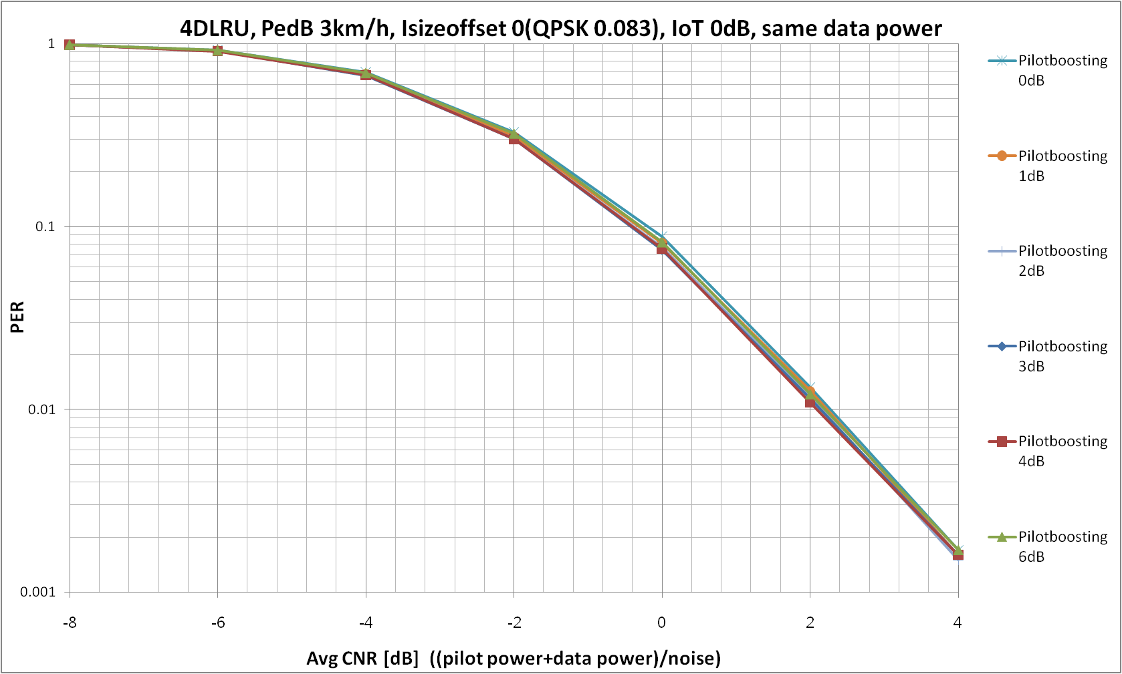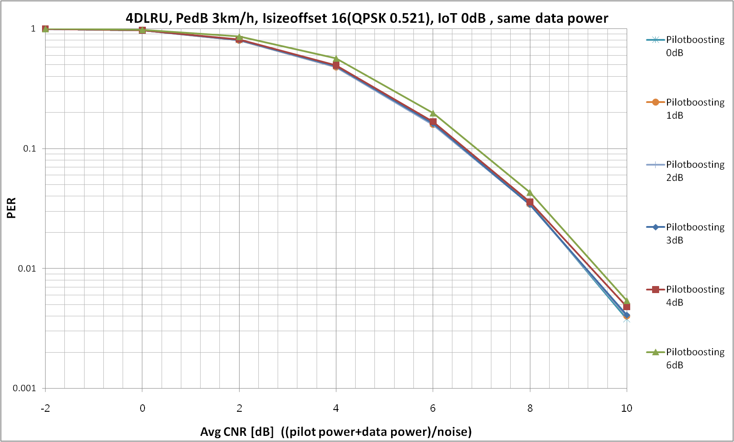
(a) I_{sizeoffset}, 0(QPSK and 0.08) (b) I_{sizeoffset} 16 (QPSK and 0.52)
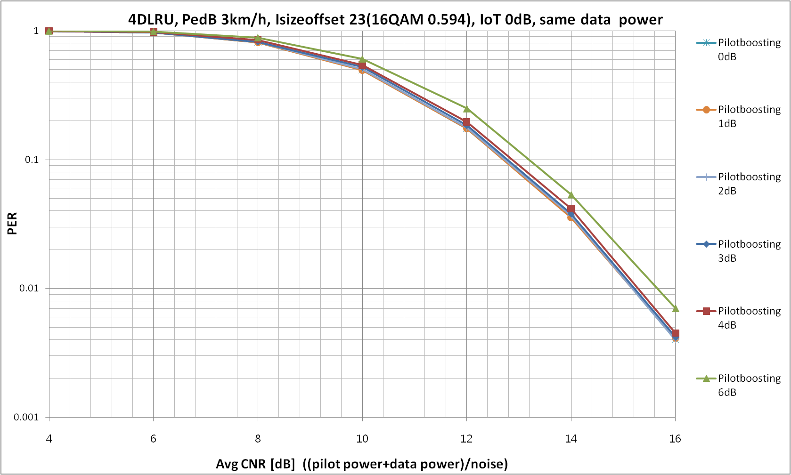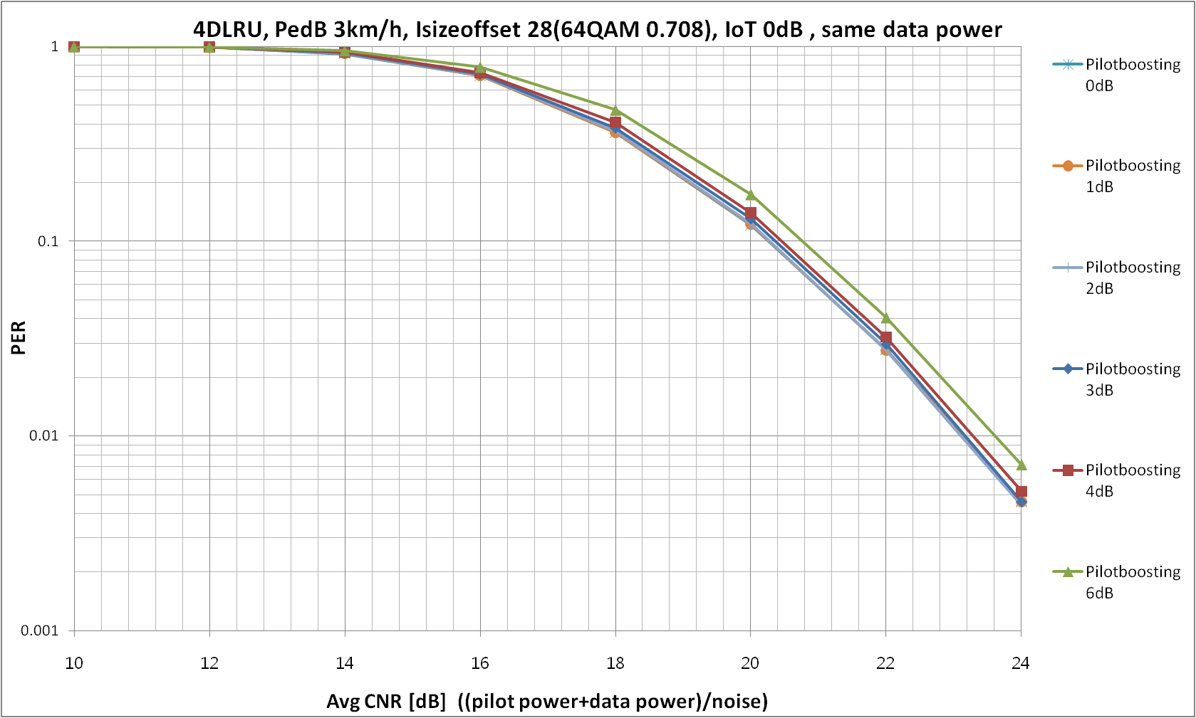
(c) I_{sizeoffset}, 23(16QAM and 0.59) (d) I_{sizeoffset}, 28(64QAM and 0.71)
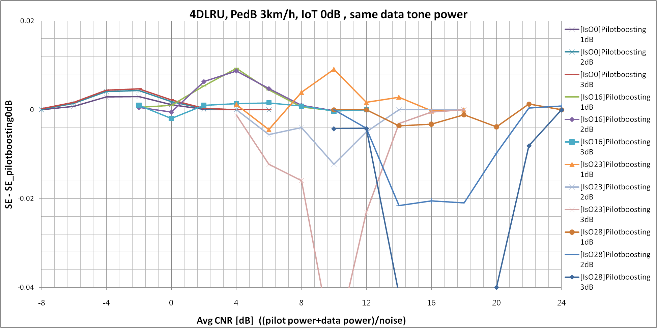
(e) Difference of spectral efficiency between boosting and non-boosting
Figure3. Performances in IoT 0dB

References
[1] DRAFT Amendment to IEEE Standard for Local and metropolitan area networks, P80216m/D7, Aug. 2010.

Text Proposal
Proposed AWD text has been underlined in blue, AWD text that has been deleted has been marked in red and struck through and existing AWD text is shown in black.
<Modify the Table 961 in section 16.3.10.3.2 on line 1, page 793 >
______________________________Start of the proposed text change #1 ______________________________
Table 961 – Uplink data and pilot subcarriers power
number of  streams M_{t} | per stream  power on data subcarriers B_{d} | per stream  pilot power B_{p} | per stream  pilot boosting level, dB
1 | 1/ M_{t} | 1.5849 | 2+10*log10(M_{t})
1-2 | 1/ M_{t} | 1 | 10*log10(M_{t})
3-4 | 1/ M_{t} | 1 | 10*log10(M_{t})
_______________________________End of the proposed text change #1 ______________________________

<Modify the text in section 16.3.10.3.3 on line 29, page 793 >
______________________________Start of the proposed text change #2 ______________________________
For uplink SU-MIMO mode with M_{t} = 1 in S-LRU and, N-LRU and DLRU allocations B_{p} shall be set to 1.5849.
_______________________________End of the proposed text change #2 ______________________________

