Project | IEEE 802.16 Broadband Wireless Access Working Group <http://ieee802.org/16>
Title | Clarification of S-SFH IE Update Procedure (Section 16.2.24)
Date Submitted | 2010-09-14
Source(s) | Bill Hillery, Mark Cudak, Eugene Visotsky, Anup Talukdar  Motorola Inc.  Jinsoo Choi, Heejeong Cho, Kiseon Ryu, Youngsoo Yuk, Jin Sam Kwak  LG Electronics | bill.hillery@motorola.com  js.choi@lge.com
Re: | Category: P802.16m/D8 comments for sb_16m  Area: Section 16.2.24 (Update of S-SFH IEs)
Abstract | The resolution of sponsor ballot comment A225 specified the adoption of contribution C802.16m-10/0973r3. However, several errors and omissions occurred during the implementation of the contribution in P802.16m/D8. The current contribution specifies the additional modifications required in D8 to completely and correctly implement the original contribution.
Purpose | Discuss and adopt
Notice | This document does not represent the agreed views of the IEEE 802.16 Working Group or any of its subgroups. It represents only the views of the participants listed in the “Source(s)” field above. It is offered as a basis for discussion. It is not binding on the contributor(s), who reserve(s) the right to add, amend or withdraw material contained herein.
Release | The contributor is familiar with the IEEE-SA Copyright Policy <http://standards.ieee.org/IPR/copyrightpolicy.html>.
Patent Policy | The contributor is familiar with the IEEE-SA Patent Policy and Procedures:  <http://standards.ieee.org/guides/bylaws/sect6-7.html#6> and <http://standards.ieee.org/guides/opman/sect6.html#6.3>.  Further information is located at <http://standards.ieee.org/board/pat/pat-material.html> and <http://standards.ieee.org/board/pat>.
Clarification of S-SFH IE Update Procedure (Section 16.2.24)

Bill Hillery, Mark Cudak, Eugene Visotsky, Anup Talukdar

Motorola, Inc.
Jinsoo Choi, Heejeong Cho, Kiseon Ryu, Youngsoo Yuk, Jin Sam Kwak
LG Electronics

Introduction
The resolution of sponsor ballot comment A225 specified the adoption of contribution C802.16m-10/0973r3 [1]. However, several errors and omissions occurred during the implementation of the contribution in P802.16m/D8 [2]. Specifically, editorial errors were made in the implementation of remedies 1 and 2. In addition, remedies 3, 4, and 5 were not implemented at all. The current contribution specifies the additional modifications required in D8 to completely and correctly implement the original contribution.

The proposal consists of five remedies:
- Remedy 1 proposes editorial changes to fix minor errors in the implementation of remedy 1 of [1].
- Remedy 2 proposes editorial changes to Figure 467 to fix minor errors in the implementation of remedy 2 of [1].
- Remedy 3 has been modified to incorporate changes proposed in sponsor ballot comment B142.
- Remedies 4–5 propose the same changes proposed in remedies 4–5 of [1], with editorial instructions updated to apply to D8 (Note that the proposed modifications for remedy 4 include the correction of a newly discovered spelling error).
As noted, the proposed changes include changing the name of the “S-SFH applying offset” field to “S-SFH application hold indicator”.

References
  - IEEE C802.16m-10/0973r3, “Clarification of S-SFH IE Update Procedure (Section 16.2.24)”, August 16, 2010.
  - IEEE P802.16m/D8, “DRAFT Amendment to IEEE Standard for Local and metropolitan area networks.”

Proposed Text Changes in IEEE P802.16m/D8
[Adopt remedies 1–5 as detailed below.]

[REMEDY #1: Editorial corrections]

[Modify the paragraph beginning on line 27 of p.460 as follows:]

The S-SFH change count shall remain constant as long as all of the values (except MSB of superframe number in S-SFH SP1 IE) in the S-SFH SP IEs remain constant. The S-SFH change count shall be incremented only in the specific superframe number (SFN) that satisfies SFN modulo S-SFH change cycle = 0, where the S-SFH change cycle is indicated in S-SFH SP3 IE. The modified S-SFH change count shall be maintained until the next superframe (satisfying SFN modulo S-SFH change cycle = 0) in which the S-SFH change count is incremented, as shown in Figure 467.
[Modify the paragraph beginning on line 43 of p.460 as follows:]
Each bit of the S-SFH SP change bitmap in P-SFH IE indicates the change status of the corresponding S-SFH SP IE in association with the S-SFH change count. The Bit # 0 (LSB), bit #1 and bit #2 (MSB) are mapped to S-SFH SP1 IE, S-SFH SP 2 IE and S-SFH SP3 IE, respectively. If any of the values (except MSB of superframe number in S-SFH SP1 IE) in an S-SFH SP IE are changed, the bit corresponding to the changed S-SFH SP IE is set to 1. The value of the S-SFH SP change bitmap shall be changed only when the S-SFH change count is changed. That is, the modified S-SFH SP change bitmap shall be maintained until the next superframe (satisfying SFN modulo S-SFH change cycle = 0) in which the S-SFH change count is incremented, as shown in Figure 467.
[Modify the paragraph beginning on line 18 of p.461 as follows (delete “equals” sign):]
The S-SFH application hold indicator in the P-SFH IE is used to explicitly indicate which S-SFH SPx IE content shall be applied in the current superframe — either the content corresponding to the value of S-SFH change count transmitted in the current superframe or the previously transmitted value. If the S-SFH application hold indicator is set to 0, the AMS shall use the S-SFH contents associated with the currently transmitted S-SFH change count. Otherwise, if the S-SFH application hold indicator is 1, the AMS shall use the S-SFH contents associated with previously transmitted S-SFH change count (= that is, (the current S-SFH change count -1) modulo 16).
[REMEDY #2:]

[Modify Figure 467 beginning on p. 462 as shown:]
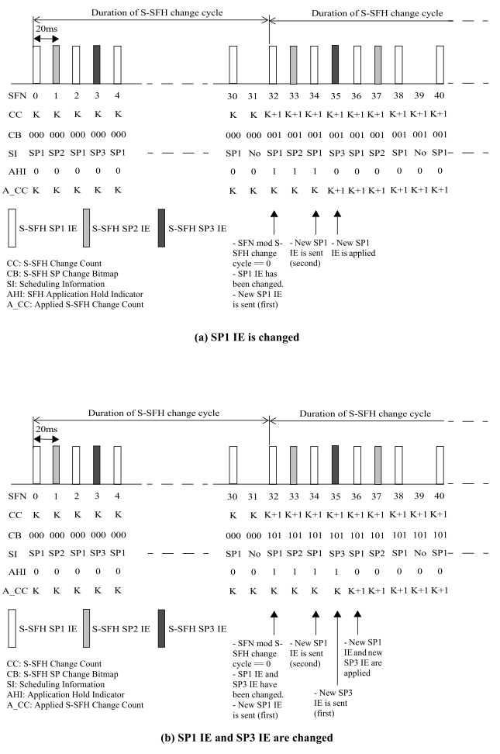
Change to: “AHI: S-SFH Application Hold Indicator”
Change to: “AHI: S-SFH Application Hold Indicator”

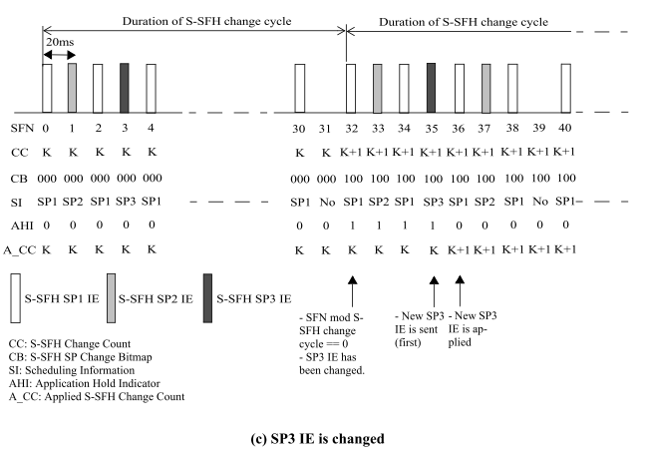
Change to: “AHI: S-SFH Application Hold Indicator”

[REMEDY #3:]

[Modify the last paragraph on p. 568 (beginning at line 47) in Section 16.3.5.2.1.2 as shown:]
When S-SFH SPx IE is changed, ABS may additionally transmit the changed S-SFH SPx IE in superframes only carrying P-SFH during the period where the S-SFH applying offset is set to 1, as illustrated in Figure 521. Though the transmission frequency of the changed S-SFH SPx IE is increased due to one or multiple additional transmissions, such additional transmissions do not affect the transmissions of changed S-SFH SPx IE determined by the scheduling periodicity and the S-SFH applying offset.
When the contents of any S-SFH SPx IE change, the ABS may additionally transmit the changed S-SFH SPx IE in superframes that carry the P-SFH only as illustrated in Figure 521. Such additional transmissions may only be scheduled in periods when the “S-SFH application hold indicator” is set to 1. Though the transmission frequency of the changed S-SFH SPx IE is increased due to one or multiple additional transmissions, these transmissions shall not affect the application time of the changed SPx IE or the transmissions determined by the original scheduling periodicity of the changed SPx IE.

[REMEDY #4:]

[Modify the “S-SFH applying offset” entry in Table 834 on p. 581 as shown:]
Table 834—P-SFH IE Format
Syntax | Size (bit) | Notes
... | ... | …
S-SFH applying offset application hold indicator | 1 | Indicate the associated S-SFH change count value used to determine the S-SFH SPx IE content to apply in this superfamesuperframe:  0b0: Use S-SFH SPx IEs content associated with the current S-SFH change count  0b1: Use S-SFH SPx IEs content associated with (the current S-SFH change count - 1) modulo 16
… | … | …

[REMEDY #5:]

[Modify the “S-SFH SP change bitmap” and “S-SFH applying offset” descriptions beginning at line 15 of p. 582 as shown:]

S-SFH SP change bitmap
A bitmap indicating the S-SFH SPx IE changed in association with the current S-SFH change count. If any field of S-SFH SPx IE is changed (except MSB of Superframe Number in S-SFH SP1), the bit corresponding to the changed S-SFH SPx IE is set to 1. Other bits corresponding to the unchanged S-SFH SPxs are set to 0. The S-SFH change bitmap is maintained until the superframe of which the next superframe has increment of the S-SFH change count. next superframe in which the S-SFH change count is incremented.
S-SFH applying offset
A one bit flag that indicates AMSs which S-SFH change count shall be considered for applying the S-SFH contents. If the S-SFH applying offset is set to '0', the AMS shall use the S-SFH contents associated with the current S-SFH change count. Otherwise, if the S-SFH applying offset is '1', the AMS shall use the S-SFH contents associated with previous S-SFH change count(= (the current S-SFH change count -1) modulo 16). If the S-SFH contents are not available, the AMS shall acquire the relevant S-SFH contents by decoding the S-SFHs carried in their corresponding scheduled superframes.
S-SFH application hold indicator
A one bit flag that indicates to AMSs which S-SFH content shall be applied in the current superframe — either the content corresponding to the value of S-SFH change count transmitted in the current superframe or the previously transmitted value. If the S-SFH application hold indicator is set to '0', the AMS shall use the S-SFH contents associated with the S-SFH change count transmitted in the current superframe. Otherwise, if the S-SFH application hold indicator is '1', the AMS shall use the S-SFH contents associated with the previous S-SFH change count (that is, (the current S-SFH change count -1) modulo 16). In other words, when S-SFH application hold indicator is ‘1’, the previous contents of the S-SFH are held while new contents are being transmitted. If the desired S-SFH contents are not available, the AMS shall acquire the relevant S-SFH contents by decoding the S-SFHs carried in their corresponding scheduled superframes.

