Project | IEEE 802.16 Broadband Wireless Access Working Group <http://ieee802.org/16>
Title | Legacy ASN support capability
Date Submitted
Source(s) | Guanghui Fan, Phillip Barber, Xiuyan Li, Xuehuan Wang, Bin Chen,  Huawei Technologies | E-mail:  fanguanghui@huawei.com  binchen@huawei.com  pbarber@huawei.com
Re: | Call for SB on “ P802.16m/D7”:
Abstract | This contribution proposes about Legacy ASN support capability
Purpose | To be discussed and adopted by TGm for 802.16m Sponsor Ballot.
Notice | This document does not represent the agreed views of the IEEE 802.16 Working Group or any of its subgroups. It represents only the views of the participants listed in the “Source(s)” field above. It is offered as a basis for discussion. It is not binding on the contributor(s), who reserve(s) the right to add, amend or withdraw material contained herein.
Release | The contributor grants a free, irrevocable license to the IEEE to incorporate material contained in this contribution, and any modifications thereof, in the creation of an IEEE Standards publication; to copyright in the IEEE’s name any IEEE Standards publication even though it may include portions of this contribution; and at the IEEE’s sole discretion to permit others to reproduce in whole or in part the resulting IEEE Standards publication. The contributor also acknowledges and accepts that this contribution may be made public by IEEE 802.16.
Patent Policy | The contributor is familiar with the IEEE-SA Patent Policy and Procedures:  <http://standards.ieee.org/guides/bylaws/sect6-7.html#6> and <http://standards.ieee.org/guides/opman/sect6.html#6.3>.  Further information is located at <http://standards.ieee.org/board/pat/pat-material.html> and <http://standards.ieee.org/board/pat>.

Legacy ASN support capability
Guanghui Fan, Bin Chen, Phillip Barber, George Cummings，Erik Colban
Huawei Technologies

Introduction
According to the network reference model defined in WiMAX Forum network architecture, one BS may be logically connected to more than one ASN GW as shown in figure A.
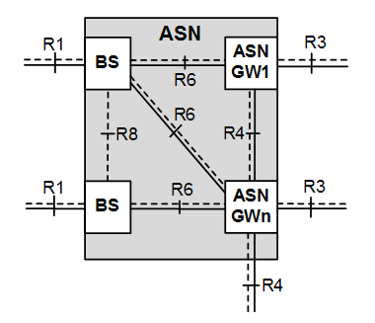
Figure A - legacy ASN Reference Model
Therefore, in first stages of advanced 16m network deployment, the advanced BS may connect to a legacy ASN containing multiple ASN-GWs. If the legacy ASN-GWs is only partially upgraded to advanced ASN-GWs, there may be such a scenario that one ABS is connected to both legacy ASN-GW and advance ASN-GW，as shown in figure B. For illustration, there are two base stations (i.e. ABS0 and ABS1) and two ASN-GWs (i.e. ASN GW1 and ASN GW2) in the model. When only the ASN GW2 is updated to an advanced entity, the ABS0 will connect to both ASN GW1 with legacy control plane function entity and ASN GW2 with advanced control plane function entity.
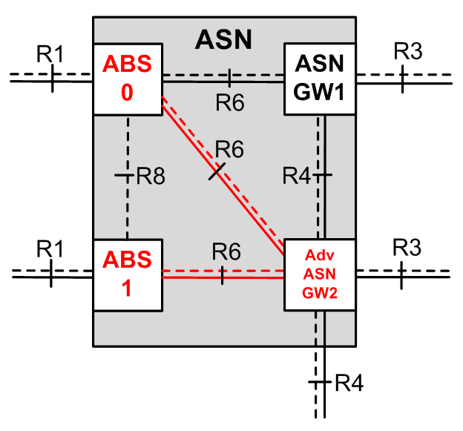
Figure B – Mixed-deployment scenario with legacy and advanced ASN
However, for a given AMS, its serving ABS is connected to a single ASN-GW. The initial network entry or network reentry procedure is different when its selected ABS is connected to ASN-GW with different mode. For instance, the AMS will use AMSID* in the ranging request message if it connects to the advanced ASN-GW, while the MAC address is used for legacy ASN-GW based entry. The ABS should broadcast such a configuration status to the AMSs and to neighbor ABSs, in order to facility the network entry/reentry decision.
When the AMS is aware of such a mixed-mode deployment, it will decide to perform either kind of network entry according to its own predefined subscriber logic. However, the ASN may redirect the AMS to connect to a different mode ASN-GW for load balancing and redundancy purposes. This redirection can be supported by using an indication in ranging response message.
The AMS may support either both legacy ASN and advanced ASN or advanced ASN only. This capability should be informed to the ASN network for the purpose of connection mode selection or handover decision.
This contribution proposes some modifications to the air interface control messages to support the scenarios described above.

Text proposal for inclusion in the P802.16m/D7
========================== Start of Proposed Text ==============================
[Remedy 1: modify the following field description in “Table 838—S-SFH SP2 IE format” in page 556]
Table 838—S-SFH SP2 IE format
Syntax | Size (bit) | Notes
Network Configuration | 1 2 | Indicates configuration of the ABS network  0b0: AAI network configuration  0b1: WirelessMAN-OFDMA network configuration  0b00: AAI network configuration  0b01: WirelessMAN-OFDMA network configuration  0b10: Both AAI network and WirelessMAN-OFDMA network configuration  0b11: Reserved
[Remedy 2: modify the following field description in “Table 680—AAI_RNG-REQ message Field Descriptions” in page 72]

M/O | Attributes/ Array of attributes | Size (bits) | Value / Note | Conditions
M | AMSID* or MAC address included | 1 | This bit indicates which identifier follows.  0：AMSID* is included  1：AMS MAC address is included | Not applicable
O | AMSID* | 48 | The AMSID hash value. Refer to Table 16.2.5.3.1 | It shall be included when the AMS is attempting network entry in the advanced network mode, handover from a legacy BS, or zone switch to MZONE from LZONE.
O | MAC version | 8 | See 11.1.3 | It shall be included when the AMS is attempting network entry.
O | AMS MAC address | 48 | AMS’s real MAC address | In the legacy network mode it shall be included when the AMS is attempting network entry, location update, network reentry or un coordinated handover.
O | WirelessMAN-OFDMA network configuration support | 1 | 0: WirelessMAN-OFDMA network configuration supported  1: WirelessMAN-OFDMA network configuration not supported | It shall be included when the AMS uses AMSID* to enter/reenter the network.
[Remedy 3: modify the following field description in “Table 681—AAI_RNG-RSP message Field Descriptions” in page 77]
M/O | Attributes/ Array of attributes | Size (bits) | Value / Note | Conditions
O | Ranging Abort | 1 2 | Set to 1 when an ABS rejects the AMS  0b00: the AMS is admitted by the ABS for network entry (SUCCESS)  0b01: the AMS is prohibited by the ABS from network entry (ABORT)  0b10: the AMS may perform network entry using different entry mode when the ABS is connected to both advanced and legacy mode access network.  0b0b11: reserved | Present when an ABS rejects the AMS or redirects the AMS  Value 0b01 is only used for redirecting the AMS when the AMS supports both WirelessMAN-OFDMA network configuration and AAI network configuration
O | Ranging Abort Timer | 16 | Timer defined by an ABS to prohibit the AMS from attempting network entry at this ABS, for a specific time duration. Value: 0 (Do not try ranging again at the ABS.) Value: 1-65535, In units of seconds | It shall be included when Ranging Abort is set to 1 0b00.
[Remedy 4: modify the text as following]
1. Page239 Line 62
MS Addressing depends on the operation mode. If S-SFH Network Configuration bit = 0b1 the AMS is connecting to a legacy network, it shall be 48bit AMSID. Otherwise, MS Addressing input shall be AMSID* - a permutation of AMSID (i.e., AMS MAC address) sent by AMS to ABS in initial AAI_RNG-REQ message, this is used to bind the key to the AMSID and AMSID* is derived according to Section 16.2.5.3.1.
2. Page 251 Line 30
During direct HO procedure from WirelessMAN-OFDMA reference BS to WirelessMAN-OFDMA Advanced ABS with S-SFH Network Configuration bit = 0b1 when the AMS is connecting to a legacy network, key update follows the same procedure as defined for intra-WirelessMAN-OFDMA Advanced handover.
During direct HO from WirelessMAN-OFDMA reference BS to WirelessMAN-OFDMA Advanced ABS with S-SFH Network Configuration bit = 0b0 when the AMS is connecting to an advanced network, ….
3. Page 251 Line 57
During zone switch from LZone to MZone (with handover process optimization bitmap bit#1=1 "omit PKM authentication phase" and S-SFH Network Configuration bit = 0b0 the AMS is connecting to an advanced network), AMS shall perform network reentry procedure in MZone to derive new AK, CMAC keys and TEKs to be used in MZone as follows.
4. Page 252 Line 12
During zone switch from LZone to MZone (with handover process optimization bitmap bit#1=1 "omit PKM authentication phase" and S-SFH Network Configuration bit = 0b1 the AMS is connecting to a legacy network), AMS shall perform network reentry procedure in MZone to derive new AK, CMAC keys and TEKs to be used in MZone as follows.
5. Page 272 Line 29
AMS identity privacy support is the process of protecting the identity of AMS so that AMS MAC Address (ie., AMSID) is not revealed via air interface. While S-SFH Network Configuration bit = 0b1 the AMS is connecting to a legacy network, AMS identity privacy is not possible due to the need to send the real AMSID as plain text in the AAI_RNG-REQ.
A hash value of the real AMSID, AMSID*, is defined for the privacy of the AMSID. The AMSID* is derived as follows:
AMSID*=Dot16KDF(AMSID|80-bit zero padding, NONCE_AMS, 48), where
•NONCE_AMS is a random 64-bit value generated by the AMS. If the S-SFH Network Configuration bit = 0b0 (see Table 838) the AMS is connecting to an advanced network, the AMSID* is transmitted in the AAI_RNG-REQ message during network entry. If the AMS does not receive a successful AAI_RNG-RSP message from the ABS, and if Ranging Request Retries (see Table 983) has not been exhausted, the AMS shall send another AAI_RNG-REQ message with the AMSID* derived from the same NONCE_AMS to the ABS. If Ranging Request Retries has been exhausted, the AMS shall use another AMSID* derived from a newly generated NONCE_AMS.
When operating in S-SFH Network Configuration bit = 0b1 the AMS is connecting to a legacy network:
AMSID is used in stead of AMSID* when sending AAI_RNG-REQ message and deriving AK.
16.2.5.3.2 AMS location privacy
AMS location privacy support is the process of protecting the mapping between AMS MAC address and STID so that intruders cannot obtain the mapping information between the MAC address and STID. To protect the mapping between STID and AMS MAC address, a TSTID is assigned during initial ranging process, and is used until STID is allocated.
The STID is assigned during registration process after successful completion of initial authentication/authorization process, and is encrypted during transmission. The temporary STID is released after STID is securely assigned. The STID is used for all remaining transactions. The detailed procedures are described as follows:
AMS generates a new NONCE_AMS and derive AMSID* if S-SFH Network Configuration bit = 0b0 the AMS is connecting to an advanced network, then it sends AAI_RNG-REQ carrying the AMSID* to ABS. When ABS receives the AAI_RNG-REQ, it returns AAI_RNG-RSP containing temporary STID (instead of STID) and the AMSID* which the AMS sent. Alternatively, if S-SFH Network Configuration bit = 0b1 the AMS is connecting to a legacy network, AMSID is used in place of AMSID* when transmitting AAI_RNG-REQ and AAI_RNG-RSP messages.
6. Page 388 Line 5
If the Network Configuration bit in the S-SFH is set to 0b1 the AMS is connecting to a legacy network, the AMS provides its actual MAC address in the AAI_RNG-REQ message.
The ABS can determine the AMS’s capability to legacy Wireless-MAN OFDMA network from the AAI_RNG-REQ message. If AMS sends its actual MAC address in the ranging request, the ABS determines that the AMS supports both advanced and legacy access network. If the AMS sends its AMSID* in the ranging request, the WirelessMAN-OFDMA network configuration support bit in AAI_RNG-REQ indicates whether the AMS supports the legacy access network.
The ABS may be connected to both advanced and legacy access network. In such a case, the ABS may redirect an AMS that is capable of connecting to both a legacy and an advanced network to connect to a different mode access network by using the Ranging Abort bit in AAI_RNG-RSP message
7. Page 411 Line 58
If the Network Configuration bit in the S-SFH is set to 0b1 the AMS is connecting to a legacy network before Idle Mode entry, the AMS provides its actual MAC address in the AAI_RNG-REQ message, instead of providing the DID.
8. Page 412 Line 11
If the Network Configuration bit in the S-SFH is set to 0b1 the AMS is connecting to a legacy network before Idle Mode entry, the AMS provides its actual MAC address in the AAI_RNG-REQ message, instead of providing the DID.
9. Page 876 Line 63
The ABS shall set the Network Configuration bit in the S-SFH to ë1í 0b01 to indicate that the ABS is connected to a legacy access network, or 0b11 to indicated that the ABS is connected to both legacy access network and advanced access network.

========================== End of Proposed Text ==============================

