Project | IEEE 802.16 Broadband Wireless Access Working Group <http://ieee802.org/16>
Title | Proposed Text Change for Mapping of Pilot Modulation Sequence to Pilot Subcarriers of CoFIP (16.3.10.3.3.)
Date Submitted | 2010-09-13
Source(s) | Klutto Milleth, Sunil Kaimalettu  Kiran Kuchi, Padmanabhan  CEWIT  Yan-Xiu Zheng  ITRI | Email: klutto@cewit.org.in
Re: | Comment on IEEE P802.16m/D8 for Sponsor Ballot
Abstract | The contribution proposes the text change for Mapping of pilot modulation sequence to pilot subcarriers of CoFIP to be included in the IEEE P802.16m/D9.
Purpose | To be discussed and adopted by TGm for the IEEE P802.16m/D9.
Notice | This document does not represent the agreed views of the IEEE 802.16 Working Group or any of its subgroups. It represents only the views of the participants listed in the “Source(s)” field above. It is offered as a basis for discussion. It is not binding on the contributor(s), who reserve(s) the right to add, amend or withdraw material contained herein.
Release | The contributor grants a free, irrevocable license to the IEEE to incorporate material contained in this contribution, and any modifications thereof, in the creation of an IEEE Standards publication; to copyright in the IEEE’s name any IEEE Standards publication even though it may include portions of this contribution; and at the IEEE’s sole discretion to permit others to reproduce in whole or in part the resulting IEEE Standards publication. The contributor also acknowledges and accepts that this contribution may be made public by IEEE 802.16.
Patent Policy | The contributor is familiar with the IEEE-SA Patent Policy and Procedures:  <http://standards.ieee.org/guides/bylaws/sect6-7.html#6> and <http://standards.ieee.org/guides/opman/sect6.html#6.3>.  Further information is located at <http://standards.ieee.org/board/pat/pat-material.html> and <http://standards.ieee.org/board/pat>.

Proposed Text Change for Mapping of Pilot Modulation Sequence to Pilot Subcarriers of CoFIP (16.3.10.3.3.)
Klutto Milleth, Sunil Kaimalettu, Kiran Kuchi, Padmanabhan
CEWIT
Yan-Xiu Zheng
ITRI

- Introduction

Mapping of pilot modulation sequence to pilot subcarriers of CoFIP on page 827 in Section 16.3.10.3.3 of D8 is not very clear. Please adopt the following changes to the current text in section 16.3.10.3.3, page 827, line 50-65 and page 828, line 1-7 with the following proposed text.

…….....Start of Proposed Text…………………………………………………………………………….…

In Type 1 OL MIMO region, the pilot subcarriers within the PRU of allocation are modulated using symbols obtained from the pilot modulation sequence with sequence index i, 0 ≤ i ≤ 6 shown in Table 963. The symbols of the pilot modulation sequences symbols with sequence index i starting from left to right are mapped to pilot subcarriers in the PRU of allocation in a time domain first and frequency domain second order. The pilot modulation symbols are mapped on the pilot subcarriers sequentially starting from the subcarrier with the smallest subcarrier index and smallest OFDMA symbol index, and continue in the increasing OFDMA symbol index. For AAI subframes with 5 or 6 OFDMA symbols, when the last OFDMA symbol index is reached, continue with the next subcarrier with the smallest OFDM symbol index until the subcarrier with last subcarrier index and last OFDM symbol index is reached. For AAI subframes with 7 OFDMA symbols, pilot mapping is done for the first 6 OFDMA symbols using the same procedure as that of AAI subframes with 6 OFDMA symbols. The pilot values for the 7-th OFDMA symbol are same as that of the pilot values of the first OFDMA symbol. When the last OFDMA symbol of the PRU is reached, the mapping is continued on the next pilot subcarrier with smallest OFDMA symbol index. The example shown in Fig. xxx illustrates one such mapping of the pilot modulation sequence corresponding to sequence index 0 on to the pilot subcarriers of the PRU in AAI subframes having 5, 6, and 7 OFDMA symbols. Note that for the AAI subframes with 7 OFDMA symbols, pilot mapping is done for the first 6 OFDMA symbols using the same procedure as that of AAI subframes with 6 OFDMA symbols, and the pilot values for the seventh OFDMA symbol are same as that of the pilot values of the first OFDMA symbol

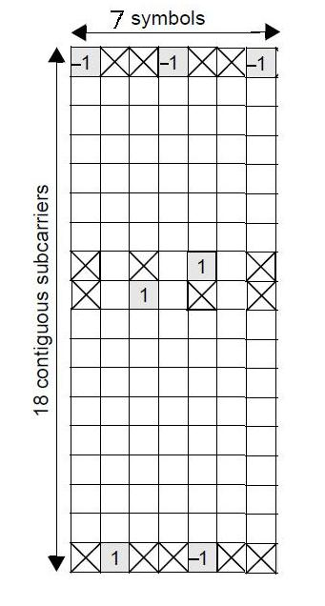
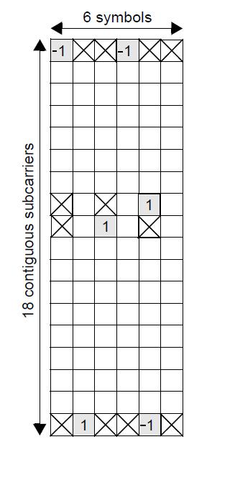
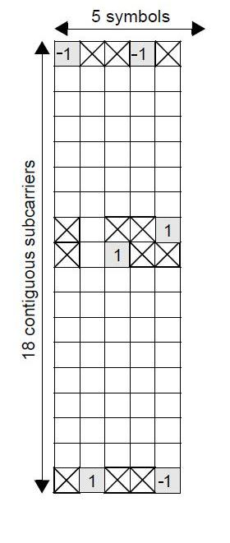
Figure xxx-Mapping of Pilot Modulation Sequence to Pilot Subcarriers of CoFIP

……End of Propose Text……………………………………………………………………………….…

