Project | IEEE 802.16 Broadband Wireless Access Working Group <http://ieee802.org/16>
Title | Proposed modification to DL basic assignment A-MAP IE in IEEE802.16m/D9
Date Submitted | 2010-11-07
Source(s) | Mohammad A. (Amir) Khojastepour,  Narayan Prasad, Meilong Jiang, Sampath Rangarajan,  Nader Zein, Linghang Fan  NEC Corporation  Roshni Srinivasan, Yang-seok Choi  Intel Corporation  Zheng Yan-Xiu  ITRI  Wookbong Lee, Jinyoung Shun  LGE | amir@nec-labs.com  nader.zein@eu.nec.com  roshni.m.srinivasan@intel.com  zhengyanxiu@itri.org.tw  wookbong.lee@lge.com
Re: | Change Request on 802.16m Draft Amendment, IEEE P802.16m/D9
Abstract | This contribution proposes change to DL basic Assignment A-MAP in DL MU-MIMO
Purpose | To be discussed and adopted by TGm for the 802.16m amendment.
Notice | This document does not represent the agreed views of the IEEE 802.16 Working Group or any of its subgroups. It represents only the views of the participants listed in the “Source(s)” field above. It is offered as a basis for discussion. It is not binding on the contributor(s), who reserve(s) the right to add, amend or withdraw material contained herein.
Release | The contributor grants a free, irrevocable license to the IEEE to incorporate material contained in this contribution, and any modifications thereof, in the creation of an IEEE Standards publication; to copyright in the IEEE’s name any IEEE Standards publication even though it may include portions of this contribution; and at the IEEE’s sole discretion to permit others to reproduce in whole or in part the resulting IEEE Standards publication. The contributor also acknowledges and accepts that this contribution may be made public by IEEE 802.16.
Patent Policy | The contributor is familiar with the IEEE-SA Patent Policy and Procedures:  <http://standards.ieee.org/guides/bylaws/sect6-7.html#6> and <http://standards.ieee.org/guides/opman/sect6.html#6.3>.  Further information is located at <http://standards.ieee.org/board/pat/pat-material.html> and <http://standards.ieee.org/board/pat>.
Proposed modification to the DL basic assignment A-MAP IE in IEEE802.16m/D9

Mohammad A. (Amir) Khojastepour, Narayan Prasad, Meilong Jiang,
Sampath Rangarajan, Nader Zein, Linghang Fan
NEC Corporation

Roshni Srinivasan, Yang-seok Choi
Intel Corporation

Zheng Yan-Xiu
ITRI

Wookbong Lee, Jinyoung Shun
LGE

Introduction

Both competing IMT-advanced technologies, LTE-A and IEEE 802.16m support 8 streams in the DL for SU-MIMO. In the DL MU-MIMO on the other hand the total number of streams is limited to at most four in LTE-A; thus, it is only possible to have at most 4 co-scheduled users with one stream each. This limitation was removed for IEEE 802.16m and the option for 8 stream transmission is now available in MU-MIMO mode as well as SU-MIMO mode. However, simulation results by several companies in LTE-A have shown that it is difficult to find more than 4 users with enough data to co-schedule on the same sub-band. Pairing 2 users is seen to be the most common case. For an ABS with polarized TX antennas, the possibility of scheduling an MU-MIMO user with 2 streams is important. Thus, both LTE-A and IEEE802.16m allow for assigning up to 2 streams to an MU-MIMO user.

In the current IEEE802.16m draft, support for 8 stream MU-MIMO transmission targets only an ABS with 8 TX antennas since the much more typical case of an ABS with 4 TX will not co-schedule more than 4 streams in the DL. Since it is suspected that the deployment of 4 TX ABS would be the primary target for most companies, this enhancement of 8 streams MU-MIMO may not apply is most cases. On the other hand, with more flexible decoding of the DL basic assignment MAP IE, more support for MLD can be exploited by ABSs with both 4 TX and 8 TX antennas.

This contribution proposes to interpret the Si field in the DL A-MAP for MU-MIMO differently for 4 TX and 8 TX cases. This will retain the current table for 8 stream support for an ABS with 8 TX antennas and provide more entries to support MLD for 3 and 4 streams for a 4TX ABS. The number of the transmit antennas at the base station (N_{t}) is available in S-SFH SP3.

This contribution proposes to interpret the Si field in the DL A-MAP for MU-MIMO differently for 4 TX ABS in the case it is determined by the ABS that a scheduled AMS can support (quasi-)MLD for 3 or 4 streams. In such a case modulation constellation of the paired user for up-to 4 stream transmission can be provided. In all other cases the current table in D8 is used and modulation constellation of paired user in the case of 2 stream transmission is provided. The number of the transmit antennas at the base station (N_{t}) is available in S-SFH SP3.

Simulation Results

Here, we present some simulation results which emphasize the role of additional modulation support for DL MU-MIMO. In particular we compare the linear-MMSE (LMMSE) receiver with the partial-MLD receiver in figures 1 and 2. In the partial-MLD receiver, we implement LMMSE filtering followed by noise-whitening and two-stream MLD. In both the following simulation plots, we consider a 4TX ABS with one AMS having 2 RX antennas. The AMS is scheduled on a fixed set of PRBs with a fixed MCS (16 QAM and coding rate 2/3). On each PRB the AMS is served one stream and is co-scheduled with 2 other streams. For each PRB, the AMS selects the best rank-1 vector (using the SU-MIMO rule) from a (3 or 6 bit) quantization codebook. On each PRB, the ABS then serves one stream to the AMS using the reported rank-1 vector. The ABS also selects 2 vectors (such that the three vectors are mutually near-orthogonal). These 2 vectors are used to serve the 2 co-scheduled streams. We randomly pick 2 modulations to serve the 2 co-scheduled streams.

The partial-MLD receiver is implemented with and without UE pairing selection. “UE pairing selection” means that on each PRB, one of the 2 co-scheduled streams is dynamically selected based on channel estimates as the paired stream for two-stream MLD. Without “UE pairing selection” means that on each PRB the choice of paired stream for two-stream MLD remains fixed.

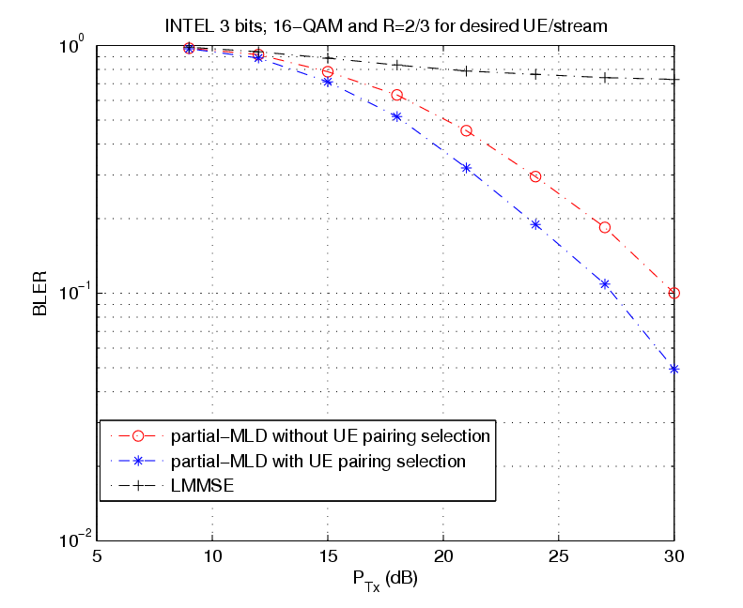

Figure 1: Partial MLD versus LMMSE

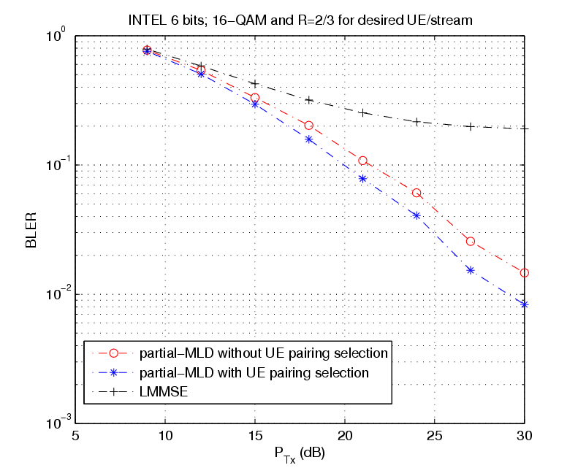
Figure2: Partial-MLD versus LMMSE

From the figures, we see that LMMSE receiver results in an error floor. This is because a 2 RX antenna AMS using the LMMSE receiver cannot handle 3 mutually interfering co-scheduled streams. We note that with ideal CSI the ABS can ensure that the co-scheduled streams are non-interfering when received by the AMS. However, even with per-PRB PMI selection and a 6-bit quantization codebook there is enough residual interference. On the other hand, the partial-MLD receiver is able to handle the residual interference with a complexity that is almost-the same as 2-stream MLD. Modulations of interfering co-scheduled streams is needed to implement partial-MLD.

Text Proposal
Proposed AWD text has been underlined in blue, AWD text that has been deleted has been marked in red and struck through and existing AWD text is shown in black.
<Modify the section 16.3.5.5.2.4.1 on page 647 Table 844 as shown >
_______________________________Start of proposed text change #1 _____________________________

16.3.5.5.2.4.1 DL basic assignment A-MAP IE
Table 848 describes the fields in a DL Basic Assignment A-MAP IE used for resource assignment in the DL.
A-MAP IE Type: Defines the structure of the assignment A-MAP IE for the bits in the assignment A-MAP IE following the A-MAP IE type field. A-MAP IE Type distinguishes between assignment A-MAP IEs used for the UL/DL, and assignment A-MAP IEs used for resource allocation and control signaling. Additional A-MAP IE types are reserved for future use.
Mt: Number of streams in transmission. The DL pilot pattern with Mt streams shall be used in the allocated resource.
Si: Index used to identify the combination of the number of streams and the allocated pilot stream index in a transmission with MU-MIMO, and the modulation constellation of the paired user. For Co-MIMO transmission to two users, the ABS shall indicate to one AMS a total number of streams equal to 3 using one of the values 0b01000, 0b01001 or 0b01010, in order to ensure that the AMS will perform channel estimation using one stream of the non-interlaced pilot pattern with 3 streams.

Table 844 - DL basic assignment A-MAP IE*
Syntax | Size (bit) | Description/Notes
DL_Basic_Assignment_A-MAP_IE() {
A-MAP IE Type | 4 | DL Basic Assignment A-MAP IE
I_{SizeOffset} | 5 | Offset used to compute burst size index
MEF | 2 | MIMO encoder format  0b00: SFBC  0b01: Vertical encoding  0b10: Multi-layer encoding  0b11: CDR
if (MEF == 0b01){ |  | Parameters for vertical encoding
M_{t} | 3 | Number of streams in transmission M_{t} ≤ N_{t}  N_{t} : Number of transmit antennas at the ABS  0b000: 1 stream  0b001: 2 streams  0b010: 3 streams  0b011: 4 streams  0b100: 5 streams  0b101: 6 streams  0b110: 7 streams  0b111: 8 streams
Reserved | 2 | Reserved bit
} else if(MEF == 0b10) { |  | Parameters for multi-layer encoding
if (N_{t} == 4){ |  | Parameters for multi-layer encoding for ABS with modulation constellation of paired user for up-to 4 stream transmission.
Si | 5 | Index used to identify the combination of the number of streams and the allocated pilot stream index in a transmission with MU-MIMO , and the modulation constellation of paired user  0b00000: 2 streams with PSI=stream0 and other modulation =QPSK  0b00001: 2 streams with PSI=stream0 and other modulation =16QAM  0b00010: 2 streams with PSI=stream0 and other modulation =64QAM  0b00011: 2 streams with PSI=stream0 and other modulation information not available  0b00100: 2 streams with PSI=stream1 and other modulation =QPSK  0b00101: 2 streams with PSI=stream1 and other modulation =16QAM  0b00110: 2 streams with PSI=stream1 and other modulation =64QAM  0b00111: 2 streams with PSI=stream1 and other modulation information not available  0b01000: 3 streams with PSI=stream0  0b01001: 3 streams with PSI=stream1  0b01010: 3 streams with PSI=stream2  0b01011: 4 streams with PSI=stream0  0b01100: 4 streams with PSI=stream1  0b01101: 4 streams with PSI=stream2  0b01110: 4 streams with PSI=stream3  0b01111: 3 streams with PSI=stream0 and stream1  0b10000: 4 streams with PSI=stream0 and stream1  0b10001: 4 streams with PSI=stream2 and stream3  0b10010: 3 streams with PSI=stream2 and other modulation =QPSK  0b10011: 3 streams with PSI=stream2 and other modulation =16QAM  0b10100: 3 streams with PSI=stream2 and other modulation =64QAM  0b10101: 3 streams with PSI=stream0 and stream1 and other modulation =QPSK  0b10110: 3 streams with PSI=stream0 and stream1 and other modulation =16QAM  0b10111: 3 streams with PSI=stream0 and stream1 and other modulation =64QAM  0b11000: 4 streams with PSI=stream0 and stream1 and other modulation =QPSK  0b11001: 4 streams with PSI=stream0 and stream1 and other modulation =16QAM  0b11010: 4 streams with PSI=stream0 and stream1 and other modulation =64QAM  0b11011: 4 streams with PSI=stream2 and stream3 and other modulation =QPSK  0b11100: 4 streams with PSI=stream2 and stream3 and other modulation =16QAM  0b11101: 4 streams with PSI=stream2 and stream3 and other modulation =64QAM  0b11110: reserved  0b11111: reserved
} else { |  | Parameters for multi-layer encoding for ABS
Si | 5 | Index used to identify the combination of the number of streams and the allocated pilot stream index in a transmission with MU-MIMO , and the modulation constellation of paired user in the case of 2 stream transmission  0b00000: 2 streams with PSI=stream0 and other modulation =QPSK  0b00001: 2 streams with PSI=stream0 and other modulation =16QAM  0b00010: 2 streams with PSI=stream0 and other modulation =64QAM  0b00011: 2 streams with PSI=stream0 and other modulation information not available  0b00100: 2 streams with PSI=stream1 and other modulation =QPSK  0b00101: 2 streams with PSI=stream1 and other modulation =16QAM  0b00110: 2 streams with PSI=stream1 and other modulation =64QAM  0b00111: 2 streams with PSI=stream1 and other modulation information not available  0b01000: 3 streams with PSI=stream0  0b01001: 3 streams with PSI=stream1  0b01010: 3 streams with PSI=stream2  0b01011: 4 streams with PSI=stream0  0b01100: 4 streams with PSI=stream1  0b01101: 4 streams with PSI=stream2  0b01110: 4 streams with PSI=stream3  0b01111: 3 streams with PSI=stream0 and stream1  0b10000: 4 streams with PSI=stream0 and stream1  0b10001: 4 streams with PSI=stream2 and stream3  0b10010: 8 streams with PSI=stream0  0b10011: 8 streams with PSI=stream1  0b10100: 8 streams with PSI=stream2  0b10101: 8 streams with PSI=stream3  0b10110: 8 streams with PSI=stream4  0b10111: 8 streams with PSI=stream5  0b11000: 8 streams with PSI=stream6  0b11001: 8 streams with PSI=stream7  0b11010: 8 streams with PSI=stream0 and stream1  0b11011: 8 streams with PSI=stream2 and stream3  0b11100: 8 streams with PSI=stream4 and stream5  0b11101: 8 streams with PSI=stream6 and stream7  0b11110: reserved  0b11111: reserved
}
} else {
Reserved | 5 | Reserved bits
}
Resource Index | 11 | 5 MHz: 0 in first 2 MSB bits + 9 bits for resource index  10 MHz: 11 bits for resource index  20 MHz: 11 bits for resource index  Resource index includes location and allocation size.
Long TTI Indicator | 1 | Indicates number of AAI subframes spanned by the allocated resource.  0b0: 1 AAI subframe (default)  0b1: 4 DL AAI subframes for FDD or all DL AAI subframes for TDD
HFA | 3 | HARQ Feedback Allocation
AI_SN | 1 | HARQ identifier sequence number
ACID | 4 | HARQ channel identifier
SPID | 2 | HARQ subpacket identifier for HARQ IR  0b00: 0  0b01: 1  0b10: 2  0b11: 3
CRV | 1 | Constellation Rearrangement Version  0b0: 0  0b1: 1
Reserved | 1 | Reserved bit
}

_______________________________End of proposed text change #1 ______________________________

References:
1. Higuchi, K. Kawai, H. Maeda, N. Taoka, H. Sawahashi, M. "Experiments on real-time 1-Gb/s packet transmission using MLD-based signal detection in MIMO-OFDM broadband radio access" Page(s): 1141 - 1153, IEEE JSAC June 2006
2. P. Aggarwal, N. Prasad, X. Wang and M. Madihian, "A Low Complexity MMSE-based Sequential Monte Carlo Algorithm for Near-Optimal MIMO Demodulation", IEEE Transaction on Signal Processing 2007:55(6) pp. 2395-2406

