Project | IEEE 802.16 Broadband Wireless Access Working Group <http://ieee802.org/16>
Title | AMS Transmission Power Status/Limitation Reporting for Multicarrier
Date Submitted | 2010-11-04
Source(s) | Chien-Hwa Hwang, Alex Hsu, Yih-Shen Chen, Pei-Kai Liao  MediaTek Inc. | pk.liao@mediatek.com
Re: | Sponsor Ballot on the Draft Amendment (IEEE P802.16m/D9)
Abstract | This contribution proposes changes on AMS power status reporting for multicarrier
Purpose | Propose to be discussed and adopted by TGm for the 802.16m Amendment
Notice | This document does not represent the agreed views of the IEEE 802.16 Working Group or any of its subgroups. It represents only the views of the participants listed in the “Source(s)” field above. It is offered as a basis for discussion. It is not binding on the contributor(s), who reserve(s) the right to add, amend or withdraw material contained herein.
Release | The contributor grants a free, irrevocable license to the IEEE to incorporate material contained in this contribution, and any modifications thereof, in the creation of an IEEE Standards publication; to copyright in the IEEE’s name any IEEE Standards publication even though it may include portions of this contribution; and at the IEEE’s sole discretion to permit others to reproduce in whole or in part the resulting IEEE Standards publication. The contributor also acknowledges and accepts that this contribution may be made public by IEEE 802.16.
Patent Policy | The contributor is familiar with the IEEE-SA Patent Policy and Procedures:  <http://standards.ieee.org/guides/bylaws/sect6-7.html#6> and <http://standards.ieee.org/guides/opman/sect6.html#6.3>.  Further information is located at <http://standards.ieee.org/board/pat/pat-material.html> and <http://standards.ieee.org/board/pat>.

AMS Transmission Power Status/Limitation Reporting for Multicarrier
Chien-Hwa Hwang, Alex Hsu, Yih-Shen Chen, Pei-Kai Liao
MediaTek Inc.

Introduction
This paper investigates the restrictions of the transmit power of an AMS with the introduction of CA. We discuss what information an AMS shall report to the serving ABS to provide the latter with sufficient information to allocate resources to the former considering the power limitations.

Discussion

2.1 Maximum Transmit Power in CC, PA, and AMS Levels
The maximum transmit power of an AMS has the following limitations
- AMS maximum transmit power: an AMS level limitation
- Non-ideal PA (non-linear region, out-of-band emission, and spurious emission): a PA level limitation
- A CC level limitation
In the following, the limitations in the levels of CC, PA, and UE are discussed in details.

2.2 Transmit Power Limitation (TPL)
Each maximum transmit power of P_{MAX_CC,i}’s, P_{MAX_PA,j}’s, and P_{MAX_AMS} corresponds to a TPL, where P_{MAX_CC,i} and P_{MAX_PA,j} represent the maximum transmit powers of the i-th CC and the j-th PA, respectively, and P_{MAX_AMS} is the maximum transmit power of the AMS. For example, consider an AMS in which there are two PA (PA₁ and PA₂); PA₁ serves CC₁ and CC₂, and PA₂ serves CC₃ (See the PA/CC configuration in Figure 1). Let the transmit power of the i-th CC be represented as P_{CC,i}. Then the TPLs are given as
TPL at CC₁: P_{CC,1} ≦ P_{MAX_CC,1}
TPL at CC₂: P_{CC,2} ≦ P_{MAX_CC,2}
TPL at CC₃: P_{CC,3} ≦ P_{MAX_CC,3} (1)
TPL at PA₁: P_{CC,1} ＋ P_{CC,2} ≦ P_{MAX_PA,1}
TPL at PA₂: P_{CC,3} ≦ P_{MAX_PA,2} (2)
TPL at AMS: P_{CC,1} ＋ P_{CC,2} ＋ P_{CC,3} ≦ P_{MAX_AMS}
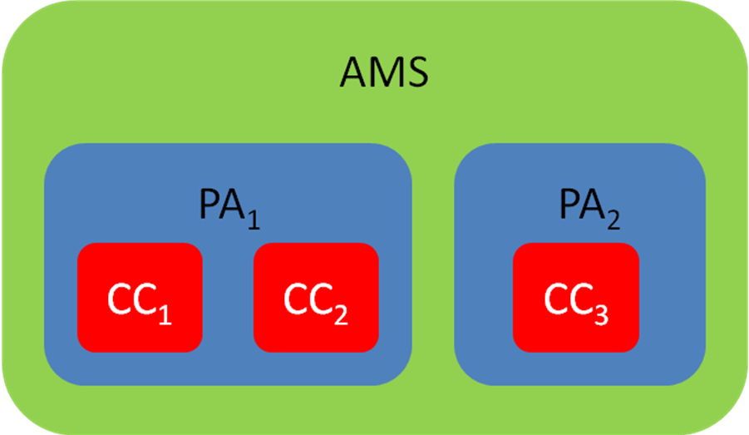
Figure 1: The PA/CC configuration of the AMS
It can be observed that some TPLs are redundant, and TPL reduction is possible. For example, the TPLs in (1) and (2) can be combined into a single TPL as
P_{CC,3} ≦ min(P_{MAX_CC,3}, P_{MAX_PA,2}).

2.3 AMS Power Status Reporting
An AMS shall report the information to the serving ABS such that the latter can deduce all the TPLs. Take Figure 1 as an example. The reports from the AMS shall provide the ABS with sufficient information such that the latter knows the PA/CC configuration (so that the six TPLs can be deduced) and the values of P_{MAX_CC,1}, P_{MAX_CC,2}, P_{MAX_CC,3}, P_{MAX_PA,1}, P_{MAX_PA,2}, and P_{MAX_AMS}. The AMS shall also report the information regarding its transmit power in each CC so that the ABS knows how much power remains in each CC.
- Proposed Solution
- During network entry, only the maximum available power of the primary carrier, P_{MAX_CC,1}, is reported through AAI-SBC-REQ.
  - Since AMS will conduct network entry procedure through primary carrier only, reporting maximum available power of the primary carrier is enough at this stage.
- During carrier activation, the maximum available power of each activated carrier, P_{MAX_CC,i}, and the power amplifier configuration of all activated carriers is reported through AAI-CM-IND.
  - The information is reported semi-statically.
  - With these information, we can derive P_{MAX_CC,i}, P_{MAX_PA,j} and P_{MAX_AMS} so that all limitation values can be known by ABS.
- During power status reporting, P_{backoff} is reported through uplink power status report header to reflect the change of the maximal available power, P_{MAX_CC,i}, due to dynamic uplink resource allocation for AMS.
  - The information is reported periodically.

- Text Proposal
Remedy #1:
[Adopt the text change from line 9 on the page 838, section 16.3.8.4 as follows:]
-------------------------------------------------------- Start of the Text ------------------------------------------------
An AMS shall report the maximum available power of primary carrier by MAX Tx Power field when the AMS transmits AAI-SBC-REQ. , and shall report the maximum available power of each activated carrier and the corresponding power amplifier configuration when the AMS send AAI-CM-IND.

For interference level control, current interface level of each ABS may be shared among ABSs.

--------------------------------------------------------- End of the Text ------------------------------------------------

Remedy #2:
[Adopt the text change from line 9 on the page 109, section 16.2.3.4 as follows:]
-------------------------------------------------------- Start of the Text ------------------------------------------------
M | MAX Tx Power | 24 | The maximum available power of primary carrier:  Bit 0-7: Maximum transmitted power for QPSK.  Bit 8-15: Maximum transmitted power for 16-QAM  Bit 15-23: Maximum transmitted power for 64-QAM.  Each unsigned 8-bit integer specifies the maximum transmitted power value in dBm. The maximum transmitted power is quantized in 0.5 dBm steps ranging from -64 dBm (encoded 0x00) to 63.5 dBm (encoded 0xFF). Values outside this range shall be assigned the closest extreme. If AMS does not support 64-QAM, the AMS shall report the value of 0x00 for Bit 15-23.

--------------------------------------------------------- End of the Text ------------------------------------------------

Remedy #3:
[Adopt the text change from line 3 on the page 271, section 16.2.3.54 as follows:]
-------------------------------------------------------- Start of the Text ------------------------------------------------
Table 748 – AAI-CM-CMDIND Message Field Description
Field | Size(bits) | Value/Description | Condition
Action Code | 1 | Used to indicate the purpose of this message  0b0: secondary carrier management  0b1: primary carrier change | Mandatory
MAX Tx Power | 24 | The maximum available power of activated carrier:  Bit 0-7: Maximum transmitted power for QPSK.  Bit 8-15: Maximum transmitted power for 16-QAM  Bit 15-23: Maximum transmitted power for 64-QAM.  Each unsigned 8-bit integer specifies the maximum transmitted power value in dBm. The maximum transmitted power is quantized in 0.5 dBm steps ranging from -64 dBm (encoded 0x00) to 63.5 dBm (encoded 0xFF). Values outside this range shall be assigned the closest extreme. If AMS does not support 64-QAM, the AMS shall report the value of 0x00 for Bit 15-23. | Mandatory
Power Amplifier Index | 4 | Used to indicate which power amplifier the corresponding activated carrier uses. The mapping from the index value to each power amplifier is decided by AMS only. If more than one carrier share the same index value, ABS shall consider that those carriers share the same power amplifier. | Mandatory

--------------------------------------------------------- End of the Text ------------------------------------------------

Remedy #4:
[Adopt the text change from line 51 on the page 843, section 16.3.8.4.7 as follows:]
-------------------------------------------------------- Start of the Text ------------------------------------------------
16.3.8.4.7 Uplink Power Status Reporting
16.3.8.4.7.1 Power Status Reporting Information
There are twothree key parameters for power status reporting: the base uplink transmission PSD, and the SIR_{DL} and the P_{backoff} defined in 16.3.8.4.1. The power status shall be reported for each activated carrier.
The base uplink transmission PSD is derived from Equation (291) by setting SINR_{Target} = 0 and Offset = 0:
PSD(base) = L + NI (300)
The parameter is reported in dBm and is coded using 8 bits in 0.5 dBm steps ranging from -74 dBm (coded 0x00) to 53.5 dBm (coded 0xFF). The NI value used here is the NI value of the primary frequency partition supported by home sector.
The reported SIR_{DL} value is coded using 10 bits in 1/16 dB steps ranging from -12dB (coded 0x000) to 51.9375 dB (coded 0x3ff).
The P_{backoff} is used to indicate the required power backoff value from the MAX Tx Power reported in AAI-CM-IND to reflect the change of the MAX Tx Power value due to dynamic uplink resource allocation for AMS. The reported P_{backoff} value is coded using 3-bits in 1/2 dB steps ranging from 0 dB (coded 0b000) to 3.5 dB (coded 0b111).
After the ABS has received PSD(base), and SIR_{DL} and P_{backoff} from the AMS, the PSD for all uplink channels and up-to-date maximal available power of each activated carrier can be estimated in ABS.

--------------------------------------------------------- End of the Text ------------------------------------------------

Remedy #5:
[Adopt the text change from line 32 on the page 68, section 16.2.2.1.3.6 as follows:]
-------------------------------------------------------- Start of the Text ------------------------------------------------
Table 662 – Uplink Power Status Report Header Format
Syntax | Size (bits) | Notes
Uplink Power Status Report Header() {
FID | 4 | Flow Identifier. Set to 0b0010.
Type | 5 | MAC signaling header type = 0b00101
Length | 3 | Indicates the length of the signaling header in bytes:  0b110: 6 bytes
ULPC Parameters Updating Indicator | 1 | Indicates whether the AMS has updated its ULPC parameters from AAI-SCD:  0: No ULPC parameters have changed.  1: The confirmation of new ULPC parameters from AAI-SCD applied.
Configuration Change Count | 4 | Only valid if ULPC Parameters Updating Indicator == 0b1.  The value is the same as “Configuration Change Count” in the latest AAI-SCD message.
txPowerPsdBase | 8 | txPowerPsdBase (PSD(base)) is coded using 8-bits in 0.5 dBm steps ranging from -74 dBm (coded 0x00) to 53.5 dBm (coded 0xFF).
txSirDownlink | 10 | txSirDownlink (SIR_{DL}) is coded using 10-bits in 1/16 dB steps ranging from -12 dB (coded 0x000) to 51.9375 dB (coded 0x3ff).
txPowerBackoff | 3 | Indicates the required power backoff value from the MAX Tx Power reported in AAI-CM-IND to reflect the change of the MAX Tx Power value due to dynamic uplink resource allocation for AMS:  txPowerBackoff (P_{backoff}) is coded using 3-bits in 1/2 dB steps ranging from 0 dB (coded 0b000) to 3.5 dB (coded 0b111).
Physical Carrier Index | 6 | The relevant active carrier that this signaling header is associated with
Reserved | 54 | Shall be filled by 0 for byte alignment
}

--------------------------------------------------------- End of the Text ------------------------------------------------

