INTERIM MEETING ANNOUNCEMENT
IEEE P802.17 RPR Interim Meeting will be held in Montreal, Quebec, Canada

HOSTED BY
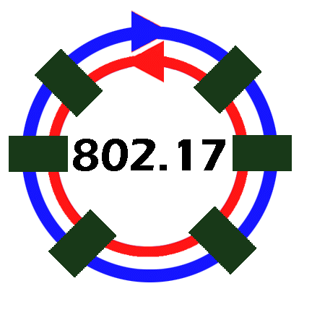
With the support of Scientific Atlanta

MEETING DATES
Monday, May 19th through Thursday, May 22nd, 2003
BOOK TODAY!
HOTEL INFORMATION:
Le Centre Sheraton Montreal
1201 Rene-Levesque Blvd West, Montreal, Quebec H3B 2L7
24 Hour Toll Free Reservations: 1-800-325-3535
Hotel Tel: 1-514-878-2000
Hotel Fax: 1-514-878-3958
Web Site: www.sheraton.com/lecentre

ROOM RESERVATIONS:

Please make your room reservations directly with the hotel or by using the toll free 800 number to book into our group room block. Please quote the group name to the hotel reservations department when making your reservation request.

IEEE 802.17 Group Room Rate: $179.00 CDN single/double occupancy (plus taxes)
Group Name: IEEE 802.17 Interim Meeting

Meeting sponsor/host: IEEE 802.17 - With the support of Scientific Atlanta
The reservation deadline for rooms in our block is April 25, 2003. Reservations made after that date will be accepted on a space available basis up to the group block of 45 rooms. Everyone is encouraged to reserve a room as quickly as possible. Reservations must be guaranteed with major credit card with cancellation at least 48 hours prior to arrival. Non-cancelled room reservations (those that do not have an appropriate cancellation number) will be charged a one night cancellation fee.

Making Room Reservations
Sheraton® Service Promise
See for yourself^{sm}...
Now your group can book on the web!

Following are instructions to include in your attendee's information:

P Go to: Meeting link (<<<Click this link)
(In addition to booking your room, you can view a slide show of the hotel and general hotel information. You can also sign up for our award winning frequent guest program, Starwood Preferred Guest on the web site)
P Enter Montreal
P Enter Your Meeting Code:9090
P and press Continue
P Click on Quebec
P Choose Le Centre Sheraton Montreal Hotel by pressing the red select button
P Meeting Code appears with the property info and you may choose your dates and book as normal from here
P Confirmation appears at the end and we also offer an email confirmation
P For reservations questions, attendees may email the Sheraton at: Reservation.Lcs@sheraton.com
P Or to reach the Sheraton’s Concierge staff: Concierge.Lcs@sheraton.com

Le Centre Sheraton Montréal Hôtel  1201 Boulevard René-Lévesque ouest  Montréal (Québec) Canada H3B 2L7  Ph:(514)878-2000 - Fax:(514)878-3958 |  | Sheraton Sweet Sleeper ^{sm} Bed

MEETING REGISTRATION:
The pre-registration cost per attendee will be $250US and the on-site registration fee will be $300US. The registration fee will cover meeting rooms, AV equipment, power hook-ups for laptop computers, Lunches, Morning and Afternoon Refreshments, a Social event, and meeting services/supplies. Meeting agendas will be posted at a later date.
IMPORTANT:
Web form for Interim Meeting registration will be posted onto the IEEE 802.17 Working Group site by Mid April.
LOCATION AND TRANSPORTATION:
This 5 star 4 diamond, completely renovated luxury hotel is centrally located in downtown Montreal. The trendy shopping district, historic old Montreal, the Glittering Casino, exquisite dining with a choice of over 4,500 restaurants, bistros and cafes are all nearby attractions. The international airport, Dorval, is 12 miles, 20 minutes from the Sheraton. Many transportation options are available to and from the airport. Shuttle service, limo service, bus service as well as the subway are all available forms of transportation from the airport to the Sheraton.
For information on the Sheraton including driving directions, visit http://www.sheraton.com/lecentre

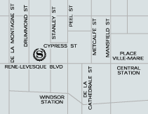

TOURIST INFORMATION:
Please visit http://www.tourisme-montreal.org/ for further meeting destination information.
CONTACT:
Please contact Face To Face Events, Inc (IEEE 802 Conference Managers) at 408/241-8906 or 802info@ieee.org for further meeting details and assistance.
Thank you.
|=========================================|
Dawn C. Slykhouse
Face To Face Events, Inc.
2699 Iversen Court
Santa Clara, CA. 95051

