IEEE P802.19
Coexistence Technical Advisory Group

Project | IEEE P802.19 Coexistence TAG
Title | Coexistence usage models for 802.15.3a
Date Submitted | 26 June, 2003 r0 created  r1: 8 July 2003 Usage categories (home, enterprise, hot spot, mobile) defined  r2: 16 July 2003 Data rates edited
Source | [Jim Lansford]  [Mobilian Corporation]  [6310 W. Devonshire Rd., Stillwater, OK 74074 USA] | Voice: [+1 405 377 6170]  Fax: [+1 425 671 6099]  E-mail: [jim.lansford@ieee.org]  Mobile: [+1 405 714 0074]
Re: | [Guide for 802.15.3a proposals.]
Abstract | [Description of possible traffic types and usage scenarios where 802.15.3a will be required to coexist with other wireless standards.]
Purpose | [For guidance to 802.15.3a efforts to model and measure interference between 802.15.3a proposals and other wireless systems.]
Notice | This document has been prepared to assist the IEEE P802.19. It is offered as a basis for discussion and is not binding on the contributing individual(s) or organization(s). The material in this document is subject to change in form and content after further study. The contributor(s) reserve(s) the right to add, amend or withdraw material contained herein.
Release | The contributor acknowledges and accepts that this contribution becomes the property of IEEE and may be made publicly available by P802.19.
Usage Models for 802.15.3a Devices
For reference, see the following 802.15.3a documents:
802.15-02/043r0
802.15-02/047r0
802.15-02/119r0
802.15-02/137r1
802.15-02/139r0

Traffic Types
The following are categories of compelling applications that 802.15.3a technology will enable:

- Digital Video Distribution
External sources: coming into the home via a set-top-box (HDTV or SDTV MPEG2 or MPEG4 format)
Internal sources: from sources like DVD players, digital camcorders
Expected throughput: 3-200+ Mbps (6 Mbps required for high action video such as sports, up to 10Mbps for DVD players, up to 60Mbps for digital camcorders, approximately 20Mbps for HDTV) with support for multiple streams. QoS required.

- Digital Image Distribution
Download/upload from digital still camera
Expected throughput: 100Mbps or greater for multi-megapixel cameras. QoS not required.

- High Quality Audio
Surround sound systems (AC3 at a minimum)
Hi-Fi, Dolby, etc. (CD quality)
Expected throughput: 1.5 Mbps QoS required.

- High Speed Data
External sources: xDSL, Cable
Internal sources: peripheral sharing (e.g. hard disk drive, high speed printers, scanners)
Expected throughput: 1-200Mbps QoS may be required.

- PC Graphics Distribution
Using TV or webpad as a PC terminal
Game consoles receiving graphics from a central PC (I/O latency is a critical factor that must be met here.
Expected throughput: 2-5 Mbps with compression, >100Mbps without compression

- Video and high quality Voice Communication
Video conferencing (room to room to hand-held device)
Expected throughput: 1-2Mbps per session (Requires symmetric bandwidth and a maximum 30 millisecond latency)

{This table could use updating…}
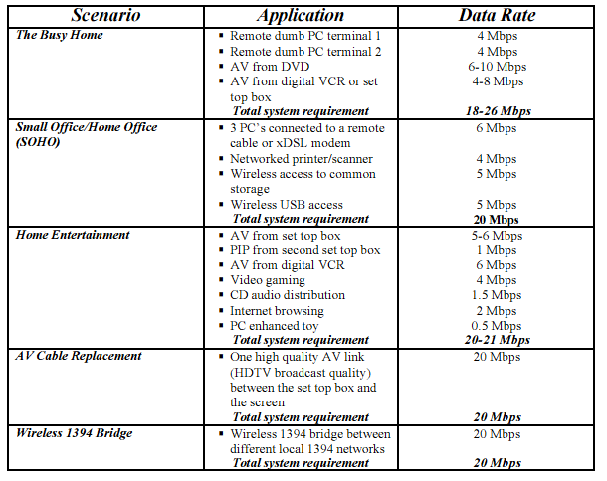

{ed: this table could either replaced the table above, or be merger in with it}

PHY Layer utilization in time
Application | Ave. Data Rate  (Mbps) | Peak Data Rate  (Mbps) | QoS | PHY Activity Factor¹  ^{(%)} | Session duration
Digital Video Distribution
SDTV , DVD, MPEG-2 | 6 | 10 | yes | 8 | 1.5 h
Dig Camcorder |  | 60 | yes | 78 | 30 min
HDTV | 20 | 25 | yes | 25 | 1-3 h
Digital Image Transfer,  HD connection |  | 77 | no | 100 | 1-60 s
High Quality Audio | 1.5 | 2 | yes | 2 | 1 h
Data Network (Printer, Internet) | 0.5 | 10 | no | 1 | 1 h
PC Graphics Distribution | 4 | 100 | yes | 5 | 1 h
Video Conferencing | 1 | 1.5 | yes | 1 | 30 min

¹Estimated average fraction of time the PHY emits assuming 110Mbps rate and that max throughput = 0.7x(bit rate)

Devices
The following are product categories that are expected to incorporate 802.15.3a technology:

- Modem Sharing (cable modems/ xDSL/ etc.) hubs/base stations;
- PC attached control points and base stations
- Set top boxes and satellite disc receivers
- Desktop PCs & notebooks;
- Computer peripherals such as hard disc drives or DVD-ROM;
- Consumer electronic devices such as HDTV monitors, or DVD players;
- Video conference equipment;
- Cordless phones
- Smartphones
- Digital Still Cameras (DSC)
- Digital Video Cameras (DVC)
- Network bridging products (802.11n to 802.15.3a, USB2 to 802.15.3a, or 1394 to 802.15.3a, for examples)
- New device categories that have not yet been developed, such as news tablets, appliance video displays, and in-room video phones;
- Adapters and accessories of all descriptions that will enable existing and already purchased devices to incorporate the functionality.
- Bridging devices that can pass traffic from one 802.15.3a “piconet” to another within the same dwelling.

{This table could also use updating….}

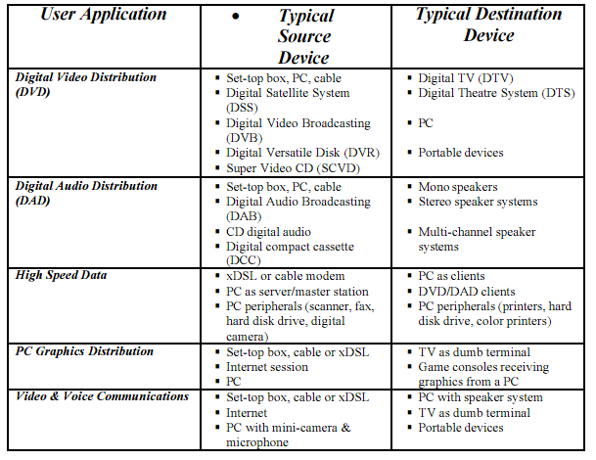

Classes of devices that could require coexistence between 802.15.3a and other wireless technologies
{See PHY layer utilization table in Section 1}

  - Home usage
    - A 15.3a digital video camera streams video to a multimedia hub in the home that also forwards the stream to an HDTV monitor, while the same multimedia hub is streaming MP3 audio to a remote audio terminal
Devices: DVC, A/V hub (WLAN/WPAN bridge), HDTV monitor, MP3 player
Traffic: HD video (QoS), MP3 audio (semi-QoS)
Distances: Video: 1-5 meters, Audio: 5-50 meters
    - The multimedia hub in a home is located 1 meter away from the cordless phone (2.4 or 5GHz) base station, or the user is talking on the cordless phone one meter away from a camera while uploading video or still images
Devices: DSC, DVC, cordless phone
Traffic: packet (DSC) or video (DVC/QoS) with voice (ADPCM over FHSS?)
Distances: approx 1 meter
  - Enterprise usage
    - A video projector equipped with 15.3a technology is used in a conference room to allow attendees to stream their presentations from their laptops, but all attendees want to use the corporate network simultaneously using 802.11b/g/a/n
Devices: Dual mode laptop, video projector
Traffic: video (QoS), packet data (WLAN)
Distances:1-5 meters

  - Kiosk/hot spot usage
    - A laptop computer equipped with 802.11b/g/a/n uploads photos to a kiosk while a DSC with 15.3a also uploads photos to the same kiosk.
Devices: laptop w/WLAN, DSC, dual mode AP (WLAN/WPAN), possibly WLAN or WPAN printer
Traffic: still images (packet), printer (packet)
Distances: 0.5-3 meters
    - In an airport hot spot, several users upload their DSC/DVCs to their laptop computers, then forward these images via WLAN to a central server for storage.
Devices: DSC/DVC, dual mode laptop, WLAN AP
Traffic: packet over WPAN and WLAN
Distances:1-25 meters
  - Mobile usage
    - Mobile phone incorporating 802.15.3a technology and GPS
Devices: Mobile phone with E911 capability
Traffic: GSM/GPRS/EDGE, WCDMA, or CDMA/CDMA2000 and GPS
Distances: <10 cm
    - Mobile phone with either DSC or DVC capability that uploads video or still images to kiosk or A/V hub while maintaining 3G connection
Devices: Mobile phone with digital camera (video or still)
Traffic: GSM/GPRS/EDGE, WCDMA, or CDMA/CDMA2000 and packet traffic (QoS required for video)
Distances: <10 cm

{others?}

Success Factors for Coexistence
{The following is a table that was used in a modified form by the Bluetooth SIG, and may be useful for us….we could modify/add/delete items in this table.}

Attributes | Priority | Target | Nice to Have | Comments
Coexistent with Microwave Oven | 1 | Throughput reduced by not more than 3% at expected distances | Minimal if any throughput reduction | More important for voice traffic
Coexistent with 802.11a/b/g/n | 1 | Throughput reduced by not more than 3% with a single 802.11b interferer expected distances. | Minimal if any throughput reduction
Coexistent with other interferers | 2 | Throughput reduced by not more than 3% | Minimal if any throughput reduction
Cost | 1 | <2$ increase in cost | No Increase in cost
Allows installation within the same enclosure | 2 | On opposite sides of a 10” wide laptop | Out of the same antenna

“Semi-QoS” – OK, I made up a new term. Technically, you can send audio over a regular WLAN link, but you have to make sure the buffer depth (maximum latency) is sufficient to prevent underflow and audio breakup. True QoS would allow much smaller buffers because latency is bounded. Given the trend in anti-skip technology in CD players (i.e., memory is cheap so put in big buffers), the preferred solution may still be to put in fat buffers and hope for the best.

