IEEE P802.19
Wireless Coexistence
Coexistence Protocol Proposal
Date: 2012-09-18
Author(s):
Name | Company | Address | Phone | Email
Jinho Kim | LGE | LG R&D Complex 533, Hogye-1dong, Dongan-Gu, Anyang-Shi, Kyungki-Do, 431-749, Korea | +82-31-450-1867 | boiler4.kim@lge.com
Jinyoung Chun | LGE
Suhwook Kim | LGE
Wookbong Lee | LGE
Jinsam Kwak | LGE
Abstract

This document contains a proposal about coexistence protocol which includes overview of layered architecture of coexistence system, connection establishment, session management, authentication, authorization, account procedures, and so on.

X. Coexistence Protocol

X.1 Overview
All the CE, CM, and CDIS are logical entities for keeping coexistence. Coexistence means an action of two or more TVBD networks/devices sharing resources without causing destructive interference to one another. In a perspective of layered network architectures, these entities shall be positioned in an application layer.

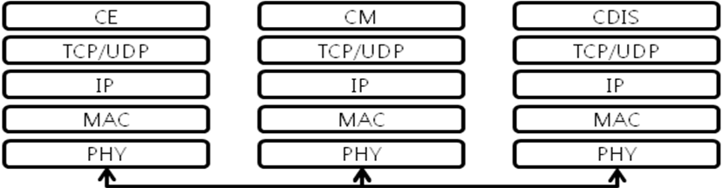

Figure x. overall layered architecture of coexistence system

HTTP (RFC 2616) shall may be used for exchanging coexistence protocol (i.e. requests and responses).
TLS (RFC 2818 and RFC 5246) shall may be used for secure transportation of coexistence protocol on top of TCP/IP stack. Alternatively SSH (RFC4253) may be used for secure transportation of coexistence protocol on top of TCP/IP stack. TCP/IP shall be used as a mandatory for exchanging coexistence messages. UDP may be used as transportation protocol for exchanging service discovery protocol. PHY layer and MAC layer are out of scope.

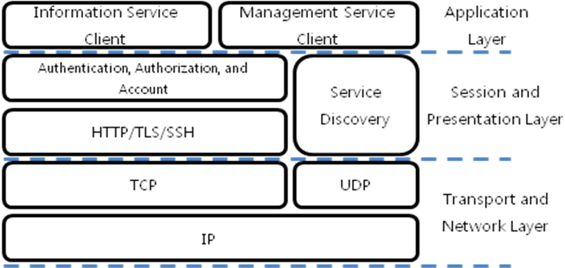
Figure x. overall functional block diagram for a CE

CE (Coexistence Enabler) is a logical entity which enables communication between WSO and a coexistence manager that serves the WSO.
Information Service Client on application layer performs coexistence protocol translation to WSO

CE provides information service and management service in conjunction with CMs. In order to perform these services, CE shall support several basic procedures, such as coexistence system discovery, session management, authentication, authorization, and account procedures.
SSDP (Simple Service Discovery Protocol) defined in UPnP Device Architecture Specification shall can be supported to provide coexistence system discovery procedure.

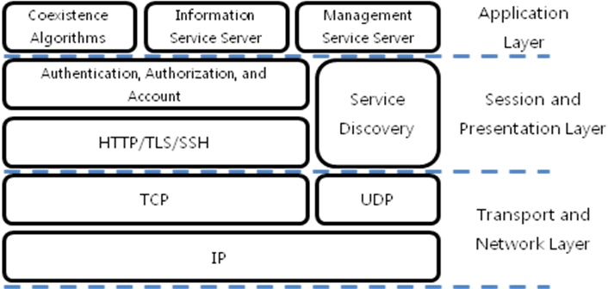
Figure x. overall functional block diagram for a CM

CM (Coexistence Manager) is a logical entity which is responsible for making coexistence decisions related to reconfiguration of television band device (TVBD) networks or devices to solve coexistence problems among them.
CM provides information service and management service in conjunction with CEs and CDISs. In order to perform these services, CM shall support several basic procedures, such as coexistence system discovery, session management, authentication, authorization, and account procedures. Moreover, CM shall perform coexistence algorithms to provide optimized frequencies and channels allocation. Even, a CM can negotiate with other CMs to provide better services.
SSDP (Simple Service Discovery Protocol) defined in UPnP Device Architecture Specification shall can be supported to provide coexistence system discovery procedure.

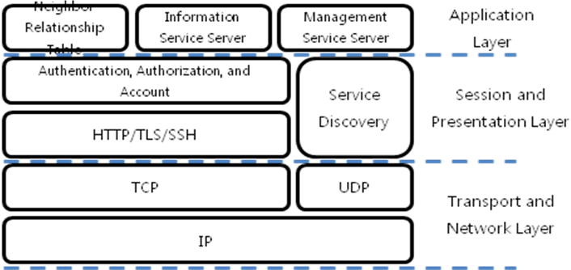
Figure x. overall functional block diagram for a CDIS

CDIS (Coexistence Discovery and Information Service) is a logical entity which is responsible for determining neighbour television band device (TVBD) networks or devices for CMs.
CDIS provides information service and management service in conjunction with CMs. In order to perform these services, CDIS shall support several basic procedures, such as coexistence system discovery, session management, authentication, authorization, and account procedures. Moreover, CDIS shall calculate and maintain a neighbor relationship table to provide optimized frequencies and channels allocation. Even, a CDIS may negotiate with other CDISs to provide better services.
SSDP (Simple Service Discovery Protocol) defined in UPnP Device Architecture Specification shall can be supported to provide coexistence system discovery procedure.

X.2 Connection Establishment
Coexistence connection is a connection which includes the range from PHY layer up to TCP/IP layer is used as lower layer connection for exchanging coexistence protocol.
Coexistence session is a network connection which includes the range from TCP/IP layer up to coexistence entities.
In order to exchange coexistence protocol between CE and CM, a coexistence connection and a coexistence session shall be established first. The connection establishment shall be processed through the procedures: addressing, discovery, authentication, authorization, and account procedure.

X.2.1 Addressing

The addressing scheme defined in UPnP Device Architecture Specification is referred to assign an IP address to coexistence system devices.

X.2.2 CE to CM Discovery

When a device in which CE is installed is added to the network, the UPnP discovery protocol, SSDP, allows that the device to advertise its coexistence service, such as information service and management service, to the CMs on the network.
Similarly, when a CM is added to the network, the UPnP discovery protocol, SSDP, allows that the CM to search for devices, which include CE, of interest on the network.
The fundamental exchange in both cases is a coexistence entity discovery message containing a few, essential specifics about the device or coexistence entity type.

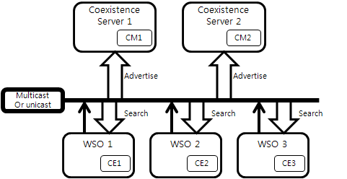
Figure x. Coexistence entity discovery architecture

When a device knows it is newly added to the network, it should unicast a number of coexistence entity discovery messages advertising itself, its embedded devices, and its coexistence entity type.
Any CM can listen to the standard unicast address for notifications that new capabilities are available.
A multi-homed device unicast the coexistence entity discovery messages on all UPnP enabled interfaces. A multi-homed CM may listen to the standard multicast or unicast address on one, some or all of its UPnP enabled interfaces.

When a new CM is added to the network, it may multicast or unicast a coexistence entity discovery message searching for interesting devices on which CEs operates. All CE devices shall listen to the standard multicast or unicast address for these messages and shall respond if any of their devices matches the search criteria in the discovery message from CM.

