Task Group Report
on
Wireless Interference and
Coexistence Evaluation

Prepared by the
ANSI ASC C63® Sub-committee 7 Task Group
on
Wireless Coexistence Evaluation Standards

The following participants contributed to the preparation of this report:

H. Stephen Berger, Chair

Charles Baylis
Don Heirman
David Hoglund
Philip Keebler
Galen Koepke
Nick LaSorte
Dheena Moongilan
Hazem Refai
Kate Remley
Seth Seidman
Jeff Silberberg
Elliott Sloane
Steve Whitesell
Don Witters
William Young

Task Group Report
on
Wireless Interference and
Coexistence Evaluation

Forward
On May 3, 2011 ANSI ASC C63® SC7 commissioned a task group to study the need for wireless coexistence evaluation methods, in response to an FDA request that the committee consider developing such evaluation methods . The FDA has observed an increasing use of wireless in medical devices and simultaneously a growing application of home telehealth, with wireless devices going with patients into a wider variety of environments. Their concern is that these devices and their wireless interface be designed to be suitable for a range of electromagnetic environments in which they will be used, particularly in the presence of in-band and adjacent band congestion.
The assignment of the task group, quoting from its PINS-C, was:
This committee project will study the need and approach to a set of tests and evaluation methods for wireless interference and coexistence. Regulators, IT system planners and others need tests that accurately evaluate the ability of wireless devices to operate in their intended environments, particularly in the vicinity of nearby in-band and adjacent-band transmitters.
This report presents the findings and recommendations of the task group.

Introduction
The proliferation of wireless devices has been both explosive and pervasive in virtually every field in our society. The everyday use of wireless devices goes well beyond the early hand-held walkie-talkies, introduced in the 1950s. It is estimated that cellular telephones outnumber individuals in the US population and and other countries have even higher penetration rates for cell (mobile) phone usage. Wireless technologies have resulted in the birth of new applications like radio-frequency identification (RFID) systems and distributed sensor systems. Thousands of types of equipment used in consumer and industrial environments now contain one or more wireless technologies. Essentially every building now contains a wireless network to support multiple uses of wireless devices.
While the benefits of wireless technology are obvious and explain the explosive growth in both number and applications for wireless technology, there are also risks and disadvantages. These risks must be carefully evaluated and managed. Particularly as wireless technology is integrated into systems that require high degrees of reliability, such as medical devices, aircraft and nuclear power plants, it is imperative that risks be quantified, mitigated and managed to be at very low levels. Validation of the risk control measures associated with the following two areas are of interest to this group: 1) traditional EMC, and 2) wireless coexistence. Traditional EMC testing is done for devices that don’t intentionally use wireless. Wireless coexistence testing focuses on devices and systems that intentionally use wireless and it extends beyond traditional EMC to include the case in which these systems disrupt each other’s operation.
This report provides the findings of the task group and its recommendation on the need for standards in this area. It describes an approach to evaluation methods for wireless interference and coexistence, which are proposed for use in the standards to be developed.

Contents
1. Forward 2
2. Introduction 2
3. Contents 3
4. Operational reliability 3
5. Shortcomings of laboratory type-testing 7
6. Wireless interference 8
7. Coexistence evaluation 9
8. Spectrum management 13
9. Conclusions 14
10. Annotated Bibliography 14
11. Recommendations 14

Operational reliability
This task group sought to understand how to evaluate the operational reliability of wireless devices. Having recognized and quantified methods of evaluation serve a number of purposes. Manufacturers and users both want to know the reliability of the wireless services they intend to use. Looking more broadly for many purposes organizations and regulators seek to understand and manage various kinds of risk. When wireless is used in a system its reliability becomes a component in a larger risk management effort. Along with its advantages, wireless introduces new potential failure modes that can result in hazardous situations. These must be understood and mitigated to the point where the risks associated by wireless are at or below acceptable levels. When the risks are adequately controlled, then wireless can be safely implemented and its benefits made available. However, before a system-wide risk assessment can be completed, the operational reliability of the wireless service used by the system must be understood. The purpose of this task group is to evaluate test methods for evaluating wireless operational reliability.
Any wireless device is a source of electromagnetic energy. As such it can be a cause of interference with other equipment operating near it. Placing a new wireless service into the environment creates not a single threat, but a family of threats because there is the potential for a single source of electromagnetic (EM) energy to impact any of the other devices and systems operating in its environment. Further, there might be more than one potential type of impact to another device or system. Moreover, some environments are highly reflective of RF energy, creating the potential for reflections to be in-phase at some locations, creating hot spots. There is also the cumulative effective, if it is possible that many wireless devices will be operating at the same time. The potential hazardous situations that can be introduced by wireless can be conceptually placed into one of two general categories. First there is the potential for interference with other equipment in the environment. Mitigating that is the traditional role of electromagnetic compatibility (EMC). Second there is the potential for other wireless services disrupting the performance of the newly introduced service or of the newly introduced service disrupting the performance of other wireless services. Wireless service disruption by wireless transceivers is the primary focus of the remainder of this report.
Figure 1 depicts the multiple possible impacts among wireless devices, which can be divided into two categories of potential interference problems The first is disruption of devices and systems that do not intentionally use RF The second is the threat of one intentional transmitter disrupting another’s communication or their mutual disruption.

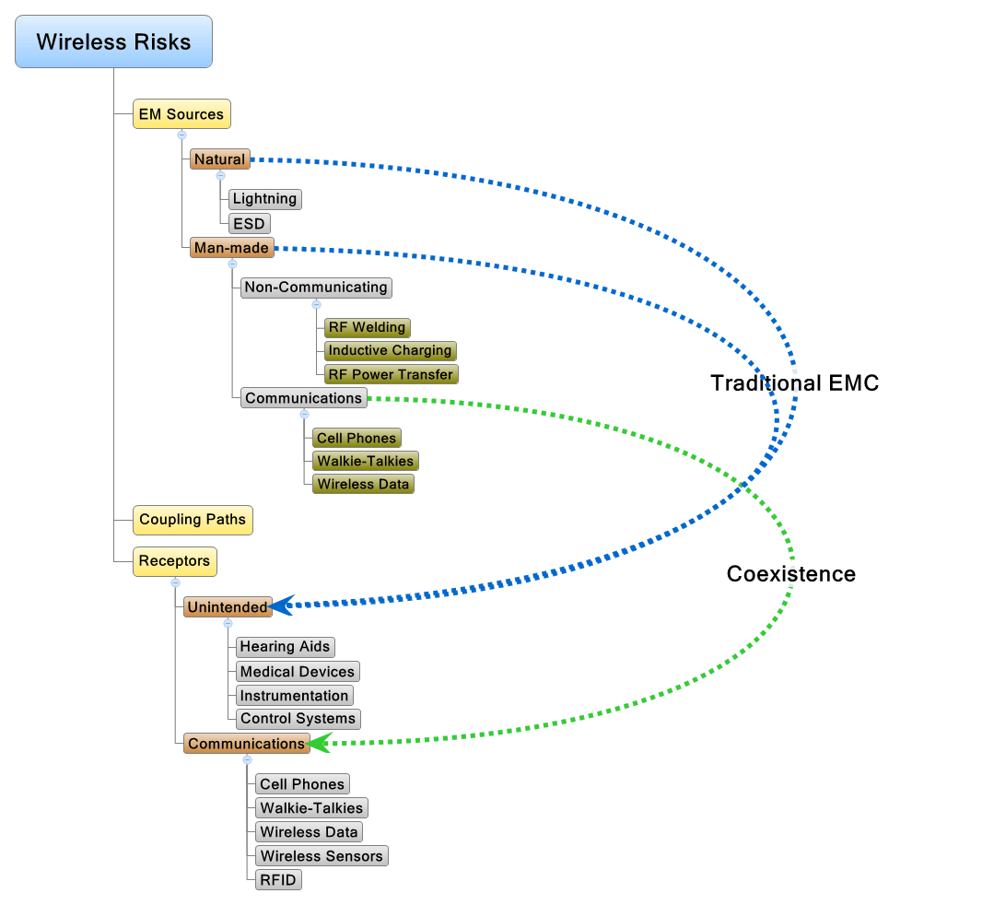
Figure 1 – Possible impacts among wireless devices
Coexistence, the focus of this report, is an issue that has been receiving increased attention. One wireless device can impact another wireless device.
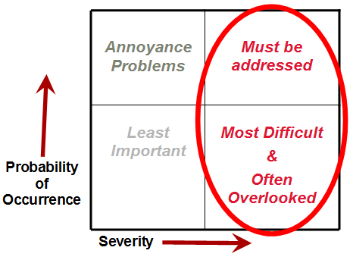
Figure 2 - Wireless Risk Matrix

Wireless risks can be organized as a matrix, created by ranking severity of the consequences on one axis and probability of occurrence on the other. Interference that is both unlikely to occur and has little consequence when it occurs can be ignored. Similarly, even frequent interference that has little impact can be ignored. These events might be annoying but they are not consequential. If they can be easily remedied that might be worth the effort, but otherwise this category of interference is often just accepted.

Most EMC efforts are focused on high probability, high impact events. These must be mitigated because they significantly disrupt other systems. This class of event occurs frequently enough that they demand attention and can be studied and solved. Sometimes tracking down the mechanism requires patience and skill. However, if an event happens often enough and its consequences are bad enough to bring the right resources to bear, then eventually it will be solved.
The hardest class of events to deal with are the “Black Swans”, those low-probability, high-impact events that happen seldom, but they do happen and when they happen terrible things occur. We can all think of electromagnetic “Black Swans”, intentional EMI by someone who wants to disrupt an operation, EMP (electromagnetic pulse), geomagnetic storms, etc. There are several problems with these events. First, they don’t happen often and so it is easy to ignore or explain them away. Second, because they happen rarely we seldom know how much RF immunity is enough. How do you know how bad an EMP pulse might be? Third, putting in protection has a current cost, which might never be needed. Who knows, especially with short life cycle equipment, if a “Black Swan” will come by while it is in service? Nevertheless, some effort must be made in high-reliability systems. Low-probability is not no probability and history teaches us that these events do happen and when they happen the consequences can be enormous.
Figure 3 - Black Swan Events
(Low-Probability, High-Impact)
are the hardest to deal with
A challenge presented in assessing risk is that it is common that a complete analysis cross several traditional boundaries between disciplines. An example that can be found in coexistence debates is a radio system raising the noise floor of another radio system. A metric often used in an increase in the carrier-to-noise, C/N₀, of 1 dB. A rise of 1 dB C/N₀, while potentially measurable is, alone non-consequential. Any radios will vary their C/N₀ by more than 1 dB with no interferer present. So, to get a stable and repeatable result the C/N₀ must be averaged over many measurements. However, when this is done, the result is more a measure of the threshold of detectable impact than anything else. To truly get to consequential impact the analysis must extend through the system to the software, system design and ultimately at what point consequences are created with significant disruption to the operation of the other system. This analysis is of necessity a probability distribution and must be reported as such. At one extreme, a potential receptor system could be operating so close to its limits that a butterfly beating its wings in France will push it over the edge and make the difference between successful and unsuccessful communication. Much more probable is that a system is operating with some margin and a 1 dB loss of that margin will have no observable consequence. The challenge of a coexistence analysis is to specify the probability distribution. Decision makers must then determine if the resulting effects of the wireless service on the system performance meet the risk acceptability criteria.

Shortcomings of laboratory type-testing
For many years EMC engineers have been developing tests and management techniques to manage RF interference. The question is, are these techniques current and adequate for the new technologies and applications using wireless connectivity?
There are several significant shortcomings in the way EMC testing is currently done. Typically, testing is ordered and specified by the manufacturer, without involvement from the end user. At times, end users aren’t even given the test reports. The problem is that the testing mightg have been improperly done or the system under test not appropriately monitored during the test. The monitoring of the system under test is particularly important because if a function is not monitored there could be a failure that would go undetected and unreported. Alternately, the functions monitored might not be correlated to consequential outcomes. When this happens, the extrapolation from lab testing to field experience becomes virtually impossible.
Additional issues
- The test is a type-test. There can be statistical variation between units of the same model.
- Often the unit is a prototype. There can be differences with the finished production model.
- The immunity test signals are simplifications of the actual electromagnetic phenomena.
- The immunity tests expose the EUT to one frequency and one phenomenon at a time. In the actual environment, there are multiple phenomena and multiple frequencies present.
- Immunity of equipment can change with age. The type-tests are performed on new products.
In addition,extrapolation from lab test results to the installed or field performance of a system is one of the most significant and challenging issues. For a system of any size, the installation and laboratory test configurations can be very different. The length of cables and their routing will almost certainly be vastly different. Connectors are likely to be applied for a laboratory test by very experienced technicians or even engineers. In an actual installation, a wider skill level is likely to be involved. A degreed engineer is unlikely to be the one building the cables, while in the lab this can be relatively common. Also, the type of cable used might be different. The actual equipment installed might have differences with the units tested. Certainly there will be manufacturing variance between the equipment installed and the equipment tested.
Particularly when wireless is to be integrated into the plant operation, it is vital that testing be done with involvement from the plant operator. Further additional controls and checks are needed to ensure that the level of immunity demonstrated in laboratory testing is present in the installed system.

Wireless interference
A newer concern is wireless coexistence. Can different wireless devices coexist without disrupting each other? A sub-set of this concern is that as use of the same service grows it could crowd out all the available channels and have problems from its own growing usage.
One radio can interfere with another in a variety of ways, depicted in Figure 4 There are a variety of mechanisms that can cause one radio to disrupt the communications of another, including:
- It is obvious that if two radios are trying to transmit on the same frequency channel there could be problems, unless they are far apart, shielded from each other, or use a collision-avoidance algorithm.
- There can also be interference from a radio operating on an adjacent channel.
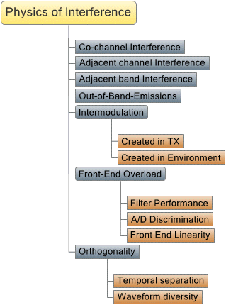
- A radio operating in an adjacent band can cause interference. With adjacent channel interference, the two radios are probably, but not always, operating under the same band service rules and have similar power limits. With adjacent band interference, the devices can be very different, with vastly different power limits. A pernicious problem with adjacent band interference is that the guiding methodology for spectrum management and the resulting service rules can be both different and in conflict. In these cases the issues are more fundamental than the individual devices and really are a result of dissimilar approaches to spectrum management being used too closely together.
Figure 4 - Physics of
wireless-to-wireless interference
- Out-of-band emissions from a device can put spurs into the adjacent band or even a far distant band.
- Intermodulation is a particularly difficult issue. All devices might be operating as intended but some non-linear element, either in the environment, the transmitter or the front end of the receiver can produce mixing products, placing energy into frequencies where no device is intentionally operating.
- A variety of mechanisms in the front end of a receiver can make it susceptible to transmissions from another device. Some of these mechanisms are non-linear, and have little or no effect until the other device is close enough to overload the front end and force it out of its linear range. Filter performance, A/D range and discrimination and linearity are all factors that can influence the sensitivity of a receiver to other transmissions.
- Differing transmissions can be separated in a number of ways. A TDMA scheme can separate transmissions in time. Transmissions can share the same frequencies but separate themselves by differences of encoding or other waveform differences. All of these techniques have limits. They can also be improperly implemented, causing interference under some circumstances. Using techniques to make transmissions orthogonal to each other is very useful for spectral efficiency, but its limits must be considered in a coexistence analysis.
All of these mechanisms get more pronounced as a band becomes more heavily used. Band crowding prevents devices from using frequency channels that are separated from each other in the band. Further, as more devices are using a band, the probabilities of their being used in locations where interference will occur becomes higher, perhaps much higher. For these reasons, and particularly for systems that require a high degree of reliability, it is necessary to evaluate the coexistence potential of wireless services that will be used in close proximity to each other.

Coexistence evaluation
A coexistence evaluation assesses and quantifies the potential of one radio system or wireless service to impact another. lists the elements of a coexistencesevaluation, starting with the analysis phase, continuing to testing and ending with an extrapolation and estimate of field performance.

Figure 5 - Elements of a coexistence evaluation
Coexistence analysis is perhaps the most overlooked and, when it is done at all, poorly done part of the process. IEEE 1900.2, “IEEE Recommended Practice for the Analysis of In-Band and Adjacent Band Interference and Coexistence between Radio Systems” provides excellent guidance on how to structure a coexistence analysis. IEEE 1900.2 was written specifically to guide a coexistence analysis, to make coexistence analysis more objective and supportive of innovation and improved use of the spectrum. It is does not provide testing methodology. So it is a good starting point, but to support a testing effort, some more-specific information must be gathered.
The analysis phase of a coexistence evaluation analyzes the source and receptor characteristics. The transmit power, modulation waveforms and operating modes are identified. The receptor’s operating modes and testing parameters are also gathered. With this information, the analyst can identify the ways and potentially worst-case combination of source transmission for causing interference.
A complete analysis cannot be done without some knowledge of both the source and receptor systems. Receptor systems have different mechanisms that could trigger interference. Some of these mechanisms are sensitive to the peak of the transmission, and if the peak level exceeds the immunity of the receptor, interference occurs. Other mechanisms are sensitive to the average power of a transmission and will be tolerant of high peaks, as long as the average power remains below the receptor’s immunity threshold.
The full task of a coexistence analysis is very complex because there not only might be many modes and waveform variations from the source but various mechanisms to be considered. The situation is further complicated by the fact that from the source side there can be many types of receptors and from the receptor side many types of source devices. Also, there may be multiple source devices of the same type, resulting in additive effects. Some receptors might be sensitive to the instantaneous peak of the transmission while others might respond to the average power. For some receptors, once a threshold is exceeded, interference will result. For others, the interference must continue for a while before it will have a discernable impact on the receptor.
Figure 6 – The analysis step
of a coexistence evaluation
Each of the tasks in the analysis divides into a set of sub-tasks. A complete analysis will provide the worst case and probability distribution of interference or coexistence for each sub-task, supporting a complete statement of both worst case and probability distribution of the completed evaluation Because there are multiple variables involved, any statement about coexistence is contingent on all the relevant variables being within the acceptable range. For example, it is common for the closest, non-interfering distance between the source and receptor to be specified. However, there is no fixed “safe” vs “unsafe” distance. Variables such as the actual transmit power from the source, the relative polarization of the antenna and other factors will increase or decrease the distance at which interference can occur. A complete analysis will account for these factors and estimate or measure their probability distributions.
Figure 7 – Detailed source characteristics analysis
Similarly a complete understanding of the receptor system will detail its modes and variables that impact interference. Its operating moves and functions must be understood. A difficult but important part of the receptor analysis is determining how much of the software will be exercised at each RF presentation. Any significant program will have many modes and function. Within each function are likely to be multiple branches that the software can go through, depending on the details of its execution. It is possible that some circuitry in the receptor is more sensitive to RF interference and only branches of the software that use that area of the circuitry would therefore experience interference. The consequence is that a unit could be tested, even tested many times, but if the functions and branches within those functions that depend on the most sensitive circuitry are not being used during the RF exposure, then a vulnerability might go undetected. Another element to be considered is the time and response characteristics. Generally this means that each frequency and modulation presentation must be maintained long enough for the software to fully complete a cycle.
Once the analysis is complete the actual testing can be planned. In most cases conducted testing will be the most repeatable and stable, compared to radiated testing. Not only is conducted testing more stable and repeatable but it generally can be done at much lower power and does not require a test chamber, greatly simplifying the cost and complexity of testing. Generally conducted testing is preferred to radiated testing when it is possible. However, conducted testing is not always possible. A small device with an embedded antenna might be very difficult to connect to with a coaxial cable, without support from the manufacturer’s design engineers. So at times conducted testing is not possible or has barriers that cannot be overcome for a particular project. So when conducted testing is not possible, then radiated testing is used. The preferred approach is to perform conducted testing and confirm the results with radiated testing. This approach gains the advantages of conducted testing but confirms that the additional variables introduced with radiated testing are included in the final conclusions.

Figure 8 – Detail Receptor Characteristics Analysis
In planning either a conducted or radiated test the transmission characteristics must be planned. The transmit power, or range of transmit power is a critical but far from the only variable. The modulation and variations in the modulation or waveform but be understood and sampled in the testing. The frequency range, frequency step size and dwell time at each frequency step must all be included in the plan.

Figure 9 – Conducted Testing Variables
For the receptor system the functions to be monitored must be identified and monitoring methods planned. The coverage per RF step must also be planned. It will not always be possible to fully exercise a receptor, going through all its functions and modes of operations and using all the paths through its software for each RF presentation. Doing so for most systems is time prohibitive. So the range of operating variability must be studied and careful choices made so that with reasonable dwell time at each frequency step an accurate assessment can be made of the receptor device’s response to that RF presentation.
Radiated testing does have its advantages. Conducted testing assumes that the energy will arrive at the receptor through its antenna and receiver front end. However, in some cases the RF could be coupled through other paths and cause interference. One purpose of radiated testing is to confirm that there are no unexpected coupling paths that allow RF energy from the source to disrupt the receptor. In most cases, when it is possible, most of the testing is done conducted and then the findings confirmed with radiated testing.
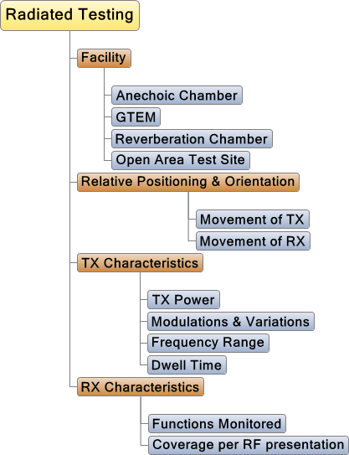

Figure 10– Radiated Testing Variables
The type of test facility is an important consideration. Anechoic chambers, GTEMs, reverberation chambers and Open Area Test Sites (OATS) each have their own strengths and weaknesses. Any of these can be used in a coexistence evaluation and each will offer particular advantages for some tests. However, each type of facility also has it weaknesses and limitations, which must be both understood and addressed in the test plan.
The variables present with conducted testing are all present with radiated tested but new variables are added. Figure 10 introduces the new variables to be considered in radiated testing, but also lists the variables that are common to both conducted and radiated testing One of the new variables is the relative positioning and orientation of the transmitting and receptor antenna The relative positioning and orientation can have a pronounced impact on the test results and must be both understood and controlled in the radiated testing.

Figure 11 – Software and Logic Testing
Software and logic testing becomes very important to fully understand the consequential chain of events. With increasingly packed frequency bands it is not longer viable to claim that any detectable energy from one system in another’s receive path is interference. Although many continue to try and claim that level of protection, ultimately that attempts to defend inferior receiver design that has insufficient filtering and frequency selection. What decision makers really need to know is the range from the earliest detectable energy to unacceptable negative consequences. Typically, before there can be negative consequences other factors must come into play. Software testing helps understand the full complexity and also how well the software can recover from a problem through its error handling.
Error detection and logging will be an increasingly important role. In most cases there will be many near misses for every significant and consequential interference event. It will be important for plant operators to know how much real margin they are operating with. Having good error detection and logging will allow plan operators to know how many near misses they are experiencing. If that number is too high, then remedial actions can be taken, potentially before a consequential event occurs.

Figure 12 – Extrapolation to Field Performance is
one of the most demanding aspects of a coexistence analysis.
The extrapolation to field performance is one of the most challenging aspects of coexistence analysis. Just because interference happens during lab test doesn’t mean that it is immediately known how frequent or sever it will be in actual experience. In a real plant environment there are many additional variables at play that make predicting actual experience from laboratory testing extremely difficult.

Spectrum management
A coexistence evaluation is an important part, but only a part, of a complete spectrum management process. The solution needed when wireless is integrated into a nuclear power plant is a total spectrum management plan which will insure that all the risks from wireless are mitigated, insured to be at or below acceptable levels, checked and confirmed to remain at those low levels. The coexistence evaluation only estimates what the actual experience is likely to be in the actual plant experience. The systems must be monitored and the predictions of the evaluation either confirmed or further action will be required.

Conclusions
Wireless services bring a host of advantages. Increasingly cell phones are our primary means for communication and WiFi the way we connect to the internet, send or receive E-Mail and a host of other useful and entertaining uses. However wireless brings its own set of risks.
In this report a risk evaluation process has been proposed, which allows the risks of wireless interference and coexistence with other wireless services to be evaluated, mitigated and managed.

Annotated Bibliography
- ETSI EN 301 908-14 V5.2.1 (2011-05), IMT cellular networks; Harmonized EN covering the essential requirements of article 3.2 of the R&TTE Directive; Part 14: Evolved Universal Terrestrial Radio Access (E-UTRA) Base Stations (BS)
ETSI EN 301-908-14 contains a number of receiver coexistence tests, including a multiple signal test.

Recommendations

This form may be submitted via E-mail to

*NOTE: Adoptions of an ISO or IEC standards require compliance with ANSI’s Sales & Exploitation Policy.

This form may be submitted via E-mail to

*NOTE: Adoptions of an ISO or IEC standards require compliance with ANSI’s Sales & Exploitation Policy.

