IEEE P 802.19/D0
Date

Draft Guide for Methodology on Evaluating Coexistence.
Sponsored by the
<name> Committee
of the
IEEE <name> Society

Copyright © 2004 by the Institute of Electrical and Electronics Engineers, Inc.
Three Park Avenue
New York, New York 10016-5997, USA
All rights reserved.
This document is an unapproved draft of a proposed IEEE Standard. As such, this document is subject to change. USE AT YOUR OWN RISK! Because this is an unapproved draft, this document must not be utilized for any conformance/compliance purposes. Permission is hereby granted for IEEE Standards Committee participants to reproduce this document for purposes of IEEE standardization activities only. Prior to submitting this document to another standards development organization for standardization activities, permission must first be obtained from the Manager, Standards Licensing and Contracts, IEEE Standards Activities Department. Other entities seeking permission to reproduce this document, in whole or in part, must obtain permission from the Manager, Standards Licensing and Contracts, IEEE Standards Activities Department.
IEEE Standards Activities Department
Standards Licensing and Contracts
445 Hoes Lane, P.O. Box 1331
Piscataway, NJ 08855-1331, USA

Introduction
(This introduction is not part of IEEE P802.19, Guide for Methodology on Evaluating Coexistence.)
See 9.3 of the IEEE Standards 2000 Style Manual for information on the Introduction. Use the heading 1 style for the Introduction and the paragraph style for succeeding paragraphs of text. (See Clauses 1-3 in this template for information about styles.)
A working group list is included in the Introduction, with names listed in alphabetical order, first name followed by last name. Working group names should always be in the member style. In the example below, a lengthy list was broken into three columns. To create columns, use the Section command to break a continuous list into three columns; do not use tabs. Tabs will cause the order of names to change when the text is converted.
NOTE—The list may use one to four columns.

Example:
At the time this standard was completed, the working group had the following membership:

Stephen Shellhammer, Chair

Aik Chindapol
David Cypher
Ian Gifford
Nada Golmie
Robert Heile

Stuart Kerry
Guenter Kleindl
Joseph Levy
Sheung Li
Mike Lynch

Stephen Shellhammer
Tom Siep
Carl Stevenson
Steve Whitesell

The following members of the balloting committee voted on this standard. Balloters may have voted for approval, disapproval, or abstention. (To be provided by IEEE editor at time of publication.)

Contents
Introduction ii
1 Overview 7
1.1 Scope 7
1.2 Purpose 7
1.3 Interference models overview 7
2 Normative references 8
3 Definitions 8
3.1 Discussion of Coexistence 8
4 Background 8
4.1 Past and present methods for interference reduction or coexistence avoidance 9
4.2 Steps to consider for evaluating coexistence 9
4.3 Summary 10
5 Interference Models 10
5.1 Interference Model 1 – Analytical Model 10
5.1.1 Geometric Model 10
5.1.2 Path Loss Model 11
5.1.3 PHY Layer Model 13
5.1.3.1 First order PHY Model 14
5.1.3.2 Simulation based PHY Model 16
5.1.4 Temporal Model 16
5.1.4.1 Temporal Collision 16
5.1.4.2 Probability Calculations Utilizing on SER 16
5.1.4.3 Simplification of Probability Calculations 19
5.1.4.4 Limits of PER Formula 20
5.1.4.5 Probability Calculations Utilizing on BER 20
5.1.4.6 Simplification of Probability Calculations 21
5.1.4.7 Random Pulse Model 22
5.1.5 Step by Step Summary of the Model 22
5.1.5.1 Step 1 – Select a Geometric Model 22
5.1.5.2 Step 2 – Select a Path Loss Model 22
5.1.5.3 Step 3 – Develop Symbol Error Rate Formula 23
5.1.5.4 Step 4 – Develop Temporal Model 23
5.1.5.5 Step 5 – Develop Packet Error Rate Formula 23
5.1.5.6 Step 6 – Calculate and Plot PER and other Performance Metrics 23
5.2 Interference Model 2 – Hybrid Analytical/Simulation Model 24
5.2.1 Interference Model 2 – Hybrid Analytical/Simulation Model – step by step 24
5.2.1.1 Step one 24
5.2.1.2 Step two 24
5.3 Interference Model 3 – Simulation Model 24
5.3.1 Defining Packet Interference: Period of Stationarity 24
5.3.2 Packet level simulation models 24
5.3.3 Digital Signal Processing level simulation models 25
5.3.4 Interfacing packet and digital signal processing models 26
5.3.5 Simulation speedup and model approximations 27
5.3.6 Simulation Scenarios 27
5.3.7 Interference Model 3 – Simulation Model – step by step 27
5.3.7.1 Step one – consider homogeneous set-up 27
5.3.7.2 Step two – consider a heterogeneous set-up 28
5.3.7.3 Step three – write-up 28
5.4 Interference Testing 28
5.4.1 Interference testing – step by step 28
5.4.1.1 Step one 28
5.4.1.2 Step two - baseline tests 30
5.4.1.3 Step three – interference tests 32
5.4.1.4 Step four - Comparison or presentation of results 33
5.4.1.5 Step five – extreme testing 34
5.4.1.6 Step six - modifications 34
5.4.1.7 Step seven - Final presentation / summary 34
5.4.1.8 Miscellaneous 34
5.4.2 Example 35
5.5 Comparison of the models 35
6 Performance Analysis 35
6.1 What to measure 35
6.2 Where to measure? 36
7 Format for the presentation of results 37
8 Examples 37
9 Bibliography 38

Draft Guide for Methodology on Evaluating Coexistence

Overview

Scope
This Coexistence Assurance (CA) Methodology document will describe several methods for predicting the impact of mutual interference on network performance.

Purpose
The purpose of this guide is to provide a standardized method for predicting impact of mutual interference on network performance between dissimilar wireless networks.

Interference models overview
In order to predict the impact of interference it is necessary to build an interference model. Such models can be built at different levels of precision. Modeling and evaluation techniques may be described at several levels of precision. The following are examples of modeling and evaluation techniques.
Interference Model 1 – Analytical Model
This interference model utilizes analytical approximations of the wireless network physical layer (PHY) and Medium Access Control (MAC) sublayer. Since analytical approximations are used the precision of the model is potentially less than the other models; however, the model can be built in less time than the other models.
Interference Model 2 – Hybrid Analytical/Simulation Model
This interference model uses a combination of analytical and simulation techniques. Portions of the PHY and MAC models are based on analytical approximations and portions of the models are based on simulations. This interference model is more detailed than the analytical model but less detailed than the simulation model.
Interference Model 3 – Simulation Model
This interference model is based on simulations of both the PHY and MAC layers of the wireless system. This model is the most detailed model.
Interference Testing
If actual wireless network hardware is available then it is possible to perform testing and experimentation of the impact of interference on network performance. This approach to measuring network performance impact has the advantage of being very accurate; however, also the accuracy of this technique is dependent on the implementation details of the wireless network hardware being used in the testing.

These modeling and evaluation techniques will be described in more detail in later clauses.

Normative references
There are no normative references.

Definitions
Affected Wireless Network – The wireless network whose performance is affected by the presence of the interfering wireless network. (802.19-05/0028r2)
Coexistence - The ability of one system to perform a task in a given shared environment where other systems have an ability to perform their tasks and may or may not be using the same set of rules. (IEEE 802.15.2-2003)
Interfering Wireless Network – The wireless network causing interference. (802.19-05/0028r2)

Discussion of Coexistence
The definition of coexistence defined in clause 3 is the result of countless debates, presentations, and contributions. To some this definition is still insufficient, since it is written in general terms, as is the suggested format for IEEE 802 definitions. It is for this reason that an explanation is necessary.
“The ability of one system to perform a task” is general enough so that it can cover a vast area of abilities, systems, and tasks. “The ability” may be as simple as the ability to send data. “One system” may be viewed as a single layer, a group of layers, or all layers of an implementation. For the IEEE 802 the system will most likely be the physical (PHY) layer and the Medium Access Control (MAC) sublayer. “Perform a task” may be defined to be to send data or to request and receive a connection. All of this would not be of any concern for one system or another if it were not for the fact that this is being done “in a given shared environment.” What this means is that if two systems are not sharing any limited resource, then coexistence is not applicable. However, for example, if a particular environment has two systems using the same radio frequency band (same time, same effective area), then coexistence now becomes an important consideration. “Where other systems have an ability to perform their tasks” means that this is not a one way definition but rather a two way (or possibly multi-way) definition. That is it is not enough to show that one system can perform its task in the presence of another system, but that the other system must be able to perform its task also. Finally, “may or may not be using the same set of rules” covers the various cases for similar and dissimilar systems to operate each according to their prescribed protocols (set of rules).

Background
As more and more heterogeneous wireless systems use the limited resources, means other than international or national regulations and laws are needed to permit current and future usage in an unmanaged, unregulated, wireless world.
Coexistence is a lot more complicated than the simple regulatory issues on power emissions (Electro Magnetic Interference (EMI)) and radio frequency allocations (licensed and unlicensed). These are the brut force and simple methods to avoid coexistence, which are only possible when regulated and enforced. If each system is given a different radio frequency to operate in, then no two systems would ever cause interference of another system because neither would be sharing the same resource. If all other systems must limit their radio emissions below a certain level, then none of these systems would cause interference to the claimed system because the initial system would have been designed to perform in an environment with a level of interference no higher than that stated. However we are all painfully aware that there are not enough radio frequency bands so that every system has its own dedicated band, nor can we limit the radio emissions so that every system is ranked by an emission level.
Even the known methods for measuring and ensuring the above two characteristics are becoming outdated as new methods and applications are carried via wireless means. For example, bit error rate (BER) is a classic measurement that givens information that can be used to develop and improve protocols and systems. However, a BER alone in insufficient when it comes to coexistence. A certain BER may be detrimental to a particular application, but not be for another. Voice data is an example of this. Voice data can be sampled and distributed under the pulse code modulation (PCM), adaptive pulse code modulation (ADPCM), code excited linear prediction (CELP), or any of the other standards or proprietary codings. Each of these will perform differently, some not at all, given certain BERs.
Also because most systems now support multiple applications, the use of a single BER for the system may or may not satisfy all applications. Specifying the worst BER for the application that is most effected by BER, may be over kill, if that application is not the most commonly used application.

Past and present methods for interference reduction or coexistence avoidance
Previous simple solutions to reduced interference or coexistence avoidance were through national and international regulations.
Frequency band allocations were used to divide the limited radio frequency spectrum, thus avoiding coexistence.
Transmitter power was and still is a regulated form of interference reduction and coexistence improvement.
Time division access permits sharing of a limited resource.
Frequency hopping and direct sequence spread spectrum methods are used to reduce interference and to improve coexistence.
Most of these regulations and techniques consider only the electromagnetic interference from a radio spectrum point of view. This is just the beginning of other methods and techniques for coexistence, since these radio effects eventually affect the MAC sublayer and other higher layer protocols.

Steps to consider for evaluating coexistence
The follow describes briefly the steps necessary for evaluating coexistence.
The first step in evaluating coexistence starts by identifying at least two systems that you want to examine.
Once at least two systems are identified, then one needs to identify what resource is being shared. In most cases this is the wireless resource. If the two systems do not share a resource, then no further examination is needed.
After two systems, which share a common resource, have been identified, one must select the performance metrics that will be used in the further evaluations. Some performance metrics are bit error rate, packet loss, access delay, and throughput. Once the performance metrics are agreed to, then one must determine in which manner these performance metrics will be used. This should be one of the methods described here, so that results may be more easily be compared. Defining usage scenarios and “typical” applications to use needs to be defined next. Some suggestions are topology, transmission power, and traffic distribution. Given all this one can begin to generate results and to quantify the impact of mutual interference on the protocol’s performance.

Summary
By now one should see that coexistence is neither simple to describe nor easy to measure at a high level, rather it is a matter for details and specifics. This brings us to the need for such a guideline. In the following clause we introduce four models and techniques that may be used to evaluate coexistence between and among systems.
Please note that this document does not provide nor is it intended to provide levels or values that will determine whether something is coexistent or not. Only the methods for obtaining the data, which can be used to make such determinations, are described herein.

Interference Models
In order to predict the impact of interference it is necessary to build an interference model. Such models can be built at different levels of precision. Described in the following clauses are several modeling and evaluation techniques at several levels of precision. A table containing a summary of the advantages and disadvantages of each type is presented at the end of this clause.

Interference Model 1 – Analytical Model
A method of estimating the packet error rate caused by interference is introduced. This estimate of the packet error rate is then used to derive estimates of the performance metrics of the network, like throughput and latency. This model can be mixed with other models if portions of the model are not available analytically. For example, if there is not an analytic expression for the symbol error rate (SER) then a simulation can be used to find the symbol error rate, and the results of that simulation can be used in conjunction with the other parts of this model to estimate the packet error rate (PER) and ultimately the performance metrics, like throughput and latency.
The model begins with a geometric model of the affected wireless network and the interfering wireless network. In this model there are typically only two stations in each of these networks; however, a more complex geometric model could be used.
There is a path loss model that is used to estimate the average signal to interference ratio at the affected wireless network. Given transmit power of both the signal and the interferer once can use the path loss model to calculate the signal to interference ratio.
The PHY layer model calculates the symbol error rate (SER) on the affected wireless network as a function of the signal to interference ratio, assuming the interferer is transmitting continuously.
The temporal model converts the symbol error rate into the packet error rate. The interferer is modeled as a pulse generator with known statistical characteristics.
A step by step

Geometric Model
The geometric model describes the location of the nodes for both the affected wireless network (AWN) and the interfering wireless network (IWN). Implicit in specifying the location of the network nodes, is specifying the number of nodes in each network. In this document the simplest configuration is used, in which each network has two nodes. Also, to simplify the analysis it is assumed that one node from each network is nearby a node from the other network and that the other node in each of the networks is farther away. That allows us to focus on the interference between one node of the IWN and one node of the AWN. Figure 1 shows the recommended geometry of nodes for both the AWN and IWN.

Figure 1 : Geometry of Networks
In figure 1, the nodes along the y-axis are the nodes of the affected wireless network (AWN) while the nodes along the x-axis are the nodes of the interfering wireless network (IWN).
The distance L affects the receive signal power level within the affected wireless network. The distances d and e affect the interference power level received at the AWN.
In this geometry, if the distance L is large then the only node in the AWN that is affected by the IWN is the node at the origin. Also, in this geometry, if the distance e is large then the only node in the IWN that affects the AWN is the node at location (d, 0).
The intent of using this geometry is to isolate the interference between one node in the IWN and one node in the AWN. There are two primary distances that can be varied to illustrate the effect of interference. The distance L models the distance between devices in the affected network. For example, L can be used to model the distance between an AP and a non-AP STA if the AWN is an 802.11 WLAN. The distance d models the separation between the closest nodes in the AWN and the IWN. For example, d can be used to model the separation between an 802.11 STA and a WPAN device, which are both mobile and can easily lead to these devices coming within close proximity.

Path Loss Model
The distances in the geometric model can be translated into signal attenuation using a path loss model, which is typically an equation mapping separation distance to attenuation. Several possible path loss models can be used. One path loss model that is recommended for indoor usage is a piecewise linear model that represents free space path loss up to 8 meters and beyond 8 meters is representative of a more cluttered environment. As an example, in the 2.4 GHz band the following path loss formula was used in the 802.15.2 recommended practice.
$$\text{pl}(d)=\left\{\begin{matrix}\text{40}\text{.}2+\text{20}{\text{Log}}_{\text{10}}(d) & 0\text{.}5m<d≤8m \\ \text{58}\text{.}5+\text{33}{\text{Log}}_{\text{10}}\left(\frac{d}{8}\right) & d>8m\end{matrix}\right.$$
Depending on which frequency band the networks are using and what environment they are expected to be used in you may use the appropriate path loss model. The path loss formula is plotted in Figure 2.
By knowing the transmission power of the signal and the distance between nodes in the affected wireless network one can calculate the receive power.
Similarly given the transmission power of the interferer one can calculate the interference power at the affected wireless network.
Using the geometry of Figure 1 we have the following formula for the signal to interference ratio (SIR) in dB, at the station located at the origin,
$$γ=[P_{S}−\text{pl}(L)] −[P_{I}−\text{pl}(d)]$$
Where γ is the signal to interference ratio (SIR) in dB. The transmit signal power is given by P_{S} in dB. The interferer transmit power is given by P_{I} in dB. The distance between the two nodes in the affected wireless network is L and the distance between the two nodes in the interfering wireless network is d. In the above formula it is assumed that only the node in the interfering wireless network closest to the origin impacts the affected wireless network. This could be extended to include the impact of both nodes in the interfering wireless network, in which case there would be different values of the signal to interference ratio based on which node in the interfering wireless network is transmitting.
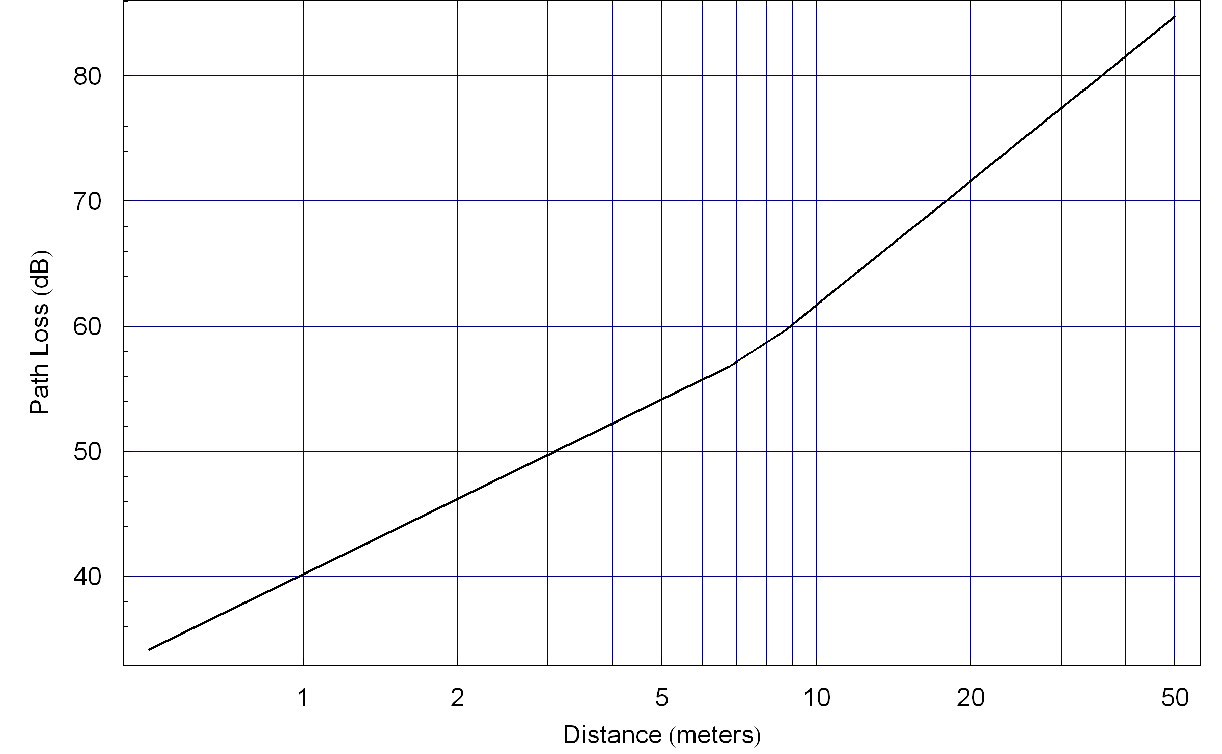
Figure 2 : Path Loss Function

PHY Layer Model
The purpose of the PHY layer model is to calculate the symbol error rate (SER) on the affected wireless network as a function of the signal to interference ratio. If binary forward error correction (FEC) is used then it may not be practical to determine the SER since the error correction is performed at the bit level. Then the PHY layer model calculates the bit error rate after FEC.
In this model it is assumed that the interference is continuous. The temporal model takes into effect the dynamic nature of the interferer.
In the geometric model shown in Figure 1 it is assumed that the packets sent from the station at the origin to the station at location (0, L) are not affected by the interference, and hence have zero (or negligibly small) symbol error rate (SER). So we are only concerned about the SER in packets transmitted from the station at location (0, L) to the station at the origin.
Most wireless packets have a structure as shown in Figure 3, where there is a preamble followed by data.
Figure 3 : General Structure of a Wireless Packet
In most designs the preamble is short and transmitted at a different modulation and coding rate than the data, so that the performance of the transmission is generally limited by the performance of the data portion of the packet. This is somewhat true when considering interference, but not always true. At low SIR the errors typically occur in the data portion of the packet, so it is reasonable to ignore errors in the preamble. At higher SIR there are also errors in the preamble and if the interference only collides with the preamble it would be a mistake to ignore the preamble. In this simplified model we will treat the packet as one homogeneous object to avoid complications. The model could be extended to address the different levels of robustness of the preamble and the data; however, it is not clear that added complexity of the model would lead to dramatically different results. The most conservative approach is to treat the packet as a single homogenous object whose length is the total length of the preamble and the data and whose modulation and coding is the same as the data. This approach is accurate at low SIR, where the data is sent a modulation and code rate comparable to that used in the preamble. A less conservative approach is to ignore the presence of the preamble entirely and only consider errors in the data section. This approach is accurate at high SIR, where the data is sent using a higher order modulation and higher code rate, so the preamble is much more robust than the data.
Figure 4 illustrates the structure of the packet that will be assumed in this model. It consists of a sequence of symbols of equal duration. This is typical of the data section of a packet. The length can be extended to approximately include the effect of the preamble.
The packet consists of N symbols each of duration T. It is assumed that these symbols are sent using a common modulation and code rate.
Figure 4 : Packet Structure
The PHY model assumes that this packet is received by the station at the origin in the geometric model and that continuous interference is received simultaneously.
The PHY model gives an expression for the symbol error rate. Let us introduce a little notation. Let SE be the event that there is a symbol error. Then the symbol error rate is defined as the probability of this event,
$$p=p(γ)=\text{SER}=P(\text{SE})$$
Since this SER will be used frequently we also call it p. It is a function of the SIR but often we will suppress the argument of γ to simplify the notation.
If binary FEC is used it may be more practical to calculate the bit error rate (BER) after FEC. We define the BER after FEC as,
$$p_{b}=p_{b}(γ)=\text{BER}=P(\text{BE})$$

First order PHY Model
The simplest approach that can be used to develop a formula for the symbol error rate is to use an additive white noise approximation. This may be a good approximation in cases of wideband noise and not such a good approximation in other cases. If there is reason to believe this approximation is not accurate to within several dB then a more accurate model may be needed and it is recommended that some PHY layer simulations be used to develop the SER function, as suggested in clause 5.1.3.2. In particular, if binary FEC is used then it is unlikely that an analytic expression is available for the symbol error rate or bit error rate. Hence a simulation-based approach should be used.
In this approach one starts with the symbol-error-rate (SER) function that assumes that the noise source is additive white Gaussian noise (AWGN). So it is only necessary to find the proper conversion so we can use a formula that is based on a signal-to-noise ratio represented as E_{S}/N₀, when we are given the SIR.
The fundamental principal of this approach is to equate the interference power in the receiver, after the receive filter, with the equivalent noise power after the receive filter.
We need to relate the signal energy in a symbol with the symbol power. This relationship is given by,
$$P_{S}=\frac{E_{S}}{T}$$
Next let us look at the noise power after the receive filter. The power spectral density of the noise is N₀/2 for all frequencies. For a symbol period of T the noise equivalent bandwidth of the receive filter is,
$$B=\frac{1}{T}$$
The noise power after the receiver filter is given by,
$$P_{N}=N_{0}B=\frac{N_{0}}{T}$$
We can now express the important ratio E_{S}/N₀ in terms of the signal power and the noise power after the receiver,
$$\frac{E_{S}}{N_{0}}=\frac{P_{S}T}{P_{N}T}=\frac{P_{S}}{P_{N}}$$
Next let us calculate the interference power after the receive filter. This depends on the bandwidth of the interferer. If the bandwidth of the interferer is less than the bandwidth of the receive filter then the power after the receive filter,$P_{I}^{r}$, is the same as the power before the receive filter.
$$P_{I}^{r}=P_{I} \text{if} B_{I}≤B$$
However, if the bandwidth of the interferer greater than the bandwidth of the receive filter then the power after the receive filter is scaled accordingly,
$$P_{I}^{r}=\frac{B}{B_{I}}P_{I} \text{if} B_{I}>B$$
Now the final step is to replace the value of the noise power after the receive filter with the value of the interference signal after the receive filter,
$$P_{N}←P_{I}^{r}$$
Making that substitution we get the following substitution for the important ratio, E_{S}/N₀,
$$\frac{E_{S}}{N_{0}}←\frac{P_{S}}{P_{I}^{r}}$$
Therefore, when the interference bandwidth is less than or equal to the signal bandwidth we have the following substitution,
$$\frac{E_{S}}{N_{0}}←\frac{P_{S}}{P_{I}^{r}}=γ \text{if} B_{I}≤B$$
If however, the bandwidth of the interference is greater than the signal bandwidth need to scale accordingly,
$$\frac{E_{S}}{N_{0}}←\frac{P_{S}}{P_{I}^{r}}=\frac{B}{B_{I}}γ \text{if} B_{I}>B$$
Given this substitution for E_{S}/N₀ in the SER formula using AWGN we now have a SER formula based on SIR.

Simulation based PHY Model
If the there is reason to believe that the first order PHY model would not be accurate to within several dB then it is possible to simulate the receiver in the presence of the interference and develop a series of points on a SER curve. Those points can be used to develop a formula for the SER function using a simple interpolation function.
In digital communication systems with binary forward error correction (FEC) codes it may not be practical to estimate the symbol error rate. This is because before mapping the data into symbols the information bits are converted into coded bits. When a symbol is received in error the decoder attempts to recover the information bits. Hence the appropriate metric is actually the bit error rate (BER) after FEC decoding, which we will often refer to as post-FEC BER.
In particular, if binary FEC is used then a simulation should be used to develop the BER after FEC. The values from that simulation can be used for the BER versus SIR formula. An actual formula can be fit to the data points or an interpolation can be used for value of SIR not calculated in the simulation.
Another common reason for using a simulation-based PHY model is to more easily model channel effects like multipath fading.

Temporal Model
This portion of the model converts from symbol error rate (SER) to packet error rate (PER) by considering the temporal aspect of both the affected wireless network and the interfering wireless network.

Temporal Collision
The packets sent over affected wireless network may, or may not, collide in time with the pulses coming from the interfering wireless network. And when there is a collision, part or all of the packet may collide with an interfering pulse. Figure 5 illustrates a packet collision.
Figure 5 : Illustration of Packet Collision
You can see in this illustration that four of symbols in the packet collide with one of the interference pulses. Clearly, there are other possibilities. There are probabilities associated with the different possibilities. Those probabilities are used to calculate the symbol error rate.

Probability Calculations Utilizing on SER
This clause describes how to set up the packet error rate calculations, utilizing SER. The next clause shows some techniques that can be used to simplify these calculations.
Let us introduce some notation. The packet error event is called PE. The packet error rate (PER) is then the probability of this event,
$$\text{PER}=P(\text{PE})$$
Let M be the number of symbols that collide with an interference pulse. M is a random variable with probability mass function,
$$f_{M}(m) m=0, 1, …N$$
Where N is the number of symbols in the packet. By the principal of Total Probability Error: Reference source not found we can write,
$$\text{PER}=P(\text{PE})=\sum_{m=0}^{N}{P(\text{PE}|m)f_{M}(m)}$$
The conditional probability of not having a packet error is the probability that all the symbols are correct. So the conditional probability of a packet error is one minus the probability of no symbol errors,
$$P(\text{PE}|m)=1−(1−p)^{m}$$
Therefore, the PER formula becomes,
$$\text{PER}=\sum_{m=0}^{N}{[1−(1−p)^{m}]f_{M}(m)}$$
Next we need to find the probability mass function for the random variable M. This probability mass function depends on the duration of the packet, the duration of the interference pulses and the duty cycle of the interference pulses.
In many cases the probability mass function takes on a special form. We will illustrate with two cases.

CASE 1 – Packet shorter than interference pulses
Figure 6 illustrates this case. The figure shows two interference pulses of equal duration. When the packet occurs relative to the interference pulses is a random process. This figure shows three possibilities. In possibility 1 the packet collides completely with one of the interference pulses. In possibility 2 the packet does not collide with an interference pulse. And in possibility 3 the packet partially collides with the pulse. We can relate these cases to the value of colliding symbols. In possibility 1 the number of colliding symbols is N. In possibility 2 the number of colliding symbols is zero. And finally, in possibility 3 the number of colliding symbols is less than N.
Figure 6 : Packet Collision with Packets shorter than Interference Pulses
If the pulses are of fixed duration we can see that the probability mass function will take on a special form,
$$f_{M}(0)=c_{1}$$
$$f_{M}(m)=c_{2} m=1, 2 \text{.}\text{.}\text{.}N−1$$
$$f_{M}(N)=c_{3}$$
There is some probability of no collision. There is also some probability of a full collision. The interesting situation in this case is that the probability of m collisions for m between one and N-1 is constant. When this is true we can simplify our probability calculations, as will be shown in clause 5.1.4.2.
The packet error rate for this case is given by,
$$\text{PER}=c_{2}\sum_{m=1}^{N−1}{[1−(1−p)^{m}]}+c_{3}[1−(1−p)^{N}]$$

CASE 2 – Packet longer than interference pulses
Figure 7 illustrates this case. The figure shows two interference pulses of equal duration. There three cases here are slightly different. Since the packet is longer than an interference pulse there is a maximum number of symbol collisions in the packet. Let us call this number K.
Figure 7 : Packet Collision with Packets longer than Interference Pulses
If the pulses are of fixed duration we can see that the probability mass function will take on a similar form to the previous case. The only difference is that the maximum number of symbol collisions is K not N. We can use this form for both cases, since we can let K be equal to N if appropriate.
$$f_{M}(0)=c_{1}$$
$$f_{M}(m)=c_{2} m=1, 2 \text{.}\text{.}\text{.}K−1$$
$$f_{M}(K)=c_{3}$$
$$f_{M}(n)=0 m=K+1, K+2 \text{.}\text{.}\text{.}N$$
Then the packet error rate is given by,
$$\text{PER}=c_{2}\sum_{m=1}^{K−1}{[1−(1−p)^{m}]}+c_{3}[1−(1−p)^{K}]$$
In the next clause if the probability mass function is uniform over an interval of values of m, a simplified formula for the packet error rate can be used.

Simplification of Probability Calculations
In many of the cases there is a portion of the probability mass function that is uniform. There were two examples shown in the previous clause. In this clause we will show how to simplify that portion of the PER formula.
Let us focus on the term in the PER formula, which we will call α for now,
$$α=\sum_{m=1}^{K−1}{[1−(1−p)^{m}]}$$
The first observation we have is that we can start the summation at m=0 since the argument of the summation is zero for m=0,
$$α=\sum_{m=0}^{K−1}{[1−(1−p)^{m}]}$$
Next we can pull out the constant,
$$α=K−\sum_{m=0}^{K−1}{(1−p)^{m}}$$
Now we can use a standard algebraic identity,
$$\sum_{m=0}^{K−1}{a^{m}}=\frac{1−a^{K}}{1−a}$$
Applying this formula to alpha we get,
$$α=K−\sum_{m=0}^{K−1}{(1−p)^{m}=K−\frac{1−(1−p)^{K}}{1−(1−p)}}$$
Which simplifies to,
$$α=\frac{\text{Kp}−1−(1−p)^{K}}{p}$$
Summarizing, we have the following simplification which we can use in our PER formula,
$$\sum_{m=1}^{K−1}{[1−(1−p)^{m}]}=\frac{\text{Kp}−1+(1−p)^{K}}{p}$$
Therefore, if the PER takes on the form listed (figure out how to add equation numbers) then the PER formula becomes,
$$\text{PER}=c_{2}\frac{\text{Kp}−1+(1−p)^{K}}{p}+c_{3}[1−(1−p)^{K}]$$

Limits of PER Formula
We can investigate the PER formula for several limits and gain insight into the properties of the PER curves under those limiting conditions. The two cases are: very small SER and very large SER.
If we let the SER tend to zero we can easily see the PER tends to zero,
$$\underset{p→0}{\text{Lim}}\text{PER}=0$$
The more interesting case is when the SER gets large. Using the simplified formula for the PER we get,
$$\underset{p→1}{\text{Lim}}\text{PER}=c_{2}(K−1)+c_{3}=1−c_{1}$$

Probability Calculations Utilizing on BER
This clause describes how to set up the packet error rate calculations, utilizing BER. The approach is similar to what was done using SER, however, the formulas do not simplify as nicely. However, this is the approach that is likely to be use when binary FEC is used in the design. The reason for the complexity is that pulses interfere with a group of symbols but after FEC we typically know the BER and not the SER.
Just as before we have a probability mass function for the number of symbol collisions and we use the Total Probability formula,
$$\text{PER}=P(\text{PE})=\sum_{m=0}^{N}{P(\text{PE}|m)f_{M}(m)}$$
Recall that we are conditioning on m symbol collisions. Now since we know the post-FEC BER and not the SER the formula for the conditional PER is a little more complicated.
Let us introduce some notation. The coded bits are mapped to symbols in groups. The number of coded bits in each symbol is N_{CBPS}. The FEC has a code rate which we will call R. Then the number of information bits in each symbol is referred to as N_{BPS}. The number of information bits per symbol and the number of coded bits per symbol are related by the FEC code rate,
$$N_{\text{BPS}}=R N_{\text{CBPS}}$$
We will represent the post-FEC bit error rate as,
$$p_{b}=p_{b}(γ)=\text{BER}=P(\text{BE})$$
We need to determine conditional packet error rate using the BER instead of the SER. The number of information bits in m symbols is m N_{BPS}. The probability of no packet error conditioned on m symbol collisions is the probability that all the information bits encoded in those m symbols are correct,
$$P(\text{PE}|m)=1−(1−p_{b})^{m N_{\text{BPS}}}$$
The PER is then written as,
$$\text{PER}=\sum_{m=0}^{N}{[1−(1−p_{b})^{m N_{\text{BPS}}}]f_{M}(m)}$$
This is a similar but different expression for the PER in terms of SER. The term $(1−p)$ has been replaced by the term $(1−p_{b})^{N_{\text{BPS}}}$.

Simplification of Probability Calculations
This clause is similar to clause 5.1.4.3 where the PER formula using SER was simplified. This clause simplifies the PER formula that utilizes post-FEC BER.
Just as was done with the PER formula using SER, if there is periodic interference pulses we can simplify the PER formula. Assume that the probability mass function of the number of symbol collisions take on the following format,
$$f_{M}(0)=c_{1}$$
$$f_{M}(m)=c_{2} m=1, 2 \text{.}\text{.}\text{.}K−1$$
$$f_{M}(K)=c_{3}$$
$$f_{M}(n)=0 m=K+1, K+2 \text{.}\text{.}\text{.}N$$
Then the packet error rate is given by,
$$\text{PER}=c_{2}\sum_{m=1}^{K}{[1−(1−p_{b})^{m N_{\text{BPS}}}]+c_{3}}[1−(1−p_{b})^{K N_{\text{BPS}}}]$$
We can simplify this formula. As before we focus on the summation term,
$$α=\sum_{m=1}^{K}{[1−(1−p_{b})^{m N_{\text{BPS}}}]}$$
We can add in the term for m=0 without changing anything, and factor out the constant term.
$$α=K−\sum_{m=0}^{K}{(1−p_{b})^{m N_{\text{BPS}}}}$$
Then,
$$α=K−\frac{1−(1−p_{b})^{K N_{\text{BPS}}}}{1−(1−p_{b})^{ N_{\text{BPS}}}}$$
This does not simplify as well as the case when we have the SER, however, we can still write down the PER formula,
$$\text{PER}=c_{2} [K−\frac{1−(1−p_{b})^{K N_{\text{BPS}}}}{1−(1−p_{b})^{ N_{\text{BPS}}}}]+c_{3} [1−(1−p_{b})^{K N_{\text{BPS}}}]$$

Random Pulse Model
The form of the probability mass function for the symbol collisions given previously is straightforward to compute assuming the pulses are of fixed duration with fixed spacing. If however, that is not a good model for the interference pulses then it is possible to model the pulses as a stochastic process of varying pulse duration and varying spacing.
If one cannot analytically calculate the probability mass function for the number of symbol collisions then a short simulation can be developed to estimate the probability mass function. Then that PMF can be utilized in the formula for the PER. It may not be possible to use the simplifications from clause 5.1.4.3; however, the general formula for the PER using total probability still applied and does not require extensive computation time to evaluate.

Step by Step Summary of the Model
This clause summarizes the steps used in estimating the PER and other performance metrics due to interference.

Step 1 – Select a Geometric Model
The first step is to select a geometric model of the two wireless networks. This consists of selecting the number of stations in both the affected wireless network and the interfering wireless network. It also involves selecting the locations of all the stations. It is recommended that if there is one primary station in the affected wireless network that is the station primarily impacted by the interference that this station be placed at the origin. Also in selecting the locations of the stations you are deciding how many stations are impacted by interference and similarly how many stations in the interfering wireless network transmit pulses that may cause measurable interference. There should be one station (or possibly several stations) in the interfering wireless network whose location varies so that the effect of distance between that station and the station primarily affected by the interference can be observed.
Also, there is where any direction antenna aspects need to be considered. Is the transmission from the stations omni-directional or is the gain directionally dependent.

Step 2 – Select a Path Loss Model
Then a path loss model is selected. There is likely a path loss model that has already been considered in the development of the proposed standard under development.

Step 3 – Develop Symbol Error Rate Formula
The next step is to develop a formula for the symbol error rate as a function of the signal-to-interference ratio. This is where the modulation and coding of the affected wireless network are considered. Also, one must consider the bandwidth of the interference relative to the bandwidth of the signal. One needs to consider if the interference is co-channel with the signal or adjacent channel.
There are two basic approaches that can be used in this step. If an analytic expression is available that can be applied then the expression can be used taking into account signal and interference bandwidths. However, in more complex systems it is unlikely an analytic expression is available. But often simulations are available since they are often developed when developing a standard. Using this simulation develop a table for the SER versus the SIR. That table can be converted into an expression for the SER using interpolation of table values as needed.

Step 4 – Develop Temporal Model
The next step is to develop a temporal model of both the affected wireless network and the interfering wireless network.
For the affected wireless network you need to determine the symbol duration and number of symbols in a packet. These parameters may depend on the selection of the modulation and code rate as well as the number of information bits embedded in the packet.
For the interfering wireless network you need to select the duration of the interference pulse. This duration may be a fixed number of a random variable. You also need to select the separation between pulses, which may also be a fixed number or a random variable.
It is simplest to normalize all the durations to multiples of the symbol period. Then all the durations are integer multiples of the symbol period, which simplifies the subsequent analysis.

Step 5 – Develop Packet Error Rate Formula
From the temporal model you then determine the probability mass function for the number of symbol collisions. For fixed pulse durations and pulse separation this can be completed in a straightforward manner as was done in the examples. If the pulse duration and spacing are random variables then a short simulation can be developed to estimate the probability mass function.
Given the probability mass function you develop a formula for the PER in terms of the SER. You should utilize the simplifying expressions of clause 5.1.4.3, if possible.

Step 6 – Calculate and Plot PER and other Performance Metrics
Using the geometric model, you vary the distance parameter specifying the distance between stations in the affected wireless network and the interfering wireless network. Let us call this distance d.
For each value of d
- Calculate the SIR at the station located at the origin
- Using the SIR calculate the SER
- Using the PER formula calculate the PER
Repeat the above steps for a range of values of d and plot the PER as a function of the distance d.

Interference Model 2 – Hybrid Analytical/Simulation Model
This interference model uses a combination of analytical and simulation techniques. Portions of the PHY and MAC models are based on analytical approximations and portions of the models are based on simulations. This interference model is more detailed than the analytical model but less detailed than the simulation model.

Interference Model 2 – Hybrid Analytical/Simulation Model – step by step
To be included

Step one
To be included

Step two
To be included

Interference Model 3 – Simulation Model
In this clause, we describe the methodology to build a simulation environment consisting of detailed models for the RF channel, the PHY, and MAC layers.
These detailed simulation models constitute an evaluation framework that is useful to studying the various intricate effects between the MAC and PHY layers. Although interference is generally associated with the RF channel modeling and measured at the PHY layer, it can significantly impact the performance of higher layer applications including the MAC layer. Similarly, changes in the behavior of the MAC layer protocol and the associated data traffic distribution can play an important factor in the interference scenario and affect the overall system performance.

Defining Packet Interference: Period of Stationarity
For interference to occur, packets must overlap in both time and frequency.
In a system with many interfering systems, there may be interference from more than one packet at any given time. We define a period of stationarity (POS) as the time during which the interference is constant.
During a POS where there is one or more interferers, the number and location of bit errors in the desired packet depends on a number of factors: (1) the signal-to-interference ratio (SIR) and the signal-to-noise ratio at the receiver, (2) the type of modulation used by the transmitter and the interferer, and (3) the channel model.
For this reason, it is essential to use models that accurately characterize the channel and the PHY layer. Just because two packets overlap in time and frequency does not necessary lead to bit errors and the consequent packet loss. While one can use (semi-)analytic models instead, the use of detailed signal processing-based models better allows one to handle multiple simultaneous interferers.

Packet level simulation models
Discrete event packet level simulation models are developed to include the behavior of the transmission protocols considered ranging from layer 2 (MAC) to layer 7 (application).
A wide variety of applications ranging from voice, video, to data (e.g., FTP, email, web browsing, printing and file sharing) are envisioned in a wireless environment leading to the need for a number of traffic models that accurately reflect the application space. Traffic models are generally classified into two categories, mainly: (1) generic, (2) application specific.
Using a generic traffic source captures the non-continuous nature of packet transmission. A simple on-off source often used in the evaluation of network protocols, consists of generating packets of fixed length, packet size, according to an exponential interarrival time, T, that is proportional to the overall medium capacity. The offered load is defined as a portion of the medium data rate. T is given by the following equation:
T = (packet size / data rate)/(offered load).
An alternative to a generic model is to actually include the details of the application and higher layer protocols such as TCP/IP. The advantage of the application specific models is a higher level of fidelity to the application behavior including retransmissions, timeouts, segment size, etc.
Another critical component in the packet level simulation models is the Medium Access Control (MAC) protocol that includes the details of the transmission, backoff, retransmission, acknowledgement, and scheduling procedures.

Digital Signal Processing level simulation models
Digital signal processing level modeling is required to simulate the wireless device physical layer including the transmitter, receiver, and the channel propagation properties.
For a given transmitter inphase and quadrature samples are generated at a certain sampling rate that is chosen to provide several samples per symbol for the technology considered.
The received complex samples from both the desired transmitter and the interferer(s) are added together at the receiver. As before the inphase and quadrature components of these chips are transmitted. The receiver looks at the received symbol and decides which was the most likely transmitted one based on the specifics of the decoder procedure implemented.
The channel model consists of a geometry-based propagation model for the signals, as well as a noise model. For the indoor channel, the following propagation model can be used [Kamerman00]. It consists of two parts: (1) line-of-sight propagation (free-space) for the first 8 meters, and (2) a propagation exponent of 3.3 for distances over 8 meters.
Consequently, the path loss in dB is given by
Equation | Condition
L_{p} = 40.2 + 20 log₁₀ (d) | 0.5 < d <= 8 m
L_{p} = 58.3 + 33 log₁₀ (d/8) | d > 8 m
where
d is the distance in meters.
Assuming unit gain for the transmitter and receiver antennas and ignoring additional losses, the received power in dBmW is
P_{R} = P_{T} – L_{p}
where
P_{T} is the transmitted power also in dBmW.
This equation is used for calculating the power received at a given point due to either interferer or victim transmitters, since this equation does not depend on the modulation method.
The main parameter that drives the PHY layer performance is the signal-to-interference ratio between the desired signal and the interfering signal. This ratio is given in dB by
SIR = P_{R} - P_{I},
where
P_{I} is the interference power at the receiver.
In the absence of interference, the bit error rate for either system is almost negligible for the transmitter powers and ranges under consideration.
To complete the channel model, noise is added to the received samples, according to the specified SNR. In decibels, the signal-to-noise ratio is defined by
SNR = P_{R} - S_{R},
where
P_{R} is the received signal power, and
S_{R} is the receiver's sensitivity in dBmW;
This latter value is dependent on the receiver model and so is an input parameter. A number of noise models including Additive white Gaussian noise (AWGN), multipath fading, can be used to model the noise at the receivers.

Interfacing packet and digital signal processing models
Putting it all together, the packet level simulation models are interfaced to the DSP models in order to provide a complete evaluation platform. The step-by-step simulation process works as follows.
Traffic is generated by sources located above the MAC layer. The message is then passed to the MAC layer where it undergoes encapsulation and obeys the MAC transmission rules.
At the end of each packet transmission, the MAC layer generates a data structure that contains all the information required to process the packet. This structure includes a list of all the interfering packets with their respective duration, timing offset, frequency, and transmitted power. The topology of the scenario is also included. This data structure is then passed to the physical layer along with a stream of bits representing the packet being transmitted. The physical layer returns the bit stream after placing the errors resulting from the interference.
Consider the transmitter-channel-receiver chain of processes in the physical layer. For a given packet, the transmitter creates a set of signal samples that are corrupted by the channel and input to the receiver; interference may be present for all or only specific periods of stationarity.
The physical layer returns the bit stream after placing the errors resulting from the interference. At this point, the MAC layer applies the error correction algorithm corresponding to the packet encapsulation used before deciding whether to accept or drop a packet.

Simulation speedup and model approximations
In order to speed up the simulation process, each transmitter-channel-receiver process can be replaced with a table-based approach combined with a binary symmetric channel. BER tables for different values of SIR and for different frequency offsets can be derived.
To create the table, the curves are sampled for fixed steps in both SNR and SIR.
For a segment of a packet where the interference is stationary, the SNR and SIR are computed using the transmitters' powers, the topology, and the path loss model. Thus, using the calculated SIR and the given frequency offset of the intended signal with respect to the interference signal, the average BER can be extracted by a simple table lookup operation. Errors are then generated for each bit of the packet segment using the binary symmetric channel with crossover probability equal to the average BER of the segment. The SNR in these tables is assumed to be very high (greater than 30 dB), which is the case for interference-limited environments. Still, the software can check this assumption by comparing the SIR to this value.
Using tabulated BER values, as opposed to running the detailed signal processing receiver and channel simulation models in real-time, is expected to give a speed up factor. However, in order to verify that the speedup gained does not jeopardize the accuracy of the results, simulation results for both the MAC and
PHY models should be compared and validated against analytical results for packet loss given different traffic scenarios both types of results should be compared.

Simulation Scenarios
Given the simulation models, the last component of a performance evaluation is to define simulation scenarios including (1) network topologies that define the placement of devices on a two-dimensional grid, (2) usage scenarios consisting of parameters for traffic models (generic or application specific).
For the quantification of interference, a 4-node topology consisting of at least two devices from each wireless technology considered represents the simplest case of interference and constitutes a controlled environment for investigating the effects and the interactions of various parameters. More realistic topologies can also be considered, namely with multiple devices in each system. This interference model is based on simulations of both the PHY and MAC layers of the wireless system. This model is the most detailed model. This model contains both physical layer and MAC sublayer protocol behavior details. This model is used to study a number of “what if” scenarios. Under these “what if” scenarios, one can analyze the effects of mutual interference under various accuracy ranges.

Interference Model 3 – Simulation Model – step by step
This clause contains a step by step approach to creating, modeling, measuring, and gathering information for the simulation model for interference evaluation and performance data collection.

Step one – consider homogeneous set-up
Create a model of the Radio Frequency, Physical layer, and MAC sublayer for the system. Other items to include are models of the expected or designed for traffic and the expected interference models. The expected interference model may be based on experimental measurements or analysis.
All of this is used to create an environment for two communicating systems that is used to measure performance of homogeneous systems. After this is done a baseline is now available for proceeding to the next step.

Step two – consider a heterogeneous set-up
In this step the model created from step one is added to a model from another system. In its simplest form there will be two systems communicating using one model and two other systems communicating using another model. The interference model from step one is now a combined model, which permits in this case, both communications that will act upon each other, possibly as interference.

Step three – write-up
Document the work done and the results collected. See performance analysis clause (6) and format for the presentation of results clause (7) for more information.

Interference Testing
If actual wireless network hardware is available, then it is possible to perform testing and experimentation of the impact of interference on network performance. This approach to measuring network performance impact has the advantage of being very accurate; however, the accuracy of this technique is dependent on the implementation details of the wireless network hardware being used in the testing. This type of testing is vendor implementation specific and there is difficulty in tying results to protocol options and parameters, rather than to implementation decisions. That is why it is critical to provide as much information and documentation as is possible and available. One reason for this is to permit repeatability of the interference testing. The steps that follow present guidance for these.

Interference testing – step by step
Since interference testing with real implementations includes vendor specific implementations decisions, it is a requirement that all of the devices used be explicitly named including, but not limited to (device manufacturer, operating system, version or release number.) In other words, all information necessary in order to guarantee repeatability of the experiments by another must be provided. If the tests are not repeatable, then the information provided by such testing cannot be considered as proper coexistence assurance information, but rather should be considered as vendor marketing information.

Step one
The first steps for interference testing are the gathering of information about the hardware implementations to be used for testing and experimentation, setting of goals for each experiment, defining of the experiment, and measuring of the interference. Above all it is critical to document as much as is possible.
Completing the Coexistence Evaluation Form(s) from annex A may be the first step, since it should help to organize the experiment(s).

Creating a detailed list of hardware and software information
For every implementation a detailed list of information must be created. This list shall contain at least vendor name, product version, and model number of the target system, the interfering system(s), and any monitoring system(s).
The list shall also include the relevant details about the target wireless system’s features and functions. These items are specific to the wireless technology, but at a minimum would include the physical layer used, the MAC sublayer used, and any higher layers used.
The use of the PICS Proforma (if one exists for the wireless technology) for this item would be extremely helpful. The completion of the PICS Proformas for the wireless technologies under investigation would satisfy this step.

Setting goals
For every experiment at least one goal is necessary for any and all tests conducted. The main goal is to show coexistence between a target (i.e., IEEE 802) wireless technology and another (i.e, IEEE 802) potentially interfering wireless technology. This can be extended to all potential interfering (i.e., IEEE 802) wireless technologies.
The always present goal is the testing and measuring of interference of the target system and potential interfering system(s), but specific goals are needed. Some examples of goals are
- A what distance does the target system’s transmitter need to be before the interference is too great for the potential interfering system to be able to complete its task?
- If the transmitter power can be changed, then it is a combination of at what power level and at what distance does the target system’s transmitter need to be before the interference is too great for the potential interfering system to be able to complete its task?
- At what distance does the potential interfering system’s transmitter need to be before the interference is too great for the target system to be able to complete its task?
- If the transmitter power can be changed, then it is a combination of at what power level and at what distance does the potential interfering system’s transmitter need to be before the interference is too great for the target system to be able to complete its task?

Defining of the experiment
The defining of the experiment (or set-up) is crucial in obtaining results. At a minimum this consists of topology configuration, tasks to be done by each system, and measurement points.
a) The topology shall describe the environment in which the tests were conducted. These include, but not limited to, a description of the location (e.g., a room, a hallway, an open field, temperature, existing electromagnetic interference) and the placement and number of the devices from both the target and potentially interfering systems. The more details provided about the topology, the better. However creating an exhaustive list is impractical. Even a list of minimum requirements is not possible because it is case by case, and all prediction of all possibilities is not possible. At a minimum two devices (one transmitter and one receiver) from each system will be needed.
For example: If one were to describe a room, one might give the dimensions, and the placement of objects within that room. However some might say that this is not enough information, and want more like the materials and thickness of the floors, walls, and ceiling. But it might not stop there, one might asked for the amount of wiring in the walls or the temperature of the air within the room. However this information may be completely irrelevant if the room was an anechoic (EMC) chamber.
The placement of the devices may be in two-space or three-space. The details may indicate the distances based on the antenna, but since these are real implementations, if the location of the antenna is not visible, then one could not use it as a measurement point for distances. The critical thing is that all experiments are well documented.
b) A task is specific to the wireless technology(ies) being tested. Some examples of general tasks are:
- the ability to receive a beacon, if the technology supports a beacon(s);
- the ability to establish a connection between transmitting and receiving implementations, if a connection function is included;
- the ability to transfer data;
- the ability to transfer a file (higher layer function);
- the ability to distinguish the intended signal by the receiver in the presence of another wireless technology.
The task selected should be the most likely or typically used task of the particular wireless technology. By selecting and defining the most likely or typical task for the target wireless system provides a bench mark for other coexistence studies (i.e., it begins to build a resource from which others may use). Extreme (or stress) tasks should be considered later (see 5.4.1.4).
It is expected that each wireless technology will define its own specific tasks to be examined because those developing and designing the wireless technology should be the most familiar with the applications and functions for that technology. These specific tasks will be reused by other groups when considering coexistence between this technology and their own.
NOTE: At the time of writing the IEEE 802.11n task group has defined some highly detailed tasks that may be used for coexistence. Since these are specific to 802.11 and are not finalized, they are not contained in this document.
c) The measurement points are the most critical in determining the accuracy of the data collected, however, in most cases the measurement points that would provide the most useful information are not usually available in actual implementations. For IEEE 802, the minimum measurement point would be at the interface between the MAC sublayer and the next higher layer. Another measurement point would be the interface between the MAC sublayer and the physical layer. Whatever the measurement point, one shall define what it is, and what is being measured and how it is being measured (5.4.1.1.4).

Measuring the interference
In clause 6 potential measurement points and items to measure are described. After reviewing that clause it should be determined and recorded what and where the measurements will be collected. Usually for implementation few of these are readily available. However one should strive to select from these, as it will make comparing results easier, than if other measurement points and measurements are taken. It made be necessary to use what is available on the implementations. If there are none of those already described in clause 6, then a full description of the measurements shall be provided.

Step two - baseline tests
Whatever the tests or experiments to be run, baseline tests must be run in order to have a benchmark of results before a potential interfering system is introduced into the environment. At least two sets of baseline tests will be needed. One is for the target system and the other is for the potentially interfering system. This is needed since coexistence is a “two-way street”. Both systems must survive the other’s interference.
These baseline tests should be conducted using the topologies from step one, but have only one of the systems (either the target or the interferer) on and operating. At a minimum this will usually consist of two devices that will communicate with each other. If each device is using a symmetric protocol or acting as a symmetric implementation, then the notion of a transmitter device and a receiving device is not applicable. However if the protocol or devices are not symmetric, then the placement of the transmitting device should be placed in a position that when complete with baseline testing will be closest to the receiver of the opposing system when interference testing is done.
Selection of the baseline tests for each wireless technology should be based on the most likely (typical) operating case. This is done to reduce the amount of testing. For each technology one should test using the following considerations: the expected operating distances, most likely environment, the most likely task or task(s), and the most likely operating functions.
A single set of baseline tests for one of the systems may consist of many individual scenarios, where each of the scenarios is conducted multiple times for statistical purposes (e.g., average, mean, variance). The number of scenarios will be determined by the number of variables that are under test.
For example one set of baseline tests consists of two scenarios where the variables are distance between transmitter and receiver; and the tasks under investigation. The scenario for varying the distance between transmitter and receiver would result in a number of tests where each experiment would be conducted at a different distance between transmitted and receiver. However the task would not change. The scenario for tasks would result in a number of tests where each experiment would be conducted at a fixed distance between transmitter and receiver, while the task was change for each test. The order in which the scenarios are run is unimportant. One could just as easy run all of the task scenarios at one distance and then change the distance between transmitter and receiver, as one would by running distance scenarios for one task and then again for the next task. Either way this would result in a three dimensional array of collected results. The axis labels would be distance between transmitter and receiver, the specific tasks, and results collected for each of the “n” tests at that particular combination.
Figure 1 Legend/Key for the example figures
Figure 2 Topology for baseline experiments
Figure 3 A cube representation of the raw data to be collect for the possible combinations of variables under consideration

Step three – interference tests
Now that the baseline tests are complete and measurements recorded, the interference testing can commence. One repeats the baseline tests, however this time the previously present but inactive system is now active. Do not introduce any variables into these tests that do not have baseline results for.
For example continuing with the example started in the baseline tests. The first interference scenario might look at the target system under the two variables from the baseline tests with the added potential interfering system on and running one of its combinations of distance and task.
Several tests are conducted with these fixed variables for statistical purposes. Then one variable is changed and the whole process starts again. This would continue until all combinations are completed for both the target and the potential interfering systems. The result is a multidimensional array, which is the cross product of the two baseline test results.
Figure 4 Topology of interference testing along with the two cube representations of the two baseline tests

Step four - Comparison or presentation of results
After completing both the baseline and interference tests the results measurements should be compared. The results of the comparison from these tests will be a single data point in the coexistence evaluation. The more points (experiments) the better an understanding of the overall nature of the coexistence of the two technologies.
For example following the running example; you will have two 3-dimensional arrays (one for the target and the other for the potential interfering system) from the baseline tests and two multidimensional arrays from the interference tests. All contain the raw colleted data. The raw collected data can be summarized (e.g, average, mean, or variance for the 1 through n experiments per test). So for the target system at d1 and t1 a benchmark value is obtained. Then using the multidimensional array of raw collected data from the interference tests do the same thing. However since there will exist multiple values for the single d1 and t1 due to the various tests form the potential interfering systems, a graphical comparison may be visually easier to compare.
Based on the results of this comparison (such as possible trends), other tests or experiments may be pursued, (see 5.4.1.6)

Step five – extreme testing
Now that the most likely (typical) tests and experiments have been done, one can begin to conduct extreme testing or stress testing. These tests or experiments are conducted just like the baseline and interference tests. However the goal is for the interfering system to create as much interference as possible, in the hopes of causing so much interference that the target system cannot perform its tasks.
This may be accomplished by increasing transmitter power (if possible), decreasing the distance between interfering transmitter and target’s receiver, increasing the protocol functions (e.g., data transmission) to generate more need for the wireless medium, or increasing the number of similar or different systems.
Some MAC sublayer and physical layer examples of breaking points for a given a task are cannot receive beacons, thus causing the MAC sublayer to declare synchronization lost, which would terminate the communication; so much interference that the clear channel assessment (CCA) fails every time so no data can be transmitted; interference causes enough errors that the bits used to signal the beginning or ending of a frame causes the receiver never to find the beginning or end of a frame; or the interference causes enough bit errors that the cyclic redundancy check (CRC), Frame check sequence (FCS), or header error check (HEC) fails on every received packet.
It is possible that during the interference testing, one may have already encountered an experiment when the interference was enough to cause the target system’s task to fail.

Step six - modifications
The process and basic steps have already been covered, however due to the fact that not all items will apply exactly to every technology, it is important to be flexible. That is if while doing baseline, interference, or stress testing, problems occur or another possibility is thought of, one would then need to correct the problem, and then go back to step one and redoing all of the previous steps. If a new idea for a test is thought of, then document it and go back to step one and follow the process and steps previously defined.

Step seven - Final presentation / summary
Once a battery of tests or experiments have been run and a level of confidence in the results is reach, a final presentation or summary of all of the results should be presented. This will be the collection of data that will be the basis for the determination of coexistence evaluation. See Clause 7 for help.

Miscellaneous
When conducting experiments one should always:
- keep as many variables constant as is possible, except the one you are examining currently. This may be hard to do when real implementations are used, but the goal is still to keep as many of the variables constant as can be controlled.
- keep accurate records and documentation.

Example
For an example of this see annex XX Sample documentation for interference testing.

Comparison of the models
Below is a table that lists some of the advantages and disadvantages of the described models.

Model | Advantages | Disadvantages
Model 1 -Analytical | Simple, uses approximations,  Predicts relative impact of interference in a timely manner,  Intended as a first-order approximation. | Not detailed.
Model 2 – Hybrid Analytical/Simulation | Faster than simulation alone,  Better results than analytical alone. | Not as accurate as simulation alone,  More time needed than analytical alone.
Model 3 - Simulation | Lots of possibilities,  The more detailed the model the better the results. | Lots of possibilities,  Results are only as good as what is modeled,  Resource intensive.
Interference testing | “Real” results. | Results not available until products are developed,  Difficult to tie results to protocol options and parameters,  Results are vender specific.

Performance Analysis
In order to study or evaluate coexistence, performance needs to be defined. That is what items are going to determine whether the system is functioning correctly.

What to measure
Performance metrics must be defined. Some examples of performance metrics are described in the following:
Bit error rate (BER) - number of bits received in error divided by the total number of bits received.
Residual errors – number of bits that remain in error after applying an error correction code (a theoretical value)
Packet error rate - number of packets received in error divided by the total number of packets received.
Packet loss – number of packets lost due to errors divided by the number of packets successfully received.
Access delay – the time it takes to transmit a packet from the time it is passed to the MAC sublayer until it is successfully received at the destination. Generally this accounts for queuing and retransmission(s) delays.
Average access delay – sum of all access delays divided by the number of samples.
Coefficient of delay variance – access delay standard deviation divided by the average access delay.
Access delay probability distribution function (i.e., 95th, 99th percentiles)
End-to-end delay - the time it takes to transmit an “application” layer packet.
Average end-to-end delay – sum of all end-to-end delays divided by the number of samples.
Coefficient of end-to-end delay variance – end-to-end delay standard deviation divided by the average end-to-end delay
End-to-end delay probability distribution function (i.e., 95th, 99th percentiles)
Throughput – the number of bits successfully received divided by the time it took to transmit them over the medium.
Average throughput – total number of bits received at the destination divided by the simulation time.
Goodput – the number of successful packets received at the receiver’s “application” layer divided by the number of “application” layer packets that could be transmitted over the medium.
Average goodput – total number of information bits received at the destination divided by the simulation time.
The term, application layer, may or may not be referring to the application layer as described in the International Organization for Standardization (ISO) Open Systems Interconnection Basic Reference Model (ISO/IEC 7498-1:1994). Instead it is used here as a generic term for a layer higher than then layers under evaluation. For example if the system model only consists of the MAC sublayer, Physical layer, and RF, then the application layer is that layer above the MAC sublayer. On the other hand if the system model consists of those and is using the TCP/IP networking and transport function, then the application layer may be the TCP layer or the layer above. The application layer may mean the application layer (ISO/IEC) when the system model contains all of the intermediary layers. This is further described under the where to measure subclause.

Where to measure?
Given the performance metrics, now one needs to determine where these metrics will be measured. For example for BER most believe this to be relevant only to the physical layer, however there is no requirement that the BER cannot be at a higher layer. It is just by convention that at a higher layer the terms, frame and packet are more convenient.
Since this is IEEE 802, some measurement points are at the physical layer receiver, the physical layer, the interface between the physical layer and the MAC sublayer, at the MAC sublayer, between the MAC sublayer and the nearest upper layer. For IEEE 802.15.1 there are various possible measurement points within the MAC sublayer due to multiple layering within the MAC sublayer.
The more measurement points embedded into the models, then the more useful is data collected. However there is a trade-off because more information means more time to process.

Format for the presentation of results
To easily compare results it is suggest that the results are presented in a consistent format. The following are suggested.
Map parameters to relevant coordinate axis:
For Physical layer: use SNR on the x-axis and plot on the y-axis BER.
For MAC sublayer: use either the offered load or the BER on the x-axis and plot on the y-axis one of the following:
- access delay
- throughtput
- goodput
- packet loss
- coefficient of delay variation

Examples
This clause lists a number of examples that are the basis for the methodologies described.
IEEE 802.15.2 Coexistence of Wireless Personal Area Networks with Other Wireless Devices Operating in Unlicensed Frequency Bands – 2003 shows the results from using the three models (analytical, hybrid, and simulation) as applied to the two wireless technologies: IEEE 802.11 and IEEE 802.15.1.
Annex C of IEEE 802.15.3 Wireless Medium Access Control (MAC) and Physical Layer (PHY) Specifications for High Rate Wireless Personal Area Networks (WPANs) – 2003 shows the results from using an analytical (calculations) model.
Annex E of IEEE 802.15.4 Wireless Medium Access Control (MAC) and Physical Layer (PHY) Specifications for Low-Rate Wireless Personal Area Networks (LR-WPANs) –2003 shows the results from using a hybrid approach.
Annex C of IEEE 802.16.2 Recommended Practice Coexistence of Fixed Broadband Wireless Access Systems – 2001 shows the results from a simulation model.

Bibliography
IEEE 802.11 Wireless LAN Medium Access Control (MAC) and Physical Layer (PHY) Specifications –1999 [Reaffirmed 2003]
IEEE 802.15.1 Wireless Medium Access Control (MAC) and Physical Layer (PHY) Specifications for Wireless Personal Area Networks (WPANs) - 2002
IEEE 802.15.2 Recommended Practice Coexistence of Wireless Personal Area Networks with Other Wireless Devices Operating in Unlicensed Frequency Bands –2003
IEEE 802.15.3 Wireless Medium Access Control (MAC) and Physical Layer (PHY) Specifications for High Rate Wireless Personal Area Networks (WPANs) – 2003
IEEE 802.15.4 Wireless Medium Access Control (MAC) and Physical Layer (PHY) Specifications for Low-Rate Wireless Personal Area Networks (LR-WPANs) – 2003
IEEE 802.16 Air Interface for Fixed Broadband Wireless Access Systems – 2001
IEEE 802.16.2 Recommended Practice Coexistence of Fixed Broadband Wireless Access Systems – 2001

ISO/IEC 7498-1:1994 Information technology -- Open Systems Interconnection -- Basic Reference Model: The Basic Model.

Annex A Coexistence Evaluation Forms
This annex contains coexistence evaluation forms that are to be used for providing a consistent presentation of information. The first is the summary or cover page, which is to be supported by other forms. Other general forms are defined for each of the testing methodologies, task (application), and measurement.
A.1 Summary (i.e., cover sheet)
Summary (Cover Sheet)
Target system:
Potential interfering system(s): |  |  | Interference item:  (shared resource)
Excluded system(s): |  |  | Reason(s):
Check the methodology(ies) that are used to evaluate coexistence
Methodology used: | Analytical | Hybrid |  | Simulation |  | Testing |  | Other
Describe the performance metrics to be collected (attach a separate measurement form for each item listed here.)
Performance metrics to be collected:
What to measure?
Where to measure?
Describe the usage scenario(s) (attach a separate form for each item listed here.)
Describe usage scenario(s)
Describe the task(s) used for testing (attach a separate task form for each item listed here).
Target’s “typical” application
Interferer’s “typical” application

A.2 Methodology forms
For each type of testing, one methodology form should be filled in. Only one methodology in required per system. More testing methodologies may be used to have a more thorough understanding of the interference from difference perspectives.

A.2.1 Analytical Form
Analytical Form
Identification number (AF#)
If analytical methods are use, then provide the methods and/or equations and assumptions
Methods or equations

A.2.2 Hybrid Form
Hybrid Form
Identification number (HF#)

A.2.3 Simulation Form
Simulation Form
Identification number (SF#)
If simulation is used, then provide the name and version of software/hardware used. |  |  |  |  |  |  | Are the simulation models freely available?
Name of Software |  |  | Version of Software

A.2.4 Interference (Implementation) Form
This form contains the detailed information about the implementations used in interference testing. The form assumes that a system (target or interferer) will consist of two implementations and that two systems are need to conduct coexistence interference testing.
Interference (Implementation) Form
Identification number (IF#)
If a system is not composed of two identical devices, please enter the information per implementation.
Manufacturer of target system
Manufacturer of target system
Other details
Manufacturer of potential interfering system
Manufacturer of potential interfering system
Other details

A.3 Task Form
The task form is used to specify the details about the task that is being used in the testing. Use one form for each task. Since there may be more than one task defined, space for a task number is provided, as is space for a mnemonic. Space for a full text description of the task, as well as a quantitative description, are provided.

Task Form
Task number |  |  | Mnemonic
Technology
Task description
Characterize task (quantitative)

A.4 Measurement points Form
The measurement form is used to define the measurement points for testing. Use one form for each measurement.

Measurement Form
Measurement number |  |  | Mnemonic
Technology
Measurement description
Characterize measurement point (quantitative)

A.5 Experiment /topology form
For each individual test one would fill out one of these forms.
Experiment /Topology Form
Goal:
Test procedure:
Topology: | (Insert figure or grid layout)
Target system
Summary of target system information |  |  | Use serial number of Interference (Implementation) Form for the system details
Task
Task number |  | Task Mnemonic
Measurement points
Attached forms | Task |  | Measurement
Potential Interfering system
Summary of interfering system information |  |  | Use serial number of Interference (Implementation) Form for the system details
Task
Task number |  | Task Mnemonic
Measurement points
Attached forms | Task |  | Measurement

Annex XX Sample documentation for interference testing
This annex contains a sample example of the documentation to be generated when evaluating the coexistence of a target system (i.e., 802.15.4) and a (or all) potentially interfering system(s) (e.g., IEEE 802.11).
First complete all relevant Coexistence Evaluation Forms from Annex A. Since each technology will most likely have its own specific points of interest, the coexistence evaluation forms presented in Annex A are for general purposes. Once a new and more specific form is created for the technology, it will be available for others to use.
Since not all standards have PICS Proformas, they cannot be required. However, if a PICS proforma is available it should be used. In this example both are available.
Sample answers using the PICS Profroma from IEEE 802.15.4-2003 and IEEE 802.11b.
IEEE 802.15.4 PICS Proforma (selected items)
- FD1 (FFD) Yes supported for the data collection implementation
- FD2 (RFD) Yes supported for sensor
- RF2 (2450 MHz) Yes for both devices
- PLF8.1 (CCA Mode 1) Yes for both devices
IEEE 802.11 PICS Proforma (selected items)
- CF1 (Access Point) Yes supported for one device
- CF2 (Independent station) Yes supported for one device
- CF4 (DSSS) Yes supported for both
Sample Test/experiment
With this plan we begin by running baseline tests (Step 2). One baseline test will be needed to record the measurements from the 802.15.4 communication when the 802.11b device are present, but not powered on. Several baseline tests will be needed for 802.11b, since the distance between STA and 802.15.4 data collection device is the variable in this particular experiment. Select the placement of the STA and transfer the file and record the measurements, while the 802.15.4 devices are powered off.
Now run the interference experiment as described (Step 3).
Compare the measurements between the baseline tests and the interference tests (step 4).
Since we cannot control any of the features in the 802.15.4 devices, there are no extreme tests of interest, so on to Step 6. Step 5 is not covered in this particular case, or might have been covered under normal testing.

From the experiments just completed we decided to conduct another test (Step 6) by switching the locations of the 802.15.4 RX and TX, to see if this has any effect on the measurements. This requires us to go back to Step 1, because new baseline tests need to be run.
Upon completing the first set of tests and the modified tests we feel confident in the results and we create a presentation and summary (Step 7) of this work as a basis for coexistence evaluations.
XX.1 Summary (i.e., cover sheet)
Summary (Cover Sheet)
Target system: | IEEE 802.15.4
Potential interfering system(s): | IEEE 802.11, 11b, 802.15.1, 802.15.3 |  | Interference item:  (shared resource) |  | Frequency band 2450 MHz
Excluded system(s): | IEEE 802.16,  IEEE 802.11a |  | Reason(s): |  | Not within operating frequency band of target system
Check the methodology(ies) that are used to evaluate coexistence
Methodology used: | Analytical | Hybrid |  | Simulation |  | Testing  XXXXX |  | Other
Describe the performance metrics to be collected (attach a separate measurement form for each item listed here.)
Performance metrics to be collected: | Delay to transmit data;
What to measure? | Access delay
Where to measure? | The MAC sublayer and upper layer interface
Describe the usage scenario(s) (attach a separate form for each item listed here.)
Describe usage scenario(s) | A sensor network consisting of two devices: one is the sensing device (TX) and the other is the data collection device (RX) with a minimum distance of 8 meters between devices.
Describe the task(s) used for testing (attach a separate task form for each item listed here).
Target’s “typical” application | Sensor data: transmission of one MAC data frame at 50 bytes MAC sublayer payload every second. No control over changing the parameters for this function.
Interferer’s “typical” application | If more than one “typical” application, then one test for each.

XX.2 Methodology forms
For each type of testing, one methodology form should be filled in. Only one methodology in required per system. More testing methodologies may be used to have a more thorough understanding of the interference from difference perspectives.

XX.2.1 Analytical Form
Analytical Form
Identification number (AF#)
If analytical methods are use, then provide the methods and/or equations and assumptions
Methods or equations

XX.2.2 Hybrid Form
Hybrid Form
Identification number (HF#)

XX.2.3 Simulation Form
Simulation Form
Identification number (SF#)
If simulation is used, then provide the name and version of software/hardware used. |  |  |  |  |  |  | Are the simulation models freely available?
Name of Software |  |  | Version of Software

XX.2.4 Interference (Implementation) Form
This form contains the detailed information about the implementations used in interference testing. The form assumes that a system (target or interferer) will consist of two implementations and that two systems are need to conduct coexistence interference testing.
Interference (Implementation) Form
Identification number (IF#)
If a system is not composed of two identical devices, please enter the information per implementation.
Manufacturer of target system |  | A (RFD) |  |  |  | Version |  | 1.0
Manufacturer of target system |  | A (FFD) |  |  |  | Version |  | 1.0
Other details |  | A Reduced Function device (sensor) and a Full Functional Device (data collection device).
Manufacturer of potential interfering system |  | B (laptop) |  |  |  | Version |  | 5.3.2.1
Manufacturer of potential interfering system |  | B (Access point) |  |  |  | Version |  | 5.3.2.1
Other details |  | Built-in to laptop and standalone access point.

XX.3 Task Form
The task form is used to specify the details about the task that is being used in the testing. Use one form for each task. Since there may be more than one task defined, space for a task number is provided, as is space for a mnemonic. Space for a full text description of the task, as well as a quantitative description, are provided.

Task Form
Task number |  |  | Mnemonic
Technology
Task description
Characterize task (quantitative)

XX.4 Measurement points Form
The measurement form is used to define the measurement points for testing. Use one form for each measurement.

Measurement Form
Measurement number |  |  | Mnemonic
Technology | 802.15.4
Measurement description | The measurements taken from the 802.15.4 data collection device are the receptions or non-receptions of the periodic readings and their contents.
Characterize measurement point (quantitative) | Number of packets received from the MAC sublayer to the upper layer

XX.5 Experiment /topology form
For each individual test one would fill out one of these forms.
Experiment /Topology Form
Goal: | At what distance does the potential interfering system’s transmitter (IEEE 802.11b STA) need to be before the interference is too great for the target system’ receiver (IEEE 802.15.4 data collection device) to be able to complete its task (send/receive sensor data)?
Test procedure: | The target system will consist of two devices implementing 802.15.4 and two devices implementing 802.11b. The distance between the target system will be 8 meters. The distance of the Access Point (AP) from the 802.15.4 RX will be 15 meters. The 802.11b STA will be placed at 0.5 meters intervals between the AP and the 802.15.4 RX. Measurements will be taken at all intervals. The 802.11b STA will be transmitting the bulk of the data by transferring a large file using the file transfer protocol (FTP). The 802.15.4 will be taking periodic (we have no control whatsoever on the sensing device) sensor readings and transmitting them to the data collection device.
Topology: | (Insert figure or grid layout)
Target system | 802.15.4
Summary of target system information |  |  | Use serial number of Interference (Implementation) Form for the system details
Task
Task number |  | Task Mnemonic
Measurement points
Attached forms | Task |  | Measurement
Potential Interfering system | 802.11b
Summary of interfering system information |  |  | Use serial number of Interference (Implementation) Form for the system details
Task
Task number |  | Task Mnemonic
Measurement points
Attached forms | Task |  | Measurement

Annex YY Examples of Analytical Model Calculations
The examples given here are chosen to illustrate the process. They are not specific standard but rather simple examples that can be used to explain how the methodology works.
The first example is a binary phase shift keying (BPSK) system with interference pulses of the same duration as the BPSK packets.
The second example is an extension of the first example, where the modulation is extended to use higher order quadrature amplitude modulation (QAM), where the number of bits in the packet remains the same. This demonstrates two effects: the effect of using a higher order modulation requiring higher signal-to-interference ratio and the effect of shorter packets leading to lower probability of collision.
YY.1 Example 1 – BPSK with Periodic Interference Pulses
This example consists of two wireless networks, each with two stations. The geometric model is that given in Figure 1, with the distance between stations in the affected wireless network is L = 30 meters. In this example, the affected wireless network is a WLAN-type network with one access point and one mobile station. It is assumed that the station at the origin is the mobile station and the other station is the access point. The interfering wireless network is a WPAN-type network with two mobile stations. We will use the simplifying assumption that only the network closes to the origin has any appreciable interference on the affected wireless network. Similarly, it is assumed that the only station in affected wireless network that is affected by the interference is the station at the origin.
In this example the affected wireless network is transmitting at 20 dBm using binary phase shift keying (BPSK). Each packet contains 128 Kbytes or 1024 bits. The packets are being transmitted from the AP to the mobile station at the origin. It is assumed that the acknowledgements sent from the mobile unit to the AP arrive unaffected by the interference due to distances involved.
The interfering wireless network is a WPAN-type network which transmits at 0 dBm. The interference wireless network is transmitting pulses of duration exactly the same as the packets sent by the affected wireless network. We will only consider pulses sent by the station closest to the origin, and will assume that any pulses sent by the other station do not cause significant interference. We will assume that the pulses are sent at regular intervals with a 25% duty cycle. Figure 8 illustrates the timing of this example.
Figure 8 : Timing of Packets and Interference Pulses in Example 1
In this example we assume that we have co-channel interference with the same bandwidth (or smaller) than the bandwidth of the signal. So we can set the SIR to be equal to the SNR in the formula for the symbol error rate of BPSK. The SER formula for BPSK is,
${\text{SER}}_{\text{BPSK}}=Q [\sqrt{2γ}]$ ()
Where the Q function is the integral of the tail of a normalized Gaussian probability density function,
$Q(x)=\frac{1}{\sqrt{2π}}\int_{x}^{∞}{\text{exp}(\frac{−y^{2}}{2}}) \text{dy}$ ()
The BPSK symbol error rate is plotted in Figure 9 as a function of the SIR.
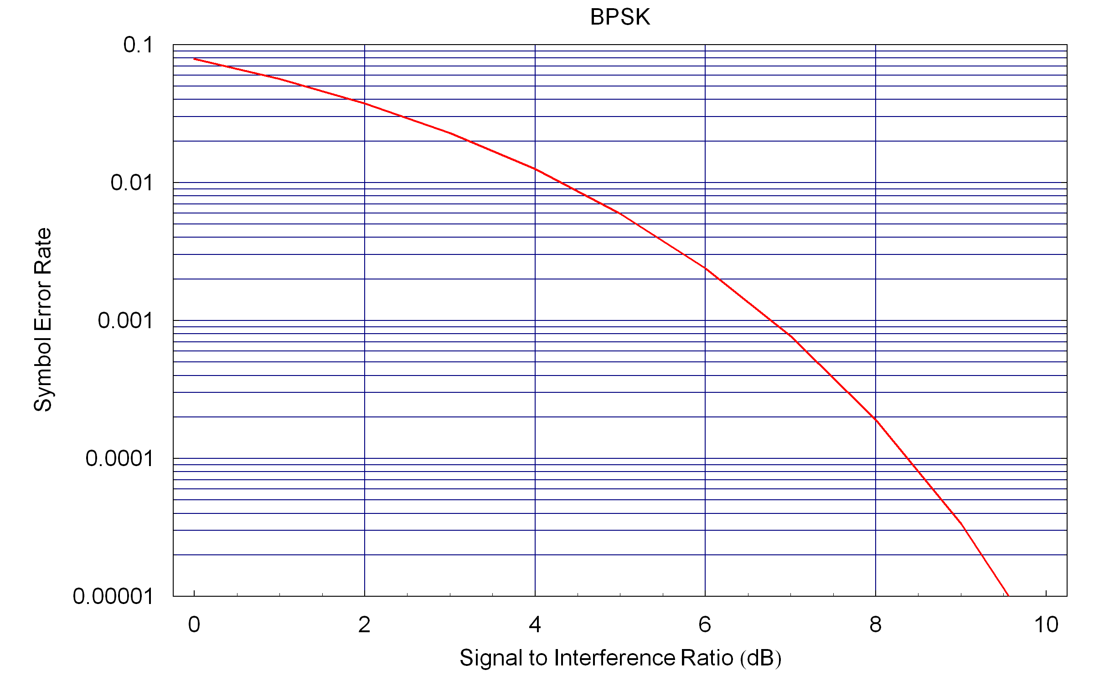
Figure 9 : BPSK Symbol Error Rate
The symbol error rate must be converted into packet error rate using the Total Probability expression, which requires the probability mass function for the number of symbol collisions. The duration of the packet is 1024T, where T is the symbol period. The duration of the interference pulse is also 1024T. The spacing between pulses is 3072T, since there is a 25% duty cycle. We need the probability mass function of the number of symbol collisions (M), which takes on values between zero and 1024.
It is easiest to use the discrete time reference and allow the packet to begin on any one of 4096 possible offsets from the beginning of a pulse. This assumes a uniform distribution of when the packet can occur, which is a reasonable assumption.
The probability of all 1024 symbols colliding is one in 4096 so we have,
$f_{M}(\text{1024})=\frac{1}{\text{4096}}$ ()
The probability of collision for other non-zero values turns out to be twice that value. This can be seen by shifting one symbol to the right and one symbol to the left, which both result in a collision of 1023 symbols. So we have,
$f_{M}(m)=\frac{1}{\text{2048}} m=1, 2, …\text{1023}$ ()
And that leaves the probability of no symbol collisions as what is remaining. Thus the probability of no collision is,
$f_{M}(0)=\frac{\text{2049}}{\text{4096}}$ ()
If we substitute these values into the calculation we developed in clause 5.1.4.2 we get,
$c_{1}=\frac{\text{2049}}{\text{4096}} c_{2}=\frac{1}{\text{2048}} c_{3}=\frac{1}{\text{4096}}$ ()
The resulting PER formula is,
$\text{PER}=\frac{1}{\text{2048}}\frac{\text{1024}p−1+(1−p)^{\text{1024}}}{p}+\frac{1}{\text{2048}}[1−(1−p)^{\text{1024}}]$ ()
We then apply the path loss formula given in clause 5.1.2, use the power calculations to calculate the SER (p) and substitute this into the formula for the PER. Figure 10 shows the resulting PER curve for this example.
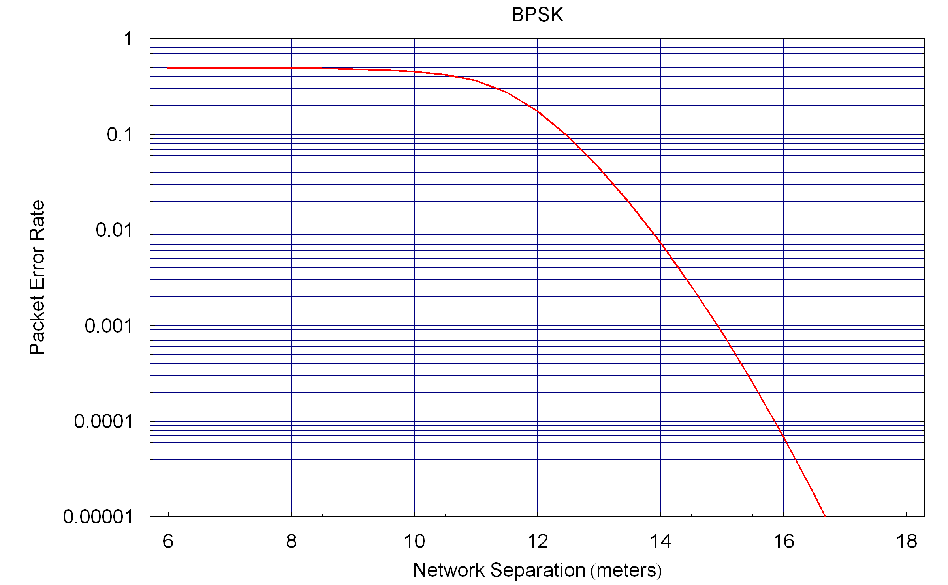
Figure 10 : PER Curve for Example 1
From this example we can observe that at large separation there is low PER, as would be expected. As the separation is reduced the PER grow and finally reaches a limit. This suggests two interesting figures of merit. How close the networks can get before the PER starts to become significant (which is a matter of opinion and application) and the maximum PER as the networks get very close. These two parameters are illustrated in Figure 11.
Figure 11 : Illustration of Coexistence Figures of Merit
Based on this illustration we would suggest two coexistence figures of merit, for this scenario. One would be the separation between networks at which point there is a 1% PER. The other would be the maximum PER. We can derive the maximum PER using the limiting formula for the PER. In this example we get,
$\underset{p→1}{\text{Lim}}\text{PER}=1−c_{1}=\frac{\text{2047}}{\text{4096}}≃\frac{1}{2}$ ()
YY.2 Example 2 – QAM with Periodic Interference Pulses
This example is an extension of the previous example, where we include higher order quadrature amplitude modulation (QAM). In addition to BPSK we include quadrature phase shift keying (QBSK), QAM with 16 symbols (16QAM) and QAM with 64 symbols (64QAM).
The symbol error rate formula for the QPSK is,
${\text{SER}}_{\text{QPSK}}=1−[1−Q (\sqrt{γ})]^{2}$ ()
The symbol error rate formula for the 16QAM is,
${\text{SER}}_{\text{16}\text{QAM}}=1−[1−\frac{2}{3}Q (\sqrt{\frac{3}{\text{15}}γ})]^{2}$ ()
The symbol error rate formula for the 64QAM is,
${\text{SER}}_{\text{64}\text{QAM}}=1−[1−\frac{\text{15}}{8}Q (\sqrt{\frac{3}{\text{63}}γ})]^{2}$ ()
The SER curves for the four modulations used in this example are given in Figure 12,
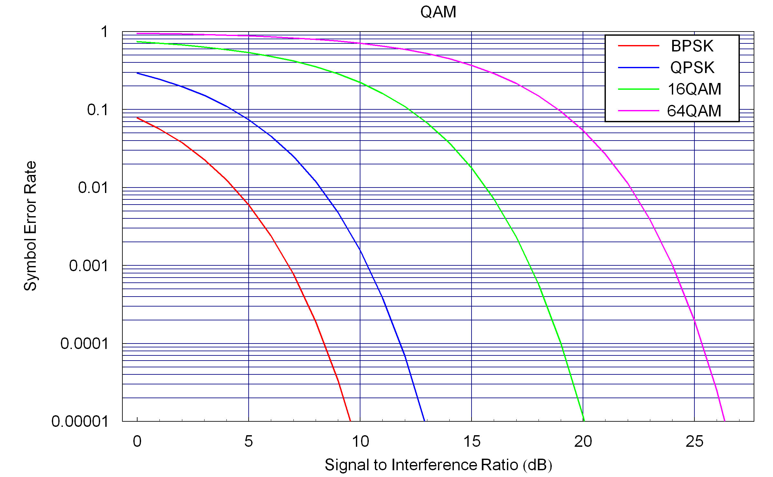
Figure 12 : SER for BPSK, QPSK, 16QAM and 64QAM
To convert from SER to PER we need the probability mass function of the number of symbol collisions. We will show how to derive the PMF for the QPSK packet. The extension to the 16QAM and 64QAM is straightforward.
In this example, we fix the number of bits in the packet at 128 Kbytes, so as we increase the modulation order the number of symbols decreases. For QPSK there are 512 symbols. Figure 13 illustrates the timing for QPSK in this example.
Figure 13 : Timing of Packets and Interference Pulses in Example 2 for QPSK
In this case of QPSK with 512 symbols, of the 4096 possible offset there are 513 that result in all 512 symbols colliding with the interference pulse, therefore we have,
$f_{M}(\text{512})=\frac{\text{513}}{\text{4096}}$ ()
For m equal to any number between one and 511, of the 4096 offsets there are two possible cases of m symbol collisions, therefore we have,
$f_{M}(m)=\frac{1}{\text{2048}} m=1, 2, …\text{511}$ ()
Finally, by knowing these values of the PMF we can find out the value at m=0, so we have,
$f_{M}(0)=\frac{\text{2561}}{\text{4096}}$ ()
The same process can be applied to the 16QAM which has 256 symbols and 64QAM which has 128 symbols.
The resulting PER curves for all four modulations is show in Figure 14.
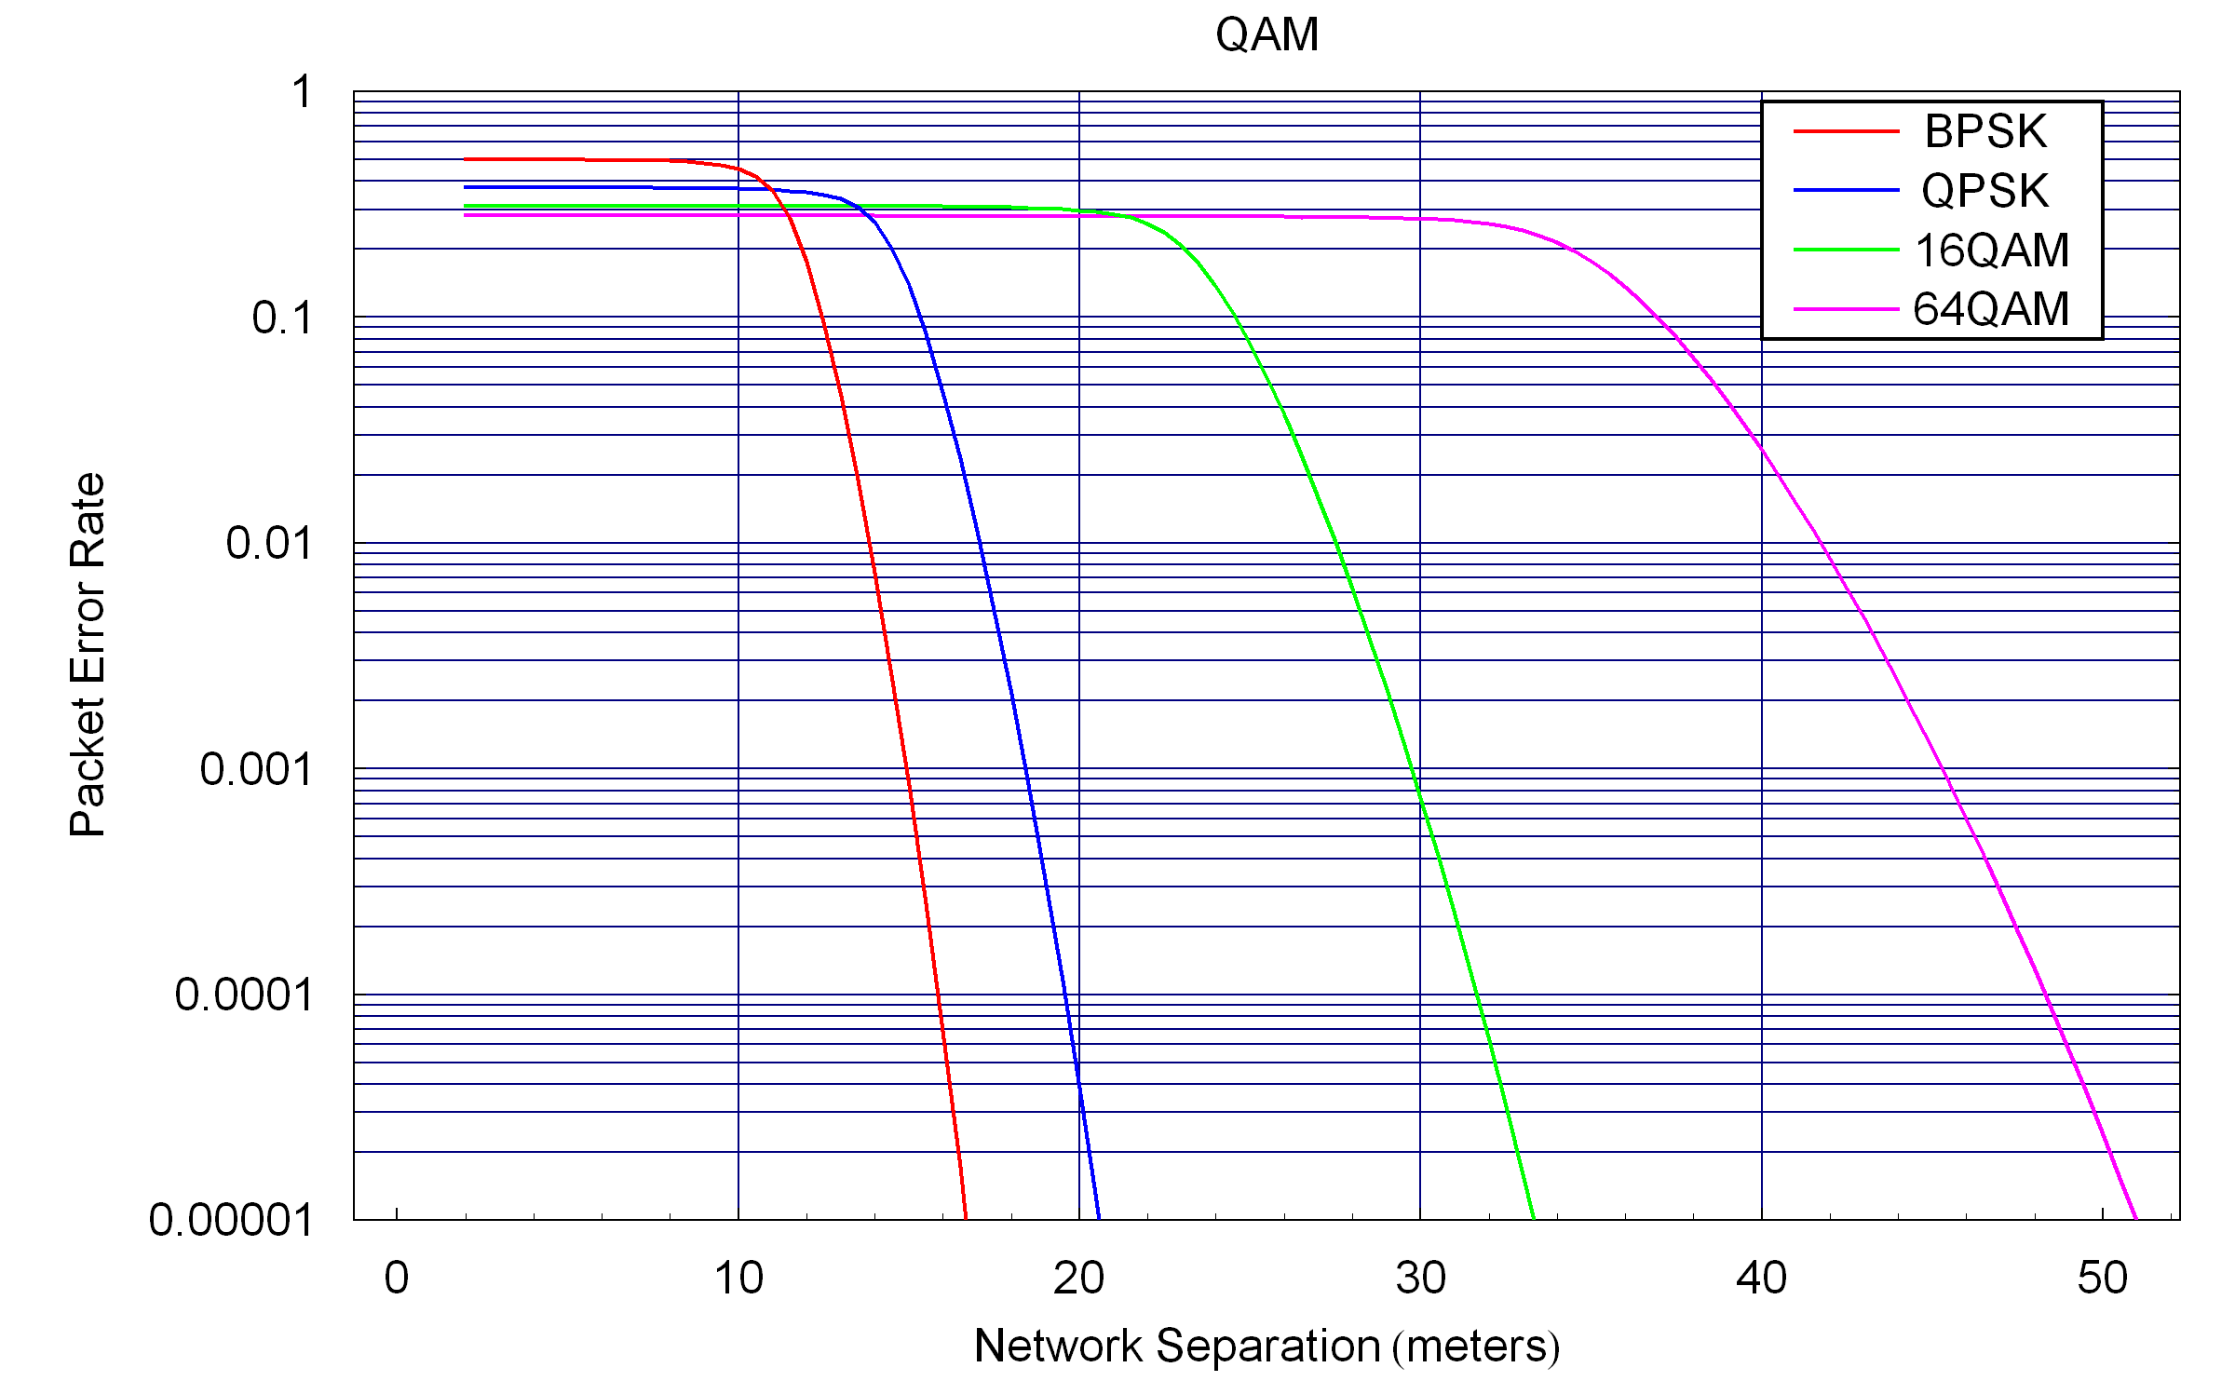
Figure 14 : PER Curve for Example 2
From this figure we can see that as we use higher order modulation the distance at which the interference has an impact is larger. However, in this example since we kept the number of bytes in the packet fixed, the duration of the packet decreased. This results in a lower value for the maximum PER value.
The two proposed figures of merit (1% PER distance and Max PER) are listed in Table 1 for the four cases.
 | 1% PER Distance (meters) | Maximum PER
BPSK | 13.8 | 0.499
QPSK | 17.1 | 0.374
16QAM | 27.5 | 0.312
64QAM | 41.7 | 0.281
Table 1: Figures of Merit for Example 2
YY.3 Example 3 – BPSK with Random Interference Pulses
This example is similar to Example 1 using BPSK but instead of using fixed interference pulse durations and pulse separation the pulse duration and separation are random variables. In order to enable comparison with example the average value of these two random variables are selected to be the same as the fixed values in Example 1.
The pulse width is a uniform random variable between 512T and 1536T. The spacing between pulses is uniformly distributed between 2048T and 4096T. Hence the average pulse duration is 1024T and the average spacing between pulses is 3072T, just as in Example 1.
For this example the probability mass function of the number of symbol collisions, M, was determined through simulation. The cumulative distribution function was calculated based on the PMF. This was also done though simulation for Example 1 and the results were consistent with the theoretical values.
The cumulative distribution function for the number of symbol collisions is plotted in Figure 15 for both Example 1 and Example 3. You can see that the CDF of the two examples are similar but with some differences.
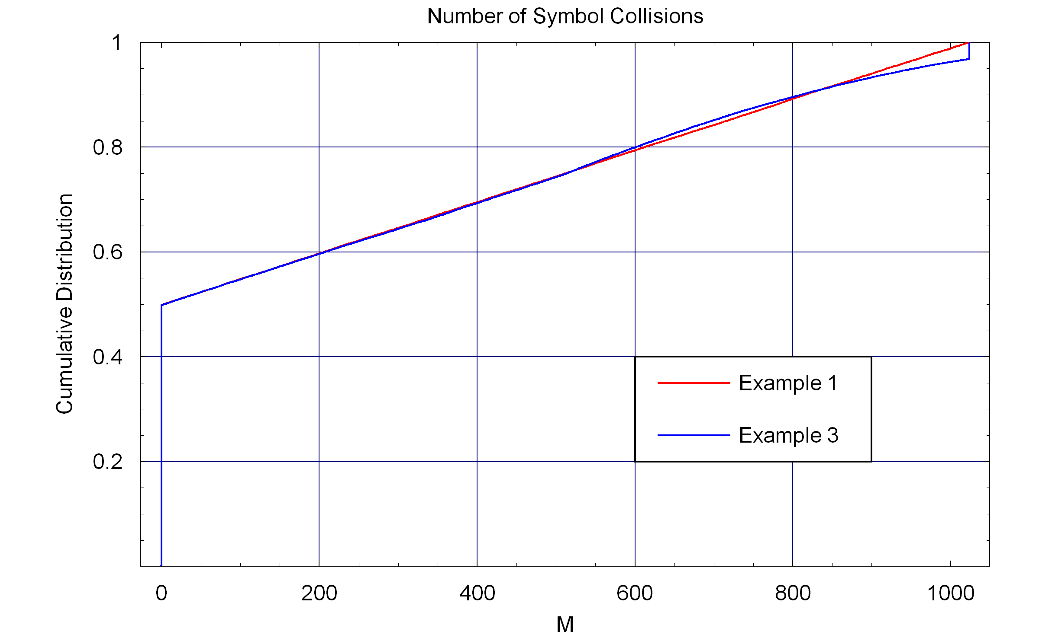
Figure 15 : Cumulative Distribution Function for Number of Symbol Collisions
Since the CDF for these two examples are similar we expect the PER curve to be similar. The PER curves for both examples are shown in Figure 16. We see that the two curves are almost identical. This gives us an indication that in many cases we can use the periodic model and the resulting PER curve will not differ significantly from the random model.
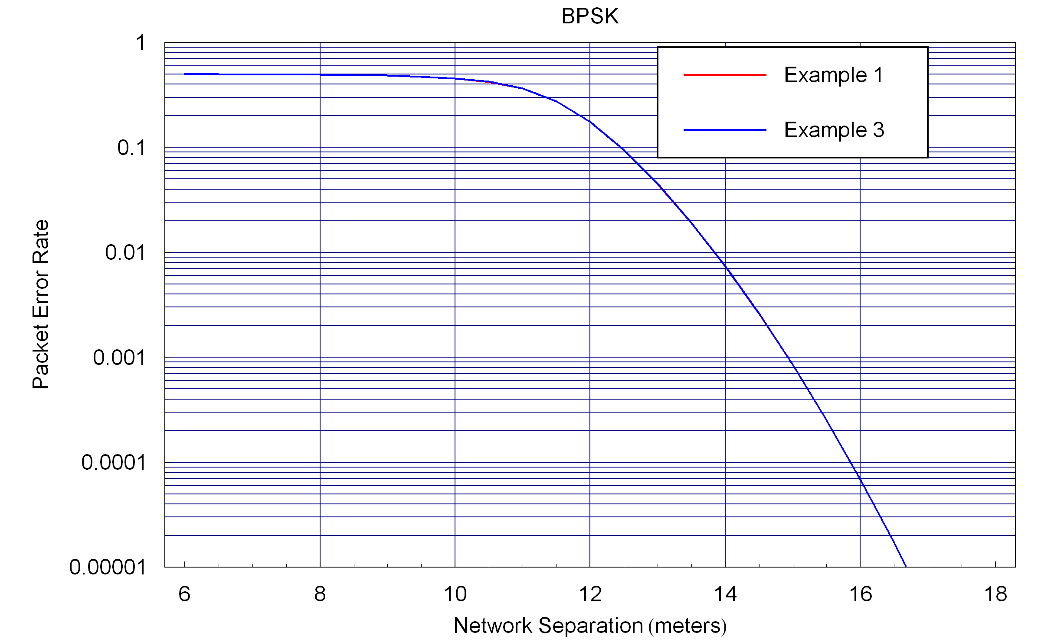
Figure 16 : Cumulative Distribution Function for Number of Symbol Collisions

