IEEE P802.19
Coexistence Technical Advisory Group

Project | IEEE P802.19 Coexistence TAG
Title | Coexistence usage models for 802.15.3a
Date Submitted | 26 June, 2003
Source | [Jim Lansford]  [Mobilian Corporation]  [6310 W. Devonshire Rd., Stillwater, OK 74074 USA] | Voice: [+1 405 377 6170]  Fax: [+1 425 671 6099]  E-mail: [jim.lansford@ieee.org]  Mobile: [+1 405 714 0074]
Re: | [Guide for 802.15.3a proposals.]
Abstract | [Description of possible traffic types and usage scenarios where 802.15.3a will be required to coexist with other wireless standards.]
Purpose | [For guidance to 802.15.3a efforts to model and measure interference between 802.15.3a proposals and other wireless systems.]
Notice | This document has been prepared to assist the IEEE P802.19. It is offered as a basis for discussion and is not binding on the contributing individual(s) or organization(s). The material in this document is subject to change in form and content after further study. The contributor(s) reserve(s) the right to add, amend or withdraw material contained herein.
Release | The contributor acknowledges and accepts that this contribution becomes the property of IEEE and may be made publicly available by P802.19.
Usage Models for 802.15.3a Devices
{Reference 802.15.3a CFA and other background documents)

Categories
The following are categories of compelling applications that 802.15.3a technology will enable:

- Digital Video Distribution
External sources: coming into the home via a set-top-box (HDTV or SDTV MPEG2 or MPEG4 format)
Internal sources: from sources like DVD players, digital camcorders
Expected throughput: 3-200+ Mbps (6 Mbps required for high action video such as sports, up to 10Mbps for DVD players, up to 60Mbps for digital camcorders, approximately 20Mbps for HDTV) with support for multiple streams. QoS required.

- Digital Image Distribution
Download/upload from digital still camera
Expected throughput: 100Mbps or greater for multi-megapixel cameras. QoS not required.

- High Quality Audio
Surround sound systems (AC3 at a minimum)
Hi-Fi, Dolby, etc. (CD quality)
Expected throughput: 1.5 Mbps QoS required.

- High Speed Data
External sources: xDSL, Cable
Internal sources: peripheral sharing (e.g. hard disk drive, high speed printers, scanners)
Expected throughput: 1-200Mbps QoS may be required.

- PC Graphics Distribution
Using TV or webpad as a PC terminal
Game consoles receiving graphics from a central PC (I/O latency is a critical factor that must be met here.
Expected throughput: 2-5 Mbps with compression, >100Mbps without compression

- Video and high quality Voice Communication
Video conferencing (room to room to hand-held device)
Expected throughput: 1-2Mbps per session( Requires symmetric bandwidth and a maximum 30 millisecond latency)

{This table could use updating…}
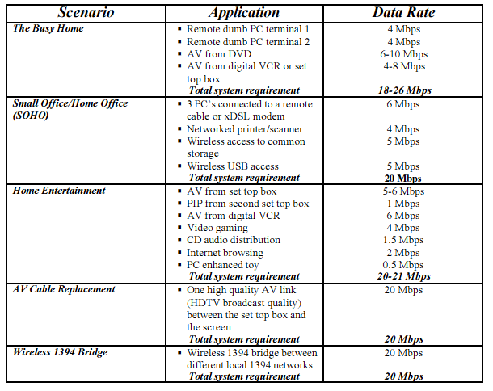

Devices
The following are product categories that are expected to incorporate 802.15.3a technology:

- Modem Sharing (cable modems/ xDSL/ etc.) hubs/base stations;
- PC attached control points and base stations
- Set top boxes and satellite disc receivers
- Desktop PCs & notebooks;
- Computer peripherals such as hard disc drives or DVD-ROM;
- Consumer electronic devices such as HDTV monitors, or DVD players;
- Video conference equipment;
- Cordless phones
- Smartphones
- Digital Still Cameras (DSC)
- Digital Video Cameras (DVC)
- Network bridging products (802.11n to 802.15.3a, USB2 to 802.15.3a, or 1394 to 802.15.3a, for examples)
- New device categories that have not yet been developed, such as news tablets, appliance video displays, and in-room video phones;
- Adapters and accessories of all descriptions that will enable existing and already purchased devices to incorporate the functionality.
- Bridging devices that can pass traffic from one 802.15.3a “piconet” to another within the same dwelling.

{This table could also use updating….}

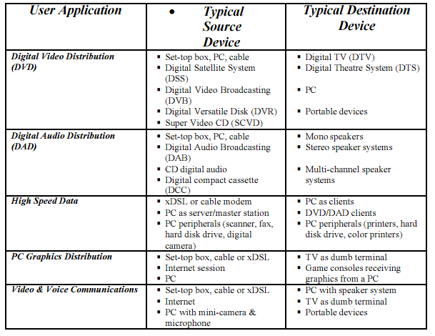

Classes of devices that could require coexistence between 802.15.3a and other wireless technologies

- Laptop computer with 802.11a/b/g/n and 802.15.3a
- Digital still camera with 802.15.3a operating in proximity of a PC, A/V hub, or kiosk that also incorporates 802.11a/b/g/n
- Digital video camera that either plays live to a TV or to a recorder (DVD or other) in the same A/V cluster as 802.11a/b/g/n
- Mobile phone with either DSC or DVC capability that uploads video or still images to kiosk or A/V hub while maintaining 3G connection.
- Mobile phone incorporating 802.15.3a technology and GPS
- 2.4 or 5GHz cordless phone in same cluster as 802.15.3a link

{others?}

Success Factors for Coexistence
{The following is a table that was used in a modified form by the Bluetooth SIG, and may be useful for us….we could modify/add/delete items in this table.}

Attributes | Priority | Target | Nice to Have | Comments
Coexistent with Microwave Oven | 1 | Throughput reduced by not more than 3% at expected distances | Minimal if any throughput reduction | More important for voice traffic
Coexistent with 802.11a/b/g/n | 1 | Throughput reduced by not more than 3% with a single 802.11b interferer expected distances. | Minimal if any throughput reduction
Coexistent with other interferers | 2 | Throughput reduced by not more than 3% | Minimal if any throughput reduction
Cost | 1 | <2$ increase in cost | No Increase in cost
Allows installation within the same enclosure | 2 | On opposite sides of a 10” wide laptop | Out of the same antenna

