Project | IEEE 802.20 Working Group on Mobile Broadband Wireless Access  <http://grouper.ieee.org/groups/802/20/>
Title | Evaluation Criteria: Fairness Metrics
Date Submitted | 2003-04-05
Source(s) | Mike Youssefmir  ArrayComm Inc  2480 N. First Street, Suite 200  San Jose, CA 95131-1014 | Voice: N/A  Fax: 408-428-9083  Email: mike@arraycomm.com
Re: | Evaluation Criteria
Abstract | This contribution proposes the use of fairness metrics in place of predetermined CDF of normalized throughputs for the purposes of fairness criteria.
Purpose
Notice | This document has been prepared to assist the IEEE 802.20 Working Group. It is offered as a basis for discussion and is not binding on the contributing individual(s) or organization(s). The material in this document is subject to change in form and content after further study. The contributor(s) reserve(s) the right to add, amend or withdraw material contained herein.
Release | The contributor grants a free, irrevocable license to the IEEE to incorporate material contained in this contribution, and any modifications thereof, in the creation of an IEEE Standards publication; to copyright in the IEEE’s name any IEEE Standards publication even though it may include portions of this contribution; and at the IEEE’s sole discretion to permit others to reproduce in whole or in part the resulting IEEE Standards publication. The contributor also acknowledges and accepts that this contribution may be made public by IEEE 802.20.
Patent Policy | The contributor is familiar with IEEE patent policy, as outlined in Section 6.3 of the IEEE-SA Standards Board Operations Manual <http://standards.ieee.org/guides/opman/sect6.html#6.3> and in Understanding Patent Issues During IEEE Standards Development <http://standards.ieee.org/board/pat/guide.html>.

Introduction
There is general agreement that it is important to evaluate fairness of user data rates in 802.20-evaluation process. This contribution proposes an alternate approach to the current approach of requiring proposals to meet a predetermined CDF of normalized throughputs.

CDF Fairness Criteria

The current proposed fairness criteria in ref [1] requires a proposal to meet a predetermined normalized user data rate CDF (“fairness criteria CDF”) as follows:
“In the evaluation of spectral efficiency and in order to make a fair comparison of different proposals, it is important that all mobile users be provided with a minimal level of throughput. The fairness is evaluated by determining the normalized cumulative distribution function (CDF) of the user throughput, which meets a predetermined function.
….
An example of normalized user throughput CDF is given in Figure 1. In this example plot, average user throughput is uniformly distributed between 20-100 Kb/s i.e. a factor of 5 difference between the best user and the worse user average throughput. It can be noted that this example CDF lies to the right of the fairness curve and hence meets the fairness criteria.

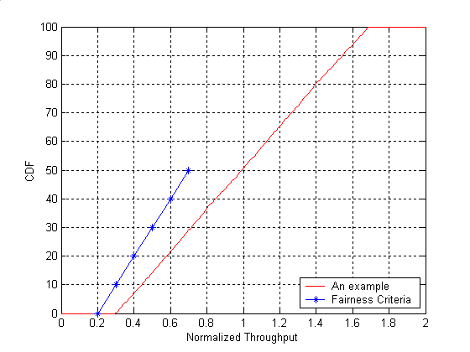
Figure 1 An example of normalized user throughput CDF.
”

While we agree in spirit with the requirement that fairness of user throughputs should be considered in evaluating proposals, we disagree with the specific method laid out by this fairness CDF criteria.

First, we do not believe there is a compelling rationale to be made for a specific predetermined normalized user data rate CDF. In essence, it seems difficult to argue on the basis of a particular operator business case that any one specific curve over another is more appropriate than another. Given this inherent arbitrariness in picking a specific CDF, proposals with user data rate CDFs to the left of the proposed CDF criterion would be unfairly penalized while those considerably to the right of the proposed CDF criterion would not be given due credit (other than having met the criterion).

In view of the fact that fairness metrics (see next section) can be derived to address the issue of fairness, we therefore see no justification for introducing a specific CDF to account for fairness.

We note, furthermore, that the tails of the user data rate CDFs are indeed important for understanding outage probabilities and minimum service levels that do factor into an operator’s business case. However, data rate CDFs and minimum service levels are already part of the evaluation criteria as currently set forth in the document and are not added to by the proposed fairness CDF criteria.

Second, to date, the evaluation criteria has set the stage and created tools for evaluating performance metrics (range, capacity, mobility etc) and has not been chartered to set performance limits. The fairness criteria CDF is a hard performance limit and as such should be avoided unless specifically requested by the requirements group.

Specific Proposals for Fairness Metrics

We propose to eliminate the fairness criteria CDF from the evaluation process and to instead use a “fairness metric” or other measure of uniformity. The metric or measure should have the property of discriminating between systems capable of delivering narrower versus wider distributions of user data rates.

Two rather simple metrics, the “normalized standard deviation of user throughputs” and the “80/20 percentile fairness metric,” are as follows. These metrics are derivable from user throughput CDFs and should be provided for each proposal at given load/coverage operating points:

1. Normalized Standard Deviation:
Let Tput[k] be the throughput for user k. The normalized standard deviation of user throughputs is given by:
${\overline{σ}}_{\text{throughput}}=\frac{\underset{i}{\text{std}}(T_{\text{put}}[i])}{\underset{}{\underset{i}{\text{avg}}(T_{\text{put}}[i])}}$.
Lower values (down to zero) of this metric imply greater fairness.

1. 80/20 Percentile Fairness Metric:
The 80/20 percentile fairness metric is defined as the ratio of the 80th percentile in the user data rate distribution (ordered so the first percentile has higher data rates than the 2nd percentile) to the 20th percentile in the user data rate distribution. Values of this metric are always less than 1 and values closer to 1 imply greater fairness.

References

[1] 802.20 Evaluation Criteria – Ver 06, IEEE C802.20-03/94

