`Project | IEEE 802.20 Working Group on Mobile Broadband Wireless Access  <http://grouper.ieee.org/groups/802/20/>
Title | BEST-WINE Complete Techonogy Proposal  (Summary Classification Statement + Technology Overview + Draft Technology Specfications)
Date Submitted | 2005-OCT-28
Authors(s) | Radhakrishna Canchi 2480 N. First Street, Suite#280 San Jose, CA 95131  Kazuhiro Murakami  2-1-1 Kagahara, Tsuzuki-ku, Yokohama, KANAGAWA 224-8502, JAPAN  Minako Kithara  2-1-1 Kagahara, Tsuzuki-ku, Yokohama, KANAGAWA 224-8502, JAPAN | Voice: +1-408-952-4701  Fax: +1-408-954-8709  Email: cradhak@ktrc-na.com  Voice: +81 45 943 6130  Fax: +81 45 943 6175  Email: kazuhiro.murakami.xm@kyocerajp  Voice: +81 45 943 6102  Fax: +81 45 943 6175  Email: minako.kitahara.nf@kyocera.jp
Re: | MBWA Call for Proposal
Abstract | This document presents the Summary Classification Statement + Technology Overview + Draft Technology Specfications for the MAC and the PHY layer of the of IEEE 802. 20 MBWA
Purpose | To disucus and Adopt BEST-WINE for Draft Specfications of IEEE802.20 MBWA
Notice | This document has been prepared to assist the IEEE 802.20 Working Group. It is offered as a basis for discussion and is not binding on the contributing individual(s) or organization(s). The material in this document is subject to change in form and content after further study. The contributor(s) reserve(s) the right to add, amend or withdraw material contained herein.
Release | The contributor grants a free, irrevocable license to the IEEE to incorporate material contained in this contribution, and any modifications thereof, in the creation of an IEEE Standards publication; to copyright in the IEEE’s name any IEEE Standards publication even though it may include portions of this contribution; and at the IEEE’s sole discretion to permit others to reproduce in whole or in part the resulting IEEE Standards publication. The contributor also acknowledges and accepts that this contribution may be made public by IEEE 802.20.
Patent Policy | The contributor is familiar with IEEE patent policy, as outlined in Section 6.3 of the IEEE-SA Standards Board Operations Manual <http://standards.ieee.org/guides/opman/sect6.html#6.3> and in Understanding Patent Issues During IEEE Standards Development <http://standards.ieee.org/board/pat/guide.html>.



BEST-WINE
(Broadband MobilE SpaTial Wireless InterNet AcEess)
A Complete and Fully Compliant TDD Technology Proposal for MBWA

Summary Classification Statement Technology Overview
&
Draft Technology Specfications

Doc No.Q05T-AA-SP001

Executive Summary

Summary Classification Statement

By this document, Kyocera Team respectfully submits and proposes a TDD technology tilted BEST-WINE, which is an enhanced Air Interface based on “ATIS-PP-0700004-2005, High Capacity-Spatial Division Multiple Access (HC-SDMA), (Pre Published American National Standard)” . The technology proposal BEST-WINE, which incorporates the necessary enhancements to the base HC-SDMA specification, is a Complete and Fully compliant Specfications of Phyisical (PHY) and Media Access Control (MAC) of an air interface for IEEE 802.20 MBWA system in Licensed Frequency Bands below 3.5 GHz.

Salient Features

The air interface BEST-WINE (Enahnced HC-SDMA = Base HC-SDMA + Additional Enhancements) proposed here is designed to maximally leverage adaptive antenna processing and take advantage of SDMA to achieve or execeed the IEEE 802.20 PAR objectives [2] and System Requiremnts [3]. BEST-WINE offer Broadband Peak Per User Data Rates, High System Spectral Efficiency , Wide Area Coverage and High System capacity.

- High Spectral Efficiency (Bits/Sec/Hz/Sector) = 9.78 with Spatail Channels
- Peak Per User Rates:
  - Maximum User Data rates of 1.473Mbps (Downlink) and 566Kbps (Uplink) with Single Channel of 625 KHz.
  - Maximum User Data rates of 5.89 Mbps (Downlink) and 2.26 Mbps (Uplink) with TDD Block assignemnet of 2.5 MHz

- Improved Coverage
- Greater Capacity by handling more than 100 Active sessions per sector and
- Reduced Spectrum Requirments and Spectrum Reuse less than 1 with no frequency Planning
- Effcient Handover
  - Radio Layer Handover
    - Mobile Directed using BS Load and Signal Strength indiacators
    - Make Before Break For Transparency
  - Network Handover
    - Simple IP – Efficient Micromobility
    - Mobile IP – For Inter System Mobility
- Security
  - Authentication
  - Encryption
  - AES

BEST-WINE Proposal Pacakage Structure

- This document ( IEEE C802.20-05/ Best-Wine-1.doc) contains
- Summary Classification Statement,
- Technology Overview and
- Proposed Draft Technology Specifications
  - A Reference to the Base Technical Specifications “ATIS-PP-0700004-2005, High Capacity-Spatial Division Multiple Access (HC-SDMA) (new standard): 9/14/2005 [1]”.
And
  - MAC Layer and PHY layer enhancements to the base specifications of HC-SDMA

- The document (IEEE C802.20-05/ Best-Wine-2.doc) contains System Requirements Compliance Report
- The document (IEEE C802.20-05/Best-Wine-3-1.doc)contains Technology Perofrmance and Evaluation Criteria Report -1
- The document (IEEE C802.20-05/Best-Wine-4.ppt) contains BEST-WINE Technology Overview Presentation.
- The document (IEEE C802.20-05/Best-Wine-5.ppt) contains BEST-WINE Technology Performance Presentation.

Table of Contents
1 Executive Summary 3
1.1 Summary Classification Statement 3
1.2 Salient Features 3
1.3 BEST-WINE Proposal Pacakage Structure 4
2 References 7
3 Definitions 8
4 Abbreviations and acronyms 9
5 Introduction 11
6 Scope of this Document 11
7 Overview 11
7.1 System Architecture 11
7.2 Layered Protocol Architecture 13
7.2.1 Physical (PHY) Layer : L1 13
7.2.2 MAC Layer L2 20
7.2.3 Data Link Control (DLC) /Logical Link Control L3 24
7.2.4 Layer3+ 28
7.3 Performance 30
7.4 Radio Characteristics 33
8 Proposed Draft Specfications of BEST-WINE 35
8.1 Draft specifications of HC-SDMA 35
8.2 Additional (Enahanced) Draft specifications to meet SRD of MBWA 35
8.2.1 MAC/LLC (L2/L3) Layer Enhancements 35
8.2.2 PHY (L1) Layer Enhancements 38
8.2.3 Supporting IPV4 and IPV6 39
9 Summary 40

List of Figures
Figure 7-1 BEST-WINE Network structure 12
Figure 7-2 BEST-WINE network (L1/L2/L3) protocol stack 12
Figure 7-3 BEST-WINE network (L1/L2/L3) protocol stack on MIP 13
Figure 7-4 BEST-WINE TDD/TDMA frame structure 13
Figure 7-5 Superframe structure 16
Figure 7-6 Carrier Aggregation in 2.5 MHz Block Assignament 17
Figure 7-7 Block Diagram of Error control Coding Scheme 18
Figure 7-8 Standard Downlink Burst structure 23
Figure 7-9 Standard Uplink Burst structure 23
Figure 7-10 Burst Payload Format 24
Figure 7-11 Protocol relationship among the Air interface Layers L1,L2 and L3 27
Figure 7-12 25m height Tower, Sydney MAP and Userterminal 30
Figure 7-13: Downlink Date Rate Results 31
Figure 7-14: Date Rate and Spectrum Efficency Test Results of HC-SDMA in Australia 31
Figure 8-1 Broadcasting/Multicasting Short Messages Service 36
Figure 8-2 Broadcasting/Multicasting Streaming Services 36

List of Tables
Table 7-1: Air interface layers 13
Table 7-2 Modulation Schemes -Logical Channel 17
Table 7-3 Modulation and Coding Rates 19
Table 7-4 Maximum User data rates per Modulation Class 20
Table 7-5 Burst types 21
Table 7-6 Radio characteristics 34
Table 8-1 Class of Services Support 35
Table 8-2 Combination of Key length, block and round in AES 36
Table 8-3 Maximum User data rates per Modulation Class 38
Table 9-1 Summary of the basic elements of the MBWA TDD MBWA air interface 40

References
- ATIS-PP-0700004*-2005, High Capacity-Spatial Division Multiple Access (HC-SDMA)
  - *The copyright of this document is owned by the Alliance for Telecommunications Industry Solutions. Any request to reproduce this document, or portion thereof, shall be directed to ATIS, 1200 G Street, NW, Suite 500, Washington, DC 20005.
  - *For Electornic Downloads, Paper Copy or CD-ROM please follow the link https://www.atis.org/atis/docstore/doc_display.asp?ID=3617
- IEEE 802.20 PD-2.doc: Mobile Broadband Wireless Access Systems: Approved PAR (02/12/11):
- IEEE 802.20 PD-06r1.doc: IEEE 802.20 System Requirement Document (V 1.0)
- IEEE_802.20-PD-08.doc: IEEE 802.20 Channel Models (V 1.0)
- IEEE_802.20-PD-09.doc: IEEE 802.20 Evaluation Criteria (V 1.0)
- IEEE_802.20-PD-10.doc: IEEE 802.20 Techology Selection Process (V 1.0)
- X.P0011-001-D on 3gpp2 TSG-X specification

Definitions

As defined in the References [1],[2],[3]

Abbreviations and acronyms

AA | Access Assignment
AAA | Adaptive Antenna Array
ACLPR | Adjacent Channel Leakage Power Ratio
ACS | Adjacent Channel Selectivity
AM | Acknowledged Mode
API | Application Programming Interface
ARQ | Automatic Repeat Request
BCH | Broadcast Channel
BS | Base Station
BSCC | Base Station Color Code
CA | Certificate Authority
CCH | Configuration Channel
CM | Configuration Message
CoS | Class of Service
CR | Configuration Request
CRC | Cyclic Redundancy Check
EUD | End User Device
FACCH | Fast Asscoiated Control Channel
FEC | Forward Error Control
FER | Frame Error Rate
GPS | Global Positioning System
HC-SDMA | High Capacity Spatial Division Multiple Access
i-HAP | Handshake and Authentication Protocol
IMSI | International Mobile Station Identifier
IPPR | Intermodulation Product Power Ratio
i-SEC | Secure Communications Protocol
i-TAP | Terminal Authentication Protocol
IWAN | Interconnection Wide Area Network
L2 | Layer 2
L2TP | Layer 2 Tunneling Protocol
L3 | Layer 3
L3 | CM L3 Connection Management
L3 | MMC L3 Mobility Management and Control
L3 | RM L3 Registration Management
LLC | Logical Link Control
LDAP | Lightweight Directory Access Protocol
LFSR | Linear Feedback Shift Register
LNA | Low Noise Amplifier
LNS | L2TP Network Server
LSB | Least Significant Bit
MAC | Medium Access Control
MBWA | Mobile Broadband Wireless Access
MSB | Most Significant Bit
PA | Power Amplifier
PAR | Project Authorization Requirments
PCH | Paging Channel
PDCL | Packet Data Conversion Layer
PHY | Physical Layer
PID | Paging Identity
PPM | Parts Per Million
PPP | Point to Point Protocol
PPPoE | PPP over Ethernet
PSS | Packet Services Switch
QoS | Quality of Service
RA | Request Access
RACH | Random Access Channel
RSA | Rivest, Shamir, Adleman
RF | Radio Frequency
RLC | Radio Link Control
RM | Registration Management
RMU | RLC Message Unit
RRC | Radio Resource Control or Root Raised Cosine
RSSI | Received Signal Strength Indicator
SDMA | Space Division Multiple Access
SDU | Service Data Unit
SINR | Signal-to-Interference plus Noise Ratio
SN | Slot Number
SNR | Signal to Noise Ratio
TCH | Traffic Channel
TDD | Time Division Duplex
TDMA | Time Division Multiple Access
TWAN | Transport Wide Area Network
UM | Unacknowledged Mode
UT | User Terminal

Introduction

By this document, Kyocera Team respectfully submits and proposse a TDD Technology Proposal tilted BEST-WINE (Broadband MobilE SpaTial Wireless InterNet AcEess), which is an enhanced Air Interface based on “ATIS-PP-0700004-2005, High Capacity-Spatial Division Multiple Access (HC-SDMA), (Pre Published American National Standard)”[1]. The technology proposal BEST-WINE, which incorporates the necessary enhancements to the base HC-SDMA specification, is a Complete and Fully compliant Specfications of Phyisical (PHY) and Media Access Control (MAC) of an air interface for MBWA system in Licensed Frequency Bands below 3.5 GHz.

Scope of this Document

This document presents overview of BEST-WINE, which is an enhanced HC-SDMA [1] and then defines the additional draft MAC/PHY layer specifications supplemental that of HC-SDMA [1] relevant to to the scope of MBWA SRD [2 ] and PAR [3]. The basic (foundation) draft specifications are available as ATIS standard: ATIS-PP-0700004-2005 and will not be copied in this Document due to Copyrights of ATIS. These additional specifications results in enhanced HC-SDMA, which is named as BEST-WINE, so as to meet system Requirements of MBWA system will presented in this document.

Overview

System Architecture

BEST-WINE system, which employs Adaptive Antenna Array and SDMA Technologies, transfers IP traffic, including Broadband IP Data, over a layered reference model. Physical and data link layers are kept distinct to clarify the operation of the wireless interface. Higher layers then integrate the physical and data link layers into an end-to-end architecture based on VPN (GRE) and PPP, over which the user establishes a session with the desired Internet Service Provider. IP packets are then transported between the end-user-device such as a personal computer and the service provider. BEST-WINE network structure is shown in Figure 7-1

Figure 7-1 BEST-WINE Network structure

Figure 7-2 show BEST-WINE network protocol stack. BEST-WINE protocol provides end to end solution for air interfece between EUD and PDSN. BEST-WINE network supports not only Simle IP but also MIP (Mobile IP) for mobility functionality on following stack..
Figure 7-3 shows the case of MIP usage.

IP
(
ISP
)
IP
IP
(
ISP
)
PPP
PPP
PPPoE
PPPoE
.
L
3
R
-
P
R
-
P
Datalink
Datalink
.
L
3
MAC
MAC
.
L
2
IP
IP
.
L
2
PHY
PHY

.
L
1
Datalink
Datalink
.
L
1
EUD
UT
(
User Terminal
)
BS
(
Base Station
)
PDSN
End Host

Figure 7-2 BEST-WINE network (L1/L2/L3) protocol stack

MIP
MIP
TCP/UDP
TCP/UDP
IP
(
ISP
)
PPP
PHY
MAC
PPPoE
PHY
MAC
PPPoE
L
1
L
2
L
3
Datalink
IP
R
-
P
Datalink
IP
R
-
P
Datalink
Datalink
IP
L
1
L
2
L
3
UT
(
User Terminal
)
BS
(
Base Station
)
PDSN
End Host
PPP
IP
(
ISP
)
EUD

Figure 7-3 BEST-WINE network (L1/L2/L3) protocol stack on MIP

The proposed air interface BEST-WINE, which is based on HC-SDMA [1], has a TDD/TDMA structure whose physical and logical characteristics have been chosen for the efficient transport of end-user IP data and to extract maximum benefit from adaptive antenna processing. The physical aspects of the protocol are arranged to provide spatial training data, and correlated uplink and downlink interference environments, for logical channels amenable to directive transmission and reception such as traffic channels. Conversely, channels not amenable to directive processing, such as paging and broadcast channels have smaller payloads and receive a greater degree of error protection to balance their links with those of the directively processed channels. Adaptive modulation and channel coding, along with uplink and downlink power control, are incorporated to provide reliable transmission across a wide range of link conditions. Modulation, coding and power control are complemented by a fast ARQ mechanism to provide as reliable link as is possible in a mobile wireless setting. Fast, low-overhead make-before-break inter-cell handover is also supported. Differentiated and tiered services are enabled through a flexible QOS mechanism. Security for the radio access link is provided by mutual authentication of the terminals and access network, and by encryption to ensure data privacy.

Layered Protocol Architecture

As shown in BEST-WINE air interface has three layers designated as L1, L2, and L3. Table 7-1describes the air interface functionality embodied in each layer. Each layer’s features are briefly described below; more detailed overviews of key aspects are described in subsequent sections of this document.

Layer | Defined Properties
L1  (PHY) | - Radio Performance (transmit and receive)  - Modulation and Coding  - Performance and Test
L2  (MAC) | - Channel Structure (frame and slot)  - Access Management  - Data and Control  - Flow over logical channels  - Mapping between logical and physical (transport) channels  - Automatic Repeat Request (ARQ)
L3  (DLC/LLC) | - Connection, Registration, Mobility Management (CM, RM, MMC)  - Radio Resource Control (RRC)  - Authentication and Security (i-HAP, i-TAP, i-SEC)  - Packet Segmentation, Slot Aggregation  - Power control  - Link Adaptation

Table 7-1: Air interface layers

Physical (PHY) Layer : L1

Physical (PHY) Layer: L1 is characterized by a TDD/TDMA structure as shown in Figure 7-4 with 5 ms frame length, each frame containing three uplink and three downlink bursts (timeslots). The air interface’s logical channels are all mapped onto this structure. In the interest of providing high spectral efficiency, many aspects of L1 are specifically designed to support the effective use of adaptive antennas. For instance, training sequences for Spatial Division Multiple Access (SDMA) are incorporated in certain burst structures.

Figure 7-4 BEST-WINE TDD/TDMA frame structure

Frame and Timeslots
This BEST-WINE TDD/TDMA frame structure is designed for deployment in a narrow frequency channelization (625 kHz) with a constant baud rate (2 μSec/symbol) across the frame. This specification has several advantages.

- Ordering uplink slots prior to downlink slots facilitates the implementation of spatial filters for adaptive antenna arrays in the BS.
- Narrow carrier bandwidth simplifies equalization, channel estimation, and network deployment in the available TDD spectrum.
- Narrow frequency channelization reduces access latency by providing many access channels

The logical channels, defined later in this document, are mapped to physical channels within the frame structure. Figure 7-1. also shows a range extension period of 85 μs, corresponding to a range of 12.7 km, suitable for metropolitan area coverage of MBWA system: BEST-WINE as described in the 802.20 PAR[2]. If inter-burst guard times in the air interface are exploited, the effective range extension period becomes 100 μs, corresponding to a maximum range in excess of 15 km. The range extension is obtained with less than 2% overhead of the frame period, and its cost is more than offset by the TDD and adaptive antenna benefits that it enables.

All TDD networks require close synchronization among all the BSs in the network. Any time reference with a stability of ±1 symbol period and with network-wide availability can be used for inter-cell synchronization of base stations. For example, the Global Positioning System (GPS) has the required stability and low-cost GPS receivers are available. In contrast, the UTs would derive their timing reference from the BSs. A single carrier and timeslot pair is reserved network-wide for the broadcast superframe structure of . The superframe is synchronized across all BSs in the network (i.e., the F burst is transmitted simultaneously from every BS).

Figure 7-5 Superframe structure

The superframe as shown in Figure 7-5begins with a downlink burst (F-type in ) designed to facilitate frequency-offset estimation between the UT local oscillator and the BS frequency reference. Similarly, a T-type burst is dedicated to frame time estimation. The UT can detect all BSs in its vicinity using the same BCH carrier and rank them according to the quality of their channel to the UT. The downlink slots labeled B0 to B7 in are dedicated to each of the pre-assigned groups of BSs. For example, only BS belonging to group 5 would send a downlink burst in the position labeled B5. The group-specific downlink slot is the BCH for all BSs in that group. Acquisition of the BCH from within a group of base stations works best if interference from other base stations in the same group is minimized. At least seven base station groups are required to ensure that only one BS from the first tier transmits during its group-assigned slot in the BCH superframe. The MBWA eight base station groups is convenient for deployment as the network evolves. The UT can use these BCH for refined estimates of time- and frequency-offset to the nearest BS. The remaining slots labeled “C” are paired uplink/downlink bursts and serve as the CCH.

Uplink and downlink symbol rates are 500 kSymbols/s in all circumstances and a 25% root-raised cosine filter is employed, which leads to a 625 kHz carrier spacing. Figure 7-6 shows an example of Carrier aggregation with 2.5 MHz Block assignment.

Figure 7-6 Carrier Aggregation in 2.5 MHz Block Assignament

The basic physical resource in the system is a spatial channel, which consists of a carrier, an uplink and downlink timeslot pair, and a spatial channel index. Multiple antennas and adaptive antenna processing make it possible to support multiple spatial channels simultaneously on the same conventional channel.

Modulation and Coding
While the symbol rate (500 KSymbols/sec) is constant for all slots in the frame definition in Figure 7-4 , the modulation order is adaptable (separately in uplink and downlink) to both the quality of a user’s channel and the current data rate requirements. Seven modulation schems proposed are shown in Table 7-2.

Modulation Scheme used | Logical channel
π/2-BPSK | Control CHannel (CCH)  Random Access CHannel (RACH)  Fast Associated Control CHannel (FACCH)
QPSK | Broadcast CHannel (BCH)  Paging CHannel (PCH)
π/2-BPSK  QPSK  8-PSK  12-QAM  16-QAM  24-QAM  64-QAM | Traffic CHannel (TCH) under control of the  higher-layer link-adaptation protocol
Table 7-2 Modulation Schemes -Logical Channel

A range of modulation and coding combinations (referred to as “ModClasses”) are employed to maximize throughput subject to FER and link conditions. Independent uplink and downlink power control and ModClass adaptation are to be performed on a burst-by-burst basis on traffic channels. Channels that have lower spatial processing gain, such as broadcast and paging channels, are to be transmitted generally with more extensive channel coding than traffic channels, balancing the tolerable path loss for all channel types. L1 employs spatial processing, multiple modulation and channel coding formats, and equalization with per-burst training data to manage the RF challenges of a mobile Non-Line-of-Sight (NLOS) environment. L1 is to support per-user data rates in excess of 1 Mbps per carrier on the downlink and in excess of 300 kbps per carrier on the return link as demanded by the MBWA PAR [2]. Carrier aggregation multiplies these per-user data rates by the number of aggregated carriers.

This set of modulation classes is flexible, consisting of both constant-modulus and rectangular constellations. The UT is not required to implement all of the ModClasses. This facilitates low-cost, power efficient devices. Note that most of the logical channels are transmitted using the lowest-order modulation classes. These low-bandwidth channels must be received correctly with high probability. The higher-order modulation classes are primarily intended for use by the traffic channels.

Figure 7-7 illustrates the coded modulation system that achieves rates from approximately 1/2 to
6 bits/symbol. Table 7-3 lists modulation classes and signal sets, together with the associated parameters for puncturing, shaping, and block coding.

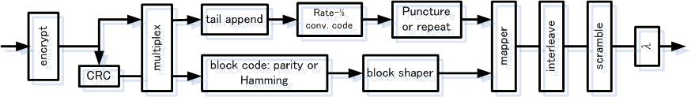

Figure 7-7 Block Diagram of Error control Coding Scheme

Coding for FEC is provided by a rate-1/2 convolutional code with 256 states combined in some cases with a block code. In some ModClasses, periodic puncturing is applied to increase the rate of the convolutional code to 2/3 or 3/4. Repetition is used in ModClass 0 to construct RA, AA and CM burst but not for CR and TCH bursts, ModClasses 6,7,8 ,9 and 10 employ four-dimensional block shaping to generate 12-,16-,24-, and 64-QAM signal sets, respectively.

ModClass | Bit/Sym | Signal Set | Puncture | Shaper | Block Code
0  1  2  3  4  5  6  7  8  9  10 | 0.5  0.67  1.0  1.5  2.0  2.5  3  3.5  4  4.5  6 | BPSK  BPSK  QPSK  QPSK  8-PSK  8-PSK  12-QAM  16-QAM  24-QAM  24-QAM  64-QAM | Repeat  1 of 4  -  2 of 6  -  -  2 of 6  2 of 6  2 of 6  2 of 6  2 of 6 | -  -  -  -  -  -  3/4  4/4  5/4  6/4  6/4 | -  -  -  -  (64,57)  (64,57)  (48,47)  (64,63)  (80,79)  (80,79)  (80,79)
10-15 | RESERVED

Table 7-3 Modulation and Coding Rates

Information bits should be subject to forward error control coding prior to transmission. The coding rates vary from 0.5 bits/symbol to 6 bits/symbol in the downlink and 0.5 bits/symbol to 3.5 bits/symbol in the uplink. The Forward Error Control (FEC) provides for these components.

- CRC-16 across the information portion of the payload.
- Error control codes including
  - Convolutional code
  - Block code
  - Shaping code
- Bit interleaving within a burst
- Scrambling

The choice of codes is a function of the modulation class and includes provisions for puncturing and/or repeating portions of the block as required for rate matching.

The BCH is a heavily coded channel with low order modulation so that the link budget on the BCH matches that on the adaptive antenna enhanced TCH and RACH. The BCH repeatedly transmits the same information within a slot to exploit spatial diversity. Similarly, the PCH is heavily coded with low order modulation..

Table 7-4 shows the maximum per user data rates for each moduration class. This table indicate a slot rate and 3 slots aggregation rate(Carrier) for up link and down link including coding ratio. The maximum data rate are calculated as following formula.

Down link : 1473Kbps x 4 Carrier aggregation = 5.89 Mbps(Max)
Up Link : 566Kbps x 4 Carrier aggregation = 2.26 Mbps(Max)

ModClass | Modulation  Method | Down Link(Kbps) |  | Up Link(Kbps)
ModClass | Modulation  Method | Data Rate  /Slot | Data Rate  /Carrier | Data Rate  /Slot | Data Rate  /Carrier
0 | BPSK | 35 | 106 | 6 | 19
1 | BPSK+ | 50 | 149 | 13 | 38
2 | QPSK | 82 | 245 | 26 | 77
3 | QPSK+ | 126 | 379 | 43 | 130
4 | 8PSK | 162 | 485 | 58 | 173
5 | 8PSK+ | 198 | 595 | 72 | 216
6 | 12QAM | 262 | 787 | 98 | 293
7 | 16QAM | 307 | 922 | 115 | 346
8 | 24QAM | 354 | 1061 | 132.8 | 398
9 * | 24QAM+ | 422 | 1267 | 162.5 | 487
10 ** | 64QAM | 491 | 1473 | 188.7 | 566

*1 24QAM+ perform error coding which has 3/4 coding rate .
*2 64QAM perform error coding which has 5/6 coding rate

Table 7-4 Maximum User data rates per Modulation Class

Support for adaptive antenna

In a frame of Figure 7-4, uplink slots are stacked together ahead of the downlink slots so that the downlink spatial signature can incorporate the received uplink signature estimate. Each uplink slot is paired with a downlink slot. The duration between any paired uplink and downlink slot is small (e.g. 1-2 ms) to prevent channel conditions from degrading the degree of channel reciprocity existing between the uplink and downlink slots and hence degrading the adaptive antennas’ performance. Therefore, the frame duration is also small (5 ms). Carrier bandwidth is relatively narrow (625 KHz) to enable low complexity adaptive antenna algorithms. On a given carrier-timeslot pair, each user is assigned a unique training sequence. Training sequences are designed for appropriately accurate estimation of the propagation channel. Each UT on a conventional channel doing SDMA uses a different training sequence from a selected set with good correlation properties. The cross correlation property between the training sequences is very low. The autocorrelation property for the non-zero lags is also very low.

Generally, Adaptive array performance is determined by number of Antenna Elements.
In BEST-WINE, Basestation can have 12 or 9 antenna while User Terminal (UT) can have 1,2,4 antenna elements.

MAC Layer L2

L2 maps control and data messages to physical resources and provides Acknowledged Mode (AM) and Unacknowledged Mode (UM) message delivery. AM data is delivered via a byte-addressable retransmission mechanism similar to that used in TCP, and provides a reliable delivery mechanism for L3 data including the preservation of byte ordering. Retransmission is done directly from the Base Station (BS) or User Terminal (UT) as appropriate to minimize ARQ latency. Traffic bursts are composed of tagged UM, AM, control and user data, allowing multiple messages to be sent in a single air interface burst for efficiency and low latency. L2 also provides bulk encryption to ensure the confidentiality of user and control data.

Logical Channels and Burst Types
A UT and a BS exchange information using a small number of logical channels. These logical channels, listed in Table 7-5, are mapped to physical bursts for transmission. There is a Standard Uplink and a Standard Downlink burst type common to the RACH, TCH, CCH in the downlink and FACCH logical channels. The remaining logical channels, namely PCH, BCH, and CCH in the uplink, are transmitted by dedicated burst types.

Burst (Transport Channel) Type | Symbol | Logical Channel
Downlink bursts:  Frequency Synchronization  Timing Synchronization  Broadcast  Page  Standard Downlink | F  T  B  P  D | BCH  BCH  BCH,CCM  PCH  RACH, TCH, CCH, FACCH
Uplink Bursts:  Configuration Request  Standard Uplink | C  U | CCH  RACH, TCH, FACCH

Table 7-5 Burst types

BCH
The Broadcast CHannel (BCH) is a downlink-only channel and the first logical channel the UT uses in establishing a connection to the BS and subsequently to the backhaul network. The purpose of the BCH is to allow the UT to gain coarse timing and frequency synchronization and to determine the best BS with which to communicate, both for initial acquisition and for handovers.

The BCH consists of the F, T, and B bursts. The F burst is used to gain coarse frequency synchronization and timing to the network. The T burst is used to calculate receive timing estimates, relative propagation delays, and relative path loss to each BS in the network. The B burst is used to provide more accurate information on the estimates derived from the T burst. Additionally, the B burst contains some information bits to aid in BS selection.

Two major considerations in the design of the BCH are the following.

- The BCH compensates for the additional spatial processing gain of other channels (namely, CCH, TCH and RACH, to be defined and described later in this section) that have increased range and significantly less network interference due to adaptive antenna processing.
- The BCH consumes a minimal amount of overhead so that it has a small impact on total base station throughput.

These design considerations lead to a B burst with a small number of information bits. The B burst contains small bit fields to indicate the transmitted power of the burst and the BS load. See Section 6.2 for more information on BS load usage.

CCH
The Configuration CHannel (CCH) serves two primary purposes.

- The CCH is used as a fine adjustment mechanism for timing synchronization, e.g., during initial network acquisition and handovers.
- The CCH is used to inform the UT of key BS and network parameters to enable the UT to continue connecting to a BS via registration

There are only two messages carried by CCH. On the uplink, the Configuration Request (CR) message has a field indicating the power of the transmitted CR burst. On the downlink, the Configuration Message (CM) needs to inform the UT of several key parameters, including the following.

  - A network ID to distinguish between collocated operators in a geographic area
  - A protocol version to identify system compatibility
  - Information relating to BS channel configuration, such as identifying which conventional channels may be used for registration

PCH
The Paging CHannel (PCH) is a downlink-only channel used to tell a UT to access the BS. It can be sent simultaneously with RACH and TCH on a given timeslot/frequency pair. Like BCH, PCH must compensate for the increased range of other channels (namely, TCH and RACH) that results from the adaptive antenna processing. The PCH conveys a small number of information bits. A page identifier (PID) is contained in each paging burst to communicate with a specific UT.

RACH
The Random Access CHannel (RACH) is used by the UT to gain access to a BS. It can be sent simultaneously with PCH and TCH on a given carrier-timeslot pair. Multiple messages are carried over this channel. The Request Access (RA) message is sent by the UT in the uplink, and contains a registration identifier (RID) that identifies a network session and indicates the transmit power of the burst containing the message. The Access Assignment (AA) message is sent by the base station in response to an RA message. The AA message is used in the downlink to grant a user terminal a TCH stream. The AA message contains several pieces of information, including the following.

- Modulation and coding information for the initial TCH burst(s) that follow
- Conventional channel (i.e., carrier-timeslot pair) assignment of the TCH stream
- Spatial training sequence (see section 6) assignment of the TCH stream
- Timing and power correction parameters

Figure 7-8 shows the Standard Downlink burst used for RACH, TCH, and FACCH. The Standard Uplink burst is shown in Figure 7-9.

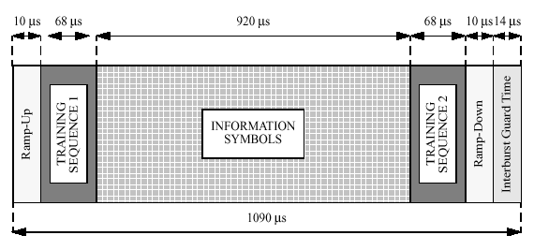
Figure 7-8 Standard Downlink Burst structure

TCH
The Traffic CHannel (TCH) is used to transport both end-user and control traffic data. The RACH initiates a TCH stream. A TCH stream is a series of TCH frames used by a single user terminal and is the basic mechanism used to convey user and control data. TCH streams are created and closed in response to the bandwidth needs of each UT.

FACCH
The Fast Associated Control CHannel (FACCH) is a logical channel associated with RACH and TCH. It carries power control and link adaptation information. The FACCH has its own modulation and coding (Walsh-Hadamard) and is recoverable at low SINR. The FACCH enables fast link adaptation since it contains real time updates of the modulation class of the TCH bursts that are being sent.
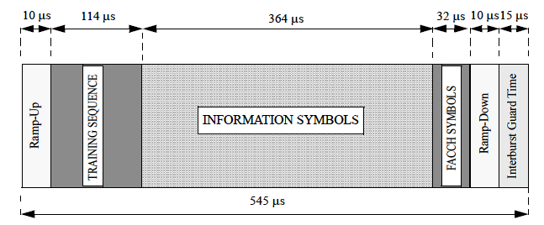
Figure 7-9 Standard Uplink Burst structure

Data Link Control (DLC) /Logical Link Control (LLC) L3
L3 manages access to air interface resources. Once a UT has registered with a BS, no air interface resources are allocated to that UT unless upstream or downstream traffic needs to be exchanged between it and the BS. All resource allocation decisions are made centrally at the BS, governed, in part, by QoS considerations including per-user limits on data rate and priority. Carrier and timeslot aggregation is employed to increase per-user throughputs on traffic channels beyond those supported by a single carrier-timeslot pair. Finally, uplink and downlink spatial rocessing at the base station results in a highly efficient access mechanism that exploits SDMA rather than conventional techniques such as collision detection/avoidance.

L3 also manages the relationship between the UT and the BS, maintaining the fundamentals of the association between those two entities that permits the exchange of end-user IP data. In addition, L3 employs physical measurements made at L1 to manage mobility and coordinate power control and link adaptation between the UT and the BS. L3 nominally receives end-user PPP or IP data from higher-level protocol entities. It provides for BS authentication so that the UT confirms the identity of the BS and vice versa.
Fig3-1 shows the structure of layer stack.

User and certain control data are transported using TCH streams. TCH streams provide two data delivery mechanisms.

- Unacknowledged Mode (UM) traffic that is not sent through ARQ.
- Acknowledged Mode (AM) traffic that is sent through ARQ.

Burst Header
UM payload
AM payload
Figure 7-10 Burst Payload Format
UM and AM traffic are multiplexed on a burst-by-burst basis within a TCH stream. In order to multiplex efficiently and flexibly, the UM messages form a prefix code. AM traffic is mostly end-user data, but it may also contain control messages that need to be sent reliably. AM traffic is sent reliably using an ARQ scheme. The following describes the attributes of the ARQ scheme.

- The endpoints are in the L2 layer of the UT and BS, minimizing the retransmission latency.

- The ARQ scheme is byte-oriented, which allows for flexible payload sizes that result from adaptive modulation and the AM/UM multiplexing scheme.
- The acknowledgement scheme is cumulative, i.e., the acknowledgements report the next byte expected for contiguous reception.

In order to facilitate the ordered and reliable delivery of AM traffic over aggregated TCH streams, a set of Packet Data Conversion Layer (PDCL) algorithms is to be applied to the AM traffic flow. The set of PDCL algorithms is extensible. The following list contains the key PDCL algorithms.

- L3 packet checksum. This is used to augment the L1 checksum that is applied to each TCH burst.
- Packet sequencing and reordering. This algorithm allows the receive side to reorder packets that have been sent in parallel by multiple streams.
- Packet Fragmentation. This algorithm fragments packets into smaller units in order to reduce latency when there are multiple streams open for a connection.

Power Control and Link Adaptation
Power control and link adaptation control algorithms are present both in the uplink and downlink. The power control algorithm has open and closed loop controls. Both loops are controlled by the BSs, and hence the BS sends uplink power control and link adaptation commands in the downlink. To support centralized control by the BSs, the UTs need to report downlink signal quality (Signal to Interference plus Noise Ratio - SINR) back to the BSs. The UTs also needs to report the available transmit power (i.e. difference between the maximum available transmit power and the current transmit power) to the BSs in order to enable effective uplink link adaptation.

Power control and link adaptation messages are sent in every slot of every frame. Therefore the system is able to adapt to fast changes in propagation channels and in the interference environment. Power control commands accommodate both fixed step commands to compensate for small changes in SINR (e.g. +/-1 dB) and variable step commands to compensate for large changes in SINR (e.g. 10 dB). These commands are low bandwidth messages. The UT report (feedback on downlink signal quality) is present in every slot of every frame. The report is able to specify small (e.g. 1 dB) as well as large changes in the SINR (e.g. 10 dB). These reports are also low bandwidth messages.

Modulation and coding information is conveyed through FACCH. This channel carries information on the recommended modulation and coding class and the current modulation and coding used to construct the payload. This information is shared between the BS and the UT on a slot-by-slot basis.

Network side

LSAP

L3-CM
Ctl action
Ctl msg
data
data
Ctl msg
Ctl action
L3-RM
New best BS
Current best BS
L3-MMC
UT class
L3-RRC
Ctl
AMdata
Ctl
UM Ctl msg
UM Ctl msg
Ctl action
AMdata
UMctl msg
UMctl msg
Ctl
RX measurement
RX data
RX measurement

AMdata

Ctl action

RLC(L2)
AMdata

MAC

PHY (L1)

Radio side

L3CM : Connection management
L3RM : Registration management
L3RRC : Radio resource control
L3MMC(UT only) : Mobility management/control
MAC :Media Access Control
RLC :Radio Link Control

Figure 7-11 Protocol relationship among the Air interface Layers L1,L2 and L3

Layer3+

QoS
This proposal supports Quality of Service (QoS), with QoS behaviors defined using common traffic engineering modeling elements, such as token buckets, meters, algorithmic droppers, shapers, etc. The proposal supports a standard DiffServ solution. Per-session QoS can be specified to the radio access network using standard DiffServ Code Points (DSCP’s). The Per Hop Behaviors (PHB’s) are defined by a standard DiffServ API.

The BS scheduler is in charge of enforcing the Quality of Service (QoS) requirements for the aggregate set of network sessions, as configured through the DiffServ API. The air-interface is highly versatile, providing the basic mechanisms used by the BS scheduler.

The scheduler incorporates individual UT RF and baseband capabilities, such as RF carrier and timeslot aggregation capabilities. Using this information and the basic stream mechanisms, the scheduler can enforce basic QoS behaviors, such as individual rate limits, priority, and soft resource partitioning between aggregate classes. The BS may schedule all users together over the complete set of physical resources. Alternately, it can separate individual users into specific registration domains by partitioning the overall set of physical resources, assigning individuals to particular registration domains during or even after registration.

Air Interface Handover
The air interface’s make-before-break handover scheme is UT-directed. Each UT monitors the broadcast channels from surrounding BSs and ranks candidates based on transmitted and received signal power, delay, and BS load as indicated by the BCH. The UT can perform these measurements as well as register with a candidate new serving BS while exchanging TCH data with its current serving BS. The handover for user data is make-before-break with the TCH data being redirected to the new serving BS after successful registration.

Security
The BEST-WINE air interface provides a robust security infrastructure with air interface confidentiality and authentication. It provides seamless support of IP-centric network, transport and application layer security. The air interface security architecture is designed to overcome known problems in contemporary wireless systems.

Authentication
Authentication (for both the BS and UT) is be based on using digital certificates signed according to ISO/IEC 9796 standard using the RSA algorithm as the signature primitive. The digital certificates present information about the owner of the certificate and its elliptic curve public key. RSA modulus ranges from a minimum of 1024 bits to a maximum of 2048 bits.

Shared Secret
Shared secret and air interface parameter exchange is performed using the public keys of the UT and the BS. The public key infrastructure is based on elliptic curve cryptography (using curves K-163 and K-233 in FIPS-186-2 standard)..

During registration the UT and BS digital certificate transmissions, together with the public key encrypted shared secret and air interface transmissions, are interleaved to optimize air interface utilization.

Shared secret exchange capacity ranges from 163 bits to 466 bits depending on the needs of the bulk encryption algorithm.

Bulk Encryption
Bulk encryption is performed using a stream cipher such as RC4 initialized by a function of the shared secret and the temporal parameters of a stream to be encrypted (system may also support any block cipher that can operate in output feedback mode (OFB) or in cipher feedback mode (CFB)). The stream cipher supports a variable length shared secret key which is diffused properly prior to each stream start and shared secret refreshment is enforced by both the UT and the BS in order to circumvent errors in UT configuration settings.

Performance

The proposed BEST-WINE’s Base systems HC-SDMA [1] has been implemented and tested in some countries. The section illustrates the performance results spacial channels in delivering high spectrum efficiency in Australia.

HC-SDMA [1] implemented spacial channel testing in Nov 7th 2003 at North Sydney (North ride). Basestation had 12 dipole antennas on 25m height tower and terminals are of PCMCIA type as shown in Figure 7-12 . Total 5MHz bandwidth (625KHz x 8Carrier) was used for performance testing. The basestation performs 8 Carrier communication including BCH and 3 spacial channels simultaneously. User terminal needs to use 625KHz bandwidths for 1Mbps communication. Therefore, Basestation delivered the following data rates to a total of24 (3 × 8) User simultaneously.

User terminal data rate without BCH : Uplink 1,061 kbps
Downlink 346 kbps
User terminal data rate with BCH : Uplink 707 kbps
:Downlink 231 kbps

So, Aggregate data rate (1,061 kbps ＋ 346 kbps) × 7 Carrier × 3 Spacial
+ (707 kbps + 231 kbps) × 1 Carrier × 3 Spacial ≅ 32.4 Mbps.

HC-SDMA system could deliver Aggregate data rate ≅ 32.4 Mbps. The corresponding Maximum Spectrum efficiency that is achieved in 5MHz band is 32.4 Mbps / 5 MHz≅ 6.5 bit/sec/Hz/cell

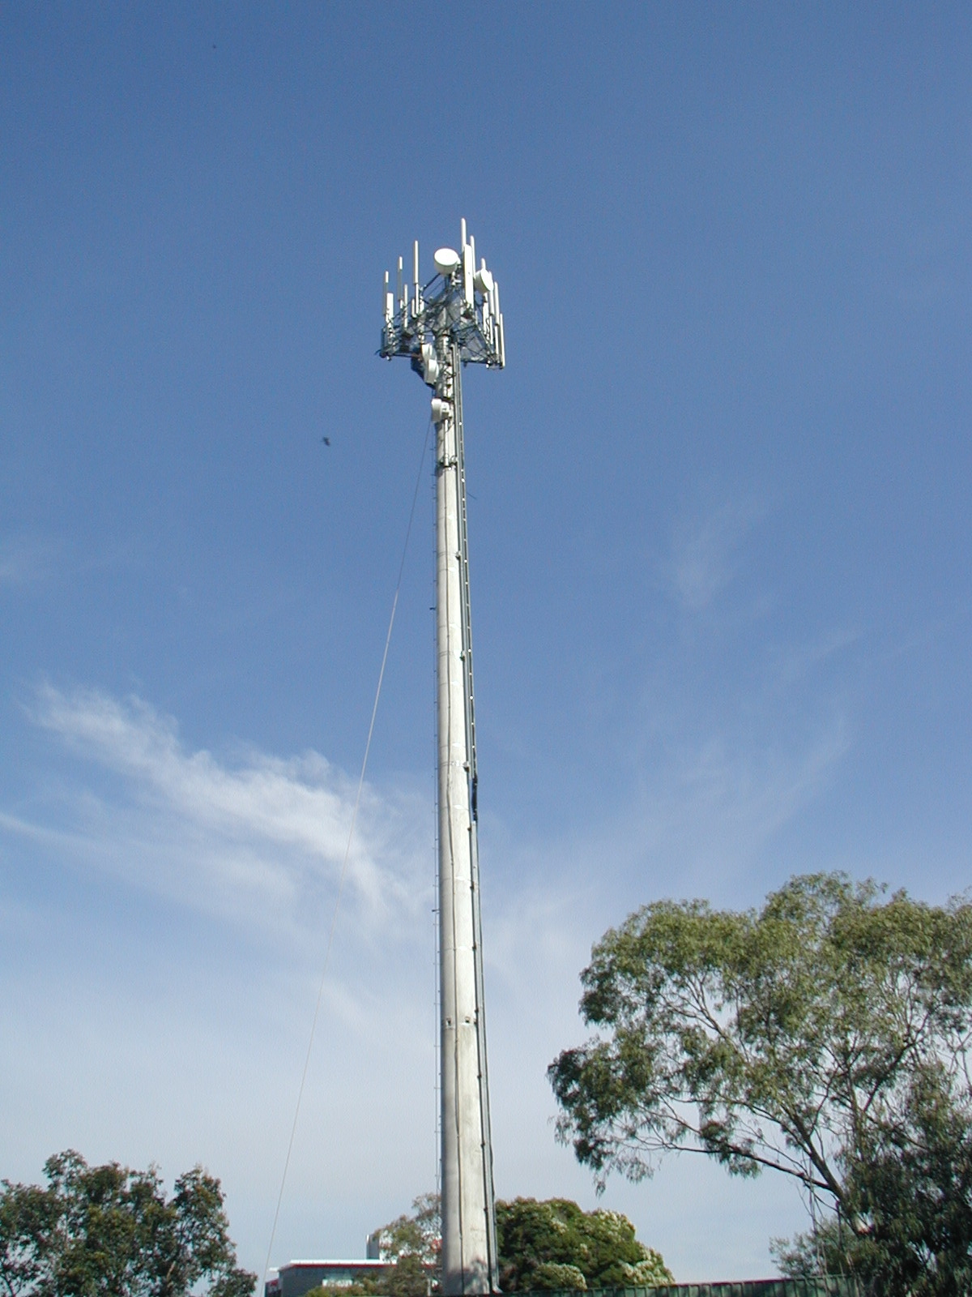 | 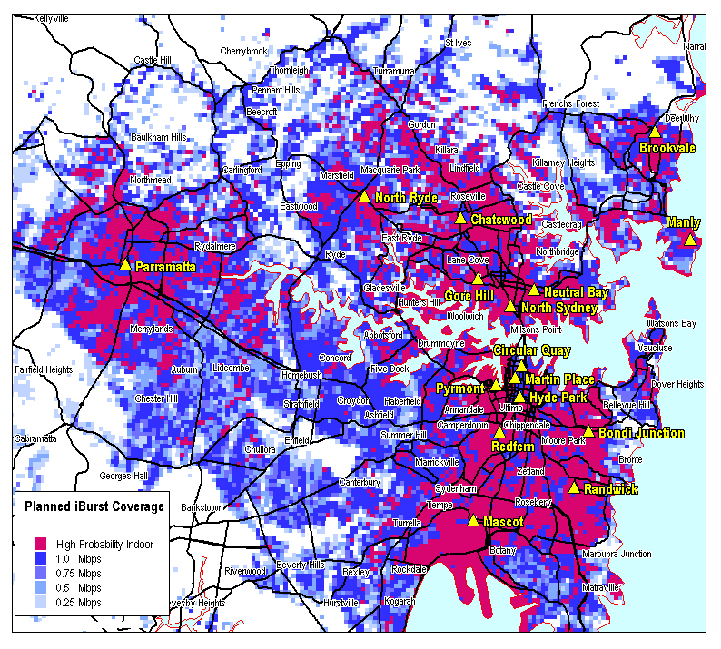 | 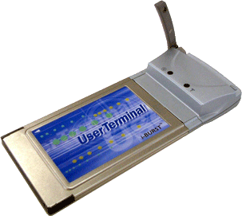
Figure 7-12 25m height Tower, Sydney MAP and Userterminal

The test result for 24 terminals communication performed total 29.6Mbps.Table 6 show throughput result for downlink performance. The logical maximum data rate is 32.4Mbps as already stated. From this result, Spacial efficiency is computed as 29.6Mbps / 32.4 Mbps ≅ 0.913 91.3%

Furthermore, about the Spectrum efficiency is computed as 29.6 Mbps / 5 MHz ≅ 5.9 bit/sec/Hz/cell

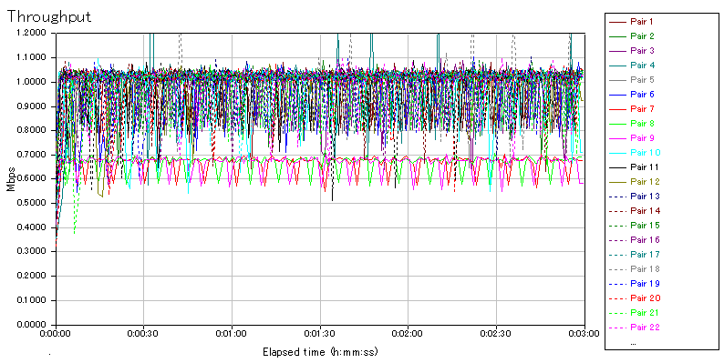
1Mbps 21Users
700Kbps 3Users
Figure 7-13: Downlink Date Rate Results

Data Flow Direction | Typical/Terminal | Total Data Rates/Basestation | Spectrum Efficiency  (bit/sec/Hz/sector)
Downlink | 942kbps | 22.6Mbps | 6.8
Uplink | 290kbps | 7.0Mbps | 4.2
Uplink | 1,232kbps | 29.6Mbps | 5.9
Figure 7-14: Date Rate and Spectrum Efficency Test Results of HC-SDMA in Australia

Low Power consumption
Usually, The realization technology of user throughput enhancement has increasing factor for power consumption. Therefore, This is very important technology for wireless broadband systems in terminal side. The choice of new process of semiconductor provides lower power consumption for wireless communication. This is big factor for low power solution.
And, The device power control technique and protocol are same as important items for low power consumption too. Definition for sleep protocol(mode) is very useful for low power control technique.
In the case of sleep mode, Mobile terminal periodically monitors own paging channel(PCH) for wake up requirement. Paging channel monitor duration go to every frames, 8 frames, 64 frames, and 512 frames. Every 1024 frame or more duration make more possibility of low consumption realization.
Duration is negotiated in the initial connection between base station.
Additionally, Fine tuning of radio power control timing is also an important technology.

Radio Network Quality monitor and control
BEST-WINE network systems provides radio network quality monitor and control functionality. These information are controlled by following strategies.

Performance Measurement
BEST-WINE equipment should be support to inform performance data for network quality maintenance.
Typical statistical data is shown below .
-Signal vs. Noise Ratio measurement (SINR)
-RSSI measurement
-Global positioning and absolute time stamp measurement (GPS)
-Total registration number
-Data rate

These performance data are transported to EMS periodically.

Diagnosis, Monitoring and Alarm
MBWA equipments should be supports diagnosis and monitoring devices functions. If a fail status is detected by these functions, BEST-WINE equipments takes the appropriate process to keep operation with minimum resource reduction and inform alarm to EMS via SNMP interface on alarm occurrence. Also, the each board on Base Unit and PA Unit also display current status using LED. Alarm severities depend on maintenance urgency.

Process statistical data and configuration control
BEST-WINE element management systems(EMS) extracts statistical data and alarm information from BEST-WINE equipments to solve network quality . EMS analyzes interference from statistical data of each equipments. And, EMS controls interference to use equipments configuration parameter .via IP network and air interface.

Radio Characteristics

The summary of radio characteristics are shown in following table.

Parameter | BS | UT
General
RF Frequency Range | 5 /10 MHz | 10 MHz
Carrier spacing | 625KHz
Ant | 12/9 | 4/2/1
Spacial Channel | 4(max) | －
TX
Average Power (dBm) per Antenna [1]  π/2-BPSK  QPSK, 8-PSK  12-QAM, 16-QAM  24-QAM  64-QAM | 30.0  dBm/stream/antenna | Class 2  27  26  25  23  21 | Class 3  22  21  20  18  16
Average Power (dBm) per Antenna per carrier | 23 dBm | Same as Average Power
Peak power(EIRP) | <55dBm( < 62dBm) | <31.5dBm( < 33dBm)
TDD activity factor (dB) [2] | 2 | 1
Antenna gain (dBi) | 11 | 0 / 4
Misc. losses (dB) [3] | 1 | 0
Adjacent Channel Power Ratio, ACPR (dB) [4]  ACPR @625 KHz off  ACPR @1.25 MHz off  ACPR @1.875 MHz to 5MHz | -9.2 dBm / ch  -16.2 dBm / ch  -16.2 dBm / ch | -35 dBc / ch  -45 dBc / ch  -50 dBc / ch
Frequency error | 0.05 ppm | 100 Hz
Out of Band Spurious Emission  0 - 5MHz  Beyond 5MHz  0kHz to 500kHz  500kHz to 5MHz  Beyond 5MHz | -3dBm/100kHz  -16dBm/100kHz  -20dBm/100kHz | Same as ACPR  -30dBm/1MHz
Modulation Accuracy (%rms)  π/2-BPSK, QPSK  8-PSK  12-QAM  16-QAM  24-QAM  64-QAM | 3.5 | 10  9  7  6  5.5  4.5
Occupied Bandwidth (kHz) | 625 | 625
Parameter | BS | UT
RX
Antenna gain (dBi) | 11 | 0 / 4
Misc. losses (dB) | 1 | 0
Thermal Noise Density (dBm/Hz) | -174
Adjacent Channel Selectivity, ACS (dB)  ACS@625KHz off (dB)  ACS@1.25MHz off to 5MHz (dB) | 30  46 | 30 (12-QAM)  27 (16, 24-QAM)  47
Active Interference Selectivity (dB) [6] | 20 – 30 | N/A
Receive Sensitivity @1% FER (dBm)  π/2-BPSK  π/2-BPSK+  QPSK  QPSK+  8-PSK  8-PSK+  12-QAM  16-QAM  24-QAM  64-QAM | -109.8  -108.2  -106.5  -103.6  -101.4  -99.1  -97.1  -95.8  -93.9  -89.4 | -108.5  -106.7  -105.2  -102.3  -100.1  -97.9  -95.8  -94.5  -92.6  -88.1
Out of Band Blocking  0.1MHz – (X-15)MHz  (Y+15)MHz – 12.75GHz  X : lower end of spectrum allocation  Y : upper end of spectrum allocation | N/A | -23 dBm  -23 dBm
Spurious Response  In-Band  1MHz > f_{off} > 0Hz  15MHz > f_{off} > 1MHz  Out of Band | 46 dB  46 dB  56 dB  56 dB | -40 dBm

Table 7-6 Radio characteristics
Notes
[1] Equivalent Isotropic Radiated Power for victim systems should be computed statistically based on the Average Power per Antenna and array geometry.
[2] A function of UL/DL ratio of the TDD mode, this parameter is not applicable to FDD operation.
[3]: Miscellaneous losses account for cable/connector losses in the TX and RX path.
[4] Defined as the ratio of the on-channel transmitted power to the power transmitted in the adjacent channel, ACPR represents out-of-band emission of the transmitter. ACPR_n in the table are ACPR values at n 5-MHz carriers away.
[5] Based on commercially available systems.
[6] Multi-antenna SDMA systems can achieve 20-30 dB active interference rejection.

Proposed Draft Specfications of BEST-WINE

This Section defines ths additional draft specification that deliver enahnaced performance to meet the SRD [3]and PAR [2]of IEEE-MBWA , which are supplemental to the Draft Specifications of the Pre published ATIS standard HC-SDMA [1]. The Complete Proposed Draft specifications are these additional specifications as listed in section 8.2 plus the Draft Specfications of HC-SDMA [1].

Draft specifications of HC-SDMA

Basic PHY/MAC/LLC (L1/L2/L3) Draft Specifications are given by the Pre published ATIS standard HC-SDMA [1].

Additional (Enahanced) Draft specifications to meet SRD of MBWA

MAC/LLC (L2/L3) Layer Enhancements

QoS Support
BEST-WINE supports the Class of Servise as listed in , which are provided by PSS and RADIUS

 | Ranking | Class definition
1) | Best Effort | Providing shared bandwidth depending on total user number
2) | Voice Priority | Providing enhanced high quality and narrow channel with link adaptation, power control and ARQ scheme.
3) | Bandwidth Priority | Providing bandwidth priority to facilitate Scheduler job.

Table 8-7 Class of Services Support

Broadcast and Multicast (BCMCS) Support
BEST-WINE supports Broadcast services for requent short message and streaming data.
For short messages broadcasting, such as Weather report, Disaster information, Maintenance etc., information, BEST-WINE uses idle CM burst as shown in Fig.

GPS 1pps timing
F
BCH(F)
CM
CCH
CR
T
BCH(T)
CM
CCH
CR
B0
BCH
CM
CCH
CR
B1
BCH
CM
CCH
CR
B7
BCH
CM
CCH
CR
FrameK+0
Frame+1
Frame+2
Frame+3
Frame+4
Frame+5
Frame+6
Frame+7
Frame+18
Frame+19
F
BCH
CM
CR
FrameK+20
～
100mS
～
Down Link
UP Link

Figure 8-15 Broadcasting/Multicasting Short Messages Service
For broadcasting the streaming data, BEST-WINE supports the use of reserved TCH burst as shown in Fig..
Approved/Authorized users can see this channel to enjoy Video streaming, IP radio so on.

625KHz
5MHz(8Carrier)
BCH
CH2
CH3
CH4
CH5
CH6
CH7
TCH
Figure 8-16 Broadcasting/Multicasting Streaming Services

Multicast Sevices also supported by using the reserved TCH channels to Multicast to the group of user or to specific area.

Security

AES
The System supports AES algorithm support with the key lengths of 128bit, 192bit and 256bit. The key length negotiation is carried out by BS and UT at the time of Registration.

Key length(bits) | Block(bits) | Round
128 | 128 | 10
192 | 128 | 12
256 | 128 | 14

Table 8-8 Combination of Key length, block and round in AES

Dos Attack
For the air interface protection, BEST-WINE provide security feature permits establishment of connection to Userterminal holding the digital certificate. This feature protects the possible damages from network hacker.

For network side protection, BEST-WINE implements the following protections against the Denial of Service Attacks (DOS) as listed in the Table. When abnormal numerical a large quantity of packets flow, BEST-WINE intiates Traffic Policing over downlink direction there by prevents CPU overload.

Kind of Dos Attack | Dos Attack type | Protection of MBWA equipments
Large Packet Sizes and and Large File Size | UDP Flooding  Ping of Death  etc | BS drops the incoming packet that packet size is larger than the internal threshold.
Extremely small packet in large quantities | UDP Flooding  Ping Flooding  Smurf  fraggle  etc | BS drops the incoming packets that it received over internal threshold Packets Per Second (ex. 6000 pps).

Low Power consumption

BEST-WINE provides Sleep Mode control Protocol to realize low power consumption at the terminal side. User (Mobile) terminal periodically monitors own paging channel (PCH) for wake up requirement. Paging channel monitoring can be configured for every frames, 8 frames, 64 frames, and 512 frames. Paing channel Monitoring durations are negotiated during the the initial connection between basestaion.

Radio Network Quality monitor and control
BEST-WINE network systems provides radio network quality monitoring and control functionality by adopting the following strategies.

Performance Measurement
BEST-WINE support the Monitoring of Air Interface Performance and its Quality maintenance by performaing the following measurements:

-Signal vs Noise Ratio measurement (SINR)
-RSSI measurement
-Global positioning and absolute time stamp measurement (GPS)
-Total registration number
-Data rate

These performance data are transported to EMS (Element Management Systems) periodically via.

Diagnosis, Monitoring and Alarm
BEST-WINE supports diagnosis, monitoring devices and alarm functions by EMS (Element Management Systems) via SNMP interface. Also, the each board on Base Unit and PA Unit also display current status using LED. Alarm severities depend on maintenance urgency.

Process statistical data and configuration control
BEST-WINE element management systems (EMS) extracts statistical data and alarm information from MBWA equipments to solve network quality . EMS analyzes interference from statistical data of each equipments. And, EMS controls interference to use equipments configuration parameter .via IP network and air interface

PHY (L1) Layer Enhancements

Peak Per User Data Rates /Spectral Effciency
Additional Modulation Class of 64 QAM.is added to the Modulation Class as shown in Table below

Table5 shows the maximum data rates for each moduration class. This table indicate a slot rate and 3 slots aggregation rate(Carrier) for up link and down link including coding ratio. The maximum data rate are calculated as following formula.

Down link : 1473Kbps x 4 Carrier aggregation = 5.89 Mbps(Max)
Up Link : 566Kbps x 4 Carrier aggregation = 2.26 Mbps(Max)

ModClass | Modulation  Method | Down Link(Kbps) |  | Up Link(Kbps)
ModClass | Modulation  Method | Data Rate  /Slot | Data Rate  /Carrier | Data Rate  /Slot | Data Rate  /Carrier
0 | BPSK | 35 | 106 | 6 | 19
1 | BPSK+ | 50 | 149 | 13 | 38
2 | QPSK | 82 | 245 | 26 | 77
3 | QPSK+ | 126 | 379 | 43 | 130
4 | 8PSK | 162 | 485 | 58 | 173
5 | 8PSK+ | 198 | 595 | 72 | 216
6 | 12QAM | 262 | 787 | 98 | 293
7 | 16QAM | 307 | 922 | 115 | 346
8 | 24QAM | 354 | 1061 | 132.8 | 398
9 * | 24QAM+ | 422 | 1267 | 162.5 | 487
10 ** | 64QAM | 491 | 1473 | 188.7 | 566

*1 24QAM+ perform error coding which has 3/4 coding rate .
*2 64QAM perform error coding which has 5/6 coding rate

Table 8-9 Maximum User data rates per Modulation Class

Supports High Mobility

In order to handle the High Mobility conditions upto 25oKmph, the training sequence space in both standard downlink burst (Figure 7-8) and standard downlink burst (Figure 7-9) of HC-SDMA carrys the training information necessary for to facilitate equalizer at the receiver end to maintain the performance even in the high mobility environment.

Training Sequence enables simple equalization at Receiver support High Mobility Conditions.

Supporting IPV4 and IPV6

MBWA Base Station (BS) and User Terminal(UT) supports IPv6 based on 3GPP2[7]. MBWA systems provides transparency interface for User IP layer. MBWA user can make possible to use IPv4 or IPv6 on the expectation. Following diagram is network protocol stack of BEST-WINE system.

PPP
IPv4 / IPv6
PL
R-P
PL
PL
MBWA
Air
Interface
R-P
PPP
IPv4 / IPv6
Link
Layer
PL
Link
Layer
IPv4 / IPv6
MS
RN(Base Station)
PDSN
End Host
3GPP2 Base Network Protocol Stack (Simple IPv6)
GRE
MBWA
Air
Interface

Summary

Table 9-10 summarizes the key elements of the BEST-WINE a TDD MBWA System

Quantity | Value
Duplex Method | TDD
Multiple Access Method | FDMA/TDMA/SDMA
Access Scheme | Collision avoidance, centrally scheduled
Carrier Spacing | 625 kHz
Frame Period | 5 ms
User Data Rate Asymmetry | 3:1 down/up asymmetry at peak rates
Uplink Time Slots | 3
Downlink Time Slots | 3
Range | > 15 km
Symbol Rate | 500 kbaud/sec
Pulse shaping | Root raised cosine
Excess channel bandwidth | 25%
Modulation and coding | - Independent frame-by-frame selection of uplink and downlink constellation + coding.  - 11 uplink constellation + coding classes  - 11 downlink constellation + coding classes  - Constant modulus and rectangular constellations
Power Control | Frame-by frame uplink and downlink open and closed loop
Fast ARQ | Yes
Carrier and timeslot aggregation | Yes
QoS | DiffServ policy specification, supporting rate limiting, priority, partitioning, etc.
Security | Mutual UT and BS authentication, encryption for privacy
Handover | UT directed, make-before-break
Resource Allocation | Dynamic, bandwidth on demand

Table 9-10 Summary of the basic elements of the MBWA TDD MBWA air interface

