`Project | IEEE 802.20 Working Group on Mobile Broadband Wireless Access  <http://grouper.ieee.org/groups/802/20/>
Title | BEST-WINE Technology Performance and Evaluation Crtieria Report 1
Date Submitted | 2005-OCT-28
Authors(s) | Radhakrishna Canchi 2480 N. First Street, Suite#280 San Jose, CA 95131  Kazuhiro Murakami  2-1-1 Kagahara, Tsuzuki-ku, Yokohama, KANAGAWA 224-8502, JAPAN  Minako Kithara  2-1-1 Kagahara, Tsuzuki-ku, Yokohama, KANAGAWA 224-8502, JAPAN | Voice: +1-408-952-4701  Fax: +1-408-954-8709  Email: cradhak@ktrc-na.com  Voice: +81 45 943 6130  Fax: +81 45 943 6175  Email: kazuhiro.murakami.xm@kyocerajp  Voice: +81 45 943 6102  Fax: +81 45 943 6175  Email: minako.kitahara.nf@kyocera.jp
Re: | MBWA Call for Proposal
Abstract | This document presents the Technology Performance and Evaluation Crtieria Report 1 of the Tehcnlogy Proposal BEST-WINE for IEEE 802. 20 MBWA
Purpose | To disucus and Adopt BEST-WINE for Draft Specfications of IEEE802.20 MBWA
Notice | This document has been prepared to assist the IEEE 802.20 Working Group. It is offered as a basis for discussion and is not binding on the contributing individual(s) or organization(s). The material in this document is subject to change in form and content after further study. The contributor(s) reserve(s) the right to add, amend or withdraw material contained herein.
Release | The contributor grants a free, irrevocable license to the IEEE to incorporate material contained in this contribution, and any modifications thereof, in the creation of an IEEE Standards publication; to copyright in the IEEE’s name any IEEE Standards publication even though it may include portions of this contribution; and at the IEEE’s sole discretion to permit others to reproduce in whole or in part the resulting IEEE Standards publication. The contributor also acknowledges and accepts that this contribution may be made public by IEEE 802.20.
Patent Policy | The contributor is familiar with IEEE patent policy, as outlined in Section 6.3 of the IEEE-SA Standards Board Operations Manual <http://standards.ieee.org/guides/opman/sect6.html#6.3> and in Understanding Patent Issues During IEEE Standards Development <http://standards.ieee.org/board/pat/guide.html>.



BEST-WINE
(Broadband MobilE SpaTial Wireless InterNet AcEess)
A Complete and Fully Compliant TDD Technology Proposal for MBWA

Technology Performance
and
Evaluation Crtieria Report 1

Executive Summary

This document BEST-WINE Technology Performance and Evaluation Crtieria Report 1 reports the performance of the BEST-WINE based on the evaluation methodology defined in IEEE802.20 Evalaution Criterai Doccument [5]. The Channel Models of Channel Model Document [4] were used.

Table of Contents
1 Executive Summary 3
2 References 8
3 Definitions 9
4 Abbreviations and acronyms 10
5 Introduction 12
5.1 Purpose of This Report 12
5.2 Key Technologies 12
5.3 System Model 12
5.3.1 Cell lay out 12
5.3.2 Base station & Mobile station (User Terminals) 14
5.4 RF parameters 14
5.5 BEST-WINE System’s PHY and MAC Layer information 15
5.5.1 BEST-WINE System Basic PHY/MAC layer parametes Channel structure 15
5.5.2 BEST-WINE Modulation classes 16
5.6 Link Budget 17
5.6.1 Suburban Macro Test Environmnet – Pedestrain B (3KMPH) 17
5.6.2 Suburban Macro at 120 KMPH 18
6 Simulation environment 20
6.1 Link – System Interface 20
6.2 Link level simulation 21
6.2.1 Link Level simulation Parameters 21
6.2.2 Channel models used in Link Level Simulations 21
6.3 System level simulation environment 23
6.3.1 System level simulation target feature 23
6.3.2 System level simulation parameters 23
6.3.3 System level simulation channel model 23
6.3.4 Traffic Model System Level Simulation 24
7 Simulation Reuslts 24
7.1 Link level simulation 24
7.1.1 Uplink (VehicularB model) FER vs SINR Performance 24
7.1.2 Downlink (Vehicular B model) FER vs SINR Performance 25
7.1.3 Uplink (PedestrianB model) FER vs SINR Performance 26
7.1.4 Downlink (PedestrianB model) FER vs SINR Performance 27
7.1.5 Uplink (Vehicular B model) Throughput vs SINR 28
7.1.6 Downlink( Vehicular B model) Throughput vs SINR 29
7.1.7 Uplink (Pedestrian B model) Throughput vs SINR 30
7.1.8 Downlink (Pedestrian B model) Throughput vs SINR 31
7.2 System level simulation calibration result 31
7.2.1 System level simulation calibration condition and parameters 31
7.3 System Level Simulation Results 32
7.3.1 User Date Rate CDF 32
7.3.2 120km/h User Date Rate CDF 32
7.3.3 Aggregated Throughput vs Base station Sepparation 34
7.4 Fairness criteria 37
8 Simulations Results Summary 39
9 Practical System Results 39

List of Figures
Figure 5-1 Cell definition in the Cartesian Coordination System and the Numbering of Cells 13
Figure 5-2 Base station Antenna pattern 13
Figure 5-3 UT positions 14
Figure 5-4 Channel Configuration in a Block Assignement of 2.5 MHz 16
Figure 6-1 Link level simulation channel models and Asscoiated Spatial Parameters 21
Figure 7-1 Uplink 120kmph FER vs received SINR 24
Figure 7-2 Downlink 120kmph FER vs received SINR 25
Figure 7-3 Uplink 3kmph FER vs received SINR 26
Figure 7-4 Downlink 3kmph FER vs received SINR 27
Figure 7-5 Uplink 120kmph Throughput vs received SINR 28
Figure 7-6 Downlink 120kmph Throughput vs received SINR 29
Figure 7-7 Uplink 3kmph Throughput vs received SINR 30
Figure 7-8 Downlink 3kmph Throughput vs received SINR 31
Figure 7-9 User Terminal Location Map for Deterministic calibration 32
Figure 7-10 120kmph User Date Rate CDF 33
Figure 7-11 3km/h CDF of throughput vs SINR 34
Figure 7-12 Contours of constant Minimum Servcie Level at 3Kmph -Downlink 35
Figure 7-13 Contours of constant Minimum Servcie Level at 120Kmph -Downlink 35
Figure 7-14 Contours of constant Minimum Servcie Level at 3Kmph -Uplink 36
Figure 7-15 Contours of constant Minimum Servcie Level at 120Kmph -Uplink 37
Figure 9-1 25m height Tower, Sydney MAP and Userterminal 40
Figure 7-13: Downlink Date Rate Results 41
Figure 7-14: Date Rate and Spectrum Efficency Test Results of HC-SDMA in Australia 41

List of Tables
Table 5-1 RF parameters 15
Table 5-2 BEST-WINE PHY/MAC Basic Parameters 16
Table 5-3 ModClasses and Maximum Data Rates 17
Table 5-4 Link Budget table (3km/h) 18
Table 5-5 Link Budget table (3km/h) 20
Table 6-1Sub-path Spatial parameters AoD and AoA offset 22
Table 6-2 Suburban Macro Environment Parameters 24
Table 7-9 120kmph User Date Rate CDF 33
Table 7-10 3km/h CDF of throughput vs SINR 34
Table 8-1 Suburban Pedestrian B Case 37
Table 8-2 Suburban Vehicular B Case 37

References
- ATIS-PP-0700004*-2005, High Capacity-Spatial Division Multiple Access (HC-SDMA)
  - *The copyright of this document is owned by the Alliance for Telecommunications Industry Solutions. Any request to reproduce this document, or portion thereof, shall be directed to ATIS, 1200 G Street, NW, Suite 500, Washington, DC 20005.
  - *For Electornic Downloads, Paper Copy or CD-ROM please follow the link https://www.atis.org/atis/docstore/doc_display.asp?ID=3617
- IEEE 802.20 PD-2.doc: Mobile Broadband Wireless Access Systems: Approved PAR (02/12/11):
- IEEE 802.20 PD-06r1.doc: IEEE 802.20 System Requirement Document (V 1.0)
- IEEE_802.20-PD-08.doc: IEEE 802.20 Channel Models (V 1.0)
- IEEE_802.20-PD-09.doc: IEEE 802.20 Evaluation Criteria (V 1.0)
- IEEE_802.20-PD-10.doc: IEEE 802.20 Techology Selection Process (V 1.0)
- X.P0011-001-D on 3gpp2 TSG-X specification

Definitions

As defined in the References [1],[2],[3]

Abbreviations and acronyms

AA | Access Assignment
AAA | Adaptive Antenna Array
ACLPR | Adjacent Channel Leakage Power Ratio
ACS | Adjacent Channel Selectivity
AM | Acknowledged Mode
API | Application Programming Interface
ARQ | Automatic Repeat Request
BCH | Broadcast Channel
BS | Base Station
BSCC | Base Station Color Code
CA | Certificate Authority
CCH | Configuration Channel
CM | Configuration Message
CoS | Class of Service
CR | Configuration Request
CRC | Cyclic Redundancy Check
EUD | End User Device
FACCH | Fast Asscoiated Control Channel
FEC | Forward Error Control
FER | Frame Error Rate
GPS | Global Positioning System
HC-SDMA | High Capacity Spatial Division Multiple Access
i-HAP | Handshake and Authentication Protocol
IMSI | International Mobile Station Identifier
IPPR | Intermodulation Product Power Ratio
i-SEC | Secure Communications Protocol
i-TAP | Terminal Authentication Protocol
IWAN | Interconnection Wide Area Network
L2 | Layer 2
L2TP | Layer 2 Tunneling Protocol
L3 | Layer 3
L3 | CM L3 Connection Management
L3 | MMC L3 Mobility Management and Control
L3 | RM L3 Registration Management
LLC | Logical Link Control
LDAP | Lightweight Directory Access Protocol
LFSR | Linear Feedback Shift Register
LNA | Low Noise Amplifier
LNS | L2TP Network Server
LSB | Least Significant Bit
MAC | Medium Access Control
MBWA | Mobile Broadband Wireless Access
MSB | Most Significant Bit
PA | Power Amplifier
PAR | Project Authorization Requirments
PCH | Paging Channel
PDCL | Packet Data Conversion Layer
PHY | Physical Layer
PID | Paging Identity
PPM | Parts Per Million
PPP | Point to Point Protocol
PPPoE | PPP over Ethernet
PSS | Packet Services Switch
QoS | Quality of Service
RA | Request Access
RACH | Random Access Channel
RSA | Rivest, Shamir, Adleman
RF | Radio Frequency
RLC | Radio Link Control
RM | Registration Management
RMU | RLC Message Unit
RRC | Radio Resource Control or Root Raised Cosine
RSSI | Received Signal Strength Indicator
SDMA | Space Division Multiple Access
SDU | Service Data Unit
SINR | Signal-to-Interference plus Noise Ratio
SN | Slot Number
SNR | Signal to Noise Ratio
TCH | Traffic Channel
TDD | Time Division Duplex
TDMA | Time Division Multiple Access
TWAN | Transport Wide Area Network
UM | Unacknowledged Mode
UT | User Terminal

Introduction

By this document, Kyocera Team respectfully submits Technolgy Performance and Evaluation Report 1 for th Proposed TDD Technology tilted BEST-WINE (Broadband MobilE SpaTial Wireless InterNet AcEess), which is an enhanced Air Interface based on “ATIS-PP-0700004-2005, High Capacity-Spatial Division Multiple Access (HC-SDMA), (Pre Published American National Standard)”[1].

This Evaluation Report 1 Report presents the both the system and linke level Technolgy Performance results obtaine by the Simulations by following the methodologies sepcficied in Evaluation Criteria Document [5] while using Suburban Macro Channel Model and related spatial parameters as defined in Channel Model Document [4]. Both the link level and System Level performaces are obtained at the User Terminal Mobility Speeds of 3Kmph and 120Kmph. Also this report provides Linkbudget calculation for each o

Purpose of This Report

This Evalaution Report 1 serves as the basis for comparing with other technology Proposals and

Key Technologies

Key technologies of the BEST-WINE system are

- Adaptive Anetenna Array Processing
- Spatial Division Multiple Access
- Link Adaptation With Modulation & Coding Classes

System Model

Cell lay out
19BS / 3sector
The systel layout consists of 19 Cell sites with each Cell split in 3 Sectors as shown in Figure 5-1. Inter BS separation is 1.73 Km and the Cell Radius is 1Km.
Each cell is divided into 3 sectors, characterized by the antenna direction of each sector. The number of sector is counter-clock wise with 0, 1 and 2, respectively, where the respective antenna direction is 0: theta=0 degree, 1: theta=120 degree,
3: theta=240 degree, where theta is the local polar angle of the cell. By this convention, the first sector of the center cell has the index (0, 0), while the last sector has the index (18,2). Mobiles are uniformly dropped in each sector, where an area around the cell center with radius 35 meters are excluded for mobiles. The unit of distance is meter.
Figure 5-1 Cell definition in the Cartesian Coordination System and the Numbering of Cells

Each base station in each sector employs Antennas that has radiation patter as shown in Figure 5-2.

Figure 5-2 Base station Antenna pattern

Base station & Mobile station (User Terminals)

Inter BS separation is 1.73 Km.
Cell Radius is 1Km.
Load user number: 58users
User terminal: Rx 4antenna or 1antenna / Tx 1antenna
BS: Rx & Tx antenna elements 12antenna
Antenna separation 10λ
UTs are placed uniform distribution in the 19BS area.
UT’s have two states: Conneced State and Not connected state.

Figure 5-3 UT positions

RF parameters

Table 1. RF parameter table
# | RF Parameter  TDD System BW | Base Value  1 MHz Channel | 2.5 MHz  TDD - SYSTEM
1 | Transmitter Power -- BS | 43 dBm/MHz | +44 dBm
2 | Transmitter Power -- MS | 27 dBm | +27 dBm
3 | Out of Band emission limits – BS and MS (emission measured in 1 MHz resolution bandwidth) | Attenuation of the transmit power P by: 43 +10 log(P) dB | -13 dBm
4* | ACLR - Attenuation of emissions into an adjacent channel (same Ch BW) – BS | 43 dB | 50.2 dB
5* | ACLR - Attenuation of emissions into an adjacent channel (same Ch BW) – MS | 36.8 dB | 35.4 dB
6 | Receiver noise figure -- BS | 5 dB | 5 dB
7 | Receiver noise figure -- MS | 10 dB | 10 dB
8 | Receiver reference sensitivity (to be proposed by each technology) | Specify at BER of 0.1% | See linkbudget
9* | Receiver Selectivity -- BS | Mod 1 /Mod 7 : 30 dB | 30 dB
10* | Receiver Selectivity -- MS | Mod 1 : 30 dB  Mod 8 : 27 dB | 30 dB  27 dB
# | Frequency offset for Blocking | 4MHz off | 5MHz off
11[*] | Receiver Blocking – BS (level of same technology blocking signal at frequency offset of 2 times Channel BW) | Mod 1 : -49.6 dBm  Mod 7 : -35.6 dBm | -49.6 dBm  -35.6 dBm
12[*] | Receiver Blocking – MS (level of same technology blocking signal at frequency offset of 2 times Channel BW) | Mod 1 : -57.5 dBm  Mod 8 : - 41.6 dBm | -57.5dBm  -41.6dBm

Table 5-1 RF parameters

BEST-WINE System’s PHY and MAC Layer information

BEST-WINE System Basic PHY/MAC layer parametes Channel structure

Items |  | Specification
Duplexing |  | TDD
Mutiple Access |  | TDMA ・SDMA
Single Carrier Bandwidth |  | 625 kHz
Frame Lenght |  | 5 ms
symbol duration |  | 2usec
Uplink Time Slot | slots | 3
 | Length | 545 us
 | Payload | 182 symbols
Downlink Time Slot | slots | 3
 | Length | 1090 us
 | Payload | 494 symbols
Symbol rate |  | 500 ksps

Table 5-2 BEST-WINE PHY/MAC Basic Parameters

For BEST-WINE TDD system Block Assignment Size of 2.5MHz has been assumed. So, this block assignment accomdates 4 Single Carriers of 625KHz width and its channel configuration is shown below.

2.5MHz
frequency
625kHz

Figure 5-4 Channel Configuration in a Block Assignement of 2.5 MHz

BEST-WINE System employs Adaptive Antenna Array Processing using MMSE Algorithm. Antenna Array Weights calculated for Uplink will be used for Downlink transmissions that follow.

BEST-WINE Modulation classes

BEST-WINE system Suppports 10 Modulation Clasess, refereed as ModClass, which defines Modulation and Coding Scheme Combination. There are 10 ModClasses as mentioned in the following Table. The tiered Multilevel Modulation schemes facilitate Link Adaptation. There are 7 Modulation Schemse: BPSK,QPSK,8-PSK,12QAM,16QAM,24 QAM and 64 QAM. The moaximu data rates associated with these ModClasses are also defined in the Table

Down link : 1473Kbps x 4 Carrier aggregation = 5.89 Mbps(Max)
Up Link : 566Kbps x 4 Carrier aggregation = 2.26 Mbps(Max)

*1 24QAM+ perform error coding which has 3/4 coding rate .
*2 64QAM perform error coding which has 5/6 coding rate.
Table 5-3 ModClasses and Maximum Data Rates

Link Budget

Suburban Macro Test Environmnet – Pedestrain B (3KMPH)
id/ii | Item | Downlink | Uplink
 | Test environment | Suburban macro-cell | Suburban macro-cell
 | Operating frequency | 1.9GHz | 1.9GHz
 | Test service | full buffer | full buffer
 | Multipath channel class | Case III(Pedestrian B) | Cases III(Pedestrian B)
ii/id | (a0) Average transmitter power per traffic channel | 1 slot Tx : 32.3 dBm | 1 slot Tx : 17.1 dBm
ii/id | (a0) Average transmitter power per traffic channel | 2 slot Tx : 35.3 dBm | 2 slot Tx : 20.1 dBm
ii/id | (a0) Average transmitter power per traffic channel | 3 slot Tx : 37.0 dBm | 3 slot Tx : 21.9 dBm
Id | (a1) Maximum transmitter power per traffic channel dBm | 39 | 27
Id | (a2) Maximum total transmitter power dBm/MHz | 43 | 27
Ii | (b) Cable,connector,and combiner losses (enumerate sources) [dB] | 3 | 0
 | Body Losses [dB] | 0 | 3
Ii | (c) Transmitter antenna gain [dBi] | 17 | 0
Id | (d1) Transmitter e.i.r.p. per traffic channel [ dBm] =a1-b+c | 53 | 27
Id | (d2) Total transmitter e.i.r.p. =a2-b+c | 57 | 27
 | Penetration Loss (Ref: 3GPP2) 10 dB (Vehicular) | 0 | 0
Ii | (e) Receiver antenna gain [dBi] | 0 | 17
Ii | (f) Cable and connector losses [dB] | 0 | 3
 | Body Losses [dB] | 3 | 0
Ii | (g) Receiver noise figure [ dB] | 10 | 5
Ii | (h) Thermal noise density dBm/Hz | -174 | -174
Ii | H) (linear unts) mW/Hz | 3.98 ´ 10–18 | 3.98 ´ 10–18 mW/Hz
Id | (i) Receiver interference density (NOTE 1) [dBm/Hz] | -120.9691001 | -120.9691001
Id | (I) (linear units) [mW/Hz] | 8E-13 | 8E-13
Id | (j) Total effective noise plus interference density [dBm/z] | -120.968884 | 120.969018
Id | = 10 log (10((g + h)/10) + I) | -120.968884 | 120.969018
Ii | (k) Information rate (10 log (Rb)) [dB(Hz)]
Ii | @mod0 | 53.98 | 53.98
Ii | @mod1 | 55.25 | 55.25
Ii | @mod2 | 56.99 | 56.99
Ii | @mod3 | 58.75 | 58.75
Ii | @mod4 | 60.00 | 60.00
Ii | @mod5 | 60.97 | 60.97
Ii | @mod6 | 61.76 | 61.76
Ii | @mod7 | 62.43 | 62.43
Ii | @mod8 | 63.01
d | (l) Required Eb/(N0 + I0) at BER0.1%
d | @mod0 | 2.51 | 2.21
d | @mod1 | 3.04 | 2.54
d | @mod2 | 2.80 | 2.50
d | @mod3 | 3.94 | 3.64
d | @mod4 | 4.89 | 4.59
d | @ mod5 | 6.12 | 5.92
d | @ mod6 | 7.43 | 7.13
d | @ mod7 | 8.06 | 7.76
d | @mod8 | 9.38
Id | (m) Receiver sensitivity = (j + k + l) @ BER0.1%
Id | @mod0 | -121.47 | -121.77
Id | @mod1 | -119.67 | -120.17
Id | @mod2 | -118.17 | -118.47
Id | @mod3 | -115.27 | -115.57
Id | @mod4 | -113.07 | -113.37
Id | @mod5 | -110.87 | -111.07
Id | @mod6 | -108.77 | -109.07
Id | @mod7 | -107.47 | -107.77
Id | @mod8 | -105.57
Id | (n) Hand-off gain[ dB] | 2 | 2
Id | (o) Explicit diversity gain [dB] | 6 | 0
Id | (o¢) Other gain [dB] | 21.6 | 10.8
Id | (p) Log-normal fade margin [dB] | 10.4 | 10.4
Id | q) Maximum patlos{d1 – m + (e – f) + o + n + o¢ – p} dB
Id | @mod0 | 190.67 | 165.17
Id | @mod1 | 188.87 | 163.57
Id | @mod2 | 187.37 | 161.87
Id | @mod3 | 184.47 | 158.97
Id | @mod4 | 182.27 | 156.77
Id | @mod5 | 180.07 | 154.47
Id | @mod6 | 177.97 | 152.47
Id | @mod7 | 176.67 | 151.17
Id | @mod8 | 174.77
Id | (r) Maximum range
Id | @mod0 | 35292.50 | 6593.49
Id | @mod1 | 31351.18 | 5934.73
Id | @mod2 | 28405.12 | 5306.76
Id | @mod3 | 23471.43 | 4385.03
Id | @mod4 | 20308.71 | 3794.16
Id | @mod5 | 17572.16 | 3261.38
Id | @mod6 | 15304.72 | 2859.29
Id | @mod7 | 14050.20 | 2624.91
Id | @mod8 | 12399.29

Table 5-4 Link Budget table (3km/h)

Suburban Macro at 120 KMPH

Id/ii | Item | Downlink | Uplink
 | Test environment | Suburban macro-cell | Suburban macro-cell
 | Operating frequency | 1.9GHz | 1.9GHz
 | Test service | full buffer | full buffer
 | Multipath channel class | Case IV(Vehicular B) | Case IV(Vehicular B)
ii/id | (a0) Average transmitter power per traffic channel | 1 slot Tx : 32.3 dBm | 1 slot Tx : 17.1 dBm
ii/id | (a0) Average transmitter power per traffic channel | 2 slot Tx : 35.3 dBm | 2 slot Tx : 20.1 dBm
ii/id | (a0) Average transmitter power per traffic channel | 3 slot Tx : 37.0 dBm | 3 slot Tx : 21.9 dBm
id | (a1) Maximum transmitter power per traffic channel dBm | 39.0 dBm | 27 dBm
id | (a2) Maximum total transmitter power dBm/MHz | 43 | 27
ii | (b) Cable,connector,and combiner losses (enumerate sources) [dB] | 3 | 0
 | Body Losses [dB] | 0 | 3
ii | (c) Transmitter antenna gain [dBi] | 17 | 0
id | (d1) Transmitter e.i.r.p. per traffic channel [ dBm] =a1-b+c | 53 | 27
id | (d2) Total transmitter e.i.r.p. =a2-b+c | 57 | 27
 | Penetration Loss (Ref: 3GPP2) 10 dB (Vehicular) | 10 | 10
ii | (e) Receiver antenna gain [dBi] | 0 | 17
ii | (f) Cable and connector losses [dB] | 0 | 3
 | Body Losses [dB] | 3 | 0
ii | (g) Receiver noise figure [ dB] | 10 | 5
ii | (h) Thermal noise density dBm/Hz | -174 | -174
ii | (H (linear unit) mW/Hz | 3.98 ´ 10–18 | 3.98 ´ 10–18 mW/Hz
id | (i) Receiver interference density (NOTE 1) [dBm/Hz] | -120.9691001 | -120.9691001
id | (I) (linear units) [mW/Hz] | 8E-13 | 8E-13
id | (j) Total effective noise plus interference density [dBm/Hz | -120.968884 | -20.969038
id | = 10 log (10((g + h)/10) + I) | -120.968884 | -20.969038
ii | (k) Information rate (10 log (Rb)) [dB(Hz)]
ii | @mod0 | 53.98 | 53.98
ii | @mod1 | 55.25 | 55.25
ii | @mod2 | 56.99 | 56.99
ii | @mod3 | 58.75 | 58.75
ii | @mod4 | 60.00 | 60.00
ii | @mod5 | 60.97 | 60.97
ii | @mod6 | 61.76 | 61.76
ii | @mod7 | 62.43 | 62.43
ii | @mod8 | 63.01
id | (l) Required Eb/(N0 + I0)
id | @mod0 | 2.51 | 2.21
id | @mod1 | 3.04 | 2.54
id | @mod2 | 2.80 | 2.50
id | @mod3 | 3.94 | 3.64
id | @mod4 | 4.89 | 4.59
id | @ mod5 | 6.12 | 5.92
id | @ mod6 | 7.43 | 7.13
id | @ mod7 | 8.06 | 7.76
id | @mod8 | 9.38
Id | (m) Receiver sensitivity = (j + k + l)
Id | @mod0 | -121.47 | -121.77
Id | @mod1 | -119.67 | -120.17
Id | @mod2 | -118.17 | -118.47
Id | @mod3 | -115.27 | -115.57
Id | @mod4 | -113.07 | -113.37
Id | @mod5 | -110.87 | -111.07
Id | @mod6 | -108.77 | -109.07
Id | @mod7 | -107.47 | -107.77
Id | @mod8 | -105.57
id | (n) Hand-off gain[ dB] | 2 | 2
Id | (o) Explicit divesity gain [dB] | 3.7 | 0
Id | (o¢) Other gain [dB] | 18.7 | 10.8
Id | (p) Log-normal fade margin [dB] | 10.4 | 1.4
Id | q) Maximum patrn loos {d1 – m + (e–f) + o + n + o¢ – p} dB
Id |  @mod0 | 188.47 | 165.17
Id | @mod1 | 186.67 | 163.57
Id | @mod2 | 185.17 | 161.87
Id | @mod3 | 182.27 | 158.97
Id | @mod4 | 180.07 | 156.77
Id | @mod5 | 177.87 | 154.47
Id | @mod6 | 175.77 | 152.47
Id | @mod7 | 174.47 | 151.17
Id | @mod8 | 172.57
id | (r) Maximum range
id | @mod0 | 30536.92 | 6593.49
id | @mod1 | 27126.68 | 5934.73
id | @mod2 | 24577.60 | 5306.76
id | @mod3 | 20308.71 | 4385.03
id | @mod4 | 17572.16 | 3794.16
id | @mod5 | 15204.36 | 3261.38
id | @mod6 | 13242.44 | 2859.29
id | @mod7 | 12156.97 | 2624.91
id | @mod8 | 10728.51

Table 5-5 Link Budget table (3km/h)

Simulation environment

Link – System Interface

The simulations were divided into two steps, link level simulatin and System level simulation.
The SINR versus FER characteristic were obtained by the link level simulation for all the modulation classes. Based on this link level simulation results, System(Network Level) were carried out to obtain the performance of BEST-WINE airinterface in the defined Suburban Macro radio test environment.

Link level simulation

Link Level simulation Parameters
- TDD /TDMA system
- 3 timeslot structure
- BS antenna number 12antennas
- UT antenna number 4antennas
- Tx 1antenna / Rx 4 or 1 antennas
- Adaptive Array Antenna (MMSE)
- Equalizer : Equalizer has been employed to over come multipath Distortion effects.

Channel models used in Link Level Simulations

Models |  | case-iii |  | case-Iv
PDP |  | Pedestrian-B (Phase I) |  | Vehicular-B (Phase I)
Number of Paths |  | 6 |  | 6
Relative Path power (dB) | Delay (ns) | 0 | 0 | -2.5 | 0
Relative Path power (dB) | Delay (ns) | -0.9 | 200 | 0 | 300
Relative Path power (dB) | Delay (ns) | -4.9 | 800 | -12.8 | 8900
Relative Path power (dB) | Delay (ns) | -8.0 | 1200 | -10.0 | 12900
Relative Path power (dB) | Delay (ns) | -7.8 | 2300 | -25.2 | 17100
Relative Path power (dB) | Delay (ns) | -23.9 | 3700 | -16.0 | 20000
Speed (km/h) |  | 3 |  | 120
Mobile Station | Topology | 0.5λ |  | 0.5λ
Mobile Station | PAS | RMS angle spread of 35 degrees per path with a Laplacian distribution |  | RMS angle spread of 35 degrees per path with a Laplacian distribution
Mobile Station | DoT (degrees) | -22.5 |  | 22.5
Mobile Station | AoA (degrees) | 67.5 (all paths) |  | 67.5 (all paths)
Base Station | Topology | 10λ-spacing
Base Station | PAS | Laplacian distribution with RMS angle spread of 2 degrees per path depending on AoA/AoD
Base Station | AoD/AoA (degrees) | 50^{ο} for 2^{ο} RMS angle spread per path 20^{ο} for 5^{ο} RMS angle spread per path

Figure 6-5 Link level simulation channel models and Asscoiated Spatial Parameters

Sub-path # (m) | Offset for a 2 deg AS at BS (Macrocell)  $Δ_{n,m,\text{AoD}}$ (degrees) | Offset for a 35 deg AS at MS  $Δ_{n,m,\text{AoA}}$(degrees)
1, 2 | $±$0.0894 | $±$1.5649
3, 4 | $±$0.2826 | $±$4.9447
5, 6 | $±$0.4984 | $±$8.7224
7, 8 | $±$0.7431 | $±$13.0045
9, 10 | $±$1.0257 | $±$17.9492
11, 12 | $±$1.3594 | $±$23.7899
13, 14 | $±$1.7688 | $±$30.9538
15, 16 | $±$2.2961 | $±$40.1824
17, 18 | $±$3.0389 | $±$53.1816
19, 20 | $±$4.3101 | $±$75.4274

Table 6-6Sub-path Spatial parameters AoD and AoA offset

System level simulation environment

System level simulation target feature
- TDD system
- 3 timeslot structure
- Spatial Divison multiple Access feature (Max. 4 )
- Power control
- Link adaptation

System level simulation parameters
- BS antenna number 12antennas (10λ)
- UT antenna number 4antennas(0.5λ)
- 19BS 3sector
- BS max Tx power 39dBm/12ant
- UT max Tx power 27dBm
- BS antenna gain 17dBi
- UT antenna gain 0dBi
- BS NF 5dB
- UT NF 10dB
- Temperature 15℃
- BS cable loss 3dB
- UT body loss 3dB
- 1carrier (625KHz). Simulation ( 1.25MHz BW= 625kHz ×4carrier)

System level simulation channel model

.
Channel Scenario | Suburban Macro
Number of paths (N) | 6
Number of sub-paths (M) per-path | 20
Mean AS at BS | E[$σ_{\text{AS}}$] =5⁰
AS at BS as a lognormal RV | $μ_{\text{AS}}$= 0.69  $ε_{\text{AS}}$= 0.13
$$r_{\text{AS}}={σ_{\text{AoD}}}/{σ_{\text{AS}}}$$ | 1.2
Per-path AS at BS (Fixed) | 2⁰
BS per-path AoD Distribution standard distribution | $η(0,σ_{\text{AoD}}^{2})$where $σ_{\text{AoD}}=r_{\text{AS}}σ_{\text{AS}}$
Mean AS at MS | E[σ_{AS, MS}] = 68⁰
Per-path AS at MS (fixed) | 35⁰
MS Per-path AoA Distribution | $$η(0,σ_{\text{AoA}}^{2}(\text{Pr}))$$
Delay spread as a lognormal RV | μ_{DS} = - 6.80  ε_{DS} = 0.288
Mean total RMS Delay Spread | E[$σ_{\text{DS}}$] = 0.17 μs
$$r_{\text{DS}}={σ_{\text{delays}}}/{σ_{\text{DS}}}$$ | 1.4
Distribution for path delays
Lognormal shadowing standard deviation | 10dB
Pathloss model (dB), d is in meters | 31.5 + 35log₁₀(d)

Table 6-7 Suburban Macro Environment Parameters

Traffic Model System Level Simulation

The simulation was carried out by full-duplex mode (UL-DL) in the same run and by assuming full buffers (Infinite backlog) model. No ARQ is employed.

Simulation Reuslts

Link level simulation

The following Sections report the FER versus SINR perfroance and LInklevel throughput curves for the 7 ModClasses in Uplink and 8 ModClasses in Downlinj

Uplink (VehicularB model) FER vs SINR Performance

Figure 7-6 Uplink 120kmph FER vs received SINR

Downlink (Vehicular B model) FER vs SINR Performance

Figure 7-7 Downlink 120kmph FER vs received SINR

Uplink (PedestrianB model) FER vs SINR Performance

Figure 7-8 Uplink 3kmph FER vs received SINR

Downlink (PedestrianB model) FER vs SINR Performance

Figure 7-9 Downlink 3kmph FER vs received SINR

Uplink (Vehicular B model) Throughput vs SINR
.

Figure 7-10 Uplink 120kmph Throughput vs received SINR

Downlink( Vehicular B model) Throughput vs SINR
The Downlink characteristic of the reception SINR and Throughput in 120kmph is shown in a figure.

Figure 7-11 Downlink 120kmph Throughput vs received SINR

Uplink (Pedestrian B model) Throughput vs SINR

Figure 7-12 Uplink 3kmph Throughput vs received SINR

Downlink (Pedestrian B model) Throughput vs SINR

Figure 7-13 Downlink 3kmph Throughput vs received SINR

System level simulation calibration result

System level simulation calibration condition and parameters
- Path number1
- Environment: Suburban macro
- BS & MS antenna number 1
- Inter BS separation 2.5km
- 1carrier(625kHz).
- 1 user/timeslot @sector
user1 (-60, R/2) @timeslot1
user2 (0,R/2)@timeslot2
user3 (60, R)@ timeslot3
(degree, distance from the BS)

System level simulation calibration result is in the attached XLS data: Calibration_data.xls.
Figure 7-14 User Terminal Location Map for Deterministic calibration

System Level Simulation Results

User Date Rate CDF
In this section we present system level simulation results as per the output metrics suggested by the Evalaution Criteria Document [5]. In the following User Data rate CDFs

120km/h User Date Rate CDF
CDF (Uplink and downlink) of User data rate in 120 kmph is shown in Figure.
Blue line shows downlink throughput CDF.
Red line shows uplink throughput CDF.

According to the result of Gnuplot in 120km/h environment, Uplink result shows higher performance about higher distribution in user data rate. On the otherhand, Downlink result shows normal distribution in user data rate. However, it can maintain higer spectram efficiency in 120km/h environment.

Table 7-8 120kmph User Date Rate CDF
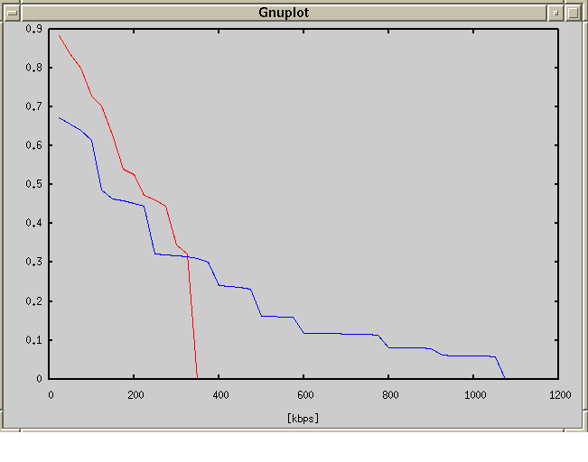
Figure 7-15 120kmph User Date Rate CDF

3km/h Uplink and Downlink
CDF (Uplink and downlink) of User data rate in 3 kmph is shown in Figure.
Blue line shows downlink throughput CDF.
Red line shows uplink throughput CDF.

According to the result of Gnuplot in 3km/h environment, Uplink and Down link results show higher performance about higher distribution in high user data rate. Also, many user can keep higher data rate stably so that user can enjoy stable higher broadband access in 3 km/h environment.. Theee results also have possibility to make higer spectral efficiency in other simulation results.
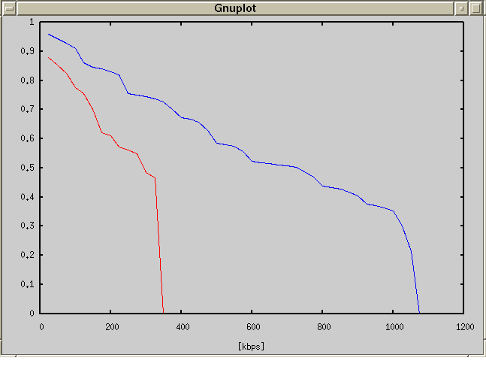
Figure 7-16 3km/h CDF of throughput vs SINR

Aggregated Throughput vs Base station Sepparation
The minimum service level is computed by the simulation, by changing inter BS Separation and the number of load users.

In measurement of Minimum service level, the degradation by the increase in load user number is larger compared with degradation by the increase in Base station separation.
The maximum SC number required of a base station is 4[SC] @4Carrier BS=48use.
In the 120 km/h simulation[vehicular B], aggravation of frequency efficiency was seen compared with 3 km/h [Pedestrian B].

Downlink
Followings are the contour plots of constant uplink minimum service levels against full buffer users per sector versus basestation separation.
The following figures are the plots by 3 time slot aggregation per 1BS and 1 career.

3 Kmph

Figure 7-17 Contours of constant Minimum Servcie Level at 3Kmph -Downlink

120 Kmph
Figure 7-18 Contours of constant Minimum Servcie Level at 120Kmph -Downlink

Uplink
Followings are the contour plots of constant downlink minimum service levels against full buffer users per sector versus basestation separation.
The following figures are the plots by 3 time slot aggregation per 1BS and 1 career.

3 Kmph
Figure 7-19 Contours of constant Minimum Servcie Level at 3Kmph -Uplink

120 Kmph
Figure 7-20 Contours of constant Minimum Servcie Level at 120Kmph -Uplink

Fairness criteria

The CDF of the Normalized throughput with Respect to average user throughput was deatermined for Cell radius 1km.

Table 8-9 Suburban Pedestrian B Case
Normalized throughput with Respect to average user throughput | Uplink | Downlink
<0.1 | 0.142% | 0.0%
<0.2 | 0.285% | 0.142%
<0.5 | 0.285% | 0.142%

Table 8-10 Suburban Vehicular B Case

Normalized throughput with Respect to average user throughput | Uplink | Downlink
<0.1 | 0% | 0
<0.2 | 0% | 0
<0.5 | 0.432% | 0.519%

Simulations Results Summary

Downlink average spectral efficiency ＝
$\frac{\text{Downlink} \text{aggregate} \text{total} \text{throughput} \text{in} \text{57} \text{sec}\text{tors} }{\text{57 sectors}×(3\text{slot}×\text{1090}μ\text{sec/}5m\text{sec})×2\text{.}5\text{MHz}}×\frac{\text{23}}{\text{24}}$

Uplink average spectral efficiency ＝
$\frac{\text{Uplink} \text{aggregate} \text{total} \text{throughput} \text{in} \text{57} \text{sec}\text{tors} }{\text{57 sectors}×(3\text{slot}×\text{545}μ\text{sec/}5m\text{sec})×2\text{.}5\text{MHz}}×\frac{\text{23}}{\text{24}}$

*Downlink time slot time: 1090 μsec, Downlink time slot time: 545 μsec
*One frame time : 5msec

 | Spectral Efficiency @pedestrian B | Spectral Efficiency @Vehicular B
Uplink | 3.155 | 2.592
Downlink | 4.248 | 1.776

Practical System Results

The proposed BEST-WINE’s Base systems HC-SDMA [1] has been implemented and tested in some countries. The section illustrates the performance results spacial channels in delivering high spectrum efficiency in Australia.

HC-SDMA [1] implemented spacial channel testing in Nov 7th 2003 at North Sydney (North ride). Basestation had 12 dipole antennas on 25m height tower and terminals are of PCMCIA type as shown in Figure 9-21 . Total 5MHz bandwidth (625KHz x 8Carrier) was used for performance testing. The basestation performs 8 Carrier communication including BCH and 3 spacial channels simultaneously. User terminal needs to use 625KHz bandwidths for 1Mbps communication. Therefore, Basestation delivered the following data rates to a total of24 (3 × 8) User simultaneously.

User terminal data rate without BCH : Uplink 1,061 kbps
Downlink 346 kbps
User terminal data rate with BCH : Uplink 707 kbps
:Downlink 231 kbps

So, Aggregate data rate (1,061 kbps ＋ 346 kbps) × 7 Carrier × 3 Spacial
+ (707 kbps + 231 kbps) × 1 Carrier × 3 Spacial ≅ 32.4 Mbps.

HC-SDMA system could deliver Aggregate data rate ≅ 32.4 Mbps. The corresponding Maximum Spectrum efficiency that is achieved in 5MHz band is 32.4 Mbps / 5 MHz≅ 6.5 bit/sec/Hz/cell

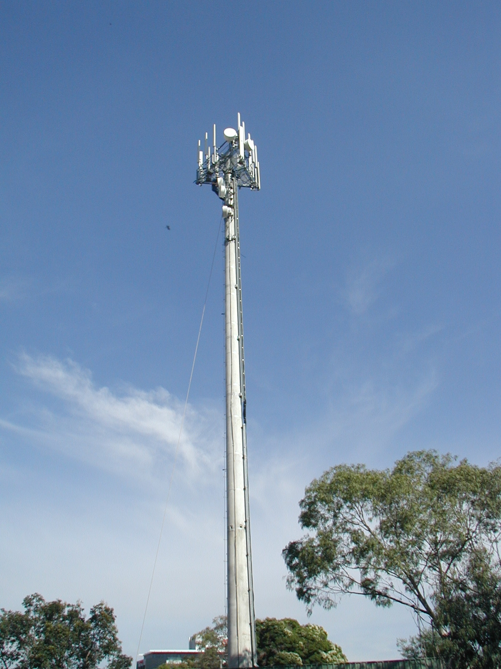 | 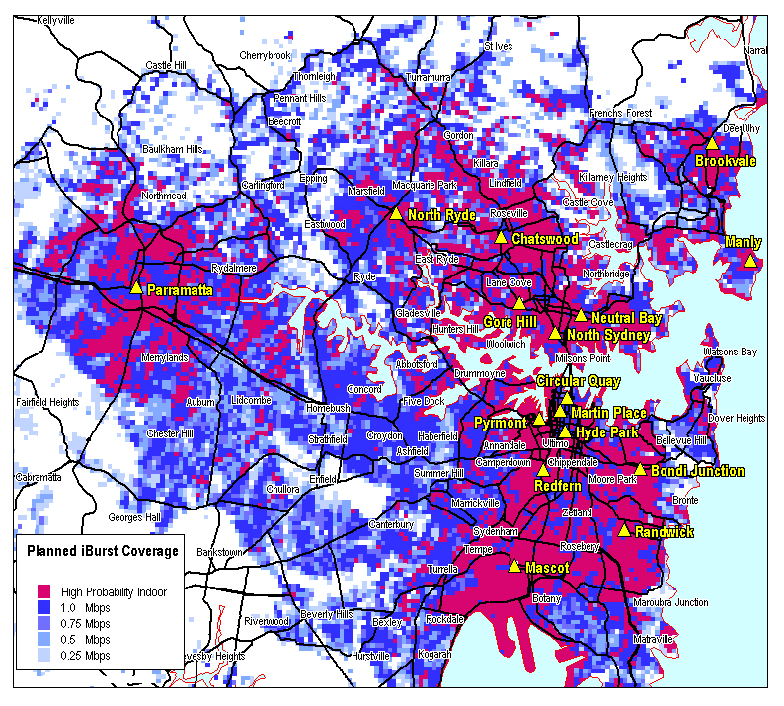 | 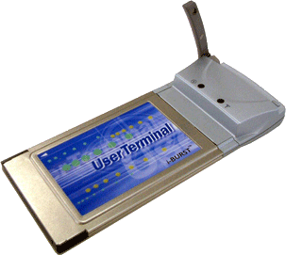
Figure 9-21 25m height Tower, Sydney MAP and Userterminal

The test result for 24 terminals communication performed total 29.6Mbps.Table 6 show throughput result for downlink performance. The logical maximum data rate is 32.4Mbps as already stated. From this result, Spacial efficiency is computed as 29.6Mbps / 32.4 Mbps ≅ 0.913 91.3%

Furthermore, about the Spectrum efficiency is computed as 29.6 Mbps / 5 MHz ≅ 5.9 bit/sec/Hz/cell

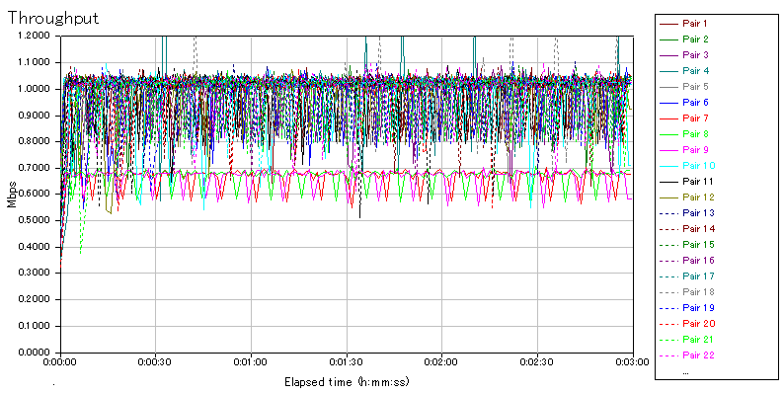
1Mbps 21Users
700Kbps 3Users
Figure 7-22: Downlink Date Rate Results

Data Flow Direction | Typical/Terminal | Total Data Rates/Basestation | Spectrum Efficiency  (bit/sec/Hz/sector)
Downlink | 942kbps | 22.6Mbps | 6.8
Uplink | 290kbps | 7.0Mbps | 4.2
Uplink | 1,232kbps | 29.6Mbps | 5.9
Figure 7-23: Date Rate and Spectrum Efficency Test Results of HC-SDMA in Australia

