9 Fairness Criteria

In the evaluation of spectral efficiency and in order to make a fair comparison of different proposals, it is important that all mobile users be provided with a minimal level of throughput. The fairness is evaluated by determining the normalized cumulative distribution function (CDF) of the user throughput, which meets a predetermined function.

Let Tput[k] be the throughput for user k. The normalized throughput with respect to the average user throughput for user k, ${\tilde{T}}_{\text{put}}[k]$ is given by:
${\tilde{T}}_{\text{put}}[k]=\frac{T_{\text{put}}[k]}{\underset{i}{\text{avg}}{\text{ T}}_{\text{put}}[i]}$.
The CDF of the normalized throughputs with respect to the average user throughput for all users in the system is determined. This CDF shall lie to the right of the curve given by the points in Table 1.
Table 1 Fairness Criterion CDF
Normalized Throughput w.r.t average user throughput | CDF
0.2 | 0.0
0.3 | 0.1
0.4 | 0.2
0.5 | 0.3
0.6 | 0.4
0.7 | 0.5

The users with normalized throughput below 0.2 are declared in outage. The percentage of users in outage shall be below 2%.

An example of normalized user throughput CDF is given in Figure 1. In this example plot, average user throughput is uniformly distributed between 20-100 Kb/s i.e. a factor of 5 difference between the best user and the worse user average throughput. It can be noted that this example CDF lies to the right of the fairness curve and hence meets the fairness criteria.

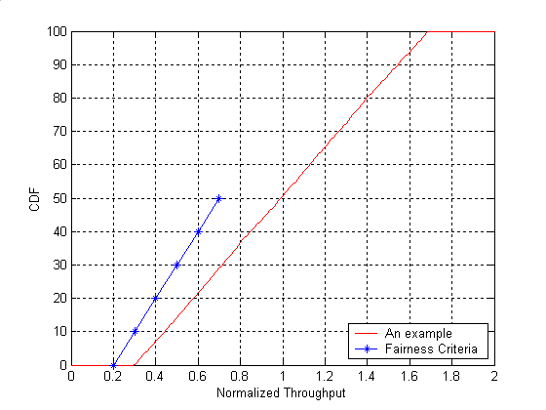
Figure 1 An example of normalized user throughput CDF.

