Project | IEEE 802.21 MIHS  <http://www.ieee802.org/21/>
Title | A new MIH Event with Subnet Information IE
DCN | 21-06-0528-00-0000
Date Submitted | February 6, 2006
Source(s) | Soohong Daniel Park  SAMSUNG Electronics.  416, Maetan-3dong, Yeongtong-gu,  Suwon, KOREA, 443-742 | Voice: +82-31-200-4508  Fax: +82-31-200-3972  {soohong.park}@samsung.com
Re: | IEEE 802.21 Session #13 in Denver, US
Abstract | This contribution proposes a parameter in conjunction with Subnet Information of Information Element of MIIS to be used for upper layer trigger when attaching to new networks.
Purpose | Adoption
Notice | This document has been prepared to assist the IEEE 802.21 Working Group. It is offered as a basis for discussion and is not binding on the contributing individual(s) or organization(s). The material in this document is subject to change in form and content after further study. The contributor(s) reserve(s) the right to add, amend or withdraw material contained herein.
Release | The contributor grants a free, irrevocable license to the IEEE to incorporate material contained in this contribution, and any modifications thereof, in the creation of an IEEE Standards publication; to copyright in the IEEE’s name any IEEE Standards publication even though it may include portions of this contribution; and at the IEEE’s sole discretion to permit others to reproduce in whole or in part the resulting IEEE Standards publication. The contributor also acknowledges and accepts that IEEE 802.2 may make this contribution public.
Patent Policy | The contributor is familiar with IEEE patent policy, as outlined in Section 6.3 of the IEEE-SA Standards Board Operations Manual <http://standards.ieee.org/guides/opman/sect6.html#6.3> and in Understanding Patent Issues During IEEE Standards Development <http://standards.ieee.org/board/pat/guide.html>.

Drawback for supporting inter-subnet handover along with Subnet Information IE

Subnet Information is to provide subnet information (I.e., prefix of IPv6, subnet mask of IPv4, etc.) as one of Information Elements of MIIS described in Table 6. It could help in inter-subnet handovers. There are, however, some of pitfalls to provide efficient handover operations based on subnet information on its local stack because of lack of related event/commend.

Table 6 – Information Elements

Higher layer services/information per PoA |  |  |  | Length  (octets)
4.1 | TYPE_IE_POA_SUBNET_INFORMATION | Information about subnets supported by a typical PoA | (IPv4/IPv6)  Each PoA may be assigned to multiple subnets. | Variables

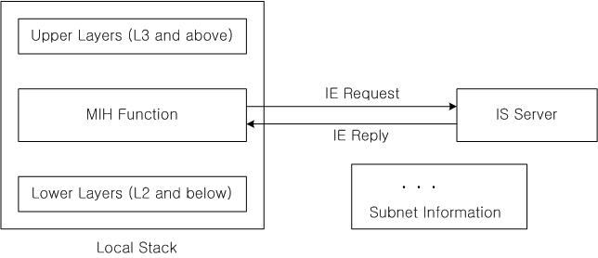

After obtaining a subnet information using MIIS on its local stack, MIH Function can not progress further related operations based on subnet information.

Proposal

To achieve a whole procedure in conjunction with Subnet Information IE, new operations are required as follows;

- Upper layer triggering when obtaining the different subnet information comparing with existing subnet information, then the MS will prepare required operations to configure its new IP address when inter-subnet handovers happen. Upon receipt of “Link Detected”, “MIH IP Reconfiguration” event is used for triggering upper layer so as to prepare its IP configuration procedure immediately.

Table 3 – MIH Events

Event  Id | MIH Event  Type | MIH Event Name | Local (L), Remote (R) | Remote Direction | Description
XX | State Change | MIH IP Reconfiguration | L | N/A | New subnet has been detected. Upper layer should prepare its new IP address configuration immediately.

7.4.5 MIH Events

7.4.5.x MIH_IP_Reconfiguration.indication

7.4.5.x Function
MIH_IP_Reconfiguration notification is sent by the MIH Function to upper layers to indicate subnet information of a new PoA. More parameters are TBD.

The event can be local only.

Parameters:

Name | Type | Valid  Range | Description
MacMobileTerminal | MAC Address |  | MAC Address of Mobile Terminal
MacNewPoA | MAC Address |  | MAC Address of new PA/BS
SubnetInformation | BITMAP |  | Subnet information of a new PoA  0: Different IPv4 subnet  1: Different IPv6 subnet

7.4.5.x When generated
This notification is generated when receiving subnet information different from existing subnet information based on value of certain Information Elements as TYPE_IE_POA_SUBNET_INFORMATION.

7.4.5.x Effect on receipt
Higher layer may take necessary actions on this notification. Upper layer may prepare to initiate a new IP configuration procedure based on the subnet information reported as part of the event.

