Project | IEEE 802.21 MIHS  <http://www.ieee802.org/21/>
Title | A new Link Command with Subnet Information IE
DCN | 21-06-0529-00-0000
Date Submitted | February 6, 2006
Source(s) | Soohong Daniel Park  SAMSUNG Electronics.  416, Maetan-3dong, Yeongtong-gu,  Suwon, KOREA, 443-742 | Voice: +82-31-200-4508  Fax: +82-31-200-3972  {soohong.park}@samsung.com
Re: | IEEE 802.21 Session #13 in Denver, US
Abstract | This contribution proposes a parameter in conjunction with Subnet Information of Information Element of MIIS to be used for lower layer trigger when attaching to new networks.
Purpose | Adoption
Notice | This document has been prepared to assist the IEEE 802.21 Working Group. It is offered as a basis for discussion and is not binding on the contributing individual(s) or organization(s). The material in this document is subject to change in form and content after further study. The contributor(s) reserve(s) the right to add, amend or withdraw material contained herein.
Release | The contributor grants a free, irrevocable license to the IEEE to incorporate material contained in this contribution, and any modifications thereof, in the creation of an IEEE Standards publication; to copyright in the IEEE’s name any IEEE Standards publication even though it may include portions of this contribution; and at the IEEE’s sole discretion to permit others to reproduce in whole or in part the resulting IEEE Standards publication. The contributor also acknowledges and accepts that IEEE 802.2 may make this contribution public.
Patent Policy | The contributor is familiar with IEEE patent policy, as outlined in Section 6.3 of the IEEE-SA Standards Board Operations Manual <http://standards.ieee.org/guides/opman/sect6.html#6.3> and in Understanding Patent Issues During IEEE Standards Development <http://standards.ieee.org/board/pat/guide.html>.

Drawback for supporting inter-subnet handover along with Subnet Information IE

Subnet Information is to provide subnet information (I.e., prefix of IPv6, subnet mask of IPv4, etc.) as one of Information Elements of MIIS described in Table 6. It could help in inter-subnet handovers. There are, however, some of pitfalls to provide efficient handover operations based on subnet information on its local stack because of lack of related event/commend.

Table 6 – Information Elements

Higher layer services/information per PoA |  |  |  | Length  (octets)
4.1 | TYPE_IE_POA_SUBNET_INFORMATION | Information about subnets supported by a typical PoA | (IPv4/IPv6)  Each PoA may be assigned to multiple subnets. | Variables

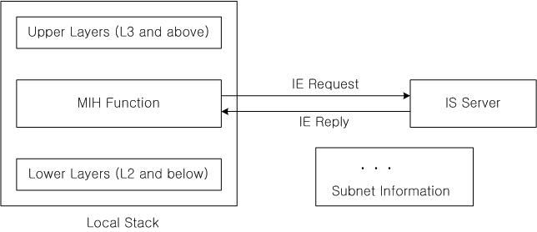

After obtaining a subnet information using MIIS on its local stack, MIH Function can not progress further related operations based on subnet information.

Proposal

To achieve a whole procedure in conjunction with Subnet Information IE, new operations are required as follows;

Note: The different subnet information is documented into a separated proposal. This section only mentions the same subnet case.

- If same subnet comparing with existing subnet information, “Link Configure Subnet Information” command is used to link configuration. “Link Handover Imminent” is configured on its link accordingly. Upon link detection, L2 handover is imminent not triggering upper layers. No operation is required for upper layer during handover.

Table 5 – Link Commands

No | Link Command | Comments
X | Link Configure Subnet Information | Configure the subnet information for the same subnet attachment. No operation is required for upper layers while attaching to a new link. Link Handover Imminent is applied for the link change.

7.3.x Link_Configure_Subnet_Information.request

7.3.x.1 Function
This primitive is used by MIH Function or the link layer to configure subnet information for Link Handover Imminent indication.

7.3.x.2 Semantics of service primitive
The primitive parameters are as follows:

Link_Configure_Subnet_Information.request (
LinkHandover
)

Name | Type | Valid Range | Description
Link Handover | Subnet Indication |  | Subnet indication for handover which prevent upper layers to initiate a new IP configuration procedure when attaching to the same subnet networks.

7.3.x.3 When generated
This primitive is generated by an upper layer entity that may need to set subnet information for handover.

7.3.x.4 Effect on receipt
The recipient responds immediately with Link_Configure_Subnet_Information.confirm primitive.

7.3.x Link_Configuration_Subnet_Information.confirm

7.3.x.1 Function
This primitive is sent in response to the Link_Configure_Subnet_Information.request primitive. This primitive specifies the subnet types of a new network either same subnet networks or different subnet networks.

7.3.x.2 Semantics of service primitive
The primitive parameters are as follows:

Link_Configure_Subnet_Information.confirm (
Status
)

Name | Type | Valid Range | Description
Status |  |  | Success  Error

7.3.x.3 When generated
This primitive is generated in response to the Lnk_Configure_Subnet_Information.request operation.

7.3.x.4 Effect on receipt
The recipient prepares to perform a Link Handover Imminent for link layer handovers which does not need a new IP configuration procedure.

