Project | IEEE 802.21 MIHS  <http://www.ieee802.org/21/>
Title | IEEE 802.3 and IEEE 802.11 Handover Scenario (An Example)
DCN | 21-06-0530-00-0000
Date Submitted | February 6, 2006
Source(s) | Soohong Daniel Park  SAMSUNG Electronics.  416, Maetan-3dong, Yeongtong-gu,  Suwon, KOREA, 443-742 | Voice: +82-31-200-4508  Fax: +82-31-200-3972  {soohong.park}@samsung.com
Re: | IEEE 802.21 Session #13 in Denver, US
Abstract | This contribution proposes an example of IEEE 802.3 and IEEE 802.11 handover implementation.
Purpose | Adoption
Notice | This document has been prepared to assist the IEEE 802.21 Working Group. It is offered as a basis for discussion and is not binding on the contributing individual(s) or organization(s). The material in this document is subject to change in form and content after further study. The contributor(s) reserve(s) the right to add, amend or withdraw material contained herein.
Release | The contributor grants a free, irrevocable license to the IEEE to incorporate material contained in this contribution, and any modifications thereof, in the creation of an IEEE Standards publication; to copyright in the IEEE’s name any IEEE Standards publication even though it may include portions of this contribution; and at the IEEE’s sole discretion to permit others to reproduce in whole or in part the resulting IEEE Standards publication. The contributor also acknowledges and accepts that IEEE 802.2 may make this contribution public.
Patent Policy | The contributor is familiar with IEEE patent policy, as outlined in Section 6.3 of the IEEE-SA Standards Board Operations Manual <http://standards.ieee.org/guides/opman/sect6.html#6.3> and in Understanding Patent Issues During IEEE Standards Development <http://standards.ieee.org/board/pat/guide.html>.

Annex D

(Informative)

D.1 IEEE 802.3 and IEEE 802.11 Handover Scenario (An Example)

D.1.1 Outlook on IEEE 802.3 and IEEE 802.11 Handover

This section describes an example of seamless handover along with MIHF (MIES and MICS) which can maintain its connectivity when attaching to the wireless network from the wired and vice versa without user intervention. Especially, Interface Manager depicted in Figure 2 below newly designed to handle the current wired and wireless interfaces status and switches over each interface by itself to support seamless handover between them. This mechanism is useful for efficient merging of the wired and wireless infrastructure as well as the new services and applications. Through this mechanism, a mobile device can simply use continuous Internet services when in motion between different technologies even if wired interface is failed on sudden.

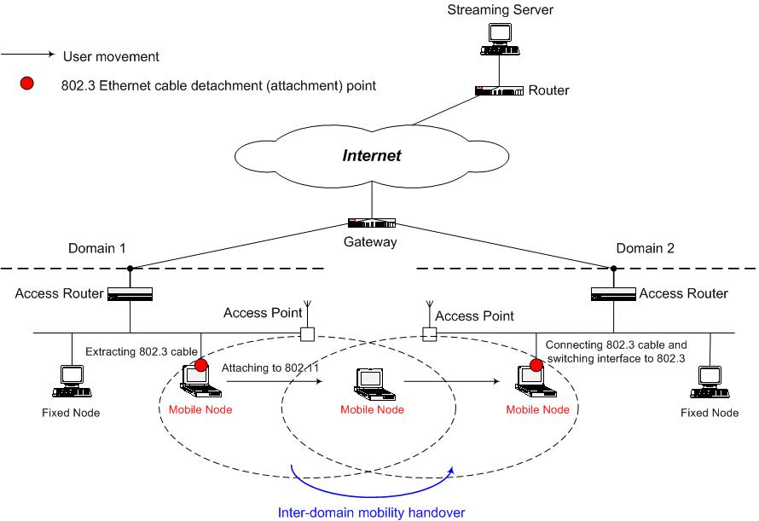

Figure 1 - Network architecture for moving between wired and wireless networks

Most of today’s devices are operating on Microsoft Windows systems which allow installations of multiple network adapters such as wired adaptor and wireless adaptor, Linux and other Operating Systems are in use though. This section tries to illustrate how mobile terminals perform its handover between wired networks and wireless networks based on Microsoft Windows Operating System following the voice of market. The example illustrated in this section can be easily expanded for other Operating Systems in their own characteristics. In addition, existing wireless technologies such as IEEE 802.15, IEEE 802.16, IEEE 802.20, etc can be also wireless interface instead of IEEE 802.11. To report what happen during handover between wired interface and wireless interface, MIES is used for indicating its status to the upper layer as Interface Manager located between MIH layer and IP layer shown in Figure 2.

D.1.2 Detailed Flow based on Windows Operating System

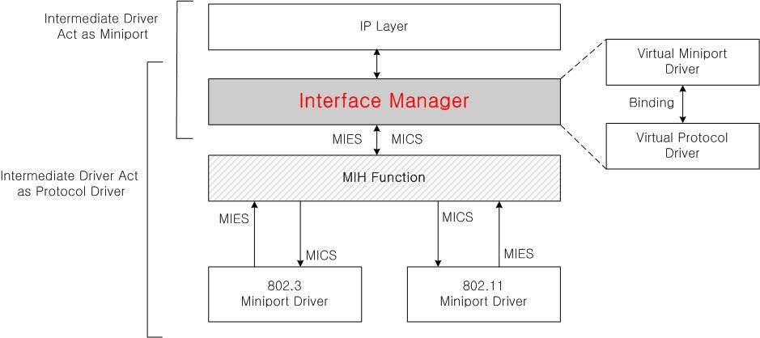
Firstly, an intermediate driver called Interface Manager is developed newly to modify packets sent from protocol driver (IP Layer) then sends them to miniport driver (Layer 2 interfaces), and vice versa. The intermediate driver resides in between protocol driver and miniport driver, communicates with both miniport and protocol drivers as shown in Figure 2. MIH Function is a transparent layer between IP Layer and Layer 2 interfaces. Note that the intermediate driver doesn't always exist, but exists only when it is needed by the developer. The intermediate drive generates virtual protocol driver on the bottom and virtual miniport drive on top.

Figure 2 - Interface Manager Conceptual Model

In other words, if we take a look at the virtual protocol drive and miniport driver on the bottom of the intermediate driver, then the intermediate driver works as the virtual protocol driver; and if we take a look at the virtual miniport driver and protocol driver on top of the intermediate driver, then the intermediate driver works as the virtual miniport driver. At this point, the virtual miniport driver is recognized by actual upper level protocol driver as just another adapter. The reason why the intermediate driver and the virtual drivers are in use is to solve some of the problems for the seamless handover.

Firstly, when there are two network adapters, each adapter must have different IP address, therefore, seamless communication is compromised during handover. Due to this reason, a virtual adapter is used, whereas the actual protocol driver binds only with the virtual adapter to operate. This way, the layers above the protocol driver use the IP address assigned to this virtual adapter to communicate.

Secondly, the intermediate drive can filter out data, which is sent to TCP/IP protocol driver in the event of a network adapter's network connection ends, to prevent session disconnection. Through this process, the layers above the protocol driver do not know what is going in the lower level.

Thirdly, use of the intermediate driver gives advantage of changing packet routing in real-time. By selecting the optimal adapter to be used for communication in accordance with the network connection status, packets can be transmitted and received through the optimal adapter.

When this is realized, handover between wired and wireless network adapters can be done without disrupting the connection. The intermediate driver in accordance with this section can be divided into virtual miniport driver and virtual protocol driver as shown in Figure 3. The virtual miniport driver includes virtual adapter control module. The virtual adapter control module generates a virtual adapter to control binding of an actual protocol driver to the virtual adapter. Furthermore, to set up each network adapter's property during the binding of the virtual protocol driver and a network adapter at lower level, the virtual adapter control module sets all network adapters that are bound, to wireless adapter's Layer 2 address. Here, under wired adapter, packet filtering property is set to promiscuous mode, which accepts all packets, and under wireless adapter, the property is set to direct/multicast/broadcast modes, which are typical. Hereinafter, the virtual adapter's Layer 2 address is used as the wireless adapter's Layer 2 address. In other words, under the wired adapter, since promiscuous mode is set, even though the virtual adapter's Layer 2 address is set as the Layer 2 address of the wireless adapter, corresponding packets can be transmitted and received. However, under the wireless adapter, since typical mode is used, the wireless adapter's Layer 2 address is just used. Therefore, to upper protocol drivers, only one virtual adapter set with a Layer 2 address is shown. Advantages from this are as follows.

Firstly, by using the same Layer 2 address, there is no need for retransmission of the address resolution protocol (ARP) packets to update ARP table in a hub.

Secondly, when assigning address dynamically using the dynamic host configuration protocol (DHCP), Layer 2 address is used as one of options of DHCP protocol to identify the corresponding host. Here, by using the same Layer 2 address again, DHCP server recognizes host as the same host and thus the same IP address is assigned over and over.

Thirdly, when using Layer 2 address in IPv6 (Internet Protocol version 6) environment assign IPv6 address through stateless auto configuration, since the Layer 2 address is the same, it is possible to assign an identical address.

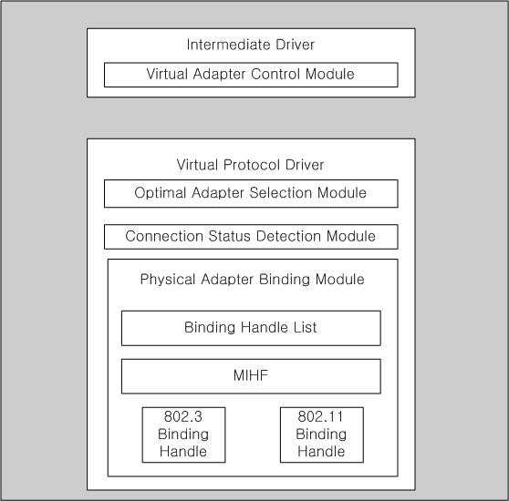
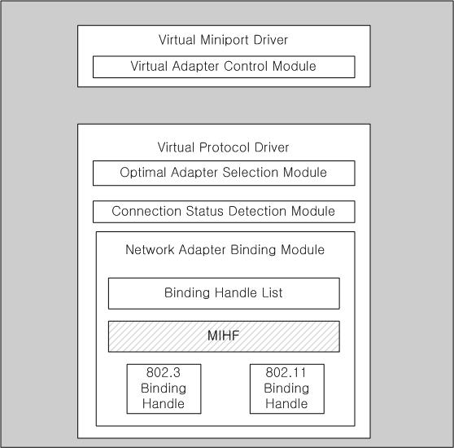

Figure 3 - Detailed Diagram of the Interface Manager

When upper level protocol drivers request data of an adapter, the virtual adapter control module reports optimal adapter information selected by an optimal adapter selection module to an upper level protocol driver. Furthermore, the virtual adapter control module sends packet through binding handle of an optimal adapter chosen by the optimal adapter selection module. A virtual protocol driver includes an optimal adapter selection module, a connection status detection module and a network adapter binding module. The optimal adapter selection module decides to which adapter to transmit or to receive in accordance with connection information of wired and wireless network adapter which is delivered from the connection status detection module. The connection status detection module detects connection status information of the wired and wireless network adapters based on the MIES (e.g., Link Up, Link Down, Link Going Down, etc.), then provides the information to the optimal adapter selection module in real-time. The network adapter binding module generates binding handle list through binding with all active adapters. In the binding handle list, binding handle and status information for controlling bound network adapters are stored.

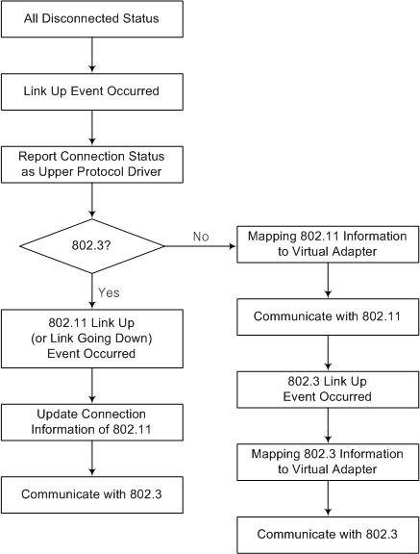

Figure 4 - Flowchart during Connection Event

As illustrated in Figure 4, when a connection event (MIES) occurs while all wired and wireless network adapters are in disconnection status, the connection status detection module is used to recognize which adapter is in connection status. Based on the connection status, connection information of the corresponding adapter that is in the binding handle list of the network adapter binding module is updated. At first, this updated information is sent to the virtual adapter control module in real-time; then, right away the virtual adapter control module reports the connection status to the upper level protocol driver. After that, the optimal adapter selection module determines whether the connected network adapter is wired or wireless through the MIH Commands (e.g., MIH Switch, etc.). If it is the wired connection, then a wired adapter is selected and sent the information to the virtual adapter control module.

If a wireless connection event (Link Up) occurs during wired communication, the connection status detection module recognizes connection of a wireless adapter, and this information updates only the connection information of the wireless adapter listed in the binding handle list of the network adapter binding module. If a connection event of a wireless adapter occurs while all others are in disconnection status, the connection information obtained by the connection status detection module updates the connection status information of the corresponding adapter listed in the binding handle list of the network adapter binding module. Upon the updated information, the optimal adapter control module selects the wireless adapter through as the optimal adapter. And then, the virtual adapter control module maps the information on the wireless adapter into a virtual adapter. Then, communication is performed via the wireless adapter. If a wired connection event (Link Up) occurs during wireless communication, the information detected by the connection status detection module is updated into the binding handle list and based on the updated information, the optimal adapter changes from the wireless to the wired by the optimal adapter selection module in conjunction with MIH Commands (e.g., MIH Switch, etc.).

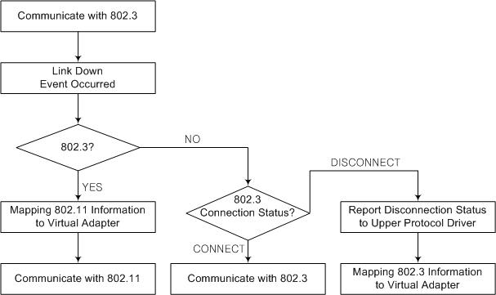

Figure 5 - Flowchart during Disconnection Event

Furthermore, the wired adapter's information is mapped on to the virtual adapter. And at last, communication is performed via the wired adapter. According to Figure 5, when a disconnection event (Link Down) occurs during the wired communication, the connection status detection module determines whether the disconnected adapter is wired or wireless. If the adapter is the wired adapter, the corresponding adapter's connection status information is updated to the binding handle list of the network adapter binding module. Then, the wireless adapter becomes the optimal adapter via the optimal adapter selection module, and the wireless adapter information is mapped to the virtual adapter. Then, communication is performed via the wireless adapter. If the disconnected adapter is not wired, the current connection status of the wired adapter must be verified. Upon the verification through MICS (e.g., MIH Get Status, MIH Scan, etc.) if the wired adapter is still in connection, then communication is performed via the wired adapter. However, if the wired adapter is in disconnected status, the status is reported to the upper level protocol driver via MIES (e.g., MIH Link Down reporting wired connection is broken and link is not available for use) , and the wireless adapter's information is mapped on to the virtual adapter.

