3GPP TSG SA WG2 Architecture — S2#52 SAE S2-061921
08 - 12 May 2006
Shanghai, China

Source: Intel, Telcordia, Toshiba, InterDigital, Huawei, Benq-Mobile, Lucent
Title: Facilitating Generic Inter-RAT Handovers
Document for: Approval
Agenda Item: 7.9.2
Work Item / Release: SAE, Release 7
Introduction & Discussion:
The scope of TR 23.882 includes several objectives for the SAE. Some of the key aspects addressed by these objectives are as follows:
- Overall architecture impacts stemming from the work in SA1 on an all-IP Network (AIPN) (see TR 22.978), e.g.:
  - support of a variety of different access systems (existing and future) and access selection based on combinations of operator policies, user preferences and access network conditions;
- Overall architecture aspects of supporting mobility between heterogeneous access networks, including service continuity. E.g.:
  - service continuity between I-WLAN and the 3GPP PS domain;
  - how to support multiple radio access technologies, and terminal mobility between different radio access technologies.
Intra-technology handovers (such as those within GSM, UMTS networks) are optimized by use of extensive measurement reporting between UE and network, neighbour cell advertisements, and network-initiated handovers. Another example is handovers between two different access networks which are both connected and controlled by a common core network such as between GSM and UMTS (totally different air-interface, common core network, inter-3GPP handovers). Even in the case of inter-technology handovers (such as between GSM and UMTS networks having different radio interfaces) the handover is optimized by use of inter-RAT (Radio Access Technology) information exchanges/advertising which includes information about neighbour cells and measurement reports, and the handovers are controlled by the network.
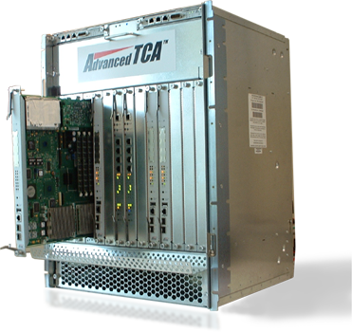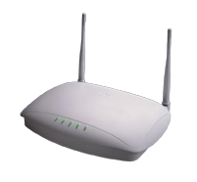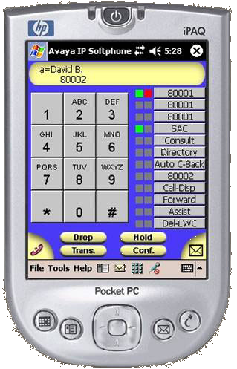

Figure -1: Exchange of Inter-RAT Information between UE and Network
Neighbour Maps/ Information

Handover Commands

This same concept can be extended to handovers between heterogeneous networks such as between 3GPP access and non 3GPP access (between 802 networks and SAE/LTE) and thus reduce long handover delays and high rate of unsuccessful handovers. In a heterogeneous network environment, the UE and the network need to interact with each other and exchange inter-RAT information. This includes information on neighbour maps of different networks available in a given geographical area, properties of different networks such as available Security and QoS, subscriber and roaming agreements across different operators for different available networks and higher layer services (such as internet connection, IMS services, etc.) available on these networks. The UE can retrieve this information using any active radio. Other radios on the UE can be in a low-power state. Once the information is available, the UE can bring the other appropriate radios into active state based on network selection procedures taking into account available networks, roaming agreements and available services.
As an example a UE could receive information about a nearby WLAN hotspot over a GSM radio. This eliminates the burden on UE of having to continuously scan for availability of different networks. Most radios in UE can remain in low power states during normal operation. The UE can power on appropriate radios only if there is a good possibility of continuing the current connection (handing over) onto the new network. This can result in significant power savings and increased battery life for the UE.
Thus in order to support efficient handover between 3GPP access and non 3GPP access there is a need for network to indicate to the UE about the supported non-3GPP Systems. UE should also be capable of retrieving additional information (such as neighbour maps and other services supported) from the network about the supported non-3GPP Systems. This capability allows the UE or the network to initiate more efficient handovers to/from non-3GPP systems.
There is also a need to define a set of handover commands for inter-technology handovers. These handover commands allow the UE and the network to exchange information about list of candidate access networks and thus co-operate in selection of best candidate access network, thereby significantly increasing the chances of successful handovers.

Proposal:
The adoption of the following text into TR 23.882
______________________________________________________________________

*** Change Start ***

5 Requirements on the Architecture
High-level principles
- 3GPP and non 3GPP access systems shall be supported.
…..
- It shall be possible for the operator to provide the UE with access network information pertaining to locally supported 3GPP and non-3GPP access technologies; The access network information may also include operator preferences based on locally available 3GPP and non-3GPP access technologies and the information may be restricted to access technologies or access networks the UE can use.

*** Change End ***

