Project | IEEE 802.21 MIHS  <http://www.ieee802.org/21/>
Title | Suggestions about Piggyback Acknowledgement: LB Issue- #33: Comment 713
DCN | 21-06-0xxx-00-0000
Date Submitted | September 7, 2006
Source(s) | Peng Yan, Guo Junxiang, Xia Bin
Re: | IEEE 802.21 Session #16 in Melbourne, Australia
Abstract | This contribution is a response to LB Issue #33 in comment assignment and provides a more efficient acknowledgement mechanism, which allows single or multiple ACKs to be piggybacked on other traffic.
Purpose
Notice | This document has been prepared to assist the IEEE 802.21 Working Group. It is offered as a basis for discussion and is not binding on the contributing individual(s) or organization(s). The material in this document is subject to change in form and content after further study. The contributor(s) reserve(s) the right to add, amend or withdraw material contained herein.
Release | The contributor grants a free, irrevocable license to the IEEE to incorporate material contained in this contribution, and any modifications thereof, in the creation of an IEEE Standards publication; to copyright in the IEEE’s name any IEEE Standards publication even though it may include portions of this contribution; and at the IEEE’s sole discretion to permit others to reproduce in whole or in part the resulting IEEE Standards publication. The contributor also acknowledges and accepts that IEEE 802.2 may make this contribution public.
Patent Policy | The contributor is familiar with IEEE patent policy, as outlined in Section 6.3 of the IEEE-SA Standards Board Operations Manual <http://standards.ieee.org/guides/opman/sect6.html#6.3> and in Understanding Patent Issues During IEEE Standards Development <http://standards.ieee.org/board/pat/guide.html>.

The use of unreliable transport may in fact lead to the optional acknowledgement service as part of the MIH protocol. The source MIH node may optionally request for an acknowledgement for the successful receipt of MIH messages at the destination node. If the original message or the acknowledgement is lost, the source node shall retransmit the same MIH message.
Two methods of acknowledgement are provided in the current draft. The destination may return an MIH level ACK packet with ACK-Rsp bit set and without other payload. As an alternative, ACK-Rsp bit may be set in the MIH response packet if the OpCode may indicate a response value.
The latter method would allow the acknowledgement to be piggybacked, when the OpCode in the original MIH message is Request and the destination need to return a response. But it doesn’t make much sense for the following reasons:
First, if the original message is a request one, when the source node receives the response, it will deduce that the destination node has received the MIH request message successfully, even if the destination didn’t set the ACK-Rsp or return a MIH ACK package. In this case, this kind of piggyback is unimportant.
Second, if the OpCode in original message may indicate an indication or response value, this kind of piggyback can’t be used in this case.
Perhaps allowing the ACK to be piggybacked on other return traffic would be more efficient.
Let’s suppose the following scenario:
Three successive messages are sent from MIHF1 to MIHF2 in the same session: Msg 1 with OpCode set to Request, Msg 2 and Msg 3 with OpCode set to Indication.

If no piggyback method is used, the message sequence would be the following:
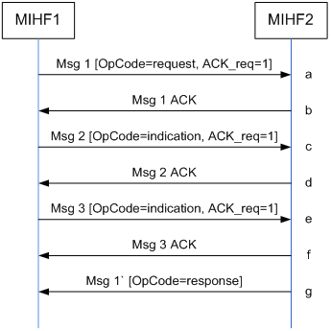
Seven messages are needed to finish the three transactions: three original MIH messages (i.e. step a, c, e), the corresponding three ACK messages (i.e. step b, d, f) and one response message (i.e. step g).

If we use the piggyback method in the current draft, we got the following sequence:
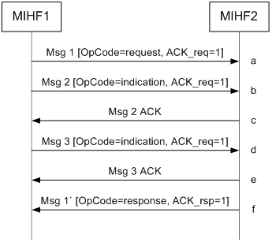
Six messages are needed to finish the three transactions: three original MIH messages (i.e. step a, b, d), two ACK messages (i.e. step c, e) and one response message (i.e. step f) where the ACK is piggybacked. Only one message is saved, comparing with none-piggyback method.

If the ACK is allowed to be piggybacked on other return traffic, it would be more efficient. And one possible message sequence would be the following:
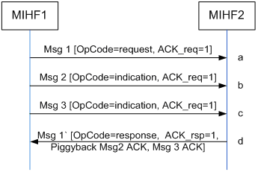
When MIHF2 received Msg 1, it may decide to immediately process the received packet. While handling the Msg 1, MIHF2 received other two messages. The MIHF2 would response the Msg 1 with ACK-Rsp bit set, and piggyback all the ACKs. In this case, only four messages are needed to finish the three transactions: three original MIH messages (i.e. step a, b, c), one response message where the three ACK is piggybacked (i.e. step d). Three messages are saved, comparing with none-piggyback method.

As an alternative, another possible message sequence would be the following:
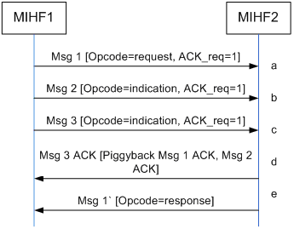
In this case, one ACK message (i.e. step d) may contain several acknowledgements.

So we suggest to make the following amendments to the description of MIH Protocol Ack Operation, we also regard that it is necessary to add the detailed definition of MIHF variable header into current latest draft.

1. Amendment to the description of MIH Protocol Ack Operation
    - MIH Protocol Ack Operation
A source MIH node may start a timer at the time of sending an MIH packet with the ACK-Req bit set and may keep a copy of the MIH packet while the timer is active. The value of the timer may depend on the RTT between the two nodes. If the acknowledgement packet is not received within the expiry of the timer, the source node may retransmit the saved packet immediately with same Message-ID (with ACK-Req bit set) and with the same Transaction-ID. If the source receives the ACK for the previous packet soon after retransmitting the same packet, then the source may determine successful delivery of the original packet and may not have to wait for any acknowledgement for the retransmitted packet. If the source received the acknowledgement before the timer expiry on original or any retransmitted attempt, then the source may reset the timer and release the saved copy of the packet. The source may at most make two retransmitted attempts in addition to the original attempt for the same message with the same Transaction-ID. The source shall not attempt to retransmit a packet with same Message-ID and Transaction-ID when the ACK-Req bit is not set in the original packet.
When a destination node receives an MIH packet with the ACK-Req bit set then the destination returns an acknowledgement packet with ACK-Rsp bit set by copying the Message-ID and Transaction-ID from the received packet. This packet may have no other payload. In instances where the destination may immediately process the received packet and a response is available, then the ACK-Rsp bit may be set in the MIH response packet. However, in this instance, the OpCode may indicate a response value. If these are transactions with the same MIHF ID and session ID requiring acknowlegement, the destination node may acknowledge them in a single response or acknowledgement packet. It should be noted that the destination node shouldn’t piggyback too many acknowelegments in one packet , in case the timers in the souce node would expire.
It is possible for a destination MIH node to set ACK-Rsp bit in an MIH response packet and additionally, act as a source node for the response packet and request MIH acknowledgement services by setting the ACK-Req bit. The destination may choose to buffer the original MIH packet header to correlate with any retransmitted packet(s) containing the same Transaction-ID for a small time duration whose value may be based on, for example, the RTT between the two nodes, to avoid duplicate processing of the same message. If such a retransmitted packet is received during this time period, the destination shall respond with an acknowledgement packet even though an acknowledgement message was sent earlier for the original packet. In any case, the destination shall not process the retransmitted packet if already done so, since it is a duplicate packet. If a destination receives an MIH packet with no ACK-Req bit set then no action is taken with respect to the MIH ACK protocol functionality.
MIH messages require reliability for remote communication on an end-to-end basis to ensure the receipt of data to the intended destination. It is particularly useful when the underlying transport used for remote communication does not provide reliable services. The nature of MIH communication may imply use of unacknowledged connection-less transport services to reduce transport overhead and ensure efficiency and reduced latency in the delivery of the MIH messages. Reliability may be provisioned with an optional acknowledgement service as part of the MIH protocol. The source end point may optionally request for an MIH ACK message to ensure successful receipt of a certain event, command or an information service message. MIH level ACK packet is used to acknowledge the successful receipt of MIH messages at the destination end point. When the MIH ACK is received by the source, it may conclude that the message was reliably delivered to the destination. If the message or the MIH ACK is lost, the source shall timeout and retransmit the same MIH message.
The optional MIH acknowledgement (ACK) capability is defined on top of the base MIH protocol. The MIH ACK capability is supported by use of two bits of information that are defined exclusively for ACK usage in the MIH header. The ACK-Req bit is set by the source MIH node and the ACK-Rsp bit is set by the destination MIH node. The underlying transport layer takes care of verifying the MIH message integrity. Verification of MIH message integrity is not required at MIHF level.

      - MIHF Variable Header

- MIHF Header TLV Format
Within the MIHF header, additional identifiers that help to analyze and coordinate the payload are embedded. All of these identifiers are represented in Header-TLV format. The syntax of this TLV format is shown in Figure . The Header Type field indicates which type of header identifier is embedded in the Value field. The value for this Header Type shall be taken from the namespace reserved for this purpose. Some possible values for the Type field are as follows.

MIHF ID / Session ID (to identify the communication peers)
Transaction ID(s) (to match piggyback ACK and original MIH message )
Synchronization Information (to identify the timestamp of the received message)

