Invitation to IEEE 802.21 Ad Hoc Meeting

September 30, 2006

Telcordia Technologies Inc. and Toshiba America Research are pleased to host the IEEE 802.21 ad hoc meeting at their facilities in Piscataway, NJ. Please find the meeting details below:

Meeting Dates and Time | October 31st , November 1-2 , 2006  9 AM – 5 PM
Address | RRC  One Telcordia Drive (Formerly 444 hoes lane)  Piscataway, NJ 08854-4157
Room | RRC Center Building 1  RRC 1B320  Note: Please come through security door located at the entrance of Building 1 (see RRC map attached). Security personal will have badges ready for attendees (if name and are available before arrival) If you have any problems please contact Pat Horan (Tel: 732 699 3173)
Contact Person | Subir Das  732-699-2483  subir@research.telcordia.com | Yoshihiro Ohba  732-699-5305  yohba@tari.toshiba.com
Additional Meeting information | Name and Affiliation required for security badges:  Email the secretary at phoran@telcordia.com  please cc: subir@research.telcordia.com
Additional Meeting information | Internet connectivity via Wi Fi will be available. A printer will also be available
Additional Meeting information | Refreshments and lunch will be provided. There will be a host sponsored dinner on Thursday evening.
Airports | Nearest airport is Newark (EWR). A taxi ride from EWR airport to Telcordia is approx $50-$65 plus gratuity.  Other Airports: La Guardia and JFK  A taxi ride from La Guardia airport to Telcordia is approx. $100 plus toll and gratuity.  A taxi ride from JFK airport to Telcordia is approx $160 plus toll and gratuity.
Hotels | A list of hotels nearby is provided below. Complementary shuttle is available from Embassy Suites to Telcordia. Guests should request the shuttle service upon arrival. Some hotels offer Telcordia rates. So please ask during booking.  Car: Renting a car is recommended.
Restaurants | There are plenty of nice restaurants in downtown New Brunswick, all in a walking distance of each other. New Brunswick is about 10 min drive from Telcordia. There are also few restaurants available on Centennial Avenue (5 mins drive from Telcordia)  Note: There are no restaurants within walking distance from Telcordia.

Travel Directions to Telcordia Technologies

Raritan River Software Systems Center (RRC)

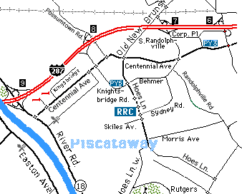

From north east, south or Newark International Airport
- Take New Jersey Turnpike south to Exit 10 (I-287, Metuchen).
- Follow signs to I-287 NORTH and proceed north for 8.4 miles.
- Take Exit 8 (Possumtown Rd., Highland Park, Middlesex).
- At the end of exit ramp [TURN RIGHT] on Possumtown Road.
- Proceed to traffic light at Centennial Avenue and turn right.
- Proceed to the first light at Knightsbridge Road and turn left.
- Proceed 0.5 miles and make a right at the light onto Telcordia Drive.
- Proceed straight until you see the tower and parking area.
- RRC1 is back side of main parking area (Pl. refer to RRC map)

Alternate Directions coming from the South on the Turnpike
- Take Exit 9 Route 18, New Brunswick.
- Take Route 18 North all the way to the end of the freeway.
- Rt. 18 ends and becomes Hoes Lane.
- Continue 1.7 miles to the RRC Tower on the left.

From east
- Take U.S. Route 22 to the Washington Ave./Green Brook jughandle and cross Rt. 22.
- After 3.8 miles, turn right onto Lakeview Avenue.
- At Stelton Road, turn left.
- Proceed 0.8 miles to traffic light and turn right onto Old New Brunswick Road.
- After 1.4 miles, at Centennial Avenue, Old New Brunswick Road becomes Hoes Lane.
- Continue 0.5 miles to RRC on the right.

From west and 287 south
- Take I-78 to the exit for I-287 south (Somerville).
- Take I-287 south for 12.5 miles to Exit 8 (Centennial Ave, Highland Park, Middlesex).
- Proceed across the light at the end of the ramp onto Knightsbridge Road.
- Proceed 0.5 miles (you will pass AT&T)and make a right at the light onto Telcordia Drive.
- Proceed straight until you see the tower and parking area.

Approximate mileage to Piscataway

- Newark Airport (EWR) 22
- La Guardia Airport (LGA) 57
- JFK Airport (JFK) 67

Public transportation
N.J. Transportation Department, Central Region (908) 308-4070

By train
1. From Penn Station in New York, or in Newark take a NJ Transit train to New Brunswick or Dunellen
2. Continue by taxi (from New Brunswick train station 10-15 min)
Note: Some Amtrak trains stop in New Brunswick.

RRC Map
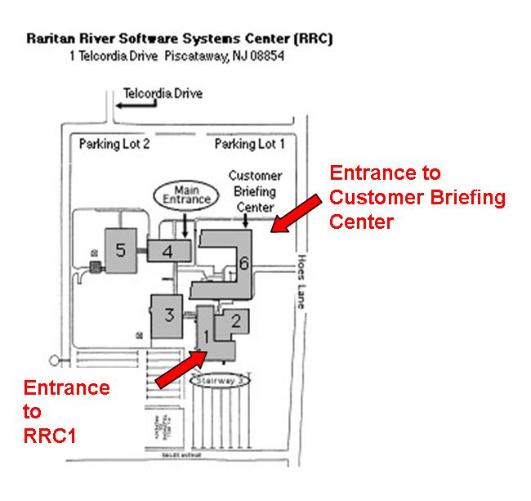

Hotels

Clarion Suites Hotel (732) 563-1000
11 Cedar Grove Lane, Somerset, NJ 08873
DoubleTree (732) 469-2600
200 Atrium Dr., Somerset, NJ 08873
Embassy Suites - Piscataway (732) 980-0500
121 Centennial Ave., Piscataway, NJ 08854
Hampton Inn - Somerset (732) 563-1600
255 Davidson Ave., Somerset, NJ 08873
Holiday Inn (732) 356-1700
195 Davidson Ave., Somerset, NJ 08873
Holiday Inn (732) 753-5500
4701 Stelton Rd., South Plainfield, NJ 07080
Hyatt Regency - New Brunswick (732) 873-1234
2 Albany Street, New Brunswick, NJ 08901
Somerset Marriott (732) 560-0500
110 Davidson Ave., Somerset, NJ 08873
Quality Inn (732) 469-5050
1850 Easton Ave., Somerset, NJ 08873
Ramada Somerset (732) 560-9880
60 Cottontail Lane, Somerset, NJ (Exit 12)
Summerfield Suites by Wyndham (732) 356-8000
260 Davidson Ave., Somerset, NJ 08873

Visit MANHATTAN, New York City

Some tips to those who want to visit New York City.

BY CAR

Manhattan is in about 50 min car ride from Telcordia facilities. There is a toll of $6 per car into the city to cross the tunnels and bridges. At peak hours traffic at the tunnels and bridges can increase travel time.

BY TRAIN

The nearest train station is located in New Brunswick. There is a train to New York Penn Station every hour. Trains run more frequently during rush hours. The train ride is less than an hour. Penn Station in New York is located on 34 st. at the heart of Midtown. The train schedule can be found at www.njtransit.com. The train line is Northeast Corridor Line (NEC)

