IEEE P802.22
Wireless RANs
IEEE 802.22 Coverage Simulations and Interference Analysis
Date: 2005-09-19
Author(s):
Name | Company | Address | Phone | email
Winston Caldwell | Fox Technology Group | 10201 W. Pico Blvd.  Los Angeles, CA 90035 | 310-369-4367 | Winston.caldwell@fox.com
Abstract
This analysis was performed to investigate the results of of both co-channel and adjacent channel IEEE 802.22 system coexistence with the existing incumbent high power TV service. The analysis looked at coverage achieved by a 4 W 802.22, interference caused by an 802.22 device into TV receivers, and interference caused by TV transmissions into an 802.22 device. Several coverage and interference plots are shown for each of the six locations studied. A table with the number of people affected by interference is presented. The resulting population table shows that a co-channel 802.22 device can operate while causing only minor interference to TV receivers within the NLC as long as the 802.22 device is located outside of the NLC. An adjacent channel 802.22 device can operate while causing only minor interference to TV receivers within the NLC even if the 802.22 device is located inside the NLC. However, co-channel and adjacent channel 802.22 devices can cause substantial interference to TV receivers that lie within the DMA. The results also show that an 802.22 device would experience so much interference from the TV receiver that the 802.22 device would be unable to practically operate.
Notice: This document has been prepared to assist IEEE 802.22. It is offered as a basis for discussion and is not binding on the contributing individual(s) or organization(s). The material in this document is subject to change in form and content after further study. The contributor(s) reserve(s) the right to add, amend or withdraw material contained herein.

Release: The contributor grants a free, irrevocable license to the IEEE to incorporate material contained in this contribution, and any modifications thereof, in the creation of an IEEE Standards publication; to copyright in the IEEE’s name any IEEE Standards publication even though it may include portions of this contribution; and at the IEEE’s sole discretion to permit others to reproduce in whole or in part the resulting IEEE Standards publication. The contributor also acknowledges and accepts that this contribution may be made public by IEEE 802.22.

Patent Policy and Procedures: The contributor is familiar with the IEEE 802 Patent Policy and Procedures
<http://standards.ieee.org/guides/bylaws/sb-bylaws.pdf>, including the statement "IEEE standards may include the known use of patent(s), including patent applications, provided the IEEE receives assurance from the patent holder or applicant with respect to patents essential for compliance with both mandatory and optional portions of the standard." Early disclosure to the Working Group of patent information that might be relevant to the standard is essential to reduce the possibility for delays in the development process and increase the likelihood that the draft publication will be approved for publication. Please notify the Chair <Carl R. Stevenson> as early as possible, in written or electronic form, if patented technology (or technology under patent application) might be incorporated into a draft standard being developed within the IEEE 802.22 Working Group. If you have questions, contact the IEEE Patent Committee Administrator at <patcom@ieee.org>.
Introduction
The purpose of this analysis was to simulate the deployment of an Institute of Electronics and Electrical Engineering (IEEE) 802.22 system operating within the television (TV) broadcast bands from both a coverage consideration and an interference consideration.

Both coverage and interference simulations were performed in different locations in the United States. These locations were selected to represent rural areas outside of both co-channel and adjacent channel TV noise limited contours. Although the locations were outside of TV noise limited contours, co-channel, and usually adjacent channel, contours were nearby.

The coverage and interference simulations were performed using News Corporation’s Fox Technology Group’s propagation prediction software.

Coverage plots were created for each of the six locations analyzed as well as interference plots. For each location, plots were created to describe the interference caused by an 802.22 base station into a TV receiver and the interference caused by a TV transmitter into an 802.22 consumer premises equipment (CPE). Occasionally additional plots were created for a location to illustrate a particularly interesting interference example.

Assumptions
- Only co-channel and adjacent channel interference was considered (“taboo” channel relationships were not considered).
- Only high power TV stations were considered (low power or “class A” TV stations were not considered).
- 8-Vestigial Side-Band (8-VSB) Advanced Television Systems Committee modulation for 802.22 systems.
- Desired to undesired ratios (D/U) from the Federal Communications Commission (FCC) Office of Engineering and Technology Bulletin 69.
- 30 meter United States Geological Survey terrain data.
- Population from 2000 Topographically Integrated Geographic Encoding and Referencing system census data.
- Terrain Integrated Rough Earth Model propagation prediction model.
- Long Term Fading, Environmental Science Services Administration (ESSA) Technical Report ESSA Research Laboratories 79-Institute for Telecommunication Sciences 67.
- Surface of the Earth Electrical Characteristics from International Telecommunication Union Recommendation 527-3.
- Receivers are outdoors at 9 m height.
- Receiver antenna patterns use a cosine exponent equal to 4.
- 802.22 coverage simulations use 99.9 % time availability.
- Digital television (DTV) interference analysis, desired and undesired signals use 90 % and 10 %, respectively for time availability.
- Analog interference analysis desired and undesired signals use 50 % and 10 %, respectively for time availability.
- TV transmitter operating parameters are from the 05/09/05 FCC database.
- Other assumptions regarding transmitter and receiver parameters for link budgets are from 802.22 document number 22-04-0002-10-0000.

Analysis Plots

Figures 1 - 18: Athens, GA
Figure 1: 802.22 Coverage
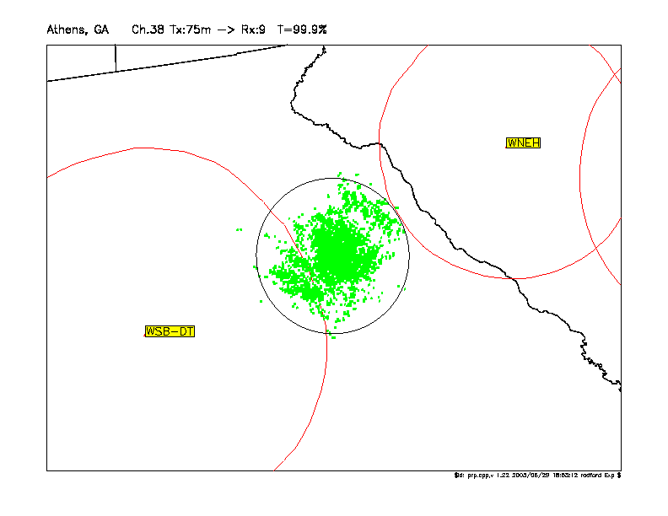

Figure 2: 802.22 into WSB-DT
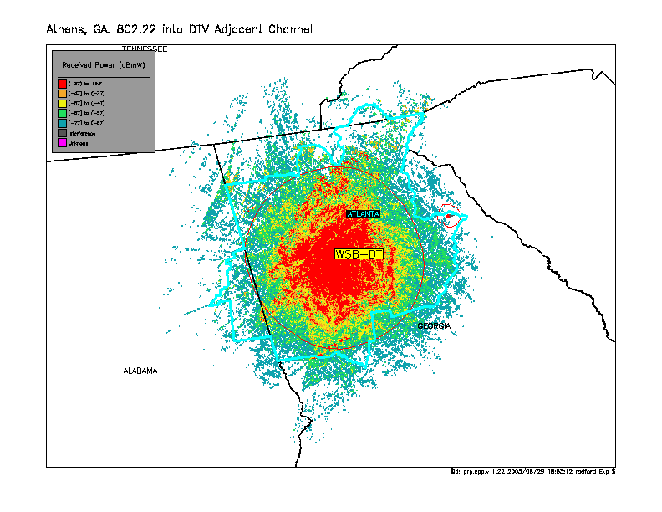

Figure 3: 802.22 into WSB-DT, Interference
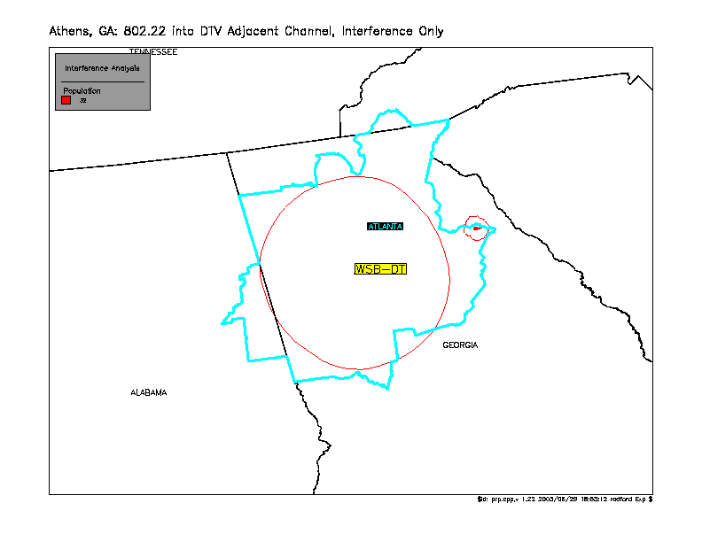

Figure 4: 802.22 into WSB-DT in NLC
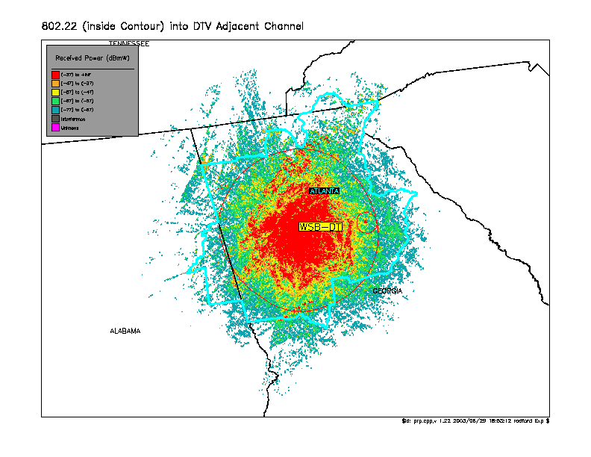

Figure 5: 802.22 into WSB-DT in NLC, Interference
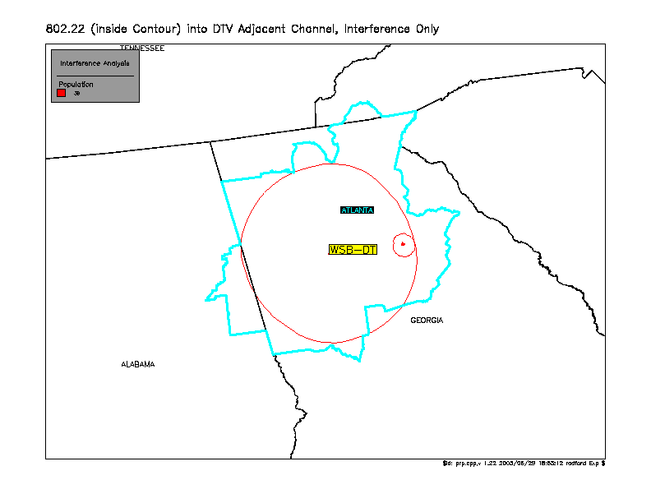

Figure 6: 802.22 into WNEH-TV
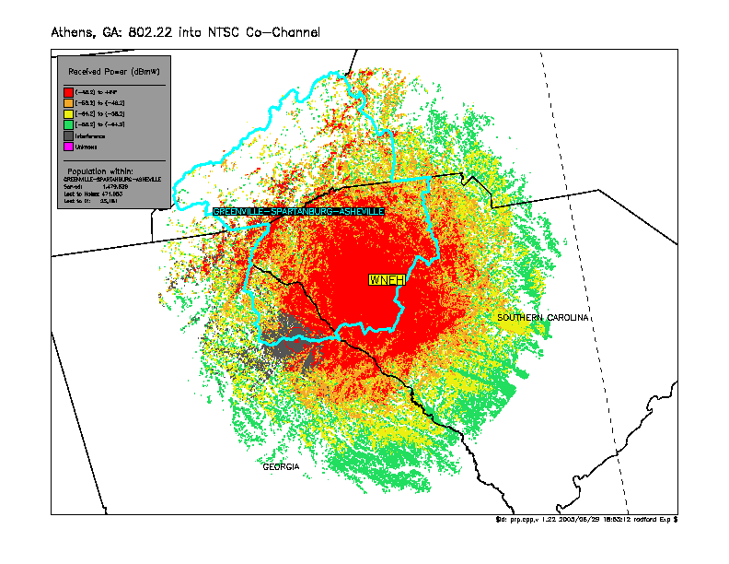

Figure 7: 802.22 into WNEH-TV, Interference
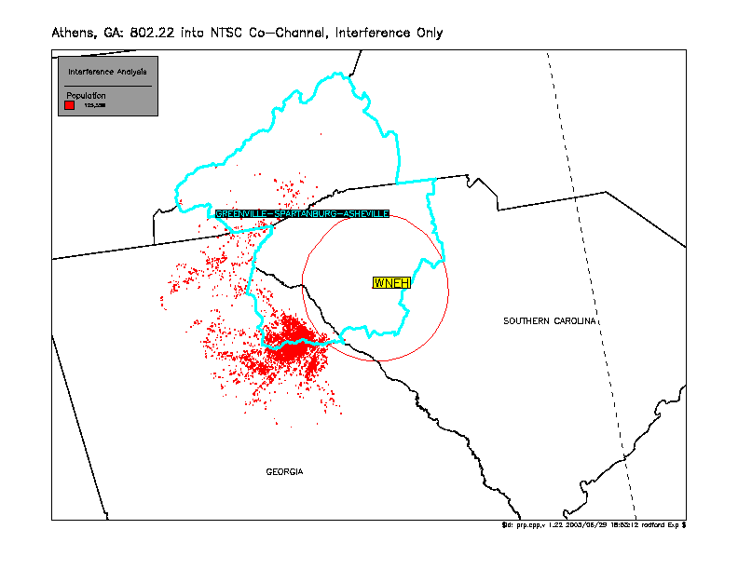

Figure 8: 802.22 into WNEH-TV (Pop. Filtered by NLC)
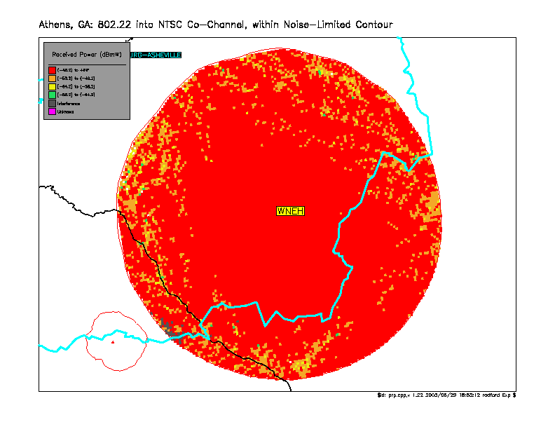

Figure 9: 802.22 into WNEH-TV, Interference (Pop. Filtered by NLC)
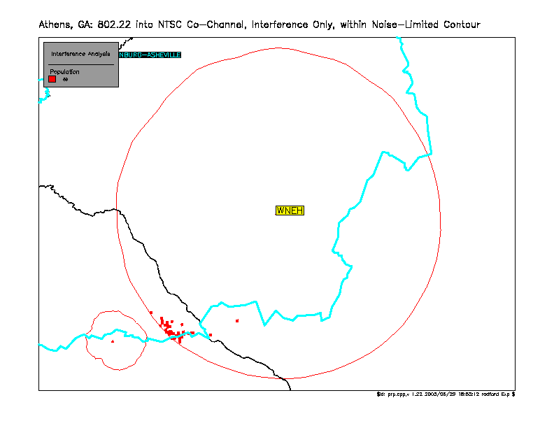

Figure 10: 802.22 into WNEH-TV in NLC
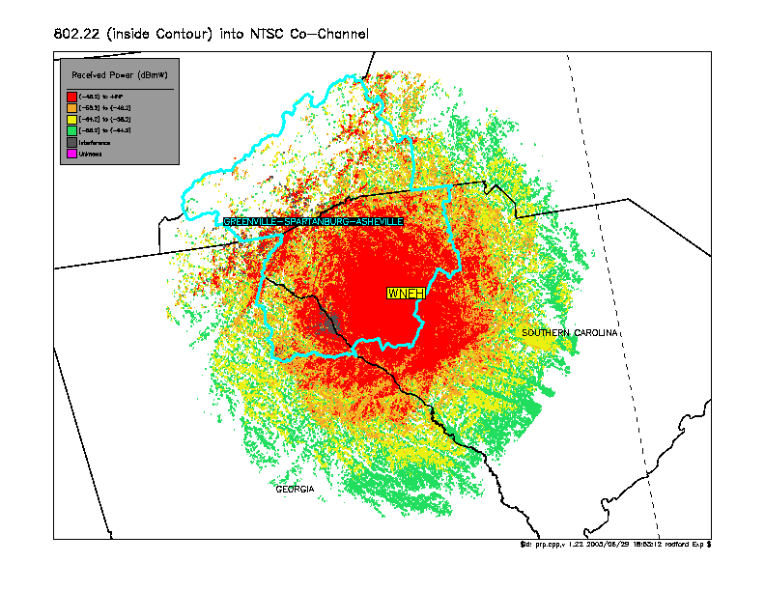

Figure 11: 802.22 into WNEH-TV in NLC, Interference
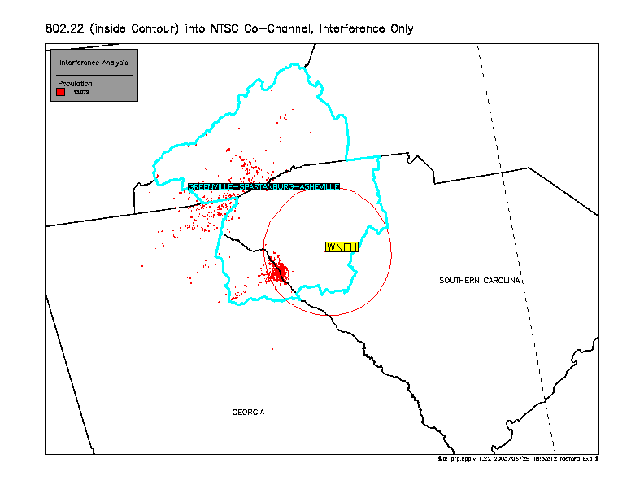

Figure 12: 802.22 into WNEH-TV in NLC (Pop. Count Filtered by NLC)
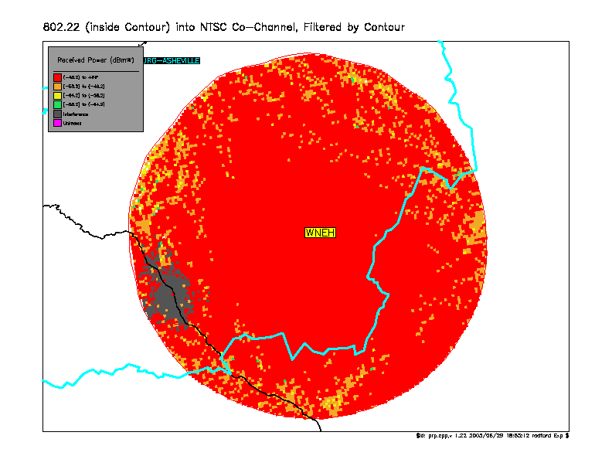

Figure 13: 802.22 into WNEH-TV in NLC, Interference (Pop. Count Filtered by NLC)
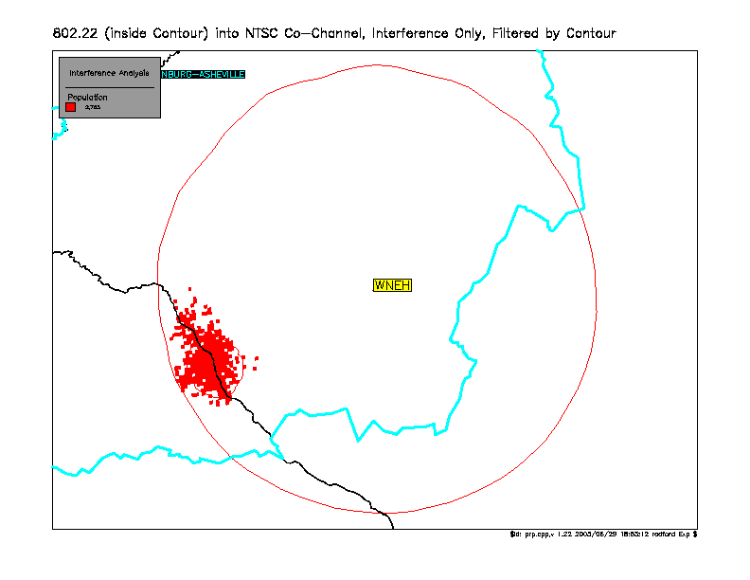

Figure 14: TV into 802.22
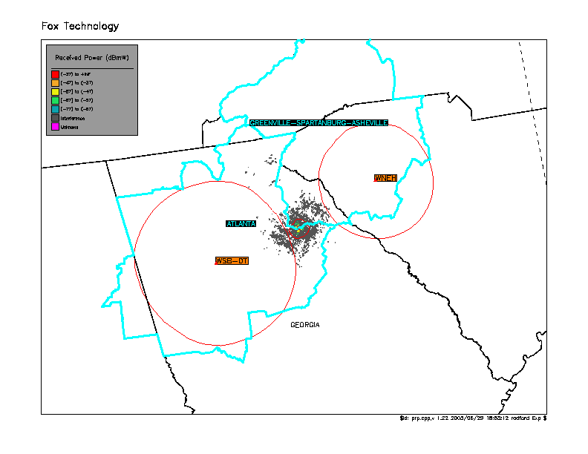

Figure 15: TV into 802.22, Interference
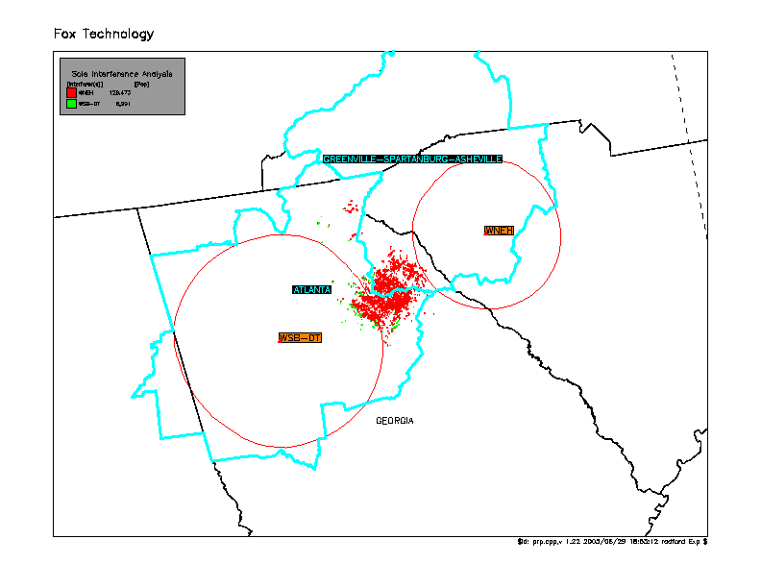

Figure 16: TV into 802.22 in WSB-DT NLC
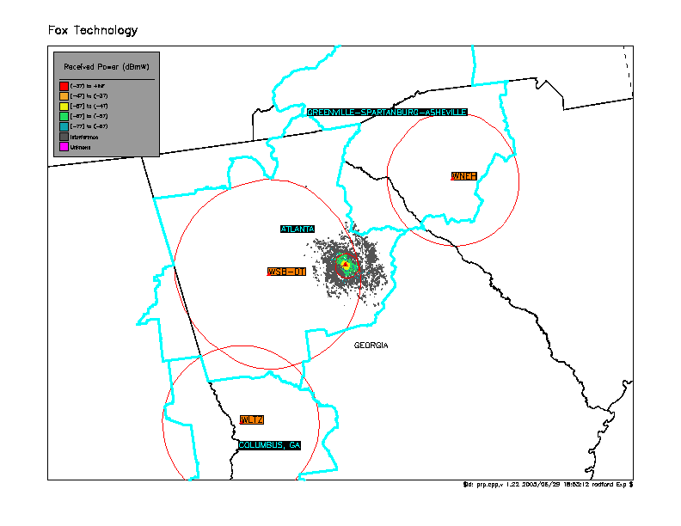

Figure 17: TV into 802.22 in WSB-DT NLC, Interference
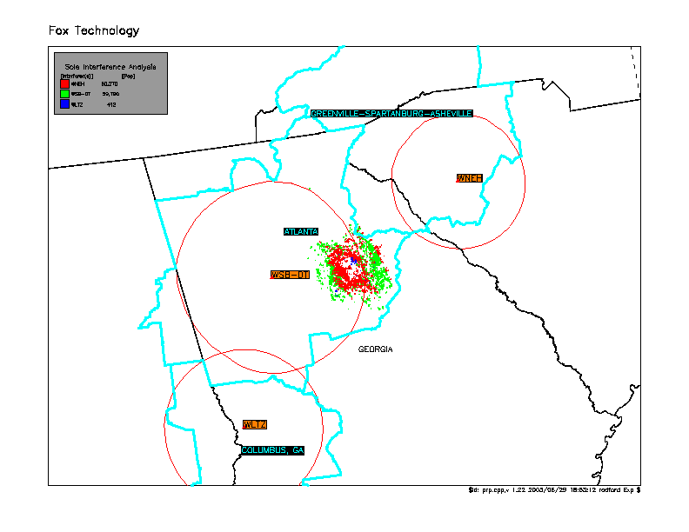

Figure 18: TV into 802.22 in WNEH-TV NLC, Interference
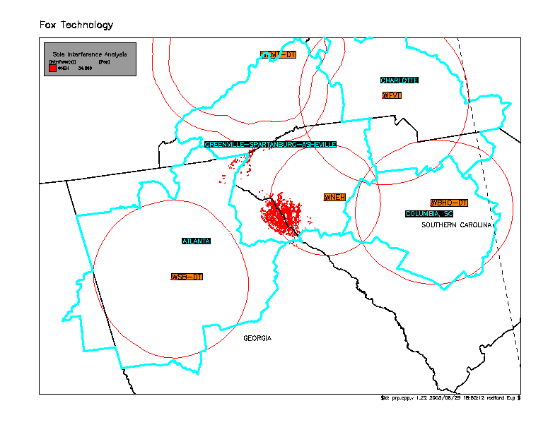

Figures 19 - 37: Linden, TN
Figure 19: 802.22 Coverage
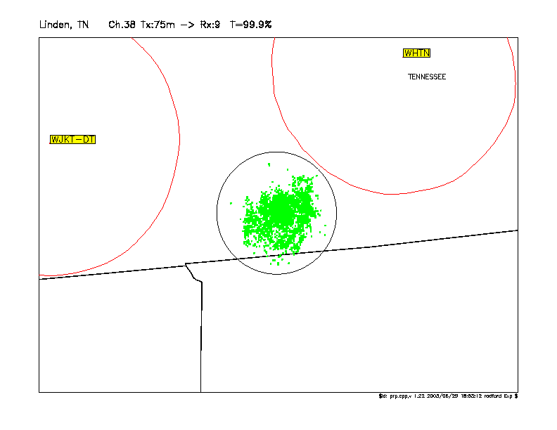

Figure 20: 802.22 into WHTN-DT
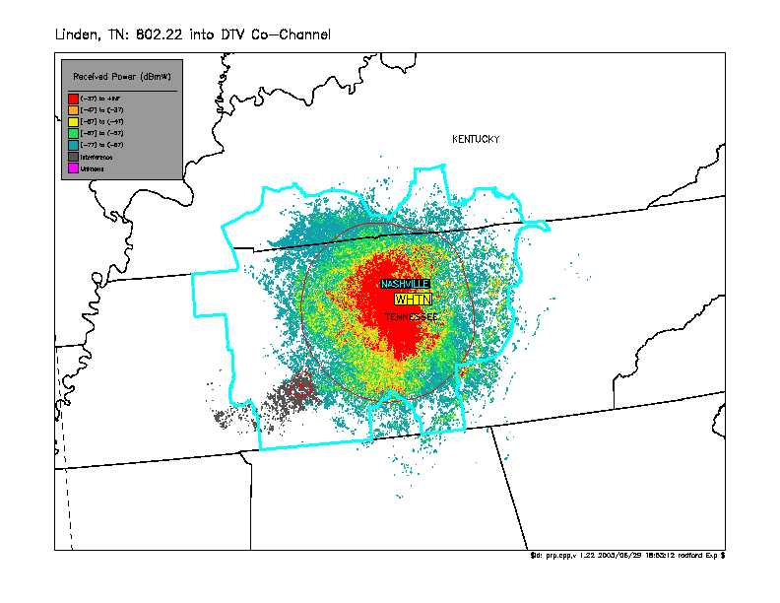

Figure 21: 802.22 into WHTN-DT, Interference
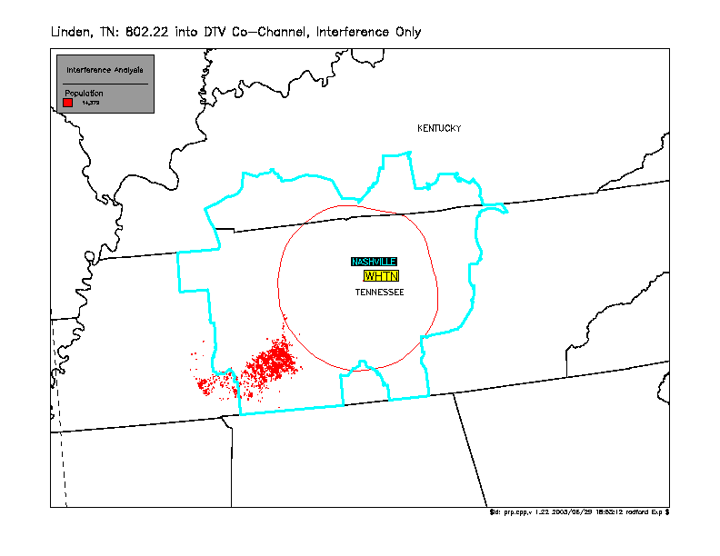

Figure 22: 802.22 into WHTN-DT in NLC
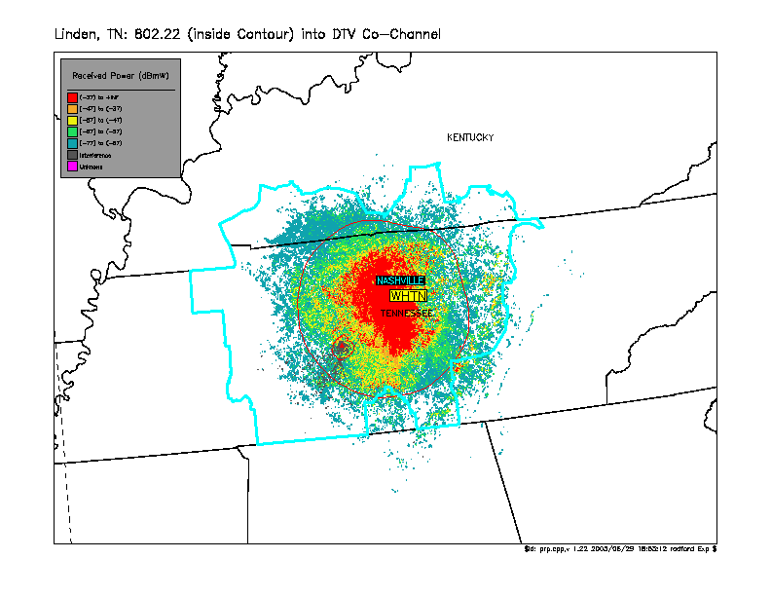

Figure 23: 802.22 into WHTN-DT in NLC, Interference
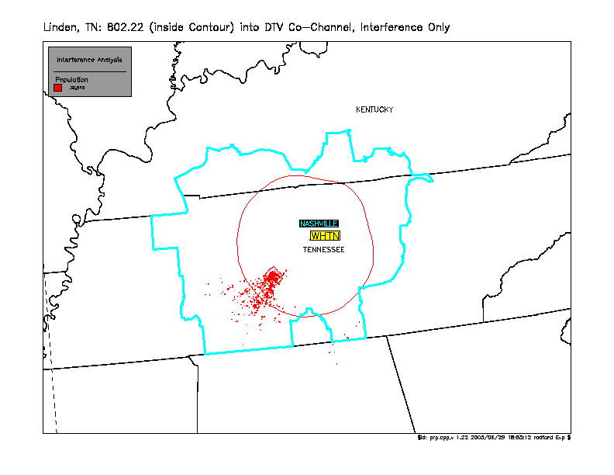

Figure 24: 802.22 into WHTN-DT in NLC (Pop. Count Filtered by NLC)
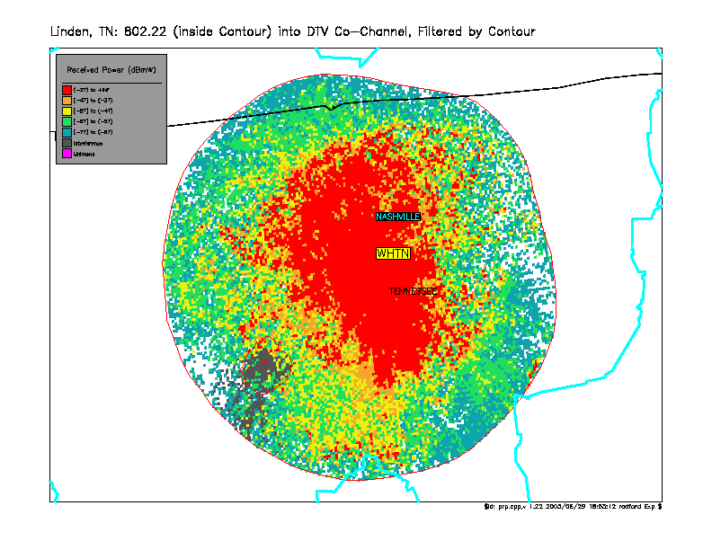

Figure 25: 802.22 into WHTN-DT in NLC, Interference (Pop. Count Filtered by NLC)
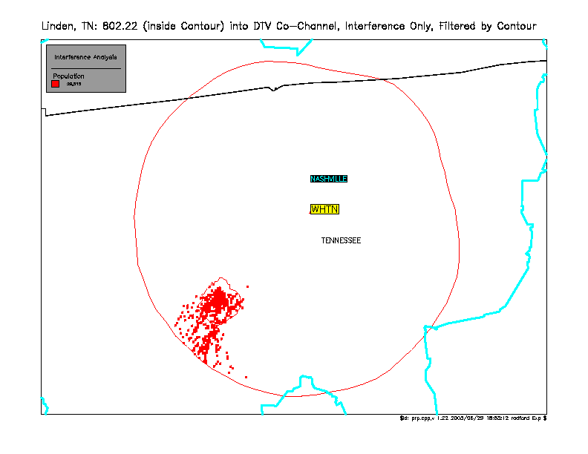

Figure 26: 802.22 into WHTN-TV
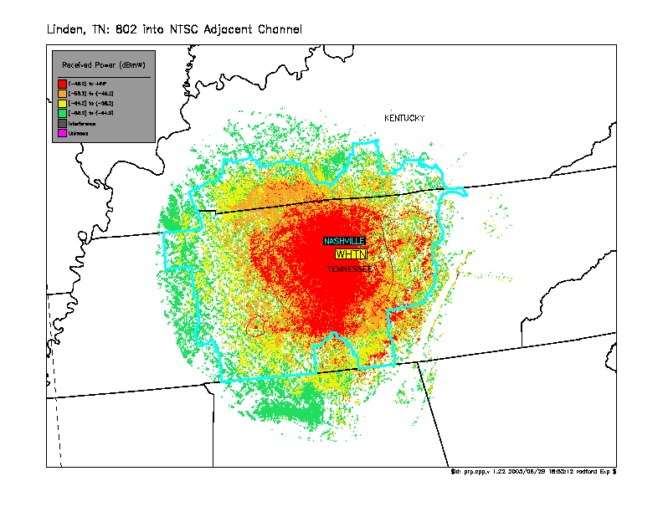

Figure 27: 802.22 into WHTN-TV, Interference
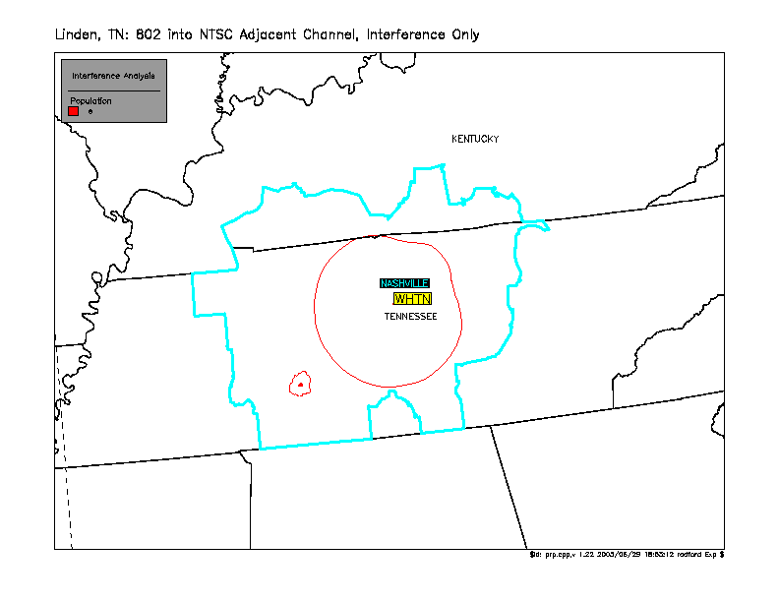

Figure 28: 802.22 into WHTN-TV in NLC
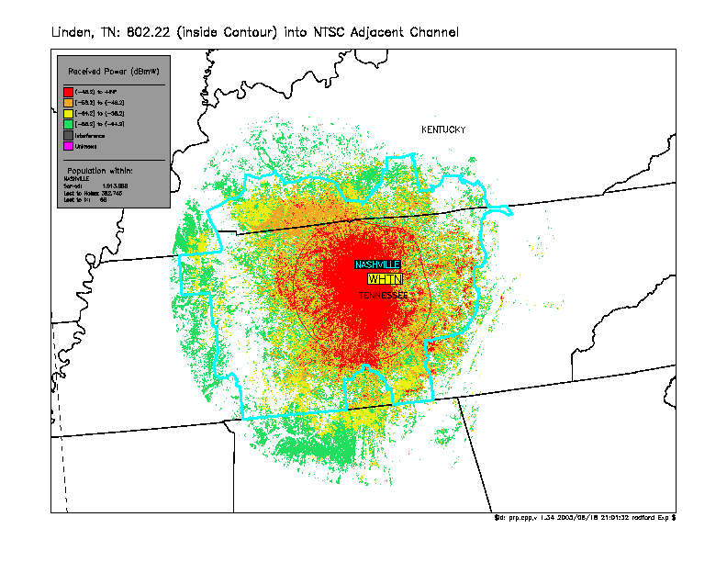

Figure 29: 802.22 into WJKT-DT
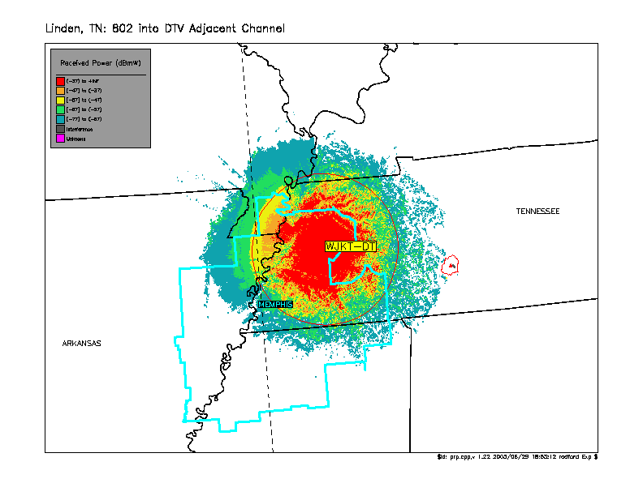

Figure 30: 802.22 into WJKT-DT, Interference
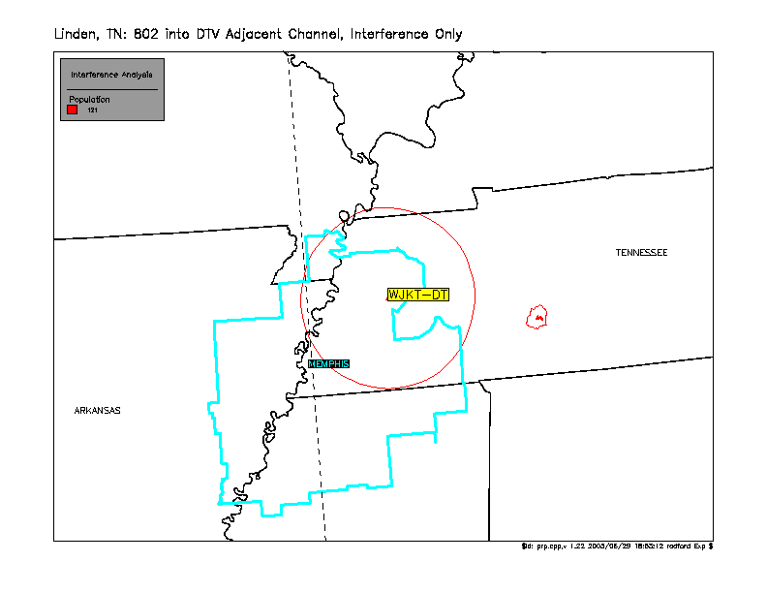

Figure 31: 802.22 into WJKT-DT in NLC
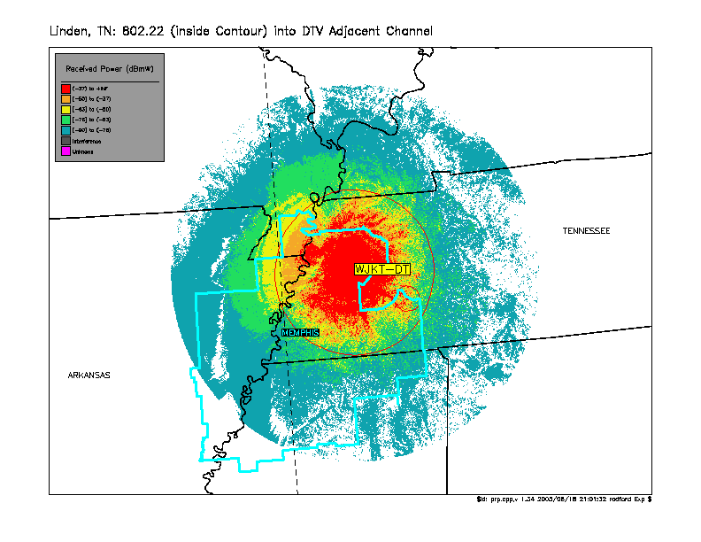

Figure 32: TV into 802.22
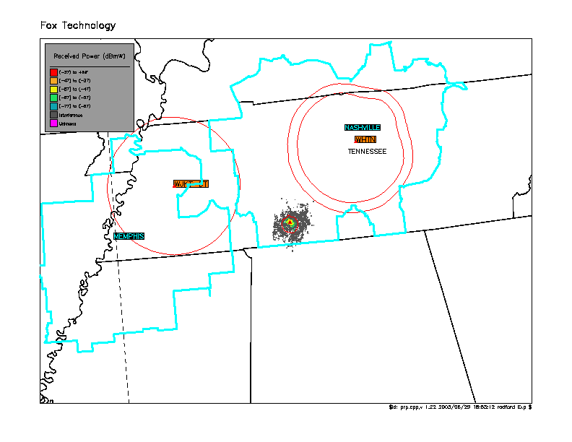

Figure 33: TV into 802.22, Interference
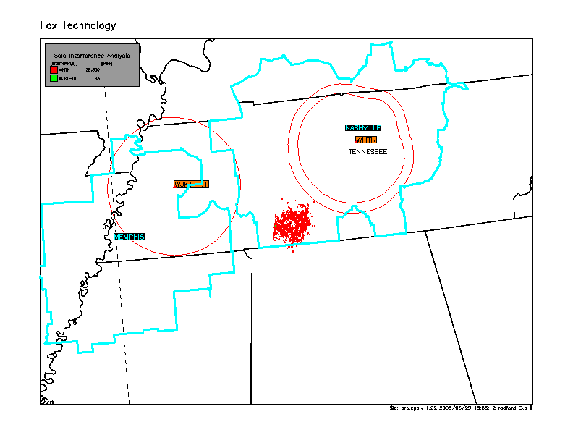

Figure 34: TV into 802.22 in WHTN NLC
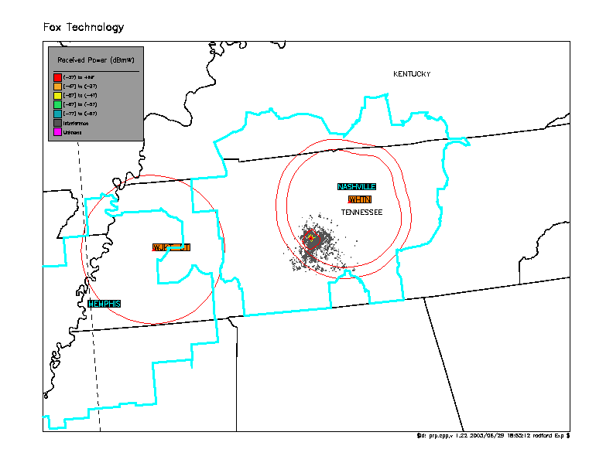

Figure 35: TV into 802.22 in WHTN NLC, Interference
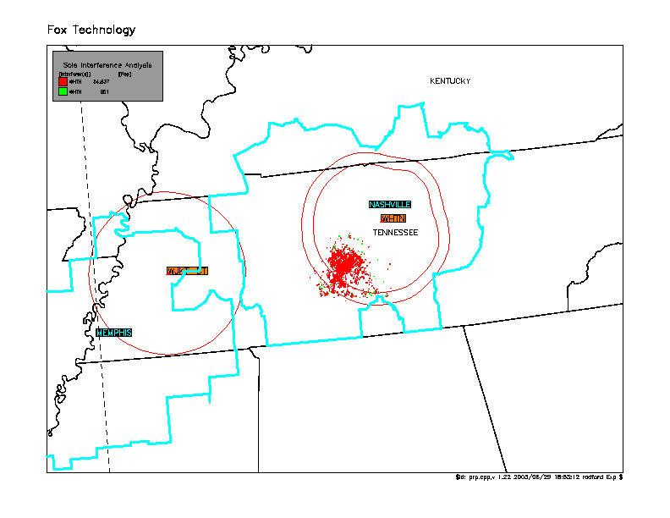

Figure 36: TV into 802.22 in WJKT-DT NLC
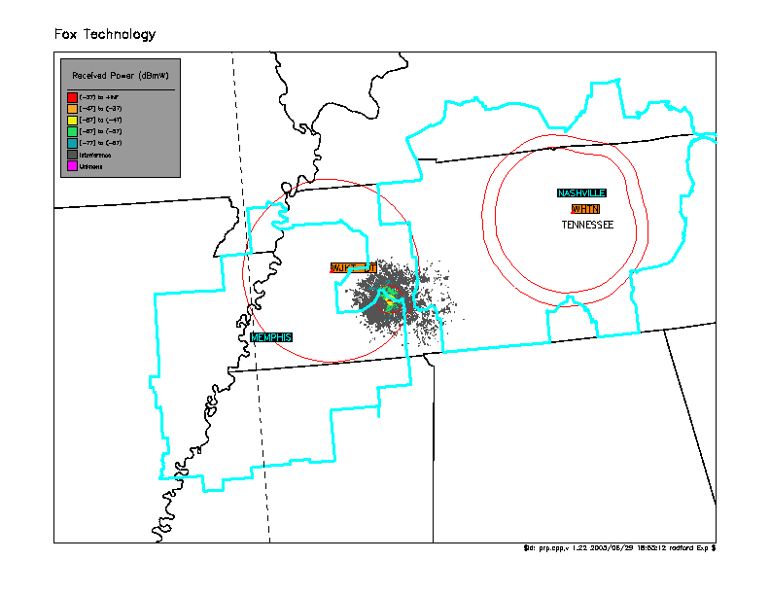

Figure 37: TV into 802.22 in WJKT-DT NLC, Interference
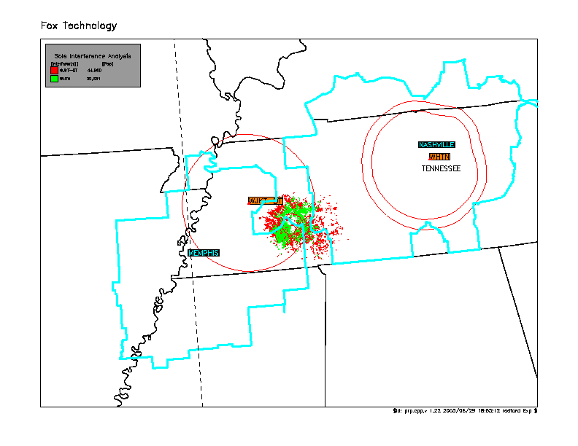

Figures 38 - 49: Clayton, LA
Figure 38: 802.22 Coverage
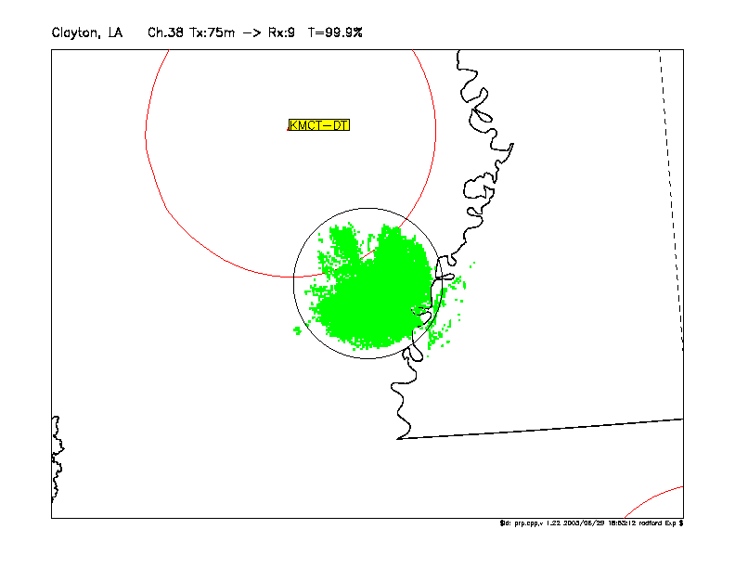

Figure 39: 802.22 into KMCT-DT
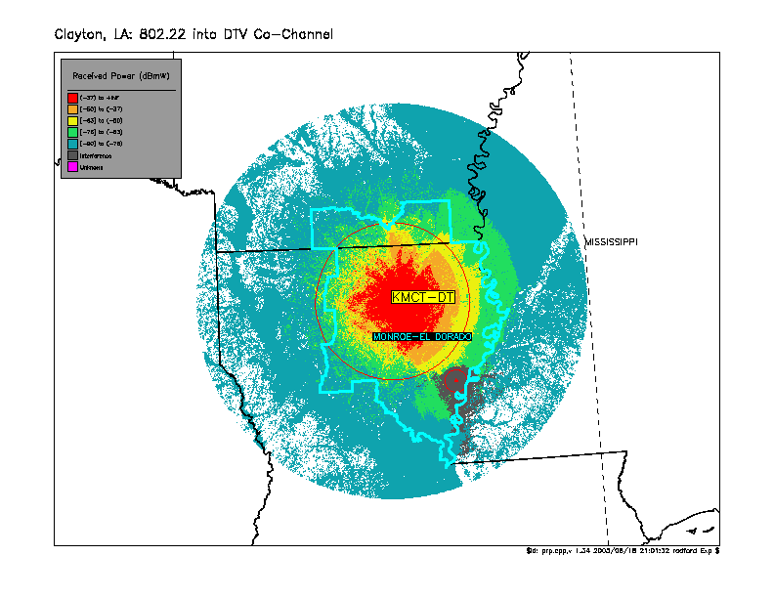

Figure 40: 802.22 into KMCT-DT, Interference
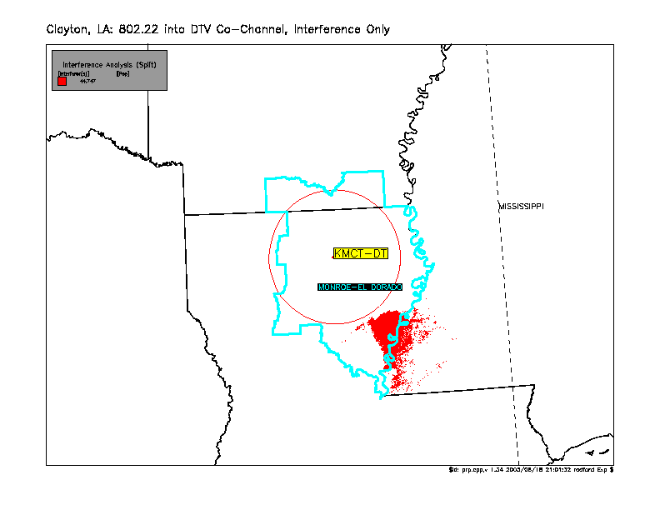

Figure 41: 802.22 into KMCT-DT in NLC
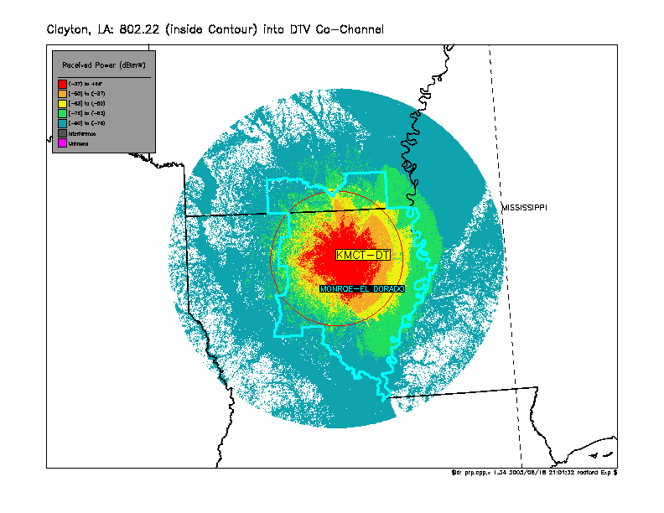

Figure 42: 802.22 into KMCT-DT in NLC, Interference
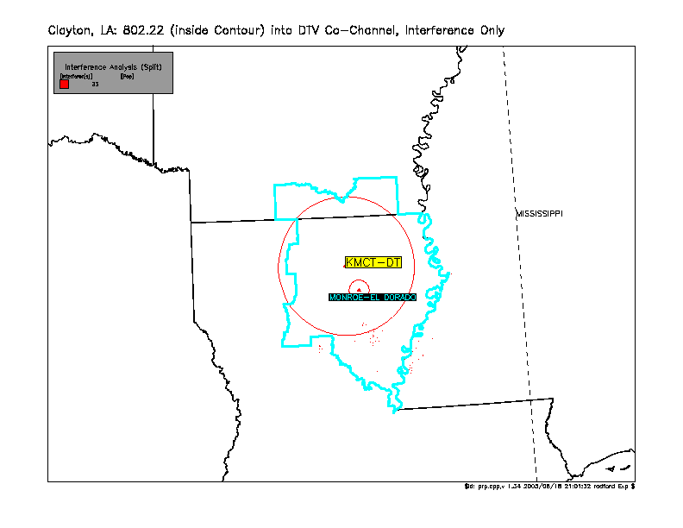

Figure 43: 802.22 into KMCT-TV
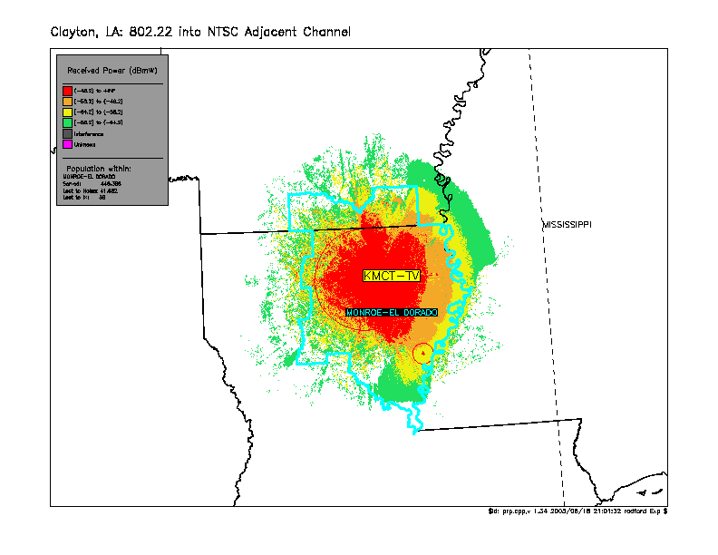

Figure 44: 802.22 into KMCT-TV, Interference
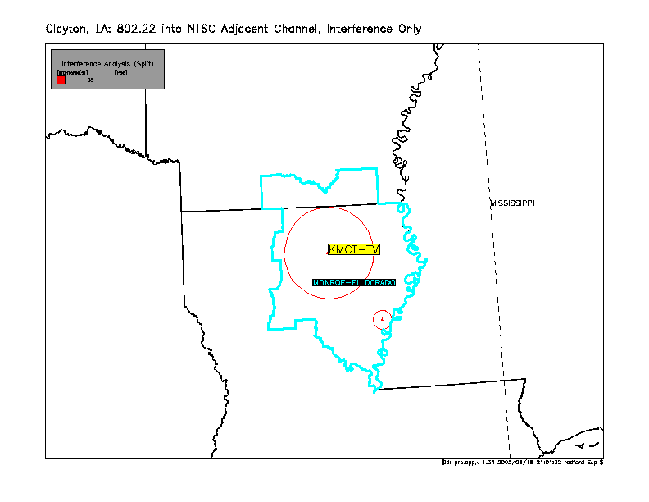

Figure 45: 802.22 into KMCT-DT in NLC
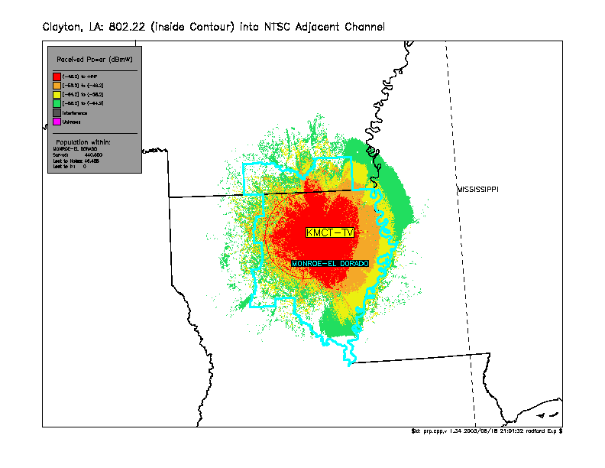

Figure 46: TV into 802.22
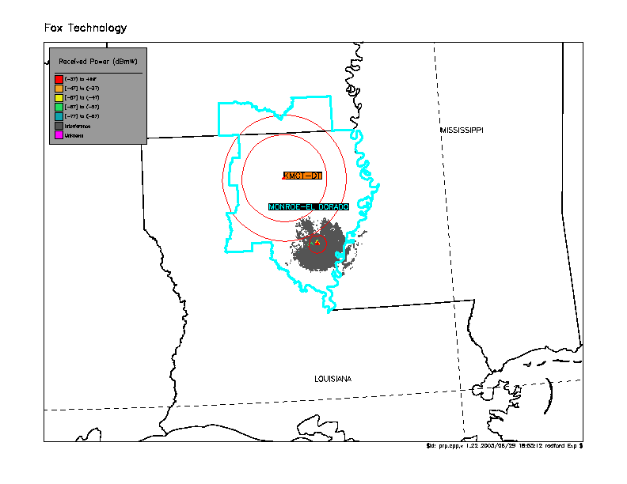

Figure 47: TV into 802.22, Interference
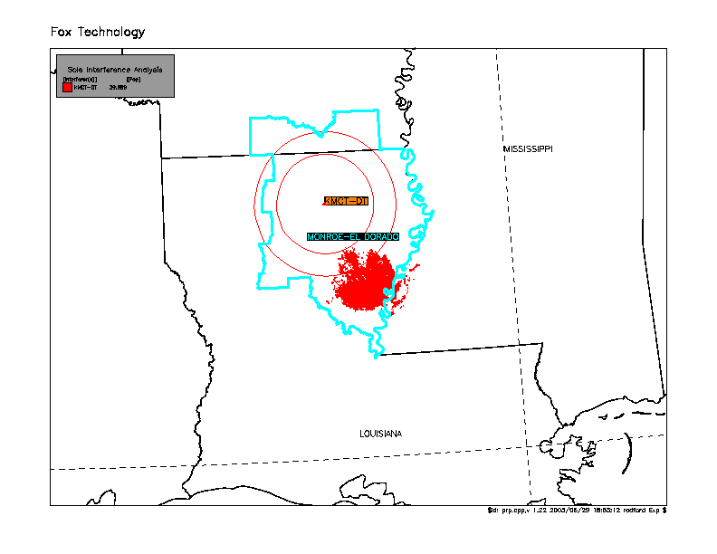

Figure 48: TV into 802.22 in KMCT NLC
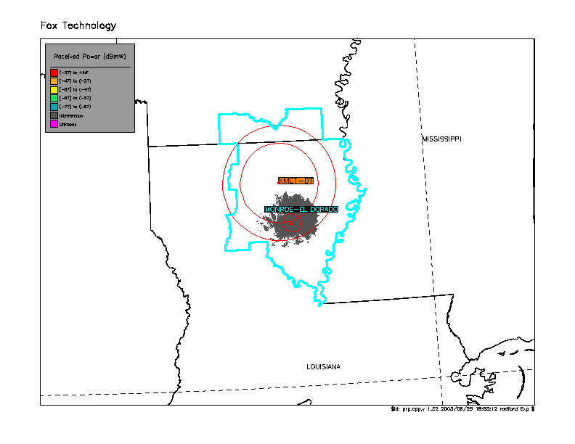

Figure 49: TV into 802.22 in KMCT NLC, Interference
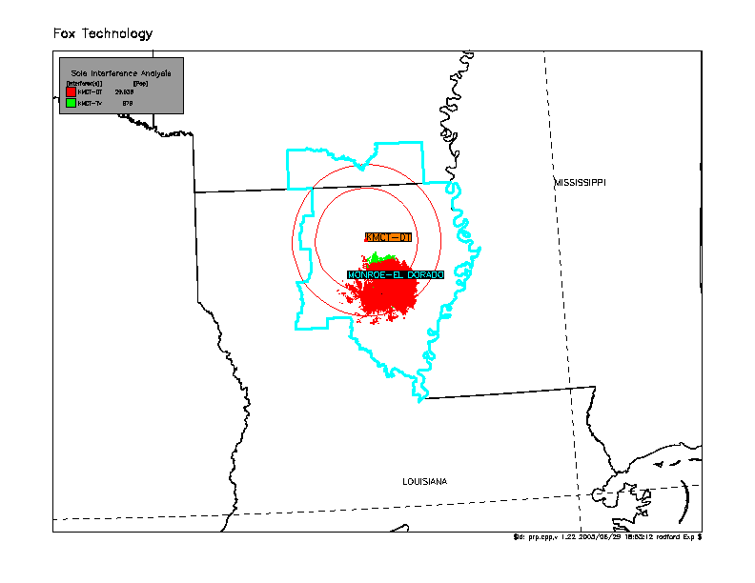

Figures 50 - 62: Georgetown, DE
Figure 50: 802.22 Coverage
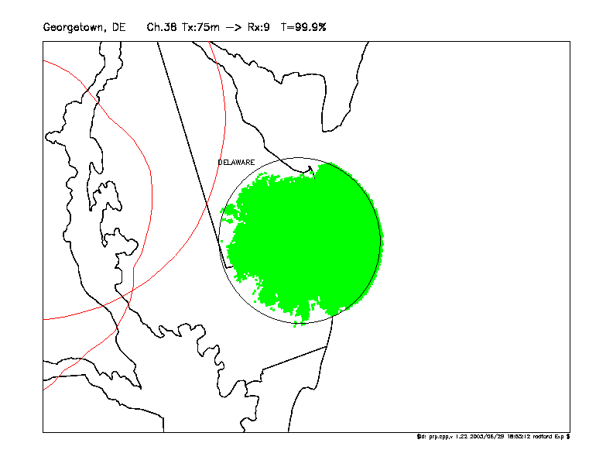

Figure 51: 802.22 into WJZ-DT
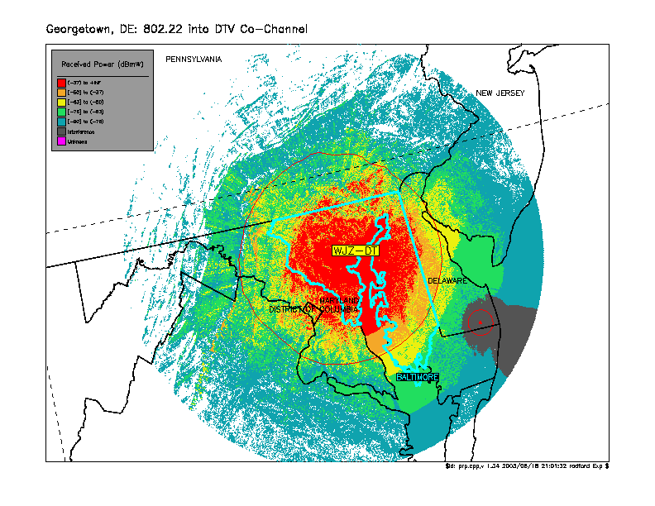

Figure 52: 802.22 into WJZ-DT, Interference
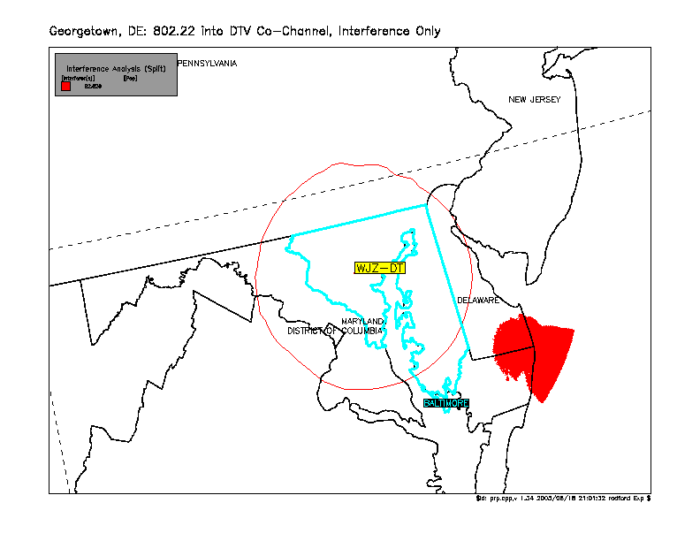

Figure 53: 802.22 into WJZ-DT in NLC
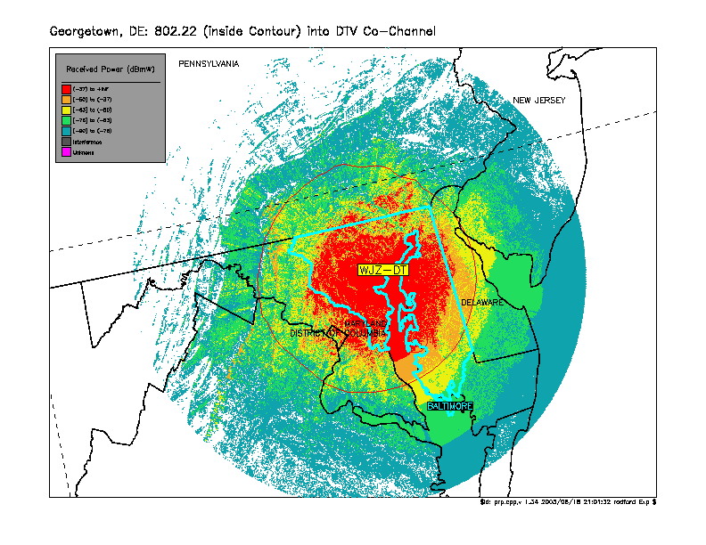

Figure 54: 802.22 into WJZ-DT in NLC, Interference
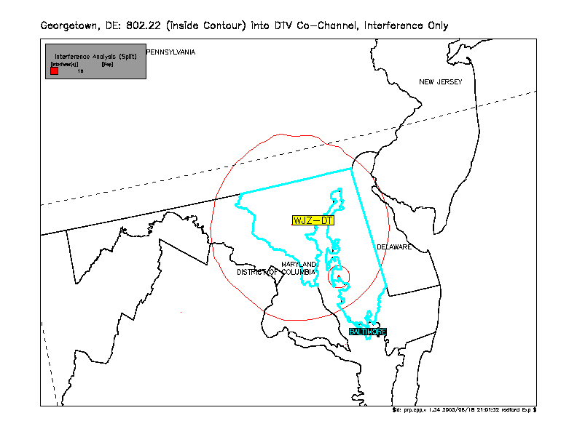

Figure 55: 802.22 into WJZ-DT in NLC (Pop. Count Filtered by NLC)
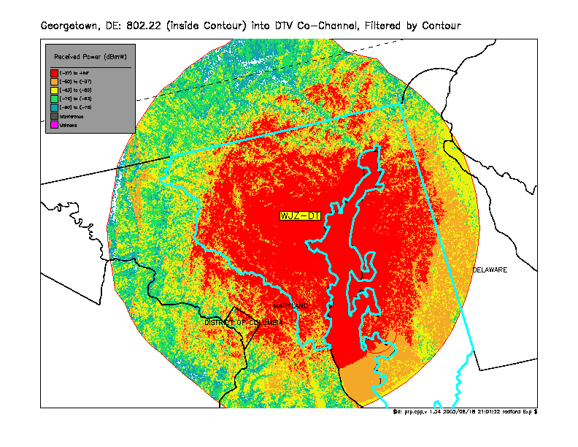

Figure 56: 802.22 into WJZ-DT in NLC, Interference (Pop. Count Filtered by NLC)
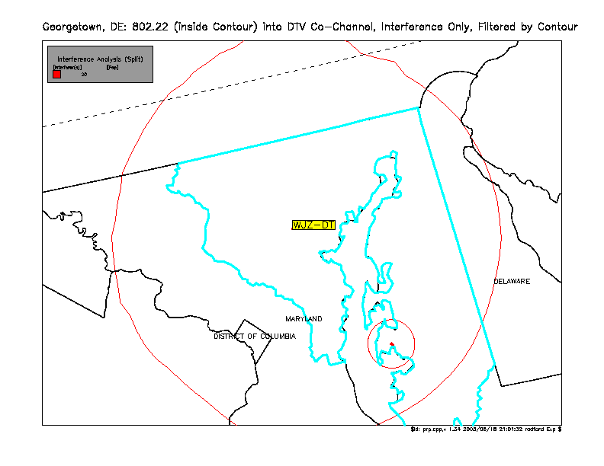

Figure 57: 802.22 into WJLA-DT
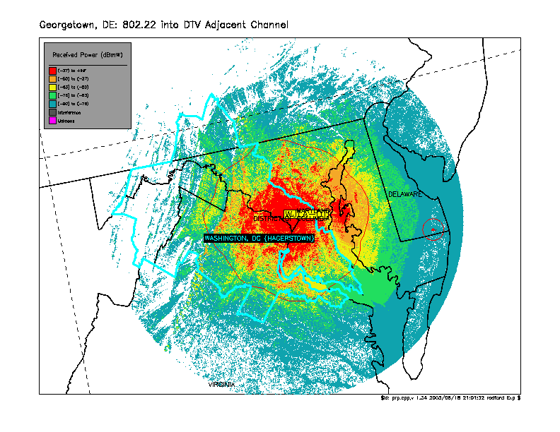

Figure 58: 802.22 into WJLA-DT, Interference
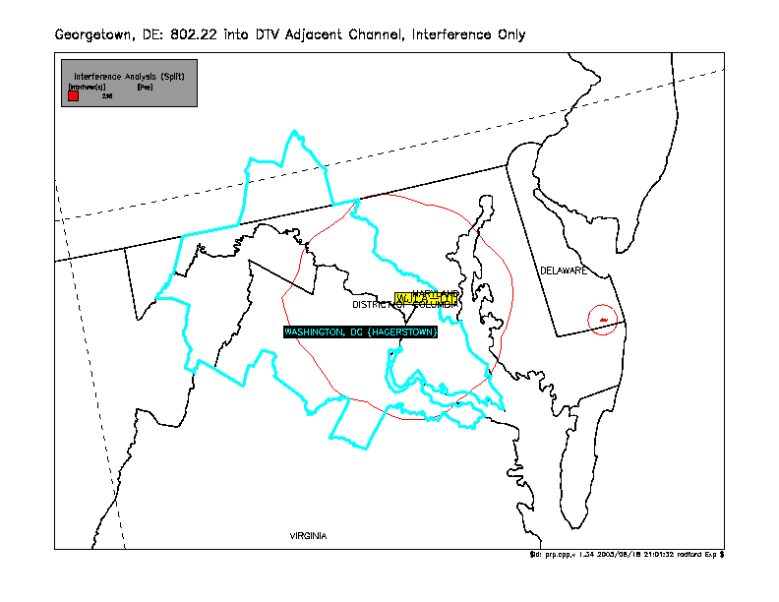

Figure 59: 802.22 into WJLA-DT in NLC
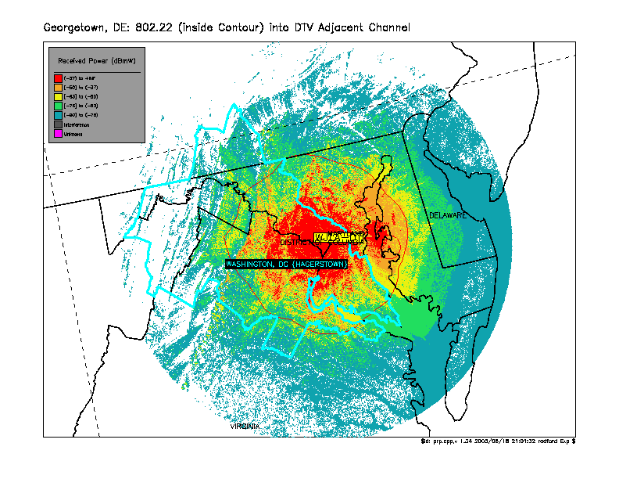

Figure 60: TV into 802.22
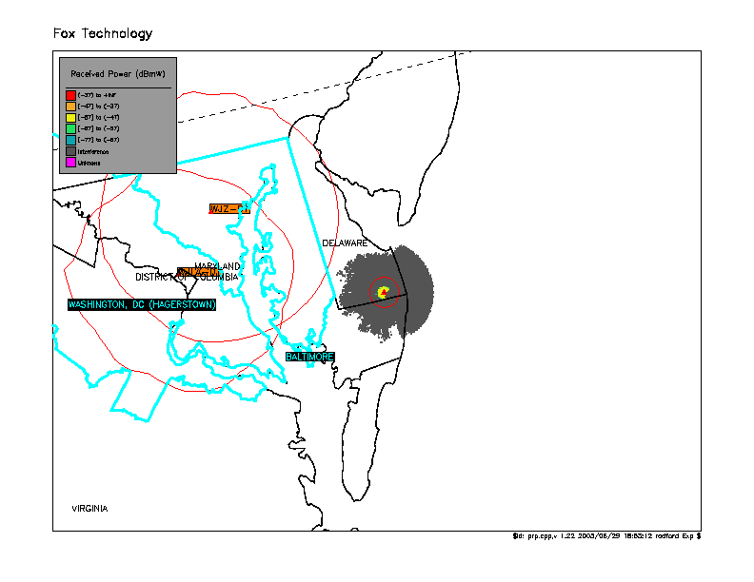

Figure 61: TV into 802.22, Interference
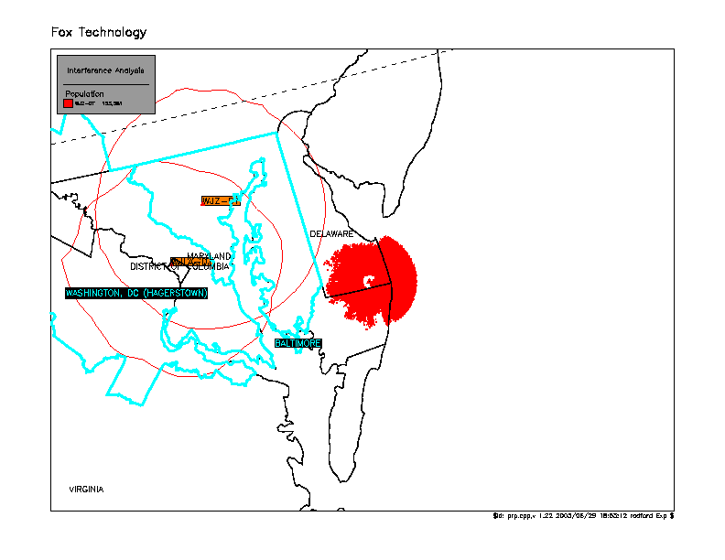

Figure 62: TV into 802.22 in NLC, Interference
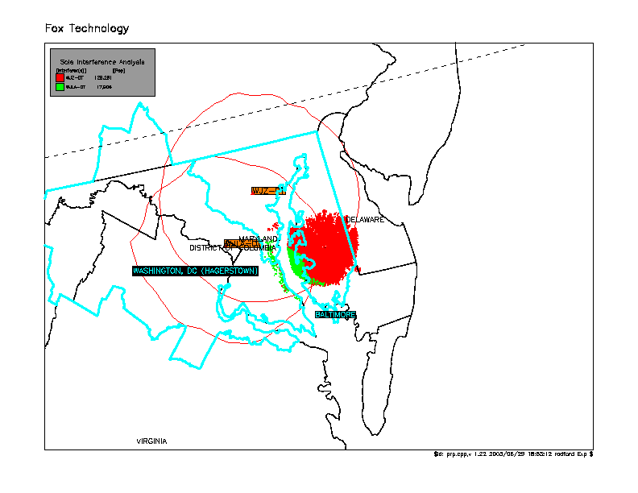

Figures 63 - 75: Norfolk, NE
Figure 63: 802.22 Coverage
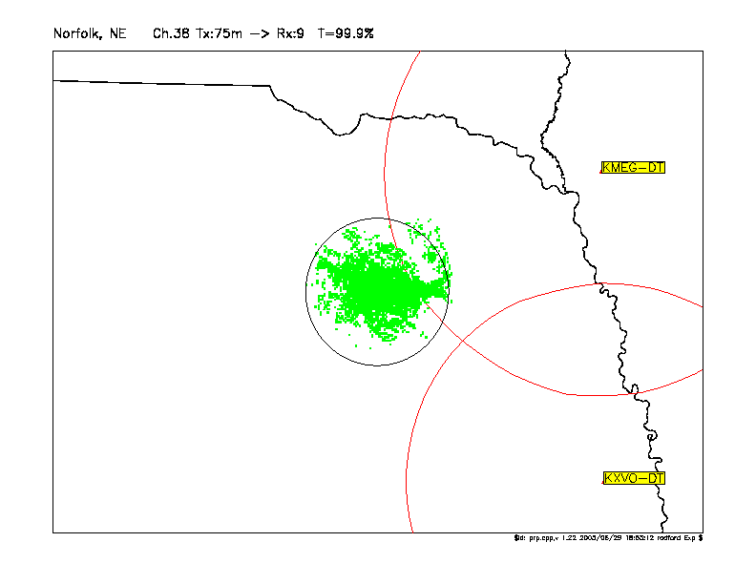

Figure 64: 802.22 into KXVO-DT
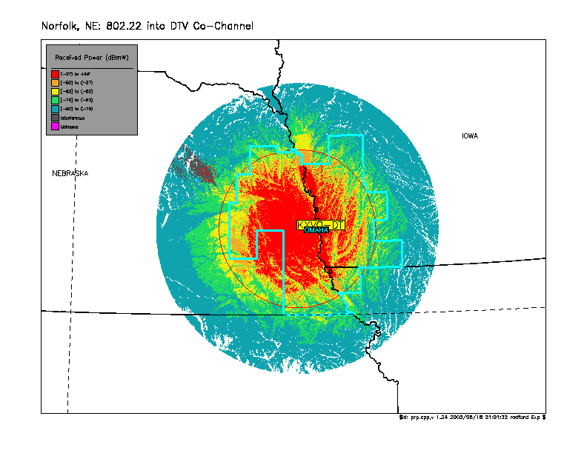

Figure 65: 802.22 into KXVO-DT, Interference
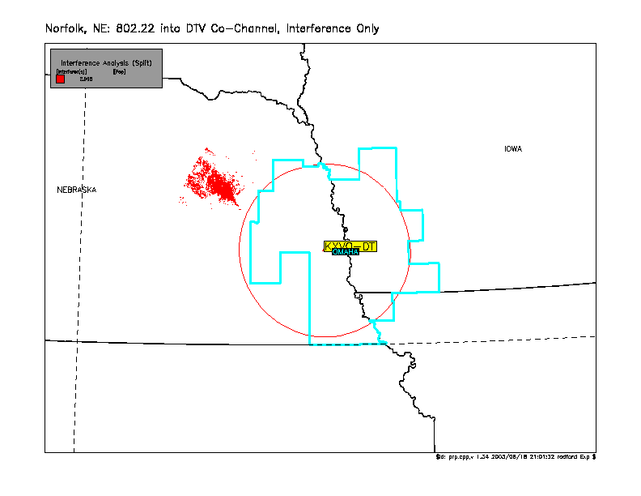

Figure 66: 802.22 into KXVO-DT in NLC
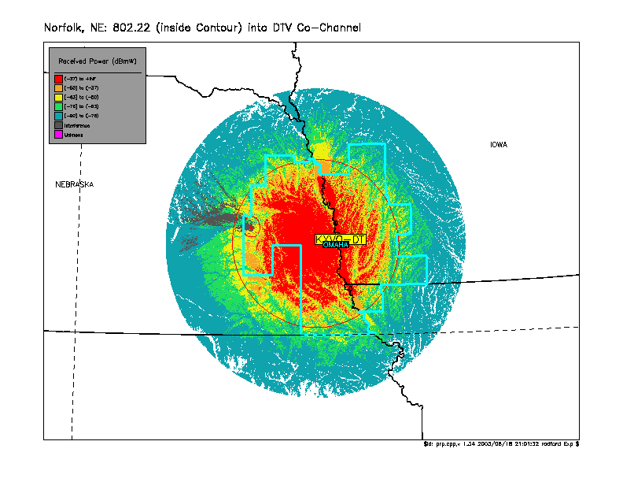

Figure 67: 802.22 into KXVO-DT in NLC, Interference
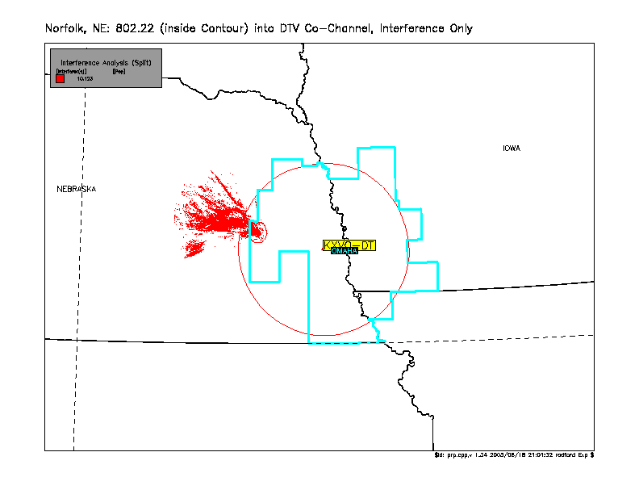

Figure 68: 802.22 into KXVO-DT in NLC (Pop. Count Filtered by NLC)
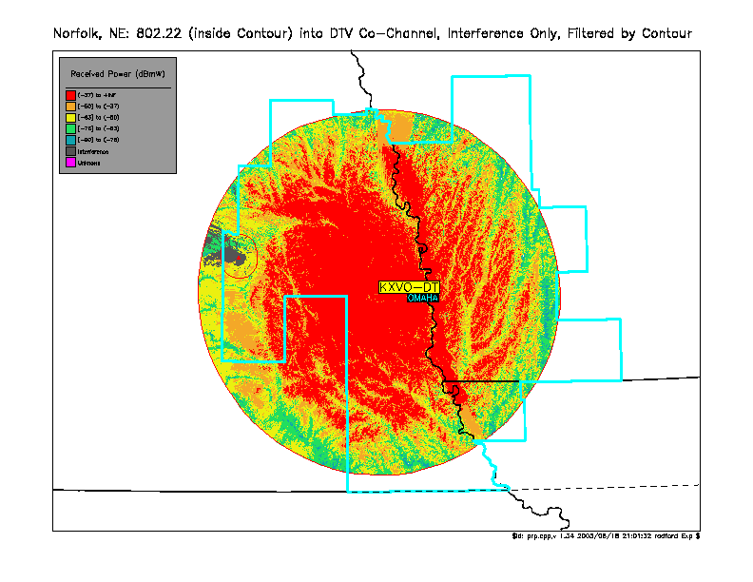

Figure 69: 802.22 into KXVO-DT in NLC, Interference (Pop. Count Filtered by NLC)
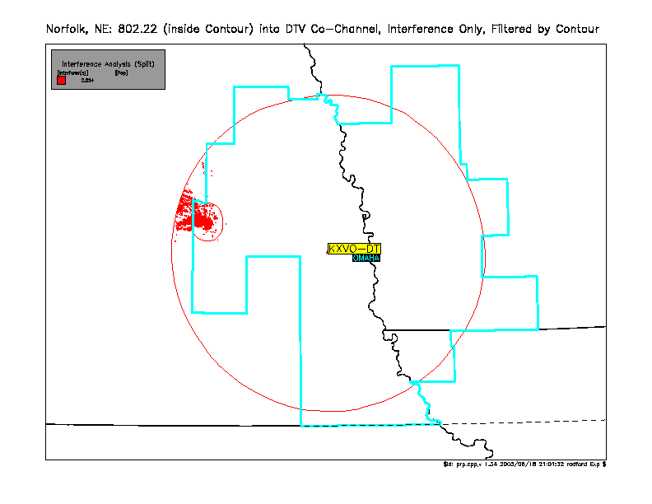

Figure 70: 802.22 into KMEG-DT
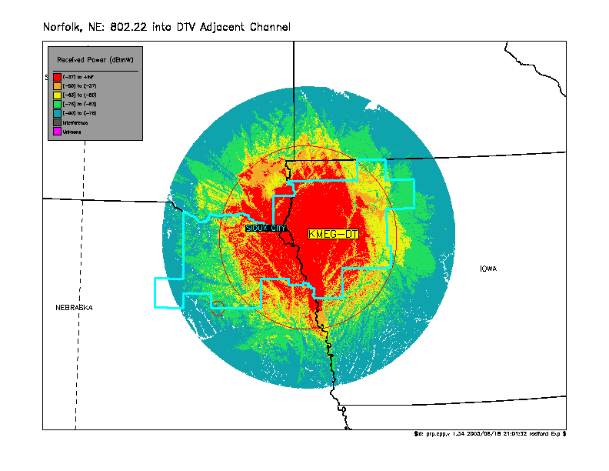

Figure 71: 802.22 into KMEG-DT, Interference
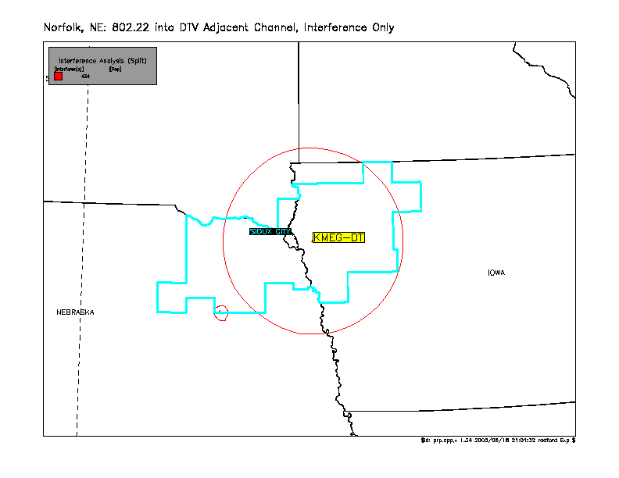

Figure 72: TV into 802.22
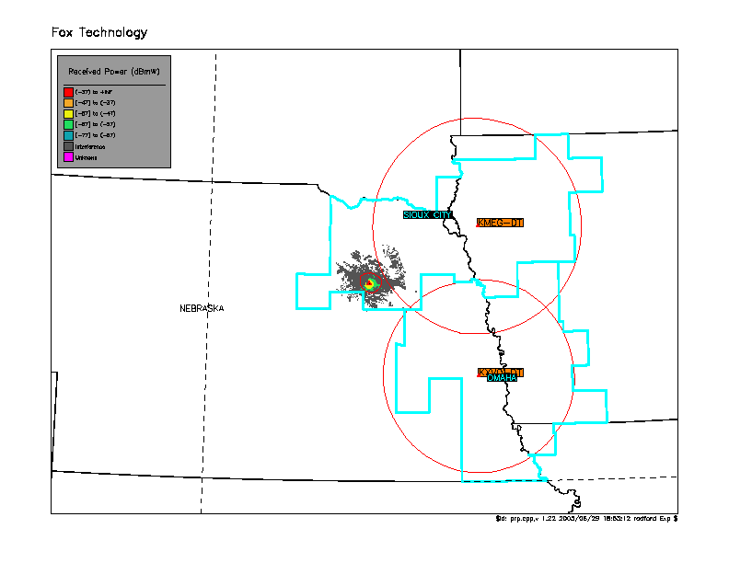

Figure 73: TV into 802.22, Interference
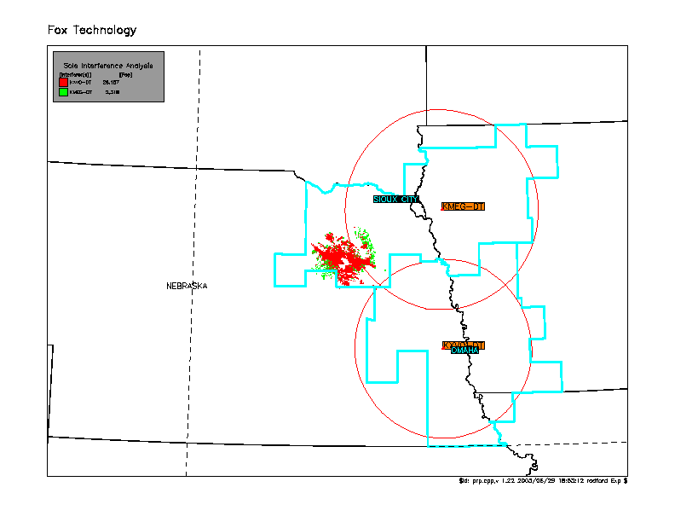

Figure 74: TV into 802.22 in KMEG-DT NLC
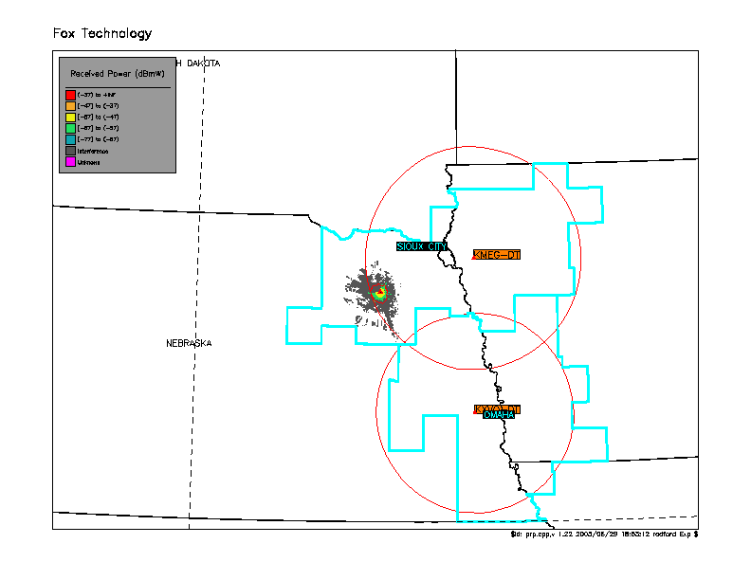

Figure 75: TV into 802.22 in KMEG-DT NLC, Interference
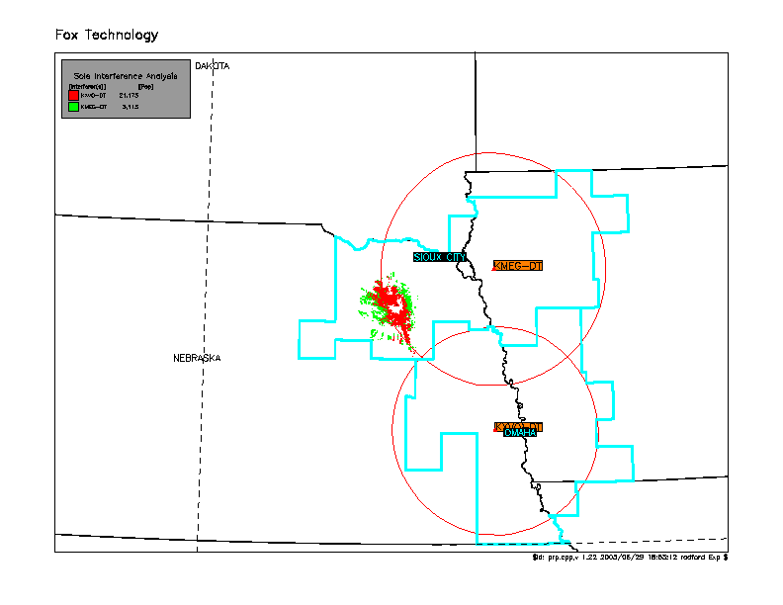

Figure 76 - 86: Hibbing, MN
Figure 76: 802.22 Coverage
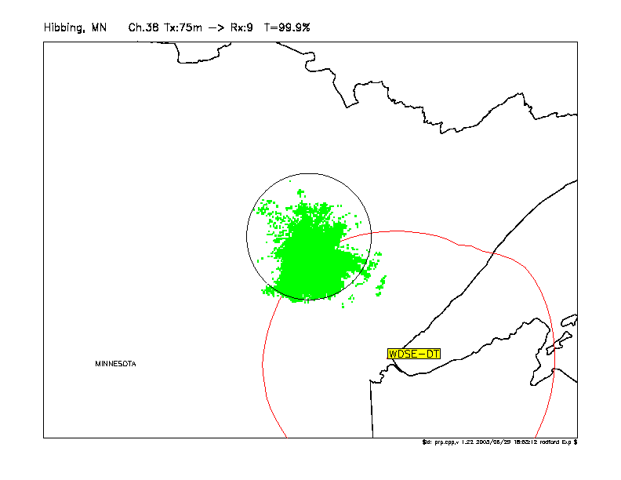

Figure 77: 802.22 into WDSE-DT
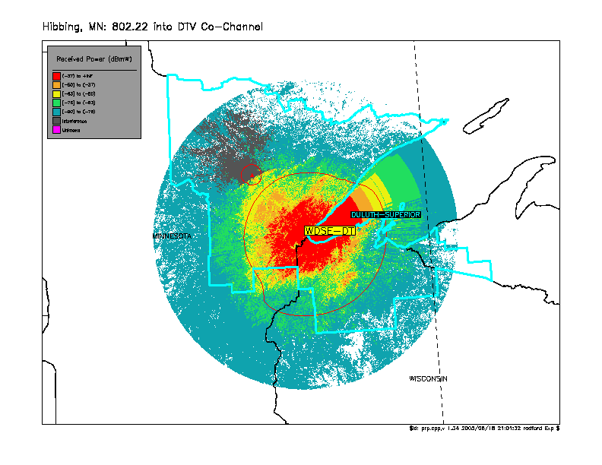

Figure 78: 802.22 into WDSE-DT, Interference
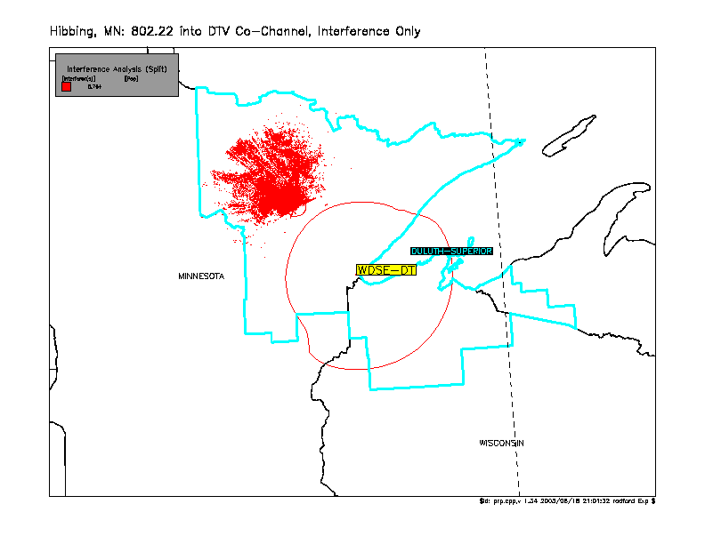

Figure 79: 802.22 into WDSE-DT in NLC
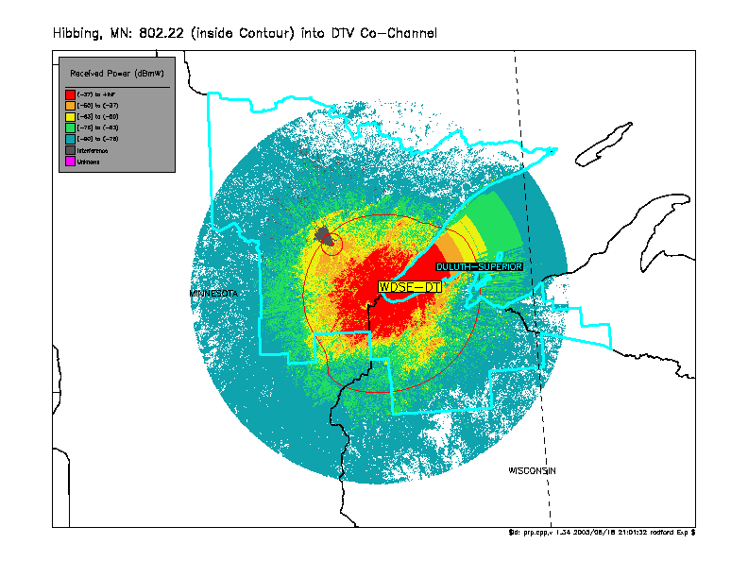

Figure 80: 802.22 into WDSE-DT in NLC, Interference
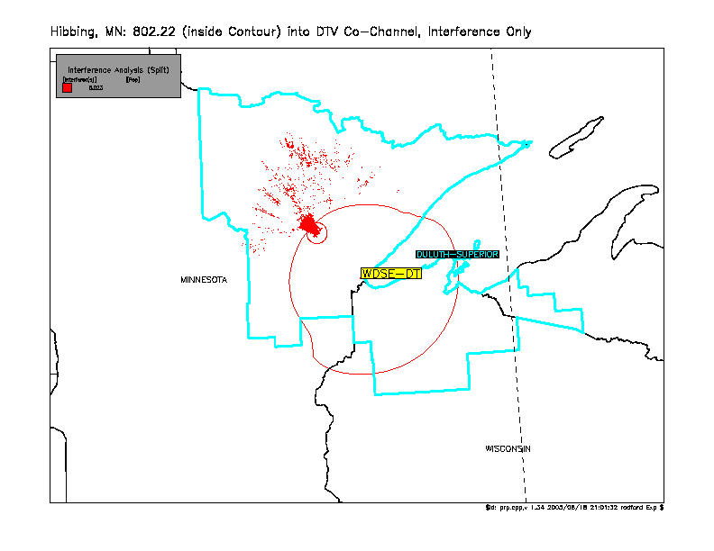

Figure 81: 802.22 into WDSE-DT in NLC (Pop. Count Filtered by NLC)
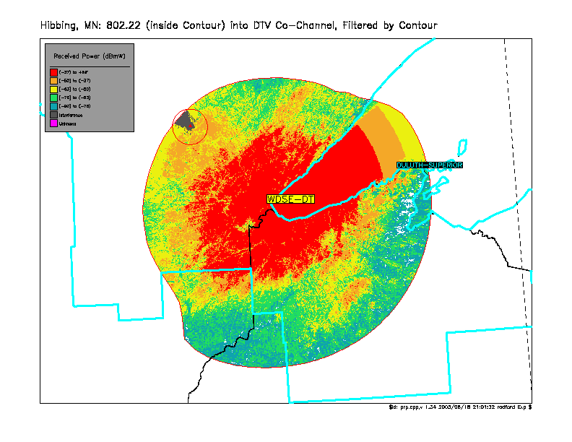

Figure 82: 802.22 into WDSE-DT in NLC, Interference (Pop. Count Filtered by NLC)
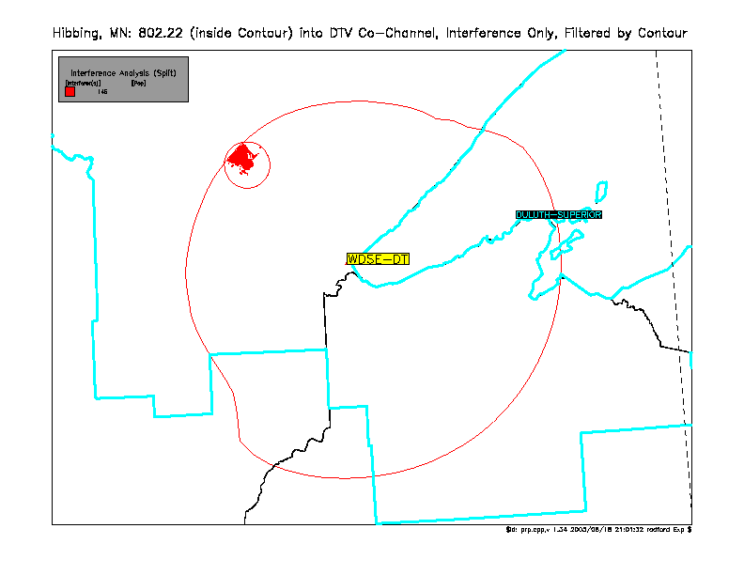

Figure 83: TV into 802.22
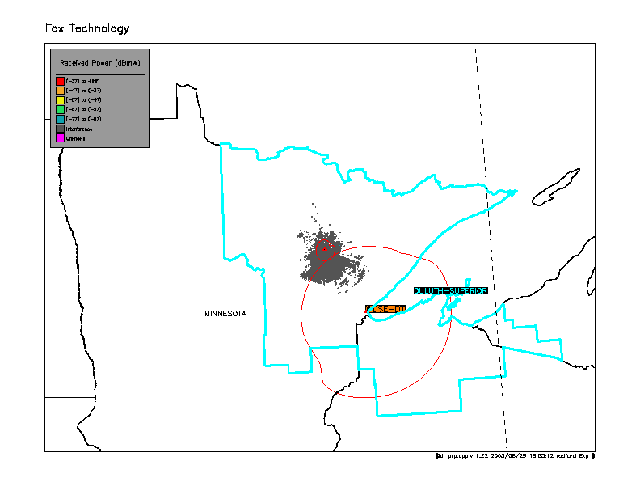

Figure 84: TV into 802.22, Interference
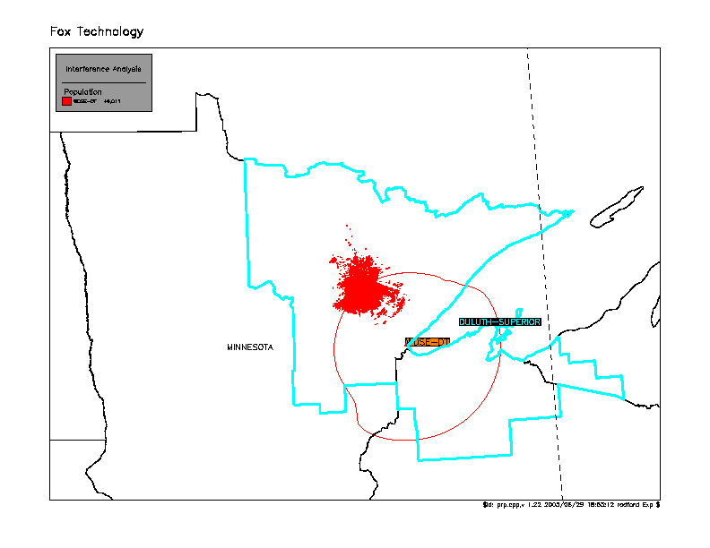

Figure 85: TV into 802.22 in NLC
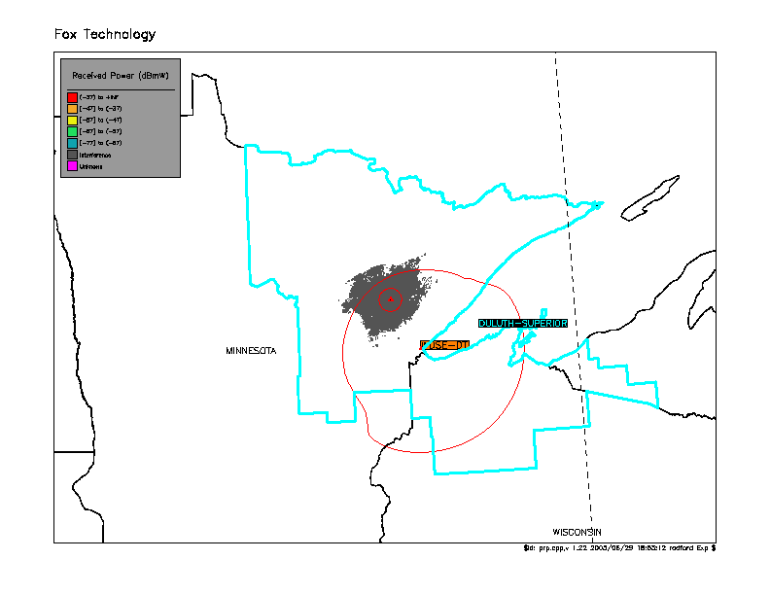

Figure 86: TV into 802.22 in NLC, Interference
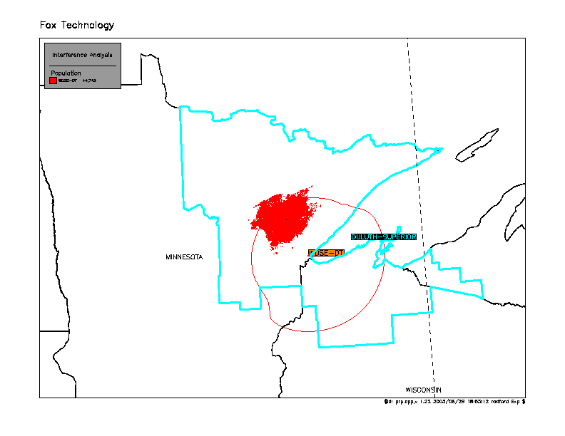

Results

 |  | Population Numbers
 |  | NTSC Co-Channel |  |  |  | NTSC Adjacent Channel |  |  |  | DTV Co-Channel |  |  |  | DTV Adjacent Channel
 |  | Outside NLC¹ |  | Inside NLC² |  | Outside NLC |  | Inside NLC |  | Outside NLC |  | Inside NLC |  | Outside NLC |  | Inside NLC
NLC Filter | : | Off³ | On⁴ | Off | On | Off | On | Off | On | Off | On | Off | On | Off | On | Off | On
Athens, GA | 802.22 into TV | 125,558 | 59 | 13,072 | 2,765 |  |  |  |  |  |  |  |  | 32 | 0 | 39 | 0
Athens, GA | TV into 802.22 | 135,764 |  | 34,868 |  |  |  |  |  |  |  |  |  | 135,764 |  | 120,472
Linden, TN | 802.22 into TV |  |  |  |  | 8 | 0 | 0 | 0 | 14,372 | 0 | 30,512 | 29,515 | 121 | 0 | 0 | 0
Linden, TN | TV into 802.22 |  |  |  |  |  |  |  |  | 28,423 |  | 55,788 |  | 28,423 |  | 77,311
Clayton, LA | 802.22 into TV |  |  |  |  | 38 | 0 | 0 | 0 | 44,747 | 0 | 33 | 0
Clayton, LA | TV into 802.22 |  |  |  |  |  |  |  |  | 39,689 |  | 30,612
Georgetown, DE | 802.22 into TV |  |  |  |  |  |  |  |  | 92,828 | 0 | 20 | 20 | 296 | 0 | 0 | 0
Georgetown, DE | TV into 802.22 |  |  |  |  |  |  |  |  | 155,581 |  | 147,167 |  | 155,581
Norfolk, NE | 802.22 into TV |  |  |  |  |  |  |  |  | 2,995 | 0 | 10,123 | 2,654 | 434 | 0 | 0 | 0
Norfolk, NE | TV into 802.22 |  |  |  |  |  |  |  |  | 28,475 |  |  |  | 28,475 |  | 24,286
Hibbing, MN | 802.22 into TV |  |  |  |  |  |  |  |  | 6,764 | 0 | 6,023 | 145
Hibbing, MN | TV into 802.22 |  |  |  |  |  |  |  |  | 46,011 |  | 44,743
- Outside NLC: the 802.22 device was located outside the TV service’s NLC.
- Inside NLC: the 802.22 device was located inside the TV service’s NLC.
- Off: all population affected by interference was considered and counted.
- On: only the population affected by interference that was located within the TV service’s NLC was counted.

Discussion

Firstly, it is important to recognize that the affected population numbers resulted from analysis where the desired-to-undesired (D/U) ratios normally used in TV interference analyses were assumed. These D/U ratios would not have been appropriate if, for example, the 802.22 transmission used a different modulation, such as Coded Orthogonal Frequency Division Multiplexing (COFDM). COFDM has a greater peak-to-average 8-VSB and can therefore be a more aggressive interfering modulation.

The resulting affected population numbers show that there are major interference complications when considering 802.22 coexistence with TV service. There are both interference problems from 802.22 transmissions into TV receivers and into 802.22 receivers from TV transmissions.

It can be seen that in the six locations where the interference caused by 802.22 devices into the TV service was examined, significant interference can be caused. If the 802.22 device is operating co-channel to the nearby TV service, many thousands of people can experience interference violating the D/U ratio. If only the affected population that is within the Noise-Limited Contour (NLC) is considered, there is not a significant interference issue as long as the co-channel 802.22 device is located outside of the NLC. There was a minor interference issue in the Athens, GA co-channel National Television Systems Committee (NTSC) example where 59 people were affected within the NLC. The interference issues become significantly more problematic if the co-channel 802.22 device operates inside the NLC. In these examples, thousands of people within the NLC experienced interference at levels above the D/U ratio.

If the 802.22 device was assumed to be operating adjacent channel to the nearby TV service, interference was caused to people on the order of hundreds. Even if the adjacent channel 802.22 device was assumed to be operating inside the TV NLC, no receivers within the NLC were affected.

The resulting numbers also demonstrate that there is a significant problem with the interference experienced by 802.22 devices from nearby TV transmissions. In every example, no matter whether the 802.22 device was co-channel or adjacent channel to the nearby TV service and whether the 802.22 device was located inside or outside the TV NLC, interference was caused to the majority, if not all, of the 802.22 service. The range of affected population numbers was more due to the distribution of the local population than to the factors mentioned above.

Conclusions

The results for the six locations examined show that in order for an 802.22 device not to interfere with a TV receiver located within the NLC, a co-channel 802.22 device must not be located inside the NLC. There is an NTSC example where a co-channel 802.22 device operating outside the NLC still interferes with a TV receiver within the NLC. Therefore, steps should be taken to ensure that the 802.22 device is located not only just outside the NLC but also far enough outside not to affect the TV receivers within the NLC. Also, because this occurs in a co-channel NTSC example, one should remember that as long as NTSC remains in service, as much effort should be afforded to protect the NTSC service as is afforded to protect the DTV service.

Although what has been proposed for regulations is to grant protection only to receivers located within the NLC, broadcasters have a greater interest in protecting the receivers that are within the Designated Market Area (DMA). The NLC of a TV transmitter was intended to cover the DMA as much as possible, however due to the occasionally odd shape of the DMA, what was intended was difficult to accomplish. For example, as shown in Figure 40, although the affected population was not located within the NLC, approximately half of the affected population (~ 22,000 people) was located within the Monroe/El Dorado DMA.

Probably the most interesting result of this analysis is the realization that an 802.22 system will be practically unable to operate anywhere near either a co-channel or adjacent channel TV station. Locating an area far enough away from a potentially interfering TV transmitter where an 802.22 system can be successfully deployed will prove to be a difficult challenge.

