IEEE P802.22
Wireless RANs
Proposed text changes to 22-06-0259-00-0000_v0.2_with_line_numbers Section 6.13.5 Annex B.2
Joint Transmitted EIRP Control for the Protection of TV Incumbents in co-channel and first adjacent channels operation outside the TV noise-protected contour.
Date: 2007-01-15
Author(s):
Name | Company | Address | Phone | email
Cheng Shan | Samsung Electronics | S. Korea | +82 31 279 7557 | cheng.shan@samsung.com
David Mazzarese | Samsung Electronics | S. Korea | +82 10 3279 5210 | d.mazzarese@samsung.com
Euntaek Lim | Samsung Electronics | S. Korea | +82 31 279 5917 | et.lim@samsung.com
Kathiravetpillai Sivanesan | Samsung Electronics | S. Korea | +82 31 279 0346 | k.sivanesan@samsung.com
Abstract
A method to determine the maximum allowed transmitted EIRP for one WRAN device, taking in account TV operations in nearby TV channels in the vicinity of the WRAN device, is described in section 6.13.5 of [1]. Revisions to this method have been submitted separately in [2]. The current transmitted EIRP control mechanism guarantees the transmission from each individual WRAN device meets the D/U ratio requirement at the TV protected contour. However, when multiple WRAN devices are scheduled to transmit within one TV channel simultaneously, the interferences induced at the TV protected contour aggregate. A method is proposed herein for the mandatory joint transmitted power control of multiple WRAN devices simultaneously transmitting on the same TV channel, in order to control the aggregate interference created at the edge of the TV protected contour, when these devices are located in a certain vicinity of each other. A recommended practice is also proposed. This feature was identified in September 2006 as an urgent “red” mandatory feature to be resolved [3]. The proposed text changes are presented in section 2.0 of this document. Sections 6.13.5.3 and 6.13.5.4 are proposed, in replacement of Annex B.2.
Notice: This document has been prepared to assist IEEE 802.22. It is offered as a basis for discussion and is not binding on the contributing individual(s) or organization(s). The material in this document is subject to change in form and content after further study. The contributor(s) reserve(s) the right to add, amend or withdraw material contained herein.

Release: The contributor grants a free, irrevocable license to the IEEE to incorporate material contained in this contribution, and any modifications thereof, in the creation of an IEEE Standards publication; to copyright in the IEEE’s name any IEEE Standards publication even though it may include portions of this contribution; and at the IEEE’s sole discretion to permit others to reproduce in whole or in part the resulting IEEE Standards publication. The contributor also acknowledges and accepts that this contribution may be made public by IEEE 802.22.

Patent Policy and Procedures: The contributor is familiar with the IEEE 802 Patent Policy and Procedures
<http://standards.ieee.org/guides/bylaws/sb-bylaws.pdf>, including the statement "IEEE standards may include the known use of patent(s), including patent applications, provided the IEEE receives assurance from the patent holder or applicant with respect to patents essential for compliance with both mandatory and optional portions of the standard." Early disclosure to the Working Group of patent information that might be relevant to the standard is essential to reduce the possibility for delays in the development process and increase the likelihood that the draft publication will be approved for publication. Please notify the Chair <Carl R. Stevenson> as early as possible, in written or electronic form, if patented technology (or technology under patent application) might be incorporated into a draft standard being developed within the IEEE 802.22 Working Group. If you have questions, contact the IEEE Patent Committee Administrator at <patcom@ieee.org>.
1.0 Comment

Section 6.13.5 addresses the following mandatory functional requirements to ensure no excessive interference beyond a threshold value at the TV protected contour. At a given time, such interference may come from one single WRAN device (CPE or BS), or multiple WRAN devices if they are scheduled to transmit within the same TV channel at the said given time.

The current version of section 6.13.5 in [1] gives the maximum transmitted EIRP constraint for an individual WRAN device, to ensure its individually induced interference at the TV protected contour meets a certain D/U requirement. As simultaneous transmission from multiple WRAN devices occurs with high probability in an OFDMA system, a joint power control function shall also be mandatory for a WRAN system to protect the incumbent users, in co-channel or first adjacent channel operation outside the TV protected contour.

“Multiple CPE joint TPC” was identified as “URGENT work - results needed for green zone” in [3]. The current version of Annex B.2 in [1] is not technically accurate. Section 2.0 in this document presents the proposed text for inclusion as sections 6.13.5.3 and 6.13.5.4, in replacement of Annex B.2. Sections 6.13.5.1 and 6.13.5.2 have been submitted in a separate comment supported by document [2] as a replacement of section 6.13.5 in [1].

2.0 Proposed Text Changes

6.13.5 Maximum Transmit EIRP Control of CPE and BS for the Protection of TV Incumbents

6.13.5.1 Individual CPE Maximum Transmit EIRP Control for the Protection of TV Incumbents
See the proposed text change to 6.13.5.1 to [1] in [2].

6.13.5.2 Individual BS Maximum Transmit EIRP Control for the Protection of TV Incumbents
See the proposed text change to 6.13.5.2 to [1] in [2].

6.13.5.3 Joint CPE Transmitted EIRP Control for the Protection of TV Incumbents
A joint EIRP constraint among CPEs located in a neighbouring area is required in order to avoid creating interference above the interference threshold into TV receivers during simultaneous transmission in the same TV channel. For example this applies in OFDMA when CPEs share the same subcarriers or sub-channels on the uplink, or when CPEs use different sub-channels but each one transmits the full 4W EIRP. In particular, this scenario applies to sharing of the spectrum by WRAN cells or operators.

The joint control of the CPEs transmitted EIRP is meant to protect incumbent services in the protected areas in the case of simultaneous transmissions from multiple CPEs located in an area close to a common boundary segment of the TV protected contour, but located outside the TV protected contour. We designate this area as a constraint area. The constraint area is determined from the Geolocation information of the CPEs and the operating incumbent systems, which are know from the spectrum map maintained by the WRAN. This joint control of the transmitted EIRP applies to WRAN operation on the same channel or on the first adjacent channel of a TV operation. The simultaneous CPE transmissions could occur in the following scenarios:

- Uplink sharing of the same TV channel but not the same subchannel
- Uplink sharing of the same subchannel within the same TV channel
- WRAN cells sharing the same TV channel but not the same subchannel (same WRAN or coexistence with another WRAN)
- WRAN cells sharing the same subchannel within the same TV channel (same WRAN or coexistence with another WRAN)
- Contention-based access to a WRAN base station.
- Coexistence with other license-exempt users whose transmissions can be modelled as another CPE transmitting simultaneously with one or more CPEs of the WRAN.

In 6.13.5.1, individual CPE maximum transmitted EIRP is defined. This individual maximum EIRP control comes prior to any CPE scheduling and other power control for each CPE. The scheduler at the BS assigns DS sub-channel and transmit power to CPEs connecting with the BS through the US-MAP message. The individual allocated CPE transmitted EIRP shall not exceed the maximum CPE transmitted EIRP with a protection margin as defined in 6.13.5.1.

In addition to the individual maximum transmitted EIRP constraint defined in 6.13.5.1, when the WRAN system attempts to schedule CPE transmission on TV channel$N$, it shall guarantee the total radiated in-band interference so caused at the TV protected contours on TV channel$N$, as well as the out-band interference in the first adjacent TV channels$N±1$, do not exceed pre-defined thresholds if any of the said TV channels are being used by the incumbent system. The actual allocated power to each CPE on TV channel $N$ must satisfy the following conditions in order not to induce excessive interference at the TV protected contour of TV channel $N$ to protect the incumbent service on TV channels$N$, $N+1$ or$N−1$:
$\sum_{k=1}^{K}{I(P_{\text{CPE},k},d_{k,n})≤T_{\text{max,}n}−M, \text{if} \text{incumbent} \text{system} \text{transmit} \text{on} \text{TV} \text{channel} n\text{.} (n=N,N±1)}$.
Here
$K$is the total number of CPEs within the constrained area;
$k$is the index of CPEs within the constraint area ranging from $1$ to$K$;
$P_{\text{CPE},k}$is the actual transmitted EIRP of CPE $k$ on its assigned sub-channels within TV channel$N$;
$d_{k,n}$is the distance from the CPE $k$ to the protected contour of the TV operation on channel $n$;
$I(P_{\text{CPE},k},d_{k,n})$is the interference level at the protected contour , induced by the transmission of CPE $k$ on channel $N$ with power $P_{\text{CPE},k}$ and distance $d_{k,n}$ from the protected contour;
$T_{\text{max,}n}$is the maximum allowed interference level created by the WRAN into the incumbent system that operates on channel$n$, given the CPEs are transmitting on TV channel$N$;
$M$is a predefined margin for the protection of the primary incumbent system by joint CPE power control.

A joint power controller shall be present after each new scheduling decision for US transmission, i.e. a joint power control algorithm shall be performed after each new allocation of US subchannels and transmitted powers to CPEs. This joint power control module tests if the allocated transmitted powers jointly satisfy the above constraint. Whenever multiple CPEs are scheduled within a TV channel$N$, the WRAN first looks at the spectrum map and determines if any neighboring incumbent system is active on any TV channels ranging from $N−1$ to$N+1$. If an incumbent service is detected on any of these channels, the above interference constraint shall be tested for each detected TV channels $n$ on which an incumbent system is active. If the joint interference exceeds the threshold, the joint power controller shall reduce the transmit power for some or all scheduled CPEs, if it is determined that some of these CPEs belong to the same constraint area relative to the TV operation on channel $n$. The new power allocation must satisfy:
$P_{\text{CPE},k}^{\text{new}}<P_{\text{CPE},k}$,
where $P_{\text{CPE},k,n}^{\text{new}}$ is the newly allocated transmit power for CPE $k$ by the joint CPE power control module. The joint interference level at the TV protected channel is then updated with the newly allocated transmit power to test if there is excessive interference. The joint power control mechanism keeps reducing the transmit power of CPEs within the constraint area until there is no harmful interference in TV channel$n$. Such a procedure is repeated for each TV channel $n$ on which an incumbent system is active. Since each execution of the procedure gives one value for$P_{\text{CPE},k}$, the minimum one is chosen to be the actual final transmit power for CPE $k$ to ensure there is no excessive harmful in-band or out-band interference on TV channels$N$, $N+1$ and $N−1$ due to the CPE transmission on channel$N$. A well-designed scheduling and power control algorithm will make sure that the joint interference meets the interference threshold requirement, so that the joint CPE power control module would not need to modify the power allocation and would not disturb the scheduling decision.

The described joint power controller shall be present for every TV channel $N$ within which multiple CPEs are scheduled, if the incumbent system occupies any of the TV channels$N$, $N+1$ and$N−1$. For bonded or aggregated channels, the joint power control algorithm shall be executed for each single TV channel. The principle of a joint power controller on a single channel is depicted in Figure 19.1.

To calculate the interference induced by CPE $k$ at the TV protected contour, it is recommended to use the following model:
$$I(P_{\text{CPE},k},d_{k,n})=P_{\text{CPE},k}\text{PL}(d_{k,n})$$
where $\text{PL}(d_{k})$ is the path-loss from the said CPE to the protected contour on TV channel $N$ according to a certain pre-determined channel model. A list of recommended channel models is available in the recommended practice document [reference to be updated in the future].
To update the invalid power allocation which would cause excessive aggregated interference at the TV protected contour, a simple implementation is given by

$P_{\text{CPE},k}^{\text{new}}=P_{\text{CPE},k}[1−Δ_{k}\text{\%}]$,
where $Δ_{k}>0$ is a pre-defined positive percentage constant for each CPE$k$.

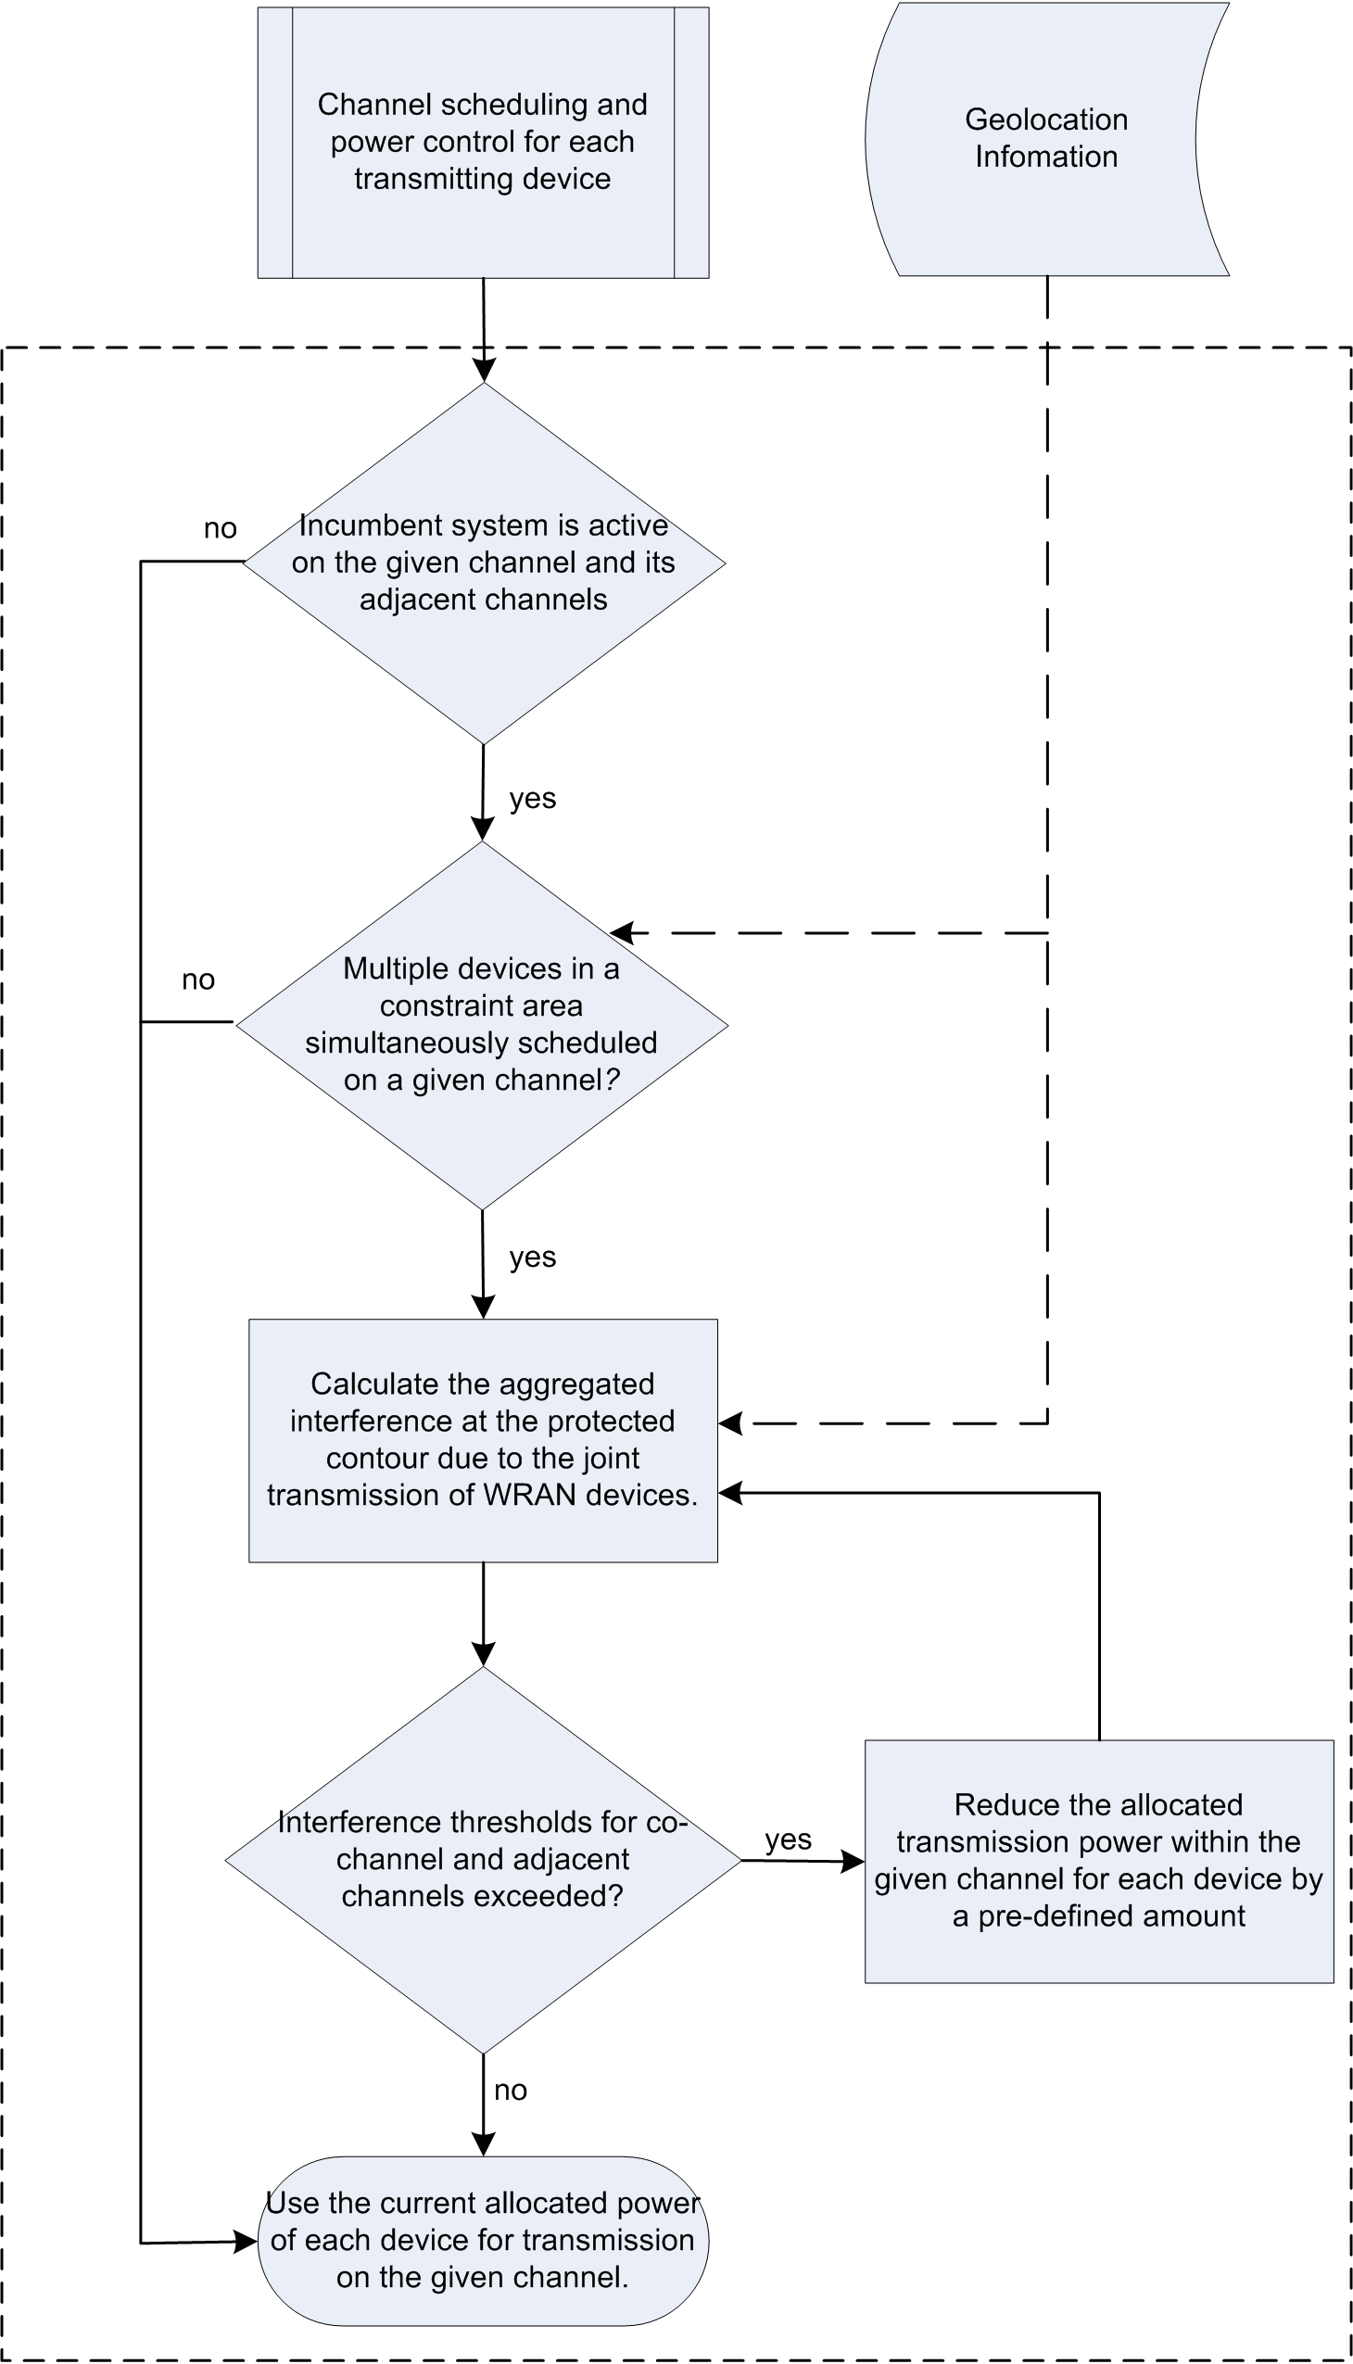
Figure -19.1 Structure of a joint power control module

Note that if the WRAN coexists with multiple incumbent systems, the joint CPE power control shall be performed with respect to each individual incumbent system. For each scheduled CPE, the minimum transmit power value from the results of joint CPE power controls with respect to multiple incumbent systems shall be chosen in order not to cause excessive interference to any of the incumbent systems.

6.13.5.4 Joint BS Transmitted EIRP Control for the Protection of TV Incumbents

when the WRAN system attempts to schedule BS transmission on TV channel$N$, it shall guarantee the total radiated in-band interference so caused at the TV protected contours on TV channel$N$, as well as the out-band interferences in the first adjacent TV channels $N±1$, do not exceed pre-defined thresholds if any of the said TV channels are being used by the incumbent system. The actual allocated power to each BS on TV channel $N$ must satisfy the following conditions in order not to induce excessive interference at the TV protected contour of TV channel $N$ to protect the incumbent service on TV channels$N$, $N+1$ or$N−1$:
$\sum_{l=1}^{L}{I(P_{\text{BS},l},d_{l,n})≤T_{\text{max,}n}−M^{'}}, \text{if} \text{incumbent} \text{system} \text{transmit} \text{on} \text{TV} \text{channel} n\text{.} (n=N, N±1)$.
Here
$L$is the total number of BSs within the constrained area;
$l$ is the index of BSs within the constraint area, ranging from $1$ to$L$;
$P_{\text{BS},l}$is the actual transmitted EIRP of BS $l$ within TV channel$N$;
$d_{l,n}$is the distance from the BS $l$ to the protected contour of the TV operation on channel n;
$I(P_{\text{BS},l},d_{l,n})$ is the interference level at the protected contour, induced by the transmission of BS $l$ on channel $N$ with power $P_{\text{BS},l}$ and distance $d_{l,n}$ from the protected contour;
$M^{'}$is a predefined margin for the protection of the primary incumbent system for joint BS power control.

Similar joint BS power control should be present as in 6.13.5.3. The joint BS power control shall decrease the scheduled BS power until the above constraint is satisfied as described in 6.13.5.3.

The described joint power controller shall be present for every TV channel $N$ within which multiple BSs are operating, given the incumbent system occupies any of the TV channels$N$, $N+1$ and$N−1$. For bonded or aggregated channels, the joint power control shall be executed for each single TV channel.

Note that if the WRAN coexists with multiple incumbent systems, the joint BS power control shall be performed with respect to each individual incumbent system. For a certain BS, the minimum transmit power value from the results of joint BS power controls with respect to multiple incumbent systems shall be chosen in order not to cause excessive interference to any of the incumbent systems.

3.0 References

[1] 22-06-0259-00-0000_v0.2_with_line_numbers, January 2007.
[2] 22-06-0219-01-0000_Proposed_text_changes_to_P802-22_D0.1_Final_Section_6_13_5, November 2006.
[3] 22-06-0200-01-0000_Table_of_Options_in_P802-22_D0.1, September 2006.

