IEEE P802.22
Wireless RANs
Text on Multi-Resolution Spectrum Sensing – For Informative Annex on Sensing Techniques
Date: 2007-05-30
Author(s):
Name | Company | Address | Phone | Email
Kyutae Lim | GEDC,  Georgia Tech | 85 5th Street NW, Atlanta, GA, USA | +1-404-385-6008 | ktlim@ece.gatech.edu
Jongmin Park | GEDC,  Georgia Tech | 85 5th Street NW, Atlanta, GA, USA | +1-404-385-6008 | minipark@ece.gatech.edu
Joy Laskar | GEDC,  Georgia Tech | 85 5th Street NW, Atlanta, GA, USA | +1-404-385-6008 | joy.laskar@ece.gatech.edu
Haksun Kim | Samsung Electro-Mechanics | 314, Maetan-Dong, Suwon, Gyunggi-Do, South Korea | +82-31-210-5662 | hszic.kim@samsung.com
Kihong Kim | Samsung Electro-Mechanics | 314, Maetan-Dong, Suwon, Gyunggi-Do, South Korea | +82-31-210-5662 | kh607.kim@samsung.com
Jungsuk Lee | Samsung Electro-Mechanics | 314, Maetan-Dong, Suwon, Gyunggi-Do, South Korea | +82-31-210-5662 | js0305.lee@samsung.com
Chang-Ho Lee | Samsung Design Center | 85 5th Street NW, Atlanta, GA, USA | +1-404-667-3280 | changholee@samsung.com

Abstract
This document contains the text on the Multi-Resolution Spectrum Sensing for the informative Annex on sensing techniques.
Notice: This document has been prepared to assist IEEE 802.22. It is offered as a basis for discussion and is not binding on the contributing individual(s) or organization(s). The material in this document is subject to change in form and content after further study. The contributor(s) reserve(s) the right to add, amend or withdraw material contained herein.

Release: The contributor grants a free, irrevocable license to the IEEE to incorporate material contained in this contribution, and any modifications thereof, in the creation of an IEEE Standards publication; to copyright in the IEEE’s name any IEEE Standards publication even though it may include portions of this contribution; and at the IEEE’s sole discretion to permit others to reproduce in whole or in part the resulting IEEE Standards publication. The contributor also acknowledges and accepts that this contribution may be made public by IEEE 802.22.

Patent Policy and Procedures: The contributor is familiar with the IEEE 802 Patent Policy and Procedures
<http://standards.ieee.org/guides/bylaws/sb-bylaws.pdf>, including the statement "IEEE standards may include the known use of patent(s), including patent applications, provided the IEEE receives assurance from the patent holder or applicant with respect to patents essential for compliance with both mandatory and optional portions of the standard." Early disclosure to the Working Group of patent information that might be relevant to the standard is essential to reduce the possibility for delays in the development process and increase the likelihood that the draft publication will be approved for publication. Please notify the Chair <Carl R. Stevenson> as early as possible, in written or electronic form, if patented technology (or technology under patent application) might be incorporated into a draft standard being developed within the IEEE 802.22 Working Group. If you have questions, contact the IEEE Patent Committee Administrator at <patcom@ieee.org>.
1. MRSS Overview
The basic theory of MRSS is presented as follows. Let’s say is one pulse of a modulated window, as defined in (1), where is the modulation frequency. is the convolution of and the incoming RF signal, . Eq. (3) is obtained with t = 0 in (2). It shows that time-domain multiplication of the RF signal and modulated window is the same as the band-pass filtered RF signal by the band-pass characteristic of the modulated window.
(1)
(2)
(3)
Fig. 1 shows a possible functional block diagram of MRSS. The receiving path is split into in- and quadrature-phase path to eliminate the need for the synchronization process. A window pulse generator generates one pulse of a window with various window frequencies,, which are modulated with the sine or cosine wave from the local oscillator. The broadband RF signal from the omni-directional antenna is amplified with a low-noise amplifier (LNA). The gain of LNA should be maximized to have a minimum noise figure of the system, but too large of a gain will saturate the following multiplier, generating many unwanted harmonics. Therefore, an adequate gain control block is required before a multiplier. The analog correlator multiplies and integrates the amplified signal and modulated window pulse. With adequate timing control, the integrated output is sampled and digitized to generate the band-pass filtered amplitude information in in-phase and quadrature-phase components. A linear amplifier or a logarithmic amplifier can be placed in front of an analog-to-digital converter (ADC) in order to maximize the dynamic range utilization of the ADC. The digitized result is further processed in the digital domain. The detected signal power can be processed in a logarithmic domain to have a processing gain over the Gaussian noise.

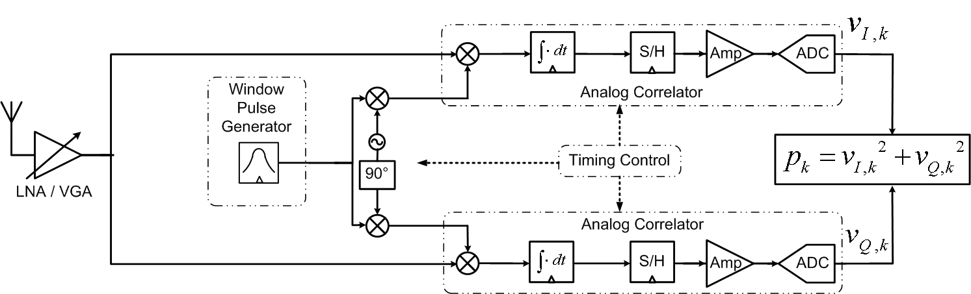

Fig. 1. Functional block diagram of the MRSS system
2. MRSS examples
Fig. 2 shows the multi-resolution property of MRSS with two window frequencies, one with = 100 kHz and the other with = 1 MHz. The inputs to this simulation are a continuous wave (CW) signal of -50 dBm at 582 MHz, Advanced Television Systems Committee (ATSC) signal of -30 dBm at 600 MHz, and Digital Video Broadcasting - Terrestrial (DVB-T) signal of -70 dBm at 615 MHz. ATSC uses 8-level vestigial sideband (8-VSB) modulation, and DVB-T uses the Orthogonal Frequency-Division Multiplexing (OFDM) modulation scheme. The total required time in performing MRSS can be calculated as
(4)
, where and is the frequency sweep range of the local oscillator, is the amount of frequency change in the oscillator, is the number of averaging in one window modulation frequency, and is the maximum switching settling time of the local oscillator. In Fig. 2, the window-modulation frequency of MRSS is swept from 570 MHz to 620 MHz with equals . No averaging is done in this case. Therefore, when = 100 kHz, it will have 500 results, each representing the detected signal power at the given window modulation frequency. In the same way, 1 MHz of will have 50 results. If is assumed to be 10 , the total processing time is 10.02 msec and 561 for = 100 kHz and 1 MHz, respectively.

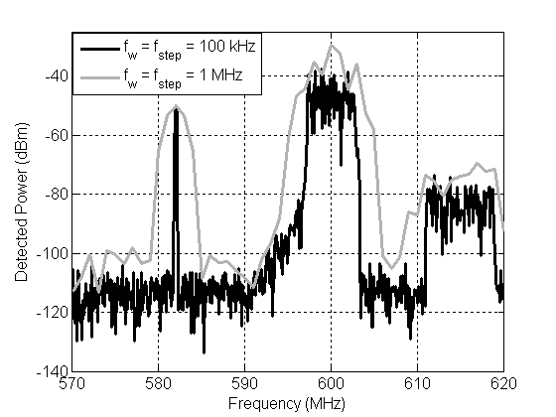
Fig. 2. Fine (= 100 kHz) and coarse (= 1 MHz) resolution property of MRSS using the window. Inputs are CW (-50 dBm @ 582 MHz), ATSC (-30 dBm @ 600 MHz) and DVB-T (-70 dBm @ 615 MHz).

