IEEE P802.22
Wireless RANs
Proposed Resolutions for Comments Related to Figure 21, CPE Network Entry and Initialization Procedure
Date: 2007-04-25
Author(s):
Name | Company | Address | Phone | email
Edward Au | Huawei & HKUST | HKUST, Clear Water Bay, Hong Kong | 852-2358-7086 | ks.au@ieee.org
Wendong Hu | ST Microelectronics | San Jose, CA, US | 1-408-467-8410 | Wendong.hu@st.com

Abstract
This submission describes the proposed normative text to resolve the following comments: 97, 109, 264, 265, 266, and 267.
Notice: This document has been prepared to assist IEEE 802.22. It is offered as a basis for discussion and is not binding on the contributing individual(s) or organization(s). The material in this document is subject to change in form and content after further study. The contributor(s) reserve(s) the right to add, amend or withdraw material contained herein.

Release: The contributor grants a free, irrevocable license to the IEEE to incorporate material contained in this contribution, and any modifications thereof, in the creation of an IEEE Standards publication; to copyright in the IEEE’s name any IEEE Standards publication even though it may include portions of this contribution; and at the IEEE’s sole discretion to permit others to reproduce in whole or in part the resulting IEEE Standards publication. The contributor also acknowledges and accepts that this contribution may be made public by IEEE 802.22.

Patent Policy and Procedures: The contributor is familiar with the IEEE 802 Patent Policy and Procedures
<http://standards.ieee.org/guides/bylaws/sb-bylaws.pdf>, including the statement "IEEE standards may include the known use of patent(s), including patent applications, provided the IEEE receives assurance from the patent holder or applicant with respect to patents essential for compliance with both mandatory and optional portions of the standard." Early disclosure to the Working Group of patent information that might be relevant to the standard is essential to reduce the possibility for delays in the development process and increase the likelihood that the draft publication will be approved for publication. Please notify the Chair <Carl R. Stevenson> as early as possible, in written or electronic form, if patented technology (or technology under patent application) might be incorporated into a draft standard being developed within the IEEE 802.22 Working Group. If you have questions, contact the IEEE Patent Committee Administrator at <patcom@ieee.org>.

Introduction

This document contains proposed normative text to resolve the following comments related to Section 6.15 (Network entry and initialization) [1]: CID#97, #109, #264, #265, #266, and #267.

CID #97
Comment: There are a number of subclauses in this section that have not been included. This section is incomplete.
Suggested Remedy: Use the 802.16 spec as a starting point and update this section with all the needed subclauses.

CID #109
Comment: This section [Section 7] seems to be far from complete.
Suggested Remedy: Start from the 802.16 spec and fill in this section accordingly.

CID #264
Comment: A section detailing the Authorize CPE block referred to in Figure 21 should be added.
Suggested Remedy: Add section.

CID #265
Comment: A section should be added detailing the Perform Key Exchange block referred to in Figure 21.
Suggested Remedy: Add section.

CID #266
Comment: A section needs to be added detailing the Perform Registration block referred to in Figure 21.
Suggested Remedy: Add section.

CID #267
Comment: A section needs to be added detailing the Set up Connections block referred to in Figure 21.
Suggested Remedy: Add section.

Review

Referring to [2], the updated Figure 21 summarizes the network entry and initialization procedure carried by CPEs. In [1], there are subclauses that detail the functions of the following blocks:
- Section 6.15.2 (Scanning Downstream Channels): Scan for downstream channel.
- Section 6.15.3 (Obtaining Downstream Parameters): Synchronization with BS.
- Section 6.15.4 (Obtaining Upstream Parameters): Obtain transmit parameters from BS (from UCD)
- Section 6.15.5 (Initial Ranging and Automatic Adjustments): Perform ranging.
- Section 6.15.6 (Neighboring Network Discovery): Perform neighboring network discovery.
In this submission, normative texts are provided for the remaining blocks of Figure 21, namely,
- Automatic Adjustments of Initial Ranging (in response to CID#97)
- Negotiate basic capabilities (in response to CID#97)
- Authorize CPE and Perform Key Exchange (in response to CID#97, #264 and #265)
- Perform Registration (in response to CID#97 and #266)
- Perform optional initialization steps, including “Establish IP Connectivity”, “Establish Time of the Day”, and “Transfer Operational Parameters” (in response to CID#97)
- Set up Connections (in response to CID#97 and #267)
Figure 21–CPE network entry and initialization procedure [2]

Comment #97

[Include new subclause 6.15.5.2 Ranging Parameter Adjustment]

Adjustment of local parameters (e.g. transmit power) in a CPE as a result of the receipt or non-receipt of a RNG-RSP message is considered to be implementation-dependent with the following restrictions:
- All parameters shall be within the approved range at all times.
- Power adjustment shall start from the initial value selected with the algorithm described in subclause 6.15.5.1 unless a valid power setting is available from non-volatile storage, in which case this value may be used a the starting point.
- Power adjustment shall be capable of being reduced or increased by the specified amount in response to the RNG-RSP messages.
- If, during initialization, power in increased to the maximum value without a response from the BS, it shall wrap back to the minimum.

On receiving a RNG-RSP message, the CPE shall not transmit until the RF signal has been adjusted in accordance with the RNG-RSP and has stabilized.

Comment #97

[Renumber Section 6.15.6 (Neighboring Network Discovery) as Section 6.15.9]

[Include new subclause 6.15.6 Negotiate Basic Capabilities]

Right after the completion of initial ranging, the CPE informs the BS of its basic capabilities by transmitting a CBC-REQ message (see Table 117 of [1]) with its capabilities set to “on” (see Figure xxa). The BS responds with a CBC-RSP message (see Table 118 of [1]) with the intersection of the CPE’s and BS’s capabilities set to “on” (see Figures xxb and xxc, respectively). Note that the CPE capability information is presented in subclause 6.8.7.3.7 of [1].

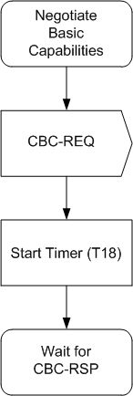
Figure xxa – Negotiate basic capabilities – CPE

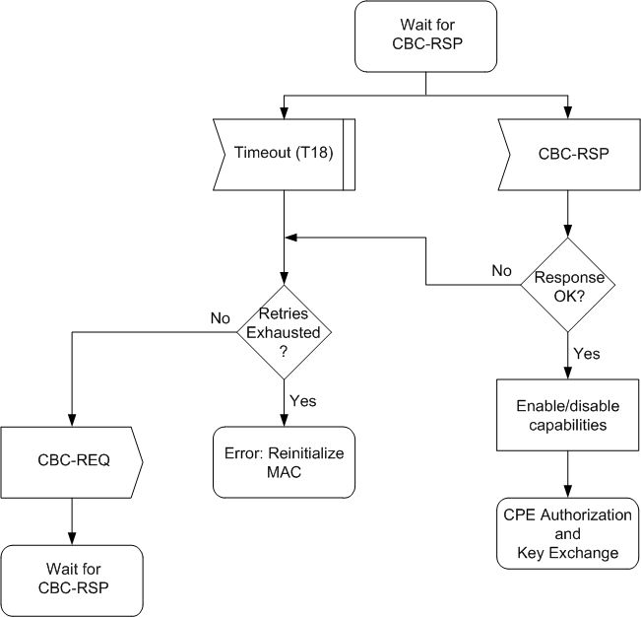
Figure xxb – Wait for CBC-RSP – CPE
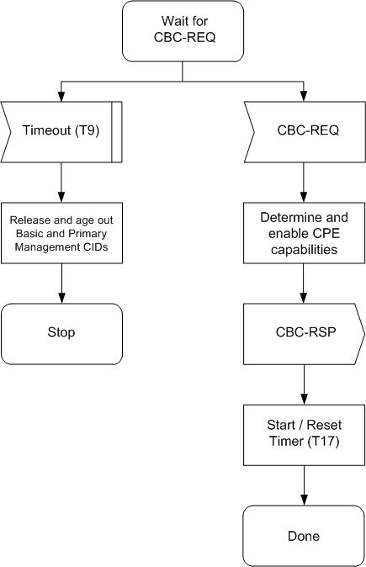
Figure xxc – Negotiate basic capabilities – BS

Comments #97, #109, #264, #265

[Include new subclause 6.15.7 CPE Authorization and Key Exchange]

The BS and CPE perform authorization and key exchange as described in subclause 7.2.

[Include new subclause 7.1.1 Secure Encapsulation of MAC PDUs]

Encryption services are defined as a set of capabilities within the MAC Security Sublayer. MAC header information specific to encryption is allocated in the generic MAC header format. Note that encryption is applied to the MAC PDU payload when required by the selected ciphersuite; the generic MAC header is not encrypted.

[Renumber and Rename subclause 7.2 Authentication as 7.1.2 Key Management Protocol]

[Replace the first sentence of this renumbered subclause 7.1.2]

The PKM protocol is mostly based on the PKM protocol defined in the IEEE802.16e/D12. In particular, the PKM protocol allows for both mutual authentication and unilateral authentication (e.g., where the BS authenticates CPE, but not vice versa).

[Include the following texts after line 15 of Page 180 of [1]]

A CPE uses the PKM protocol to obtain authorization and traffic keying material from the BS, and to support periodic reauthorization and key refresh.

PKM supports two distinct authentication protocol mechanisms as follows.
- RSA Authentication
- EAP Authentication (optional unless specifically required)

[Renumber subclause 7.2.1 PKM RSA Authentication as 7.1.2.1]
[Renumber subclause 7.2.2 PKM EAP Authentication as 7.1.2.2]

[Renumber and Rename subclause 7.3 Authorization as 7.2 PKM Protocol. Replace the text of the whole subclause by the following.]
[Include new subclause 7.2.1 Security Associations]

A Security Association (SA) is the set of security information a BS and one or more of its client CPEs share in order to support secure communications across the IEEE Std 802.22 network. Three types of SAs are defined, namely Primary, Static, and Dynamic. Each CPE establishes a Primary Security Association during the CPE initialization process. Static SAs are provisioned within the BS, whereas dynamic SAs are established and eliminated, on the fly, in response to the initialization and termination of specific service flows. Both Static and Dynamic SAs may be shared by multiple CPEs. Note that an SA-shared information shall include the Cryptographic Suite employed within the SA. The shared information may include TEKs and Initialization Vectors. The exact content of the SA is dependent on the SA’s Cryptographic Suite.

SAs are identified using SAIDs. Each CPE shall establish an exclusive Primary SA with its BS. The SAID of any CPE’s Primary SA shall be equal to the Basic CID of that CPE.

Using the PKM protocol, a CPE requests from its BS an SA’s keying material. The BS shall ensure that each client CPE only has access to the SAs it is authorized to access. Note that an SA’s keying material has a limited lifetime. When the BS delivers SA keying material to a CPE, it also provides the CPE with that material’s remaining lifetime. It is the responsibility of the CPE to request new keying material from the BS before the set of keying material that the CPE currently holds expires at the BS.

[Include new subclause 7.2.1.2 CPE Authorization and AK Exchange Overview]

CPE authorization, controlled by the Authorization State Machine, is the process of the BS authenticating a client CPE’s identity:
- The BS and CPE establishing a shared AK by RSA, from which a key encryption key (KEK) and message authentication keys are derived.
- The BS providing the authenticated CPE with the identities (i.e., the SAIDs) and the properties of Primary and Static SAs the CPE is authorized to obtain keying information for.

After achieving initial authorization, a CPE periodically reauthorizes with the BS. Reauthorization is also managed by the CPE’s Authorization State Machine. TEK state machines manage the refreshing of TEKs.

[Include new subclause 7.2.1.2.1 Authorization via RSA Authentication Protocol]

A CPE begins authorization by sending an Authentication Information message to its BS. The Authentication Information message contains the CPE manufacturer’s X.509 certificate, issued by the manufacturer itself or by an external authority. Note that the Authentication Information message is strictly informative, i.e., the BS may choose to ignore it. However, it does provide a mechanism for a BS to learn the manufacturer certificates of its client CPE.

The CPE sends an Authorization Request message to its BS immediately after sending the Authentication Information message. This is a request for an AK as well as for the SAIDs identifying any Static Security SAs the CPE is authorized to participate in. The Authorization Requests includes:
- A manufacturer-issued X.509 certificate.
- A description of the cryptographic algorithms the requesting CPE supports; a CPE’s cryptographic capabilities are presented to the BS as a list of cryptographic suite identifiers, each indicating a particular pairing of packet date encryption and packet data authentication algorithms the CPE supports.
- The CPE’s Basic CID. The Basic CID is the first Static CID the BS assigns to a CPE during initial ranging. The Primary SAID is equal to the Basic CID.

In response to an Authorization Request message, a BS validates
- the requesting CPE’s identity,
- determines the encryption algorithm and protocol support it shares with the CPE,
- activates an AK for the Capes,
- encrypts it with the CPE’s public key, and
- sends it back to the CPE in an Authorization Reply message.

The Authorization Reply message includes:
- An AK encrypted with the CPE’s public key.
- A 4-bit key sequence number used to distinguish between successive generations of AKs.
- A key lifetime
- The identities (i.e. the SAIDs) and properties of the single Primary and zero or more Static SAs the CPE is authorized to obtain keying information for.

While the Authorization Reply shall identify Static SAs along with the Primary SA whose SAID matches the requesting CPE’s Basic CID, the Authorization Reply shall not identify any Dynamic SAs.

The BS, in responding to a CPE’s Authorization Request, shall determine whether the requesting CPE (whose identity can be verified via X.509 certificate) is authorized for basic unicast services, and what additional statically provisioned services (i.e. Static SAIDs) the CPE has subscribed for. Note that the protected services a BS makes available to a client CPE can depend upon the particular cryptographic suites both CPE and BS share support for.

[Include new subclause 7.2.1.3 TEK Exchange Overview]

Upon achieving authorization, a CPE starts a separate TEK state machine for each of the SAIDs identified in the Authorization Reply message. Each TEK state machine operating within the CPE is responsible for managing the keying material associated with its respective SAID. TEK state machines periodically send Key Request messages to the BS, requesting a refresh of keying material for their respective SAIDs.

The BS responds to a Key Request with a Key Reply message, containing the BS’s active keying material for a specific SAID. The TEK is encrypted using appropriate KEK derived from the AK.

The TEK state machine, together with the Authorization state machine, can be found in Section 7.2.4 of the IEEE 802.16-2004 standard.

[Include new subclause 7.2.1.4 Security Capabilities Selection]

As part of their authorization exchange, the CPE provides the BS with a list of all cryptographic suites (i.e., pairing of data encryption and data authentication algorithms) the CPE supports. The BS selects from this list a single cryptographic suite to employ with the requesting CPE’s Primary SA. The Authorization Reply the BS sends back to the CPE includes a Primary SA-Descriptor that, among other things, identifies the cryptographic suite the BS selected to use for the CPE’s Primary SA. A BS shall reject the authorization request if it determines that none of the offered cryptographic suites are satisfactory.

The Authorization Reply also contains an optional list of Static SA-Descriptors; each Static SA-Descriptor identifies the cryptographic suite employed within the SA. The selection of a Static SA’s cryptographic suite is typically made independent of the requesting CPE’s cryptographic capabilities. A BS may include in its Authorization Reply Static SA-Descriptors identifying cryptographic suites the CPE does not support; if this is the case, the CPE shall not start TEK state machines for static SAs whose cryptographic suites the CPE does not support.

[Include new subclause 7.3 Dynamic SA Creation and Mapping]

Dynamic Security Associations are SAs that a BS establishes and eliminates dynamically in response to the enabling or disabling of specific downstream service flows. CPEs learn the mapping of a particular privacy-enabled service flow to that flow’s dynamically assigned SA through the exchange of DSx messages (c.f. Section 6.8.8 of [1]).
[Include new subclause 7.3.1 Dynamic SA Creation]

The BS may dynamically establish SAs by issuing an SA Add message. Upon receiving an SA Add message, the CPE shall start a TEK state machine for each SA listed in the message.

[Include new subclause 7.3.2 Dynamic Mapping of SA]

When creating a new service flow, a CPE may request an existing SA be used by passing the SAID of the SA in a DSA-REQ or DSC-REQ message. The BS checks the CPE’s authorization for the requested SA and generates appropriate response using a DSA-RSP or DSC-RSP message correspondingly.

With the BS-initiated dynamic service creations, a BS may also map a new service flow to an existing SA that is supported by a specific CPE. The SAID of the SA shall be communicated to the CPE in a DSA-REQ or DSC-REQ message.

[Include the following to subclause 4 Abbreviations and Acronyms]
KEK | Key Encryption Key

Comments #97, #266

[Include new subclause 6.15.8 Registration]

Registration is the process by which the CPE is allowed entry into the network and a managed CPE receives its Secondary Management CID and thus becomes manageable. To register with a BS, the CPE shall send a REF-REQ message (c.f. Table 53 of [1]). The BS shall respond with a REG-REP message (c.f. Table 54 of [1]). For a CPE that has indicated being a managed CPE in the REG-REQ message, the REG-RSP message shall include the Secondary Management CID.

Figure xxd illustrates the procedure that shall be followed by the CPE.

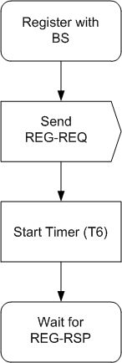
Figure xxd – Registration – CPE

Once the CPE has sent a REG-REQ message to the BS, it shall wait for a REG-RSP to authorize it to forward traffic to the network. Figure 69 shows the waiting procedure that shall be followed by the BS.

Note here that, provided the response of the REG-RSP message is alright, the managed SS shall first establish secondary management connection, then perform neighboring network discovery and perform optional initialization steps. Recall in Figure 21 that these optional steps are performed only if the CPE has indicated in the REG-REQ message that it is a managed CPE.

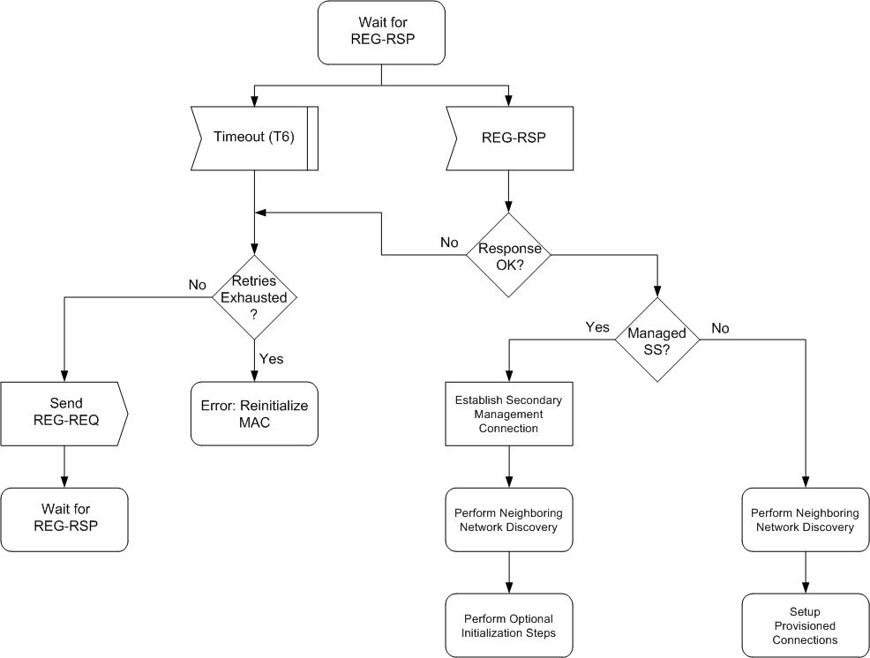
Figure xxe – Wait for REG-RSP – CPE

The BS shall perform the following operations as shown in Figure xxf.
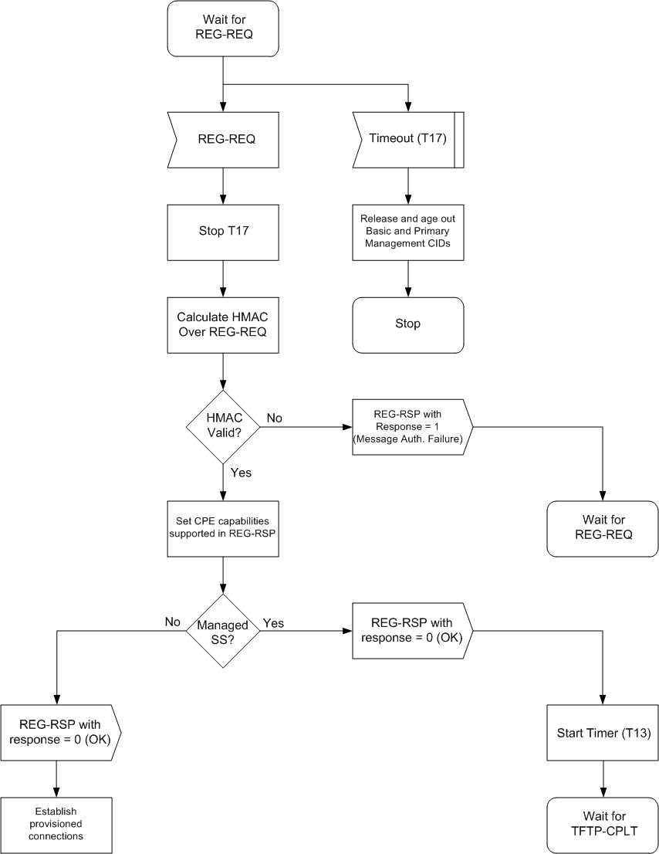
Figure xxf – Registration – BS
After receiving the REG-RSP message, the CPE shall send the TFTP-CPLT message (c.f. Table 182 of [1]) to the BS to indicate that it has completed its secondary management connection initialization and is ready to accept services. However, as shown in Figures xxg and xxh, if the timer (waiting for TFTP-CPLT) expires, the BS shall both deassign the management CIDs from that CPE and make some provision for aging out those CIDs.

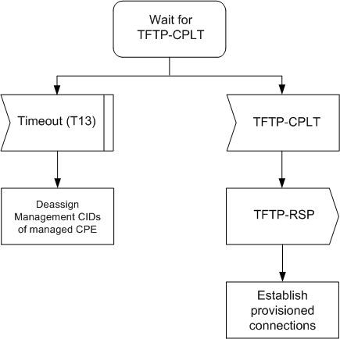
Figure xxg – Wait for TFTP-CPLT – BS
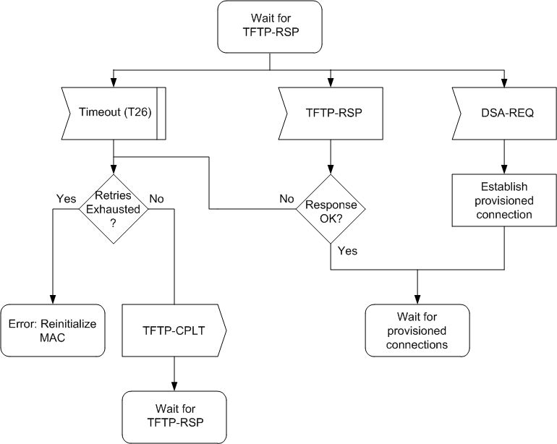
Figure xxh – Wait for TFTP-RSP – CPE

[Include the following row in Table 237 General Parameter Setting]

CPE | T26 | Wait for TFTP-RSP | 10 ms | 10 ms | 200 ms

Comment #97

[Include new subclause 6.15.10 Optional Initialization Steps]

If the CPE has indicated in the REG-REQ message that it is a managed CPE, the following three optional initialization steps should be performed after the neighboring network discovery
- Establish IP connectivity
- Establish time of day
- Transfer operational parameters

[Include new subclause 6.15.10.1 IP Version Negotiation]

The CPE may include the IP version parameter (c.f. Table 58 of [1]) in the REG-REQ message to indicate which versions of IP it supports on the Secondary Management Connection. When present in the REG-REQ message, the BS shall include this IP version parameter in the REG-RSP message to command the CPE to use the indicated version of IP on the secondary management connection. The BS shall command the use of exactly one of the IP versions supported by the CPE.

The omission of the IP Version Parameter in the REG-REQ message shall be interpreted as IPv4 support only. Consequently, the omission of the IP Version Parameter in the REG-RSP message shall be interpreted as a command to use IPv4 on the secondary management connection.

[Update Table 58 Information Elements by the following table]

Element ID | Length  (bytes) | Value | Scope
4 | 1 | Bit #0: 4 (default)  Bit #1: 6  Bits #2-7: Reserved; shall be set to zero | REG-REQ, REG-RSP

[Include new subclause 6.15.10.2 Establish IP connectivity]

The CPE shall invoke DHCP mechanism [IETF RFC 2131] in order to obtain an IP address and any other parameters needed to establish IP connectivity. If the CPE has a configuration file, the DHCP response shall contain the name of a file that contains further configuration parameters.

Establishment of IP connectivity shall be performed on the CPE’s secondary management connection as shown in Figure xxi.
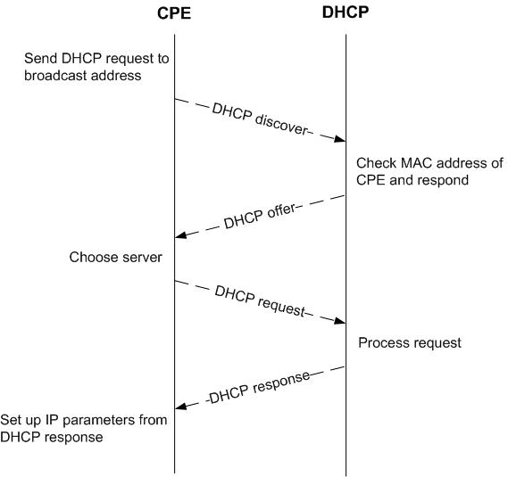
Figure xxi – Establishing IP connectivity

[Include new subclause 6.15.10.3 Establish Time of Day]

The CPE and BS need to have the current date and time. This is required for time-stamping logged events for retrieval by the management system. This needs not be authenticated and needs to be accurate only to the nearest second.

The protocol by which the time of day shall be retrieved is defined in IETF RFC 868. Referring to Figure xxj, the request and response shall be transferred using user datagram protocol (UDP). The time retrieved from the server [universal coordinated time (UTC)] shall be combined with the time offset received from the DHCP response to create the current local time. Establishment of time of day shall be performed on the CPE’s secondary management connection.
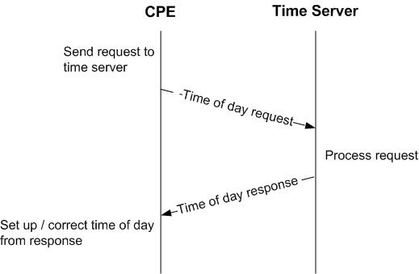
Figure xxj – Establishing time of day

Successfully acquiring the Time of Day is not mandatory for a successful registration, but is necessary for ongoing operation. The specific timeout for Time of Day Requests is implementation dependent.

[Include new subclause 6.15.10.4 Transfer Operational Parameters]

After DHCP is successful, the CPE shall download the CPE’s configuration file using TFTP on its own secondary management connection as shown in Figure xxk when specified in the DHCP response. The CPE shall use an adaptive timeout for TFTP based on binary exponential backoff [IETF RFC 1123, IETF RFC 2349].
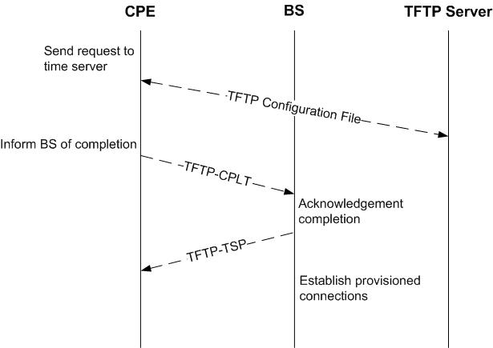
Figure xxk – Transferring operational parameters
When the configuration file download has completed successfully, the CPE shall notify the BS by transmitting the TFTP-CPLT message on the CPE’s primary management connection. Transmissions shall continue successfully until a TFTP-RSP message is received with response “OK” from the BS (see Figures xxg and xxh) or the CPE terminates retransmission due to retry exhaustion.

Comments #97, #267

[Include new subclause 6.15.11 Set Up Connections]

After the transfer of operational parameters for the managed CPE or after neighboring network discovery for unmanaged CPE, the BS shall send DSA-REQ messages (c.f. Table 72 of [1]) to the CPE to set up connections for preprovisioned service flows belonging to the CPE. The CPE responds with DSA-RSP messages. This is described further in subclause 6.20.7.1

Reference
[1] 22-06-0259-00-0000_v0.2_with_line_numbers.doc
[2] 22-07-0122-02-0000_proposed_resolutions.doc

