IEEE P802.22
Wireless RANs
Spectrum Sensing of the DTV in the Vicinity of the Pilot Using Higher Order Statistics
Date: 2007-08-15
Author(s):
Name | Company | Address | Phone | email
Apurva Mody | BAE Systems | P.O. Box 868, MER 15-2350, Nashua, NH 03061-0868 | 603-885-2621  404-819-0314 | apurva.mody@baesystems.com,  apurva_mody@yahoo.com
Abstract
We present an algorithm to detect the DTV signals in Gaussian noise using Higher Order Statistics (HOS). The algorithm performs non-Gaussianity check in the frequency domain in the vicinity of the pilot of the DTV. The Average results for all the 12 provided DTV signals are summarized as: At P_{false alarm} = 0.04,
  - For a capture of 5mS (continuous or staggered), P_{detection}= 0.9 at SNR = -16.6 dB.
  - For a capture of 10 mS (continuous or staggered), P_{detection} = 0.9 at SNR = -18.6 dB
  - For a capture of 20 mS (continuous or staggered), P_{detection} = 0.9 at SNR = -21.6 dB
  - For a capture of 40 mS (continuous or staggered), P_{detection} = 0.9 at SNR = -23.7 dB
We use a 2048 point FFT to implement the algorithm which may be used for spectrum sensing as well as OFDMA demodulation. Because of the Constant False Alarm Rate (CFAR) nature of the detector, the threshold is built into the technique and NO presetting is required. Fine adjustment is possible if needed.

The proposed technique of spectrum sensing using HOS may be used to detect wireless microphone, DVB-T and other signals operating in the TV broadcasting bands as well.

Notice: This document has been prepared to assist IEEE 802.22. It is offered as a basis for discussion and is not binding on the contributing individual(s) or organization(s). The material in this document is subject to change in form and content after further study. The contributor(s) reserve(s) the right to add, amend or withdraw material contained herein.

Release: The contributor grants a free, irrevocable license to the IEEE to incorporate material contained in this contribution, and any modifications thereof, in the creation of an IEEE Standards publication; to copyright in the IEEE’s name any IEEE Standards publication even though it may include portions of this contribution; and at the IEEE’s sole discretion to permit others to reproduce in whole or in part the resulting IEEE Standards publication. The contributor also acknowledges and accepts that this contribution may be made public by IEEE 802.22.

Patent Policy and Procedures: The contributor is familiar with the IEEE 802 Patent Policy and Procedures
<http://standards.ieee.org/guides/bylaws/sb-bylaws.pdf>, including the statement "IEEE standards may include the known use of patent(s), including patent applications, provided the IEEE receives assurance from the patent holder or applicant with respect to patents essential for compliance with both mandatory and optional portions of the standard." Early disclosure to the Working Group of patent information that might be relevant to the standard is essential to reduce the possibility for delays in the development process and increase the likelihood that the draft publication will be approved for publication. Please notify the Chair <Carl R. Stevenson> as early as possible, in written or electronic form, if patented technology (or technology under patent application) might be incorporated into a draft standard being developed within the IEEE 802.22 Working Group. If you have questions, contact the IEEE Patent Committee Administrator at <patcom@ieee.org>.
1. Spectrum Sensing of the DTV in the Vicinity of the Pilot Using Higher Order Statistics

We present an algorithm to detect the DTV Signals in Gaussian noise using Higher Order Statistics (HOS). The algorithm performs non-Gaussianity check in the frequency domain in the vicinity of the pilot of the DTV. The average results for all the 12 provided DTV Signals are summarized as: At P_{false alarm} = 0.04,
  - For a capture of 5mS (continuous or staggered), P_{detection}= 0.9 at SNR = -16.6 dB.
  - For a capture of 10 mS (continuous or staggered), P_{detection} = 0.9 at SNR = -18.6 dB
  - For a capture of 20 mS (continuous or staggered), P_{detection} = 0.9 at SNR = -21.6 dB
  - For a capture of 40 mS (continuous or staggered), P_{detection} = 0.9 at SNR = -23.7 dB
We use a 2048 point FFT to implement the algorithm which may be used for spectrum sensing as well as OFDMA demodulation. Because of the Constant False Alarm Rate (CFAR) [1, 2] nature of the detector, the threshold is built into the technique and NO presetting is required. Fine adjustment is possible if needed.

Our technique relies on the non-Gaussianity of a signal to separate it from the Gaussian noise. In the time domain, DTV signals show a Gaussian characteristic. However, in the frequency domain they are non-Gaussian. We will exploit this characteristic to detect the signals in AWGN. The proposed technique on spectrum sensing using HOS may be used to detect wireless microphone, DVB-T and other signals operating in the TV broadcasting bands as well.

2. Signal or Noise Identification Using Higher Order Statistics – Basic Concept
Use of Higher Order Statistics (HOS) is an efficient metric for detecting non-Gaussian signals at low SNRs [3]. In particular, if we assume the noise to be a Gaussian random process, then all the cumulants of order greater than 2 are supposed to be zero. Given a set of N samples x = {x₀, x₁, …, x_{N-1}}, of a random variable x, the r^{th} order moment of the collection of samples contained in the vector (x) may be approximated as

$${\hat{m}}_{r}=\frac{1}{N}\sum_{n=0}^{N−1}{(x_{n}−\bar{x})^{r}} (1)$$
where
$$\bar{x}≈\frac{1}{N}\sum_{n=0}^{N−1}{x_{n} (2)}$$

Let c_{r} = r^{th} order cumulant of x. Then the relationship between cumulants and the moments may be used to compute the higher order cumulants in a simple fashion as
$c_{n}=m_{n}−\sum_{k=1}^{n−1}{\left(\begin{matrix}n−1 \\ k−1\end{matrix}\right)c_{k}m_{n−k} (3)}$
where $\left(\begin{matrix}n−1 \\ k−1\end{matrix}\right)=\frac{(n−1)!}{(k−1)!⋅(n−k)!}$, and $y!=\text{Factorial}(y)=y⋅(y−1)⋅(y−2)⋅(y−3)…2⋅1$

This relationship may also be written for each of the cumulants by expanding (3) as shown below.
$\begin{aligned}c_{1}=m_{1} \\ c_{2}=m_{2}−m_{1}^{2} \\ c_{3}=m_{3}−3m_{1}m_{2}+2m_{1}^{3} (4) \\ c_{4}=m_{4}−4m_{1}m_{3}−3m_{2}^{2}+\text{12}m_{1}^{2}m_{2}−6m_{1}^{4} \\ ⋮\end{aligned}$
Since our data record for the determination of the HOS may not be sufficiently long, the cumulants of order greater than 2 may not be exactly zero. Hence, a threshold needs to be set in order to make a decision as to whether the samples belong to signal or noise. In this method, we compare the higher order cumulants with the power of second order moment. This is also known as bi-coherency tri-coherency etc. tests to determine if the received waveform belongs to DTV signal or the noise.

3. Signal Detection for DTV Signals in the Vicinity of the Pilot Using Higher Order Statistics

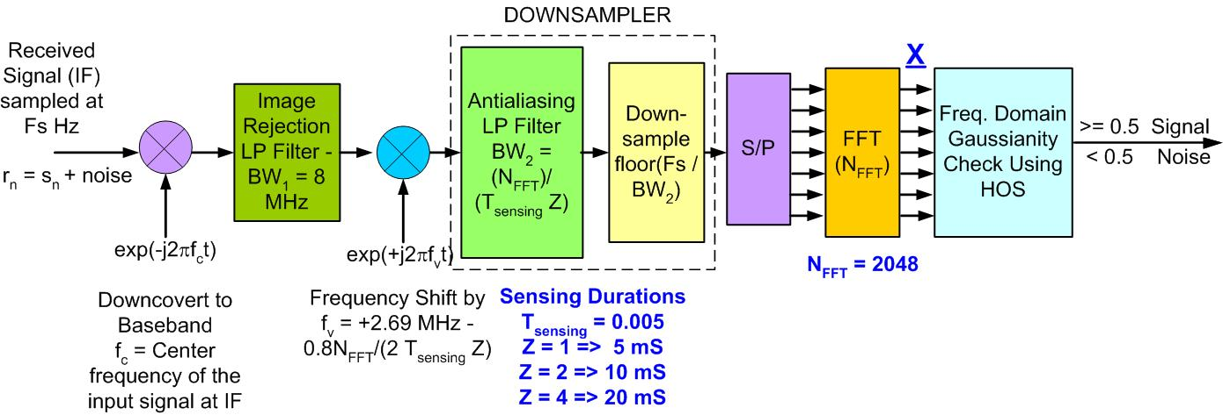

Figure 1. Signal processing chain for DTV spectrum sensing in the vicinity of pilot using higher order statistics (HOS).

Following is the description of the DTV spectrum sensing algorithm in the vicinity of pilot using HOS.
Step 1. Downshift (Downconvert) the received samples collected in the TV channel from the Radio Frequency (RF) or the Intermediate Frequency (IF) to the base band,
Step 2. Pass the down-converted signal through an image rejection Low Pass (LP) of total bandwidth (BW₁ = 8 MHz) to suppress the image.
Step 3. Upshift (Upconvert) the signal by approximately (2.69 MHz – 0.8 N_{FFT} / (2T_{sensing} Z)) so that if an ATSC DTV signal was present, its pilot would be shifted towards the d.c. or 0 Hertz frequency. T_{sensing} = Sensing Duration, Z = 1, 2, 3, …determines the multiples of the sensing duration. For example, T_{sensing} = 0.005 and Z = 1 implies the total sensing duration of 5 mS. Similarly, T_{sensing} = 0.005 and Z = 2 implies the total sensing duration of 10 mS. Fs = sampling frequency of the original received signal at RF or IF, and N_{FFT} = Size of the FFT used. Factor 0.8 N_{FFT} / (2T_{sensing} Z) is used to make sure that the pilot is shifted just enough (before the next stage of downsampling) and there are no residual contributions from the neighboring channel in the samples that are being analyzed.
Step 4. Pass the resultant signals through a Low Pass (LP) filter of total bandwidth (BW₂ = N_{FFT} / ((T_{sensing}) Z)) followed by downsampling of the signals by a factor of floor(Fs/BW₂).
Step 5. Convert the input samples from serial to parallel and transform them to the frequency domain using a Fast Fourier Transform (FFT) of length N_{FFT}. As an example, keeping the FFT length, N_{FFT} = 2048 is advantageous since the same FFT implementation may be used for spectrum sensing as well as OFDMA demodulation of WRAN.
Step 6. Collect the samples at the output of the FFT and store them in a buffer. Determine the higher order moments and cumulants of the real and imaginary portions of the stored samples using Equations (1), (2) and (3). Perform the frequency domain Gaussianity check and hence DTV detection by applying the following steps.
Step 7. Let R be the number of moments $\left(m_{r}^{\text{real}},m_{r}^{\text{imaginary}}\right)$ and cumulants $\left(c_{r}^{\text{real}},c_{r}^{\text{imaginary}}\right)$ of the order greater than two available for computation of the real and the imaginary parts of each of the segments (X) of data at the output of the FFT respectively,
- Choose a Probability Step Parameter 0 < δ < 1; As an example let δ = 0.5 / R.
- Let $P_{\text{Signal}}^{\text{real}}=P_{\text{Signal}}^{\text{imaginary}}=0\text{.}5$;
- Choose some $γ>0\text{; }γ_{\text{typical}}=1$
- for r = 3 to (R + 2);
if $\left|c_{r}^{\text{real}}\right|<γ{\left|m_{2}^{\text{real}}\right|}^{\frac{r}{2}} ⇒{\text{ P}}_{\text{Signal}}^{\text{real}}=P_{\text{Signal}}^{\text{real}}−δ$
elseif $\left|c_{r}^{\text{real}}\right|≥γ{\left|m_{2}^{\text{real}}\right|}^{\frac{r}{2}} ⇒{\text{ P}}_{\text{Signal}}^{\text{real}}=P_{\text{Signal}}^{\text{real}}+δ$
end,
if $\left|c_{r}^{\text{imaginary}}\right|<γ{\left|m_{2}^{\text{imaginary}}\right|}^{\frac{r}{2}} ⇒{\text{ P}}_{\text{Signal}}^{\text{imaginary}}=P_{\text{Signal}}^{\text{imaginary}}−δ$,
elseif $\left|c_{r}^{\text{imaginary}}\right|≥γ{\left|m_{2}^{\text{imaginary}}\right|}^{\frac{r}{2}} ⇒{\text{ P}}_{\text{Signal}}^{\text{imaginary}}=P_{\text{Signal}}^{\text{imaginary}}+δ$
end,
end
- $P_{\text{Signal}}=a⋅P_{\text{Signal}}^{\text{real}}+b⋅P_{\text{Signal}}^{\text{imaginary}}$ where a and b weight parameters. As an example $a=b=0\text{.}5$
- Due to the constant false alarm rate (CFAR) nature of the detector, the threshold is built into the system, and NO presetting is required. However, in order to carry out fine adjustment, we have provided the fine sensing threshold parameter γ, which is used to make fine adjustments of P_{false alarm} if needed. As γ increases P_{false alarm} decreases and vice-versa. In most cases γ is kept close to unity.
Step 8. if $P_{\text{Signal}}≥0\text{.}5$ then the segment X belongs the DTV signal we conclude that the TV channel is occupied by the incumbent.
if $P_{\text{Signal}}<0\text{.}5$ then the segment X belongs to noise and we conclude that the TV channel is NOT occupied by an incumbent.

4. Performance Results
The spectrum sensing algorithm using HOS was tested on the 12 DTV signals that were provided [4]. The simulations were carried out for sensing times in multiples of 5 ms however any length sensing time may be used for the actual implementation. The length of the FFT was kept at N_{FFT} = 2048 keeping in mind that the same hardware may be used for spectrum sensing as well as OFDMA demodulation of WRANs. Due to the CFAR nature of the detector, the threshold is built into the system, and NO presetting is required. However, in order to carry out fine adjustment, we have provided the fine sensing threshold parameter γ, which enables fine adjustment of the P_{false alarm} at little degradation in P_{detection}. Figure 2 shows the average (P_{detection} and P_{false alarm}) of the 12 provided DTV signals vs the fine sensing threshold parameter γ, at SNR = -20 dB and sensing duration of 20 mS. Based on this simulation, the value of the fine sensing threshold parameter γ was chosen in order to obtain a specific P_{false alarm}. Similar simulations were carried out for other sensing durations as well. Based on the results from Figure 2, the parameter γ was kept at 0.8 and 1.05 in order to obtain P_{false alarm}0.05 and P_{false alarm}0.01 respectively. Figures 3, 4, 5 and 6 show the P_{detection} vs SNR performance of the 12 provided DTV signals for 5, 10, 20 and 40 mS sensing times respectively.

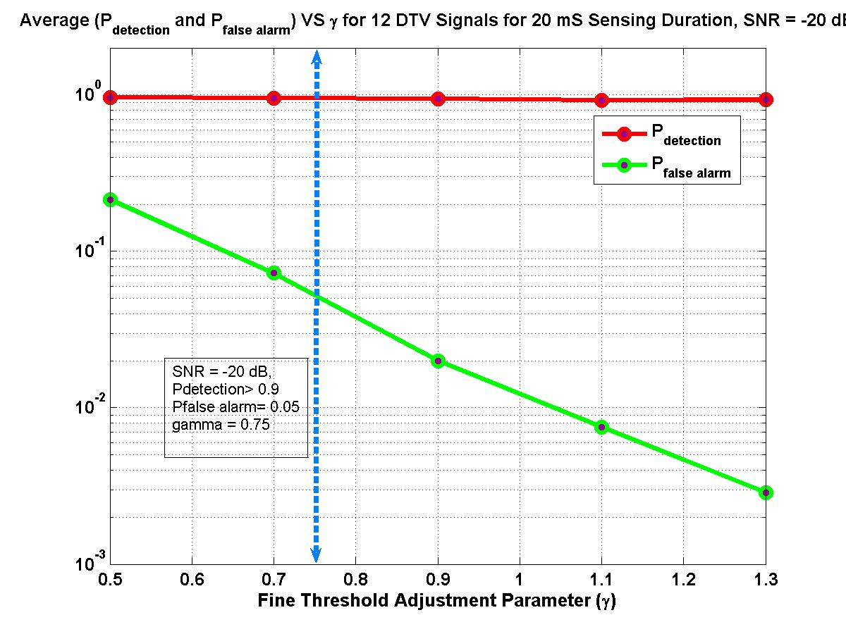
Figure 2. Average P_{detection} and P_{false alarm} of the 12 provided DTV signals vs the fine sensing threshold parameter γ, at SNR = -20 dB and total sensing duration T_{sensing}Z = 20 mS. N_{FFT} = 2048, a = b = 1.

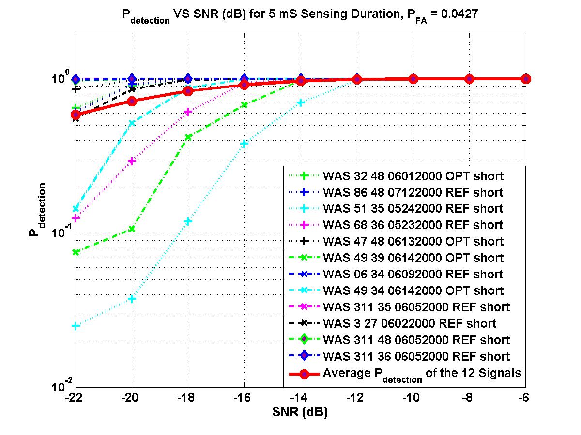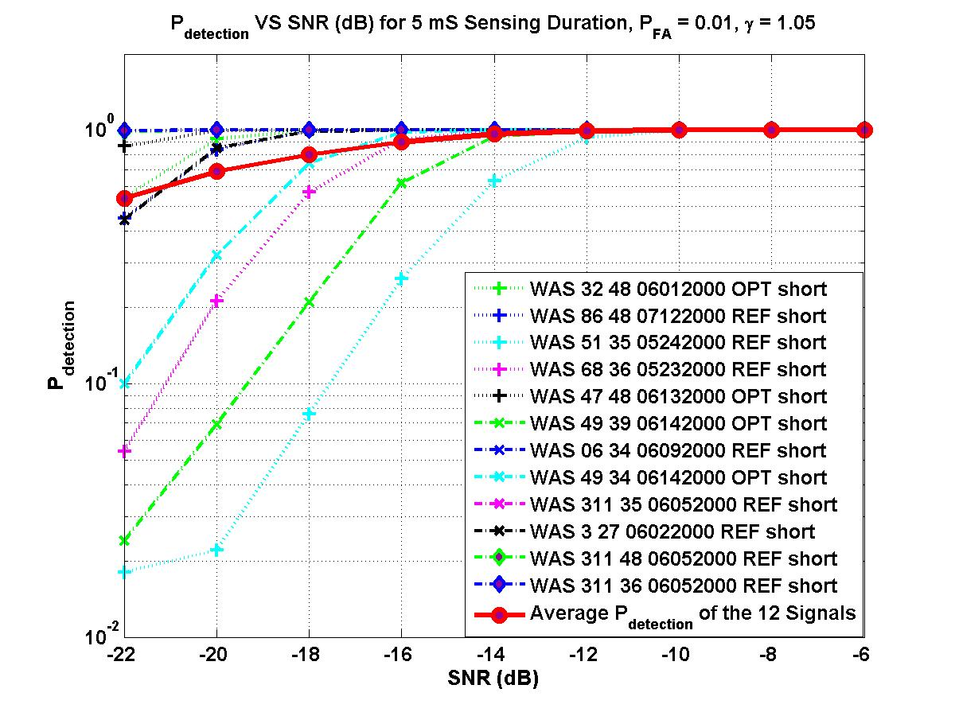
(a) (b)
Figure 3. P_{detection} vs SNR performance for the 12 provided DTV signals for the total sensing duration T_{sensing}Z = 5 mS using the algorithm utilizing HOS in the vicinity of the pilot. N_{FFT} = 2048, a = b = 1, (a) γ = 0.8, P_{FA} = 0.0427 (b) γ = 1.05, P_{FA} = 0.01

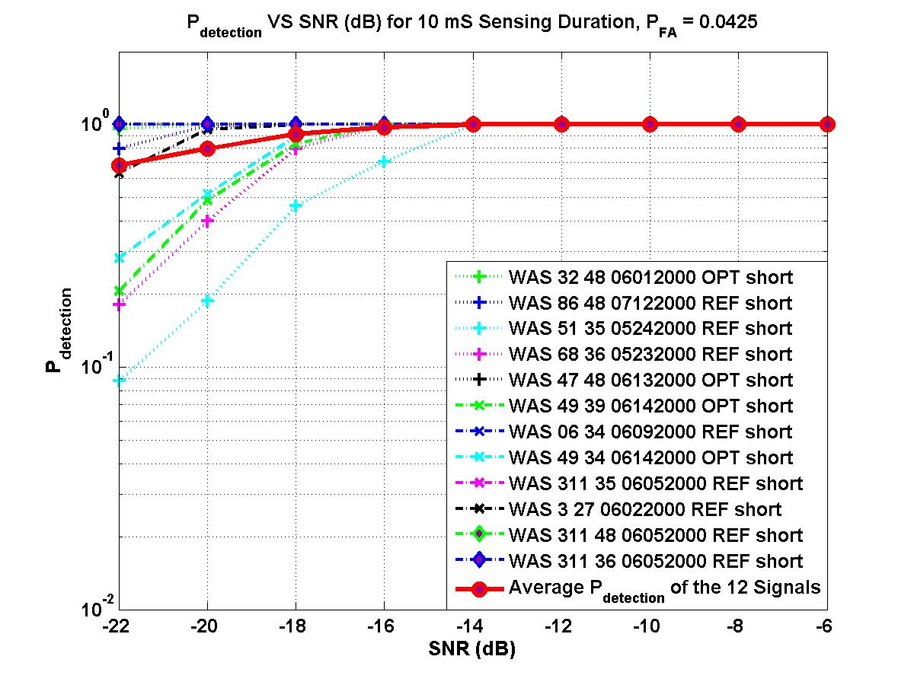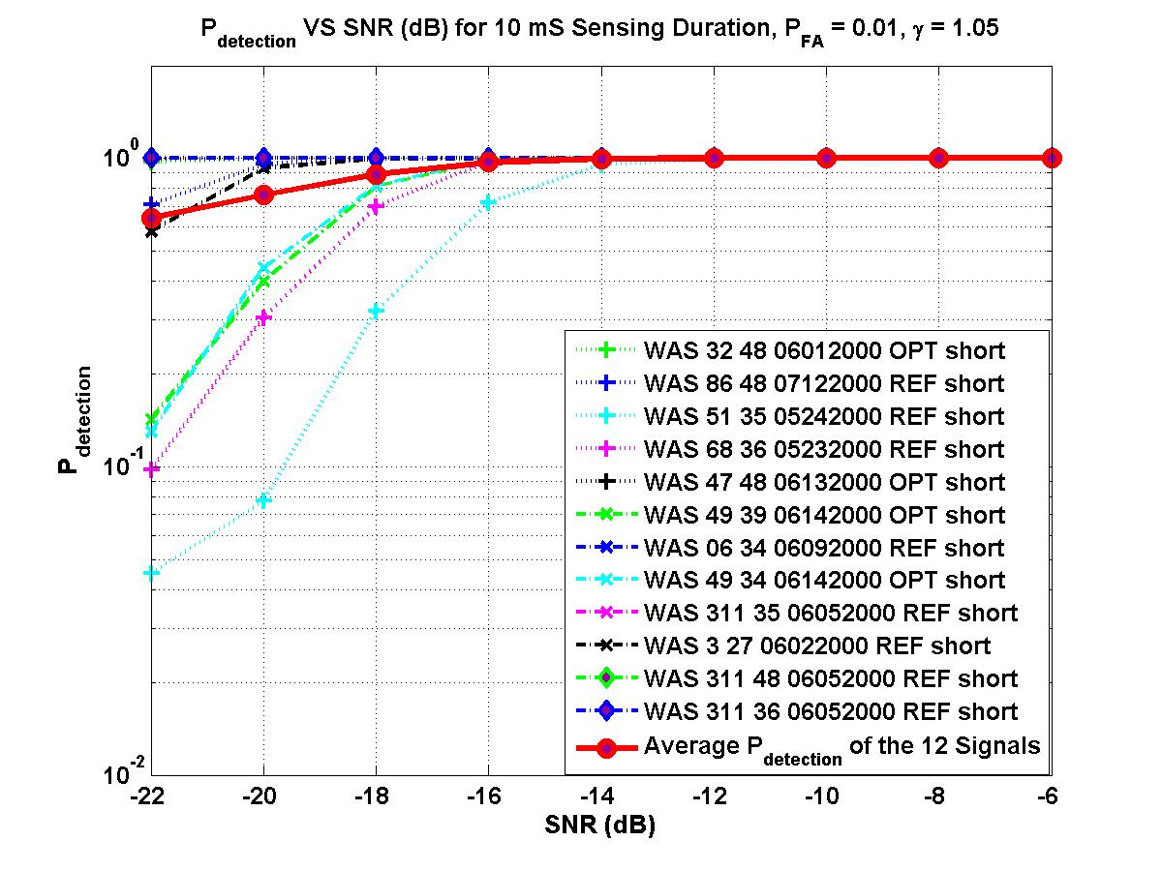
(a) (b)
Figure 4. P_{detection} vs SNR performance for the 12 provided DTV signals for the total sensing duration T_{sensing}Z = 10 mS using the algorithm utilizing HOS in the vicinity of the pilot. N_{FFT} = 2048, a = b = 1, (a) γ = 0.8, P_{FA} = 0.0425 (b) γ = 1.05, P_{FA} = 0.01

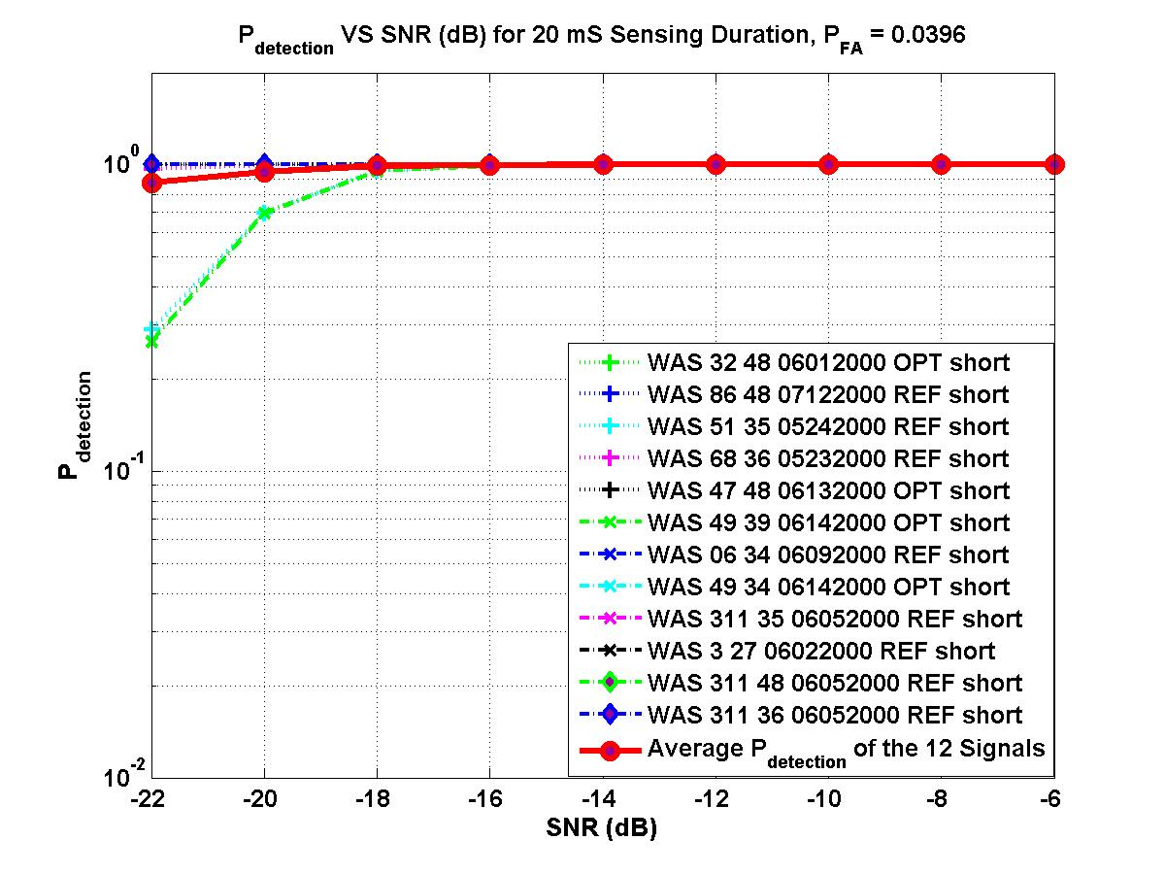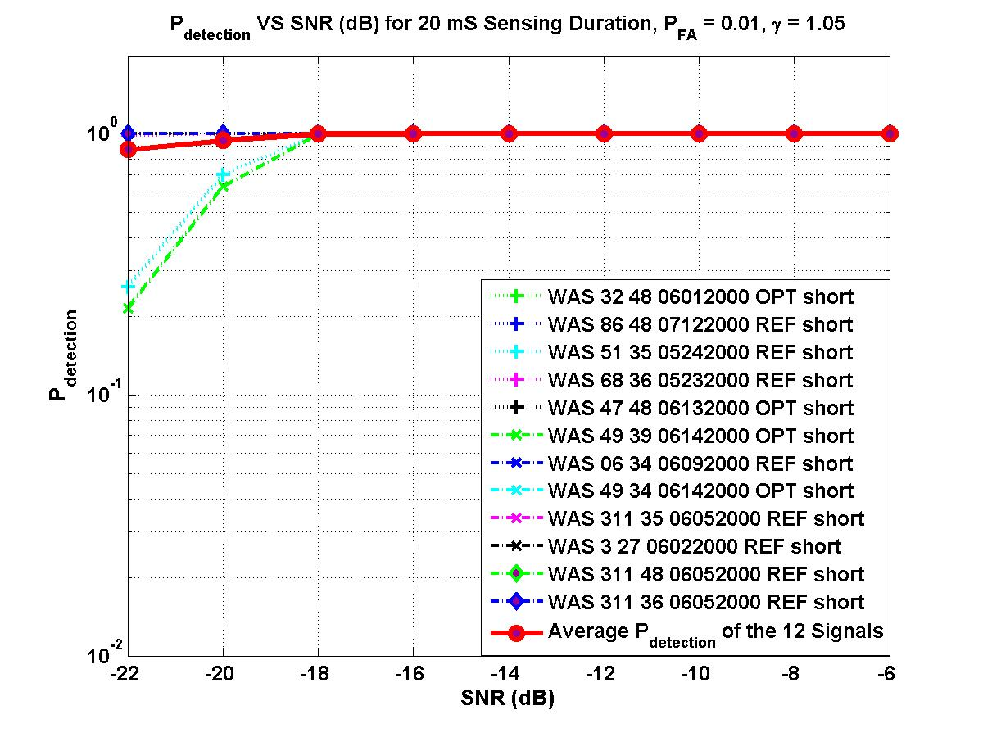
(a) (b)
Figure 5. P_{detection} vs SNR performance for the 12 provided DTV signals for the total sensing duration T_{sensing}Z = 20 mS using the algorithm utilizing HOS in the vicinity of the pilot. N_{FFT} = 2048, a = b = 1. (a) γ = 0.8, P_{FA} = 0.0396 (b) γ = 1.05, P_{FA} = 0.01

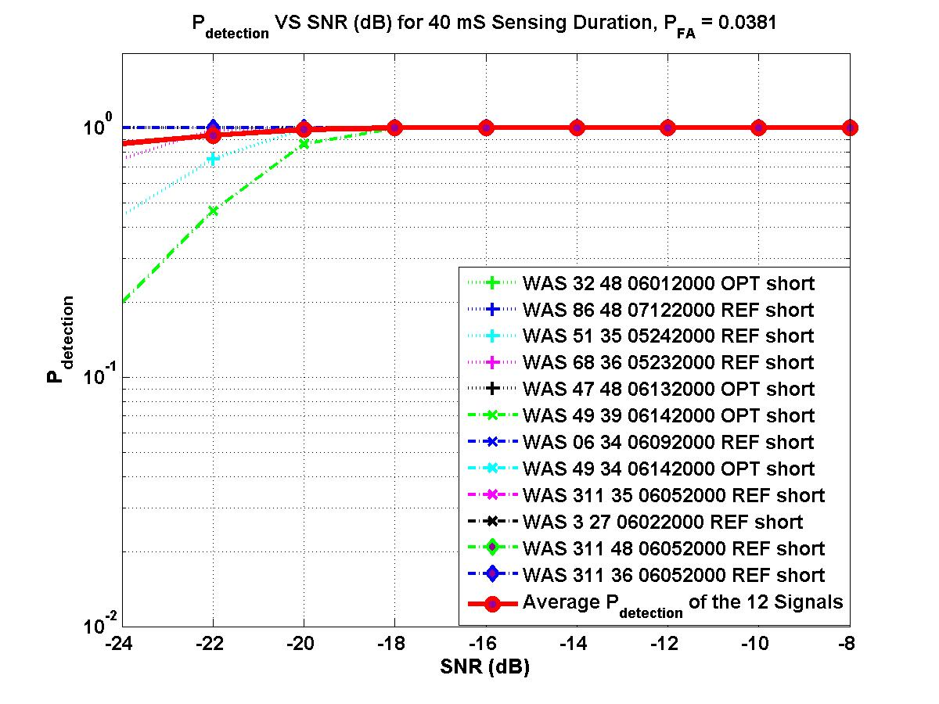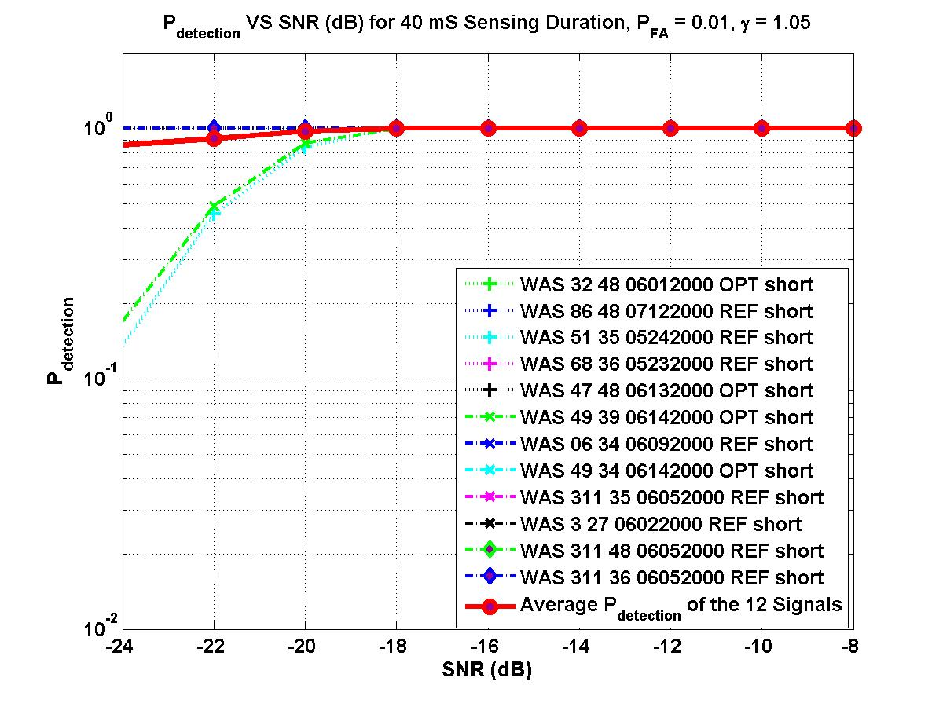
(a) (b)
Figure 6. P_{detection} vs SNR performance for the 12 provided DTV signals for the total sensing duration T_{sensing}Z = 40 mS using the algorithm utilizing HOS in the vicinity of the pilot. N_{FFT} = 2048, a = b = 1. (a) γ = 0.8, P_{FA} = 0.0381 (b) γ = 1.05, P_{FA} = 0.01

The spectrum sensing algorithm using HOS in the vicinity of the pilot was tested for the 12 provided DTV signals as shown above. Table 1 summarizes the results for the average SNR required for the collection of the 12 provided DTV signals at a P_{false alarm} = 0.05 and P_{false alarm} = 0.01 while keeping P_{detection} 0.90 for various sensing durations. This algorithm meets the DTV fine sensing requirements.

Sensing Duration | 5 ms | 10 ms | 20 ms | 40 ms
Required SNR for P_{detection} 0.9 and P_{false_alarm} 0.05) | -16.6 dB | -18.6 dB | -21.6 dB | -23.7 dB
Required SNR for P_{detection} 0.9 and P_{false_alarm} 0.01) | -16 dB | -18 dB | -21.4 dB | -23.4 dB

Table 1: Required SNR for DTV signal detection (Averaged over 12 signals)

References

[1] S. M. Kay, Fundamentals of Statistical Signal Processing, Detection Theory, Prentice Hall Signal Processing Series, 1993.
[2] S. M. Kay, Fundamentals of Statistical Signal Processing, Estimation Theory, Prentice Hall Signal Processing Series, 1993.
[3] S. K. Shanmugan, A. M. Breipohl, Random Signals, Detection Estimation and Data Analysis, John Wiley and Sons, 1988.
[4] IEEE 802.22 Contribution 22-07-0359-00-0000 at http://grouper.ieee.org/groups/802/22/Meeting_documents/2007_July/22-07-0359-00-0000_mody_spectrum_sensing_hos_1.ppt

