Supporting document for Comment #109, Part B, for D0.2.
Tom Lindsay

Specifications (for Table 68-4)
Optical SNR (OMA/(2*rms noise)) min 18.6
Jitter (rms) max 0.033

Method (for subclause 68.6.4)
The optical SNR and jitter measurements are intended to control uncorrelated noise and jitter.

The DUT shall repetitively transmit the low frequency square pattern, as defined in clause 52.??, through a test patchcord into an O/E converter and through a 7.5 GHz Bessel Thomson filter. The filter output should run into the oscilloscope and into a trigger recovery circuit. The trigger recovery circuit must recover a suitable pattern and/or clock trigger for the scope so that the waveform can be displayed. The scope should be run in infinite persistence mode. The DUT must be fully operational in both transmit and receive directions during this test.

A vertical histogram with width of 0.1 UI is used to measure amplitude noise. It should be approximately centered in the upper portion of the square wave. A horizontal histogram with height of ~0.01 OMA is used to measure jitter. It should be placed approximately at the average amplitude value of the square wave. At least 1000 hits are required in each histogram. Compensation for measurement equipment noise and jitter is allowed. Note that these methods are similar to those used to calibrate the amplitude and jitter used in the Static Stress Receiver Sensitivity Test for TP3 [note to editor – perhaps they can be combined into one piece of text].

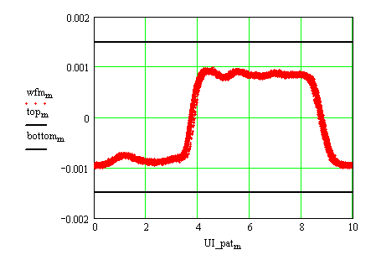
Test figure (for subclause 68.6.4)
DUT
Square wave pattern
O/E converter
7.5 GHz 4th-order Bessel Thomson filter
Trigger recovery
Scope
Optical patch cord
TP2
Infinite persistence

Histograms

