By Roger Karam. 11/16/2000
-----------------------------------------------------------------------------------------------------------------
Now from here and down are some of my test schematics and things to help Mike Mcormick
Put things together, please critize change and have fun….

Below is FIGURE A, my first cut at the test loads to verify compliance of the DC Scheme
Basically 3 switches are used to make sure we pass the 25K and fail the 30k and the 20k.
I picked these numbers based on preliminary input from vendors that they can detect the
25k within 5%. Also I am day-dreaming about say 3 classes of devices by using 3 values of
resistors now that I know that high accuracy can be achieved. At least this schematics is a starter.
Some input from Peter Schwartz at Micrel on this.

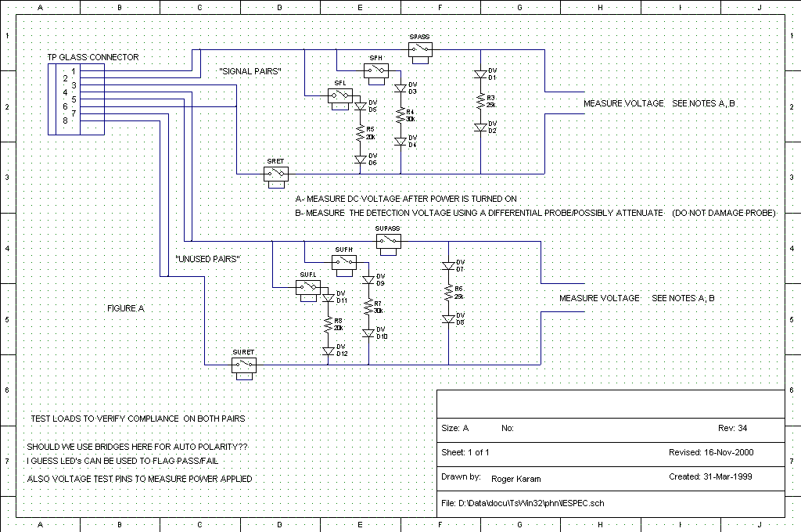

Next I throw in some modifications/test schematics (AND important Modification to some figures in
802.3 schematics needed to do the compliance testing per my San Diego presentation to make all this
possible. Please see the next THREE sets of schematics, IEEE Figure references are labeled properly
with the right Figure numbers out of the 802.3 spec.

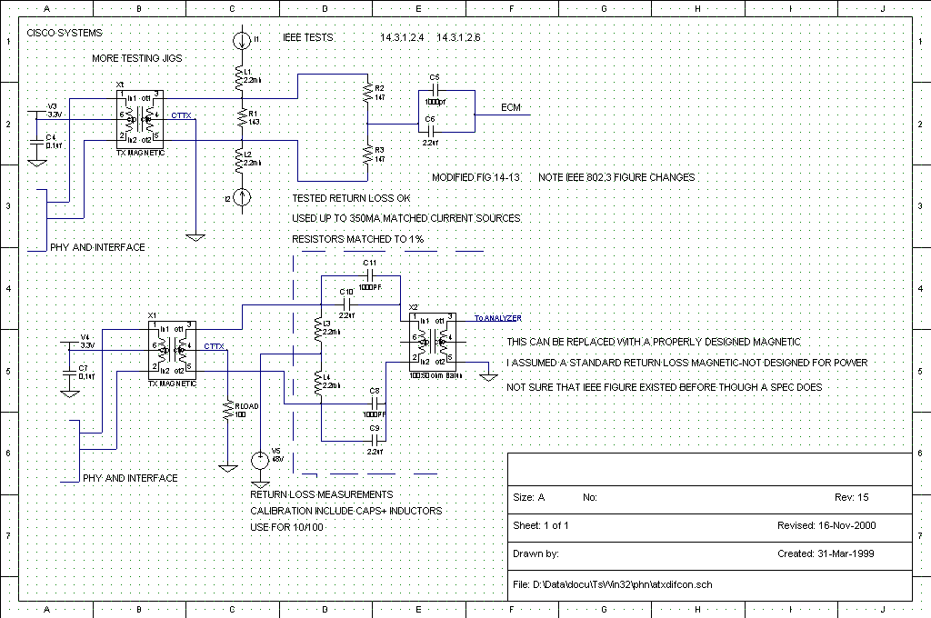
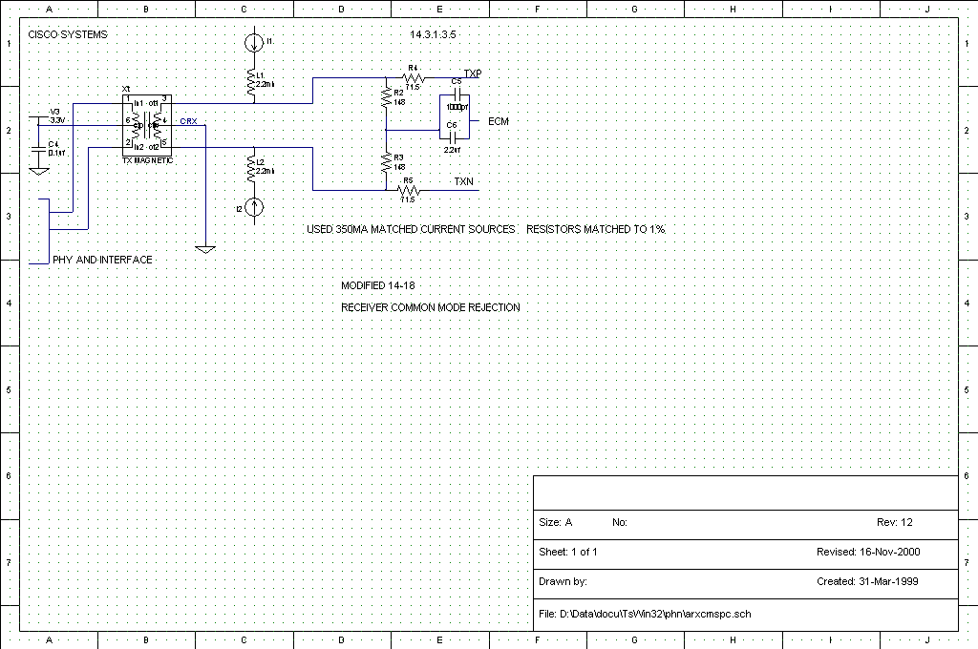

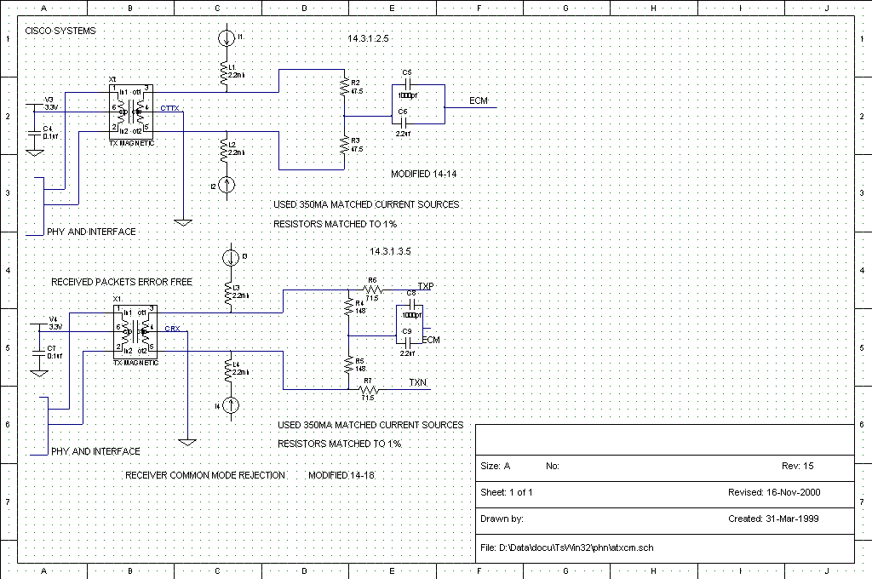
END OF FILE FOR NOW. RK…

