# Physical Coding Sublayer (PCS), Physical Medium Attachment (PMA), type 1000BASE-H

## Energy Efficient Ethernet

Each PHY that supports LPI mode advertises its capability when it is first connected to a link by setting the 1-bit field PHD.CAP.LPI of the Physical Header Data (PHD) to 1, (see Table 114-2.). It shall be required that the two link partners indicate PHD.CAP.LPI = 1 to enable bidirectional EEE functionality. PHD.CAP.LPI = 1 advertisement indicates to link partner that the local PHY can generate Transmit Blocks according to LPI mode of operation and it is able to accept Transmit Blocks from the link partner conformed to LPI operation.

If the link partner PHY does not advertise EEE capability (PHD.CAP.LPI = 0), then the link will always operate in normal mode in both transmit and receive directions although “Assert LPI” encoding is detected on the GMII. Therefore, when two link partners do not agree on enabling LPI capability, the PCS encoding will be transparent allowing carrying the LPI signaling GMII to GMII, but the PHY will not enter quiet mode.

As shown in Figure 114-42, 1000BASE-H LPI operation results in all the pilot and physical header sub-blocks being transmitted, but transmission of the payload data sub-blocks is suspended in the most part of its length (the local PHY partially turns off the PCS, PMA and PMD functionalities so that no optical power is injected into the fiber during these periods of time and power consumption is reduced). LPI mode always affects complete payload data sub-blocks and it is not possible to stop or restart transmission in the middle of a payload data sub-block.

These sub-blocks are transmitted as in normal mode, that is, each one composed by 128 modulation symbols plus the 16 zero symbols sequences of prefix and suffix (see 114.2.1).

The PHY receiver shall detect if its link partner is operating in LPI mode based on how is the signal at the beginning of the payload data sub-blocks. The PHY transmitter shall indicate to the receiver it is entering quiet period by the transmission of 80 contiguous zero value symbols. After zeroes sequence, the transmitter shall instruct to the PMD transmit function to switch off the optical power until just 80 symbol times before the end of the payload data sub-block period of time. Then, the transmitter shall insert 80 zero value symbols before the transmission of the corresponding pilot or physical header sub-block to prepare the reception of refresh signals.

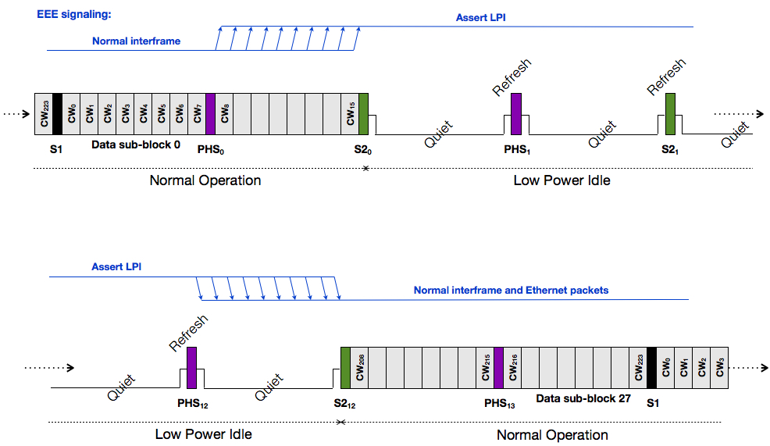

Figure 114-42 – 1000BASE-H PHY LPI operation mode

Since special control signaling is required to implement LPI mode, any PMD attached to a 1000BASE-H PCS shall provide the following service interface primitives:

* PMD_TXPWR.request(tx_pwr): this primitive is generated by PCS transmit function to request the minimum PMD optical output power compatible with LPI mode, or normal operation.
* PMD_RXPWR.request(rx_pwr): this primitive is generated by the PCS receive function to cause the PMD receive function to transition between being able to respond to received optical signals and a minimum power consumption state compatible with LPI mode. By this indication the PMD receive function also saves the internal state of the circuitry during the lack of optical power to resume the normal operation mode in a very short period of time.

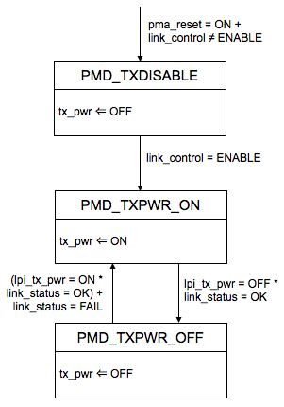

Figure 114-43 – 1000BASE-H PMD TX control state diagram

Figures 114-43 and 114-44 show the state diagrams that govern the generation of tx_pwr and rx_pwr signals, respectively, for control of the PMD. All the variables used in these state diagrams that have not been previously introduced are defined in 114.5.1.

### PMD control state variables

tx_pwr

Indicates to PMD transmit function to generate, or not, signal at the MDI.

Values:

* ON: the PMD transmit function will generate signals at the MDI.
* OFF: the PMD transmit function will not generate signal at the MDI, and shall reduce the power consumption.

rx_pwr

Indicates to PMD receive function to ignore, or not, signal at the MDI.

Values:

* ON: the PMD receive function will translate the optical signal at MDI to PCS receive function.
* OFF: the PMD receive function will ignore signals at the MDI, shall save the internal state of the circuit, and reduce power consumption.

lpi_tx_pwr

Signal internally generated by the PCS transmit function for LPI operation, which is filtered as a function of the other state variables as indicated in Figure 114-43 to finally generate the signal tx_pwr that controls the PMD transmit function. This variable takes the same values of tx_pwr.

lpi_rx_pwr

Signal internally generated by PCS receive function for LPI operation, which is filtered as a function of the other state variables as indicated in Figure 114-44 to finally generate the signal rx_pwr that controls the PMD receive function. This variable takes the same values of rx_pwr.

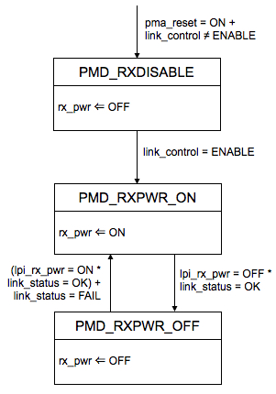

Figure 114-44 – 1000BASE-H PMD RX control state diagram

### 1000BASE-H PHY LPI transmit operation

When the start of “Assert LPI” encoding on the GMII, the transmit function of the local PHY encodes the “Assert LPI” signal on the PDBs as defined in Table 114-1.

Once a PDB that contains an “Assert LPI” has been completely transmitted to its link partner, the local PHY transmitter goes “quiet” with the next data payload sub-block unless the GMII signals normal-interframe before the end of the current data payload sub-block.

The transmit function of the local PHY is enabled periodically to transmit pilot and physical header sub-blocks (refresh signals) at the same time as they would be transmitted in normal operating mode.

During LPI operation, the transmitter replaces any data payload sub-block by:

* transmission of 80 {0} symbols, to indicate transition to quiet
* minimum PMD optical output power compatible with LPI mode during 7744 symbols (quiet)
* transmission of 80 {0} symbols, to prepare the reception of pilot and physical header sub-blocks used as refresh signals

This quiet-refresh cycle continues until the reception of the normal-interframe encoding on the GMII. The local PHY transmitter enters the normal operating state at the beginning of the next payload data sub-block.

The 64B/65B PCS encoder shall preserve the timing during quiet mode. Therefore, the time alignment of transmitted PDBs regarding to FEC codewords shall be exactly the same when the PHY re-enters the normal operation that would be if PHY had not entered the LPI quiet mode. This preserves the PCS decoder synchronization of the link partner and coherence with information encoded in the field PHD.TX.NEXT.PDB.OFFSET of the last received PHD.

Unlike some other EEE PHYs, neither sleep nor wake specific signals are used to enter and leave the LPI mode of operation, respectively. On the contrary, sleep is indicated to the link partner by the transmission of 80 {0} symbols that replace the beginning of a payload data sub-block that goes quiet. However, this sequence of symbols is not specific of sleep signaling and no additional time is used for its transmission. Wake is indicated by the event of presence of normal 16-PAM Tomlinson-Harashima precoded signal at the beginning of a payload data sub-block that transports normal inter-frame and/or Ethernet packets.

### 1000BASE-H PHY LPI receive operation

In the receive direction, entering the LPI mode is triggered by the detection of the sequence of {0} symbols after the reception of a pilot or physical header sub-block. When the local PHY receiver detects this event, it encodes “Assert LPI” on the GMII and disables some functionality to reduce power consumption. Note that “Assert LPI” can also be encoded on the GMII RX due to the reception of PDBs containing LPI signaling from the link partner (this is the case of LPI assertion on the GMII TX in the middle of a payload data sub-block transmission).

The local PHY receiver shall use the pilot and physical header sub-blocks, which are sent periodically by the link partner, to update adaptive coefficients and timing circuits and to determine the value of variable loc_rcvr_status. Therefore, in LPI mode, the receiver shall also use the refresh signals to estimate the quality of decoding (i.e. link margin) of payload data sub-blocks that is expected when normal operation re-enter.

This quiet-refresh cycle continues until the presence PAM Tomlinson-Harashima precoded signal in the time slot corresponding to a payload data sub-block is detected. Then, the local PHY starts normal operation and sends to the GMII the data contained on the PDBs received from the remote PHY. The PCS decoding shall start aligned to the boundary of the first complete PDB received from the beginning of the payload data sub-block. At this moment, the local PHY begins to send normal-interframe encoding on the GMII, since this is the information received from the remote PHY and the link is ready to provide the nominal operational data rate.

### 1000BASE-H PHY LPI mode timing parameters

Table 114-3 summarizes three key EEE parameters (Ts, Tq and Tr) defined in Clause 78 for 1000BASE-H PHY.

The period of time that the PHY remains quiet before sending the refresh signal (pilot or physical header sub-blocks), denoted as Tq, corresponds to the transmission time of a payload data sub-block subtracting the time needed to transmit the sequences of {0} symbols for quiet indication and for receiver preparation, which is given by

Tpayload (μs) = (NCW * NSYM_CW – NSYM_ZERO) / Fs = (8*988 - 160)/325 = 23.83 μs

where NCW is the number of FEC codewords transmitted per payload data sub-block, NSYM_CW is the number of symbols composing a FEC codeword, NSYM_ZERO is the total number zero value symbols summing up those for quiet indication and receiver preparation, and Fs is the symbol frequency in MHz.

The duration of the refresh signal, denoted as Tr, corresponds to the transmission time of a pilot or physical header sub-block plus the time for quiet indication and receiver preparation, which is given by

Tpilot/PHS (μs) = (NSYM + NSYM_ZERO) / Fs = (16 + 128 + 16 + 160)/325 = 0.985 μs

where NSYM is the number of symbols composing a pilot or physical header sub-block.

Additional LPI timing parameters for 1000BASE-RH PHY are specified in Table 114-4. Note that 24.82 μs is the time needed to transmit a pilot or physical header sub-block and a payload data sub-block.

Table 114-3 – Key EEE parameters for 1000BASE-H

|  |  |  |  |  |  |  |
| --- | --- | --- | --- | --- | --- | --- |
| **PHY Type** | **Ts (μs)** | | **Tq (μs)** | | **Tr (μs)** | |
| **Min** | **Max** | **Min** | **Max** | **Min** | **Max** |
| 1000BASE-RH | 0 | 0 | 23.83 | 23.83 | 0.985 | 0.985 |

Table 114-4 – LPI timing parameters for 1000BASE-H

|  |  |  |  |  |  |  |
| --- | --- | --- | --- | --- | --- | --- |
| **PHY Type** | **Case** | **Tw_sys_tx (min)  (μs)** | **Tw_phy (min)(μs)** | **Tphy_shrink_tx (min)(μs)** | **Tphy_shrink_rx (min)(μs)** | **Tw_sys_rx (min) (μs)** |
| 1000BASE-RH |  | 24.82 | 24.82 | 24.82 | 0 | 0 |