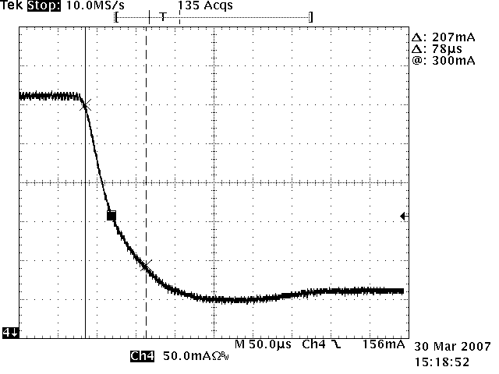
PD with synchronous rectification
Di/dt max= 3mA/us

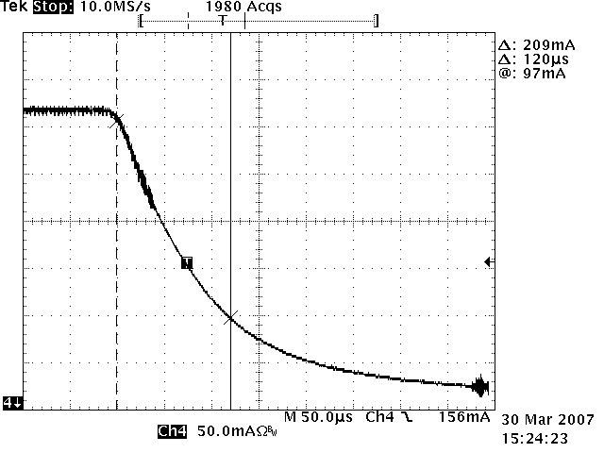
PD with diode rectification
Di/dt max= 2.5mA/us

