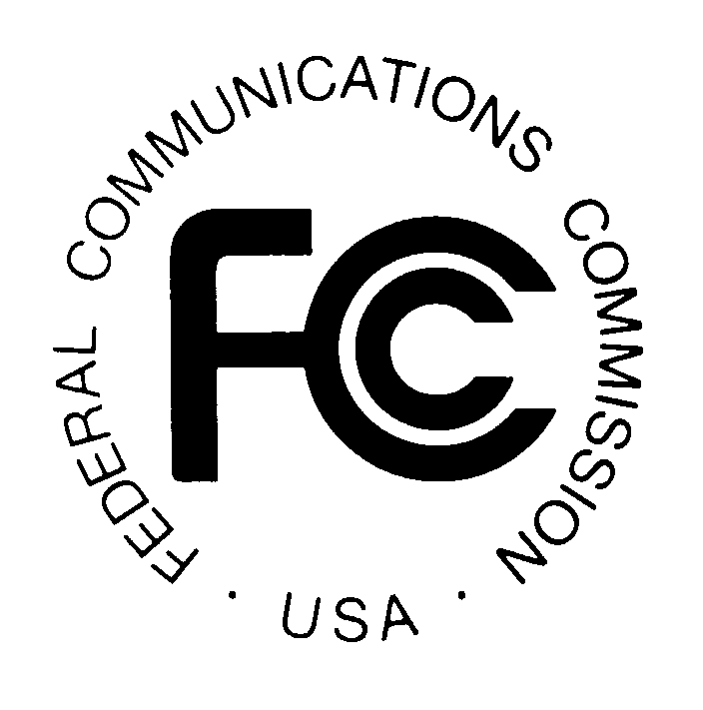PUBLIC NOTICE
FEDERAL COMMUNICATIONS COMMISSION
445 12th Street, S.W., TW-A325
WASHINGTON, DC 20554 DA 02-1643
News media information 202/418-0500 Fax-On Demand 202/418-2830 Internet: http://www.fcc.gov ftp.fcc.gov

Released: July 10, 2002

SPECTRUM POLICY TASK FORCE ANNOUNCES PUBLIC WORKSHOPS
ON ISSUES RELATED TO COMMISSION’S SPECTRUM POLICIES

OET Docket No. 02-135

The Spectrum Policy Task Force will hold four public workshops addressing issues related to the Commission’s spectrum policies. The workshop topics and corresponding dates are as follows: Experimental Licenses and Unlicensed Spectrum, August 1st; Interference Protection, August 2nd; Spectrum Efficiency, August 5th; and Spectrum Rights and Responsibilities, August 9th. All of the workshops will be held from 9 am – 3 pm in the Commission Meeting Room, 445 12th Street, S.W., Washington, DC. Panelists are currently being invited and additional information will be provided in a subsequent public notice. Audio/Video coverage of the workshops will be broadcast live over the Internet from the FCC website at www.fcc.gov/realaudio.
For further information, contact Lauren Van Wazer at 202-418-0030 voice, 202-418- 1744 fax, and e-mail lvanwaze@fcc.gov.

